
Model Railroad dual solenoid turnout driver.

Pcb 4X4CDUP4

This is only for boards with the above product code.

This board is designed to control dual solenoid turnouts such as the Marklin M track 5117, 5202, 5120, 5214, 5207 or 5128. With or without a capacitor discharge unit (CDU).

The board has a number of options for construction. Below are bill of materials for minimum use and a completely populated board.

I use a 24V 1A DC power supply with the board and this will power the Marklin turnouts without a CDU. Other brands of turnouts have not been tested.

The maximum current for any one solenoid is 500mA, this is limited by the ULN2803 darlington drivers.

Please read all this document before construction of the pcb.

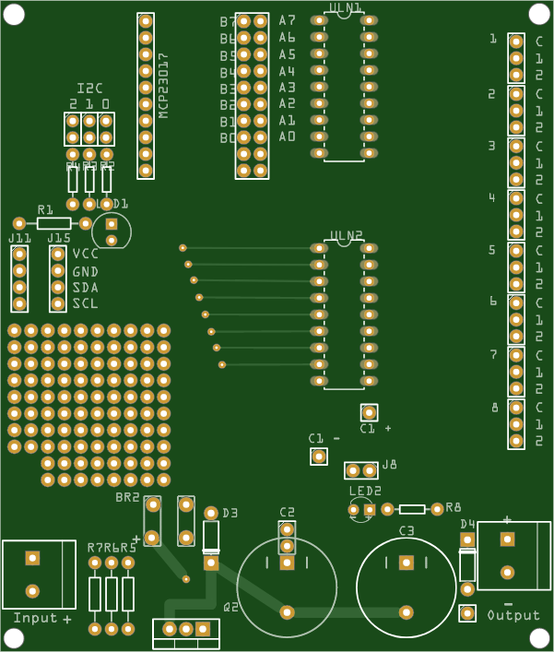

On this image the D3 should be D1 and D4 should be D2.

Bill of Materials

All builds:

1 - PCB
pcbway.com/project/shareproject/DCC_EX_Solenoid_Turnout_Driver_with_Capacitor_Discharge_Unit_8274534c.html

1 - MCP23017 I2C Serial Interface - 16 bit I/O Expander Module
ebay.com.au/itm/265734933121

Minimum use:

This is 4 turnouts and no CDU

1 - ULN2803 Darlington driver
3 - 10K 1/8w resistors
1 - 6 pin (3x2) male header
1 - 10 pin female header
1 - 20 pin (10x2) female header
1 - 2 way 2.54mm (0.1”) pitch screw terminal
4 - 3 way 2.54mm (0.1”) pitch screw terminal
1 - 4 way 2.54mm (0.1”) pitch screw terminal

Maximum use:

This is 8 turnouts and CDU

2 - ULN2803 Darlington driver
2 - 3mm led (colour of your choice)
1 - TIP41C NPN power transistor
1 - 24V zener diode (optional)
1 - 1N4001 diode
1 - 220Ω 1/8w resistor
1 - 2W10 Bridge Rectifier 2A
1 - 1K 1/8w resistor
3 - 820Ω 1/4w resistors
3 - 10K 1/8w resistors
2 - 4700uF 35V electrolytic capacitor
1 - 6 pin (3x2) male header
1 - 10 pin female header
1 - 20 pin (10x2) female header
1 - 2 way 2.54mm (0.1”) pitch screw terminal
4 - 3 way 2.54mm (0.1”) pitch screw terminal
1 - 4 way 2.54mm (0.1”) pitch screw terminal
1 - 2 way 5.08mm (0.1”) pitch screw terminal or plugable terminal

Construction of the board.

This is for a maximum build. If you don’t need a maximum build leave off the components you don’t need.
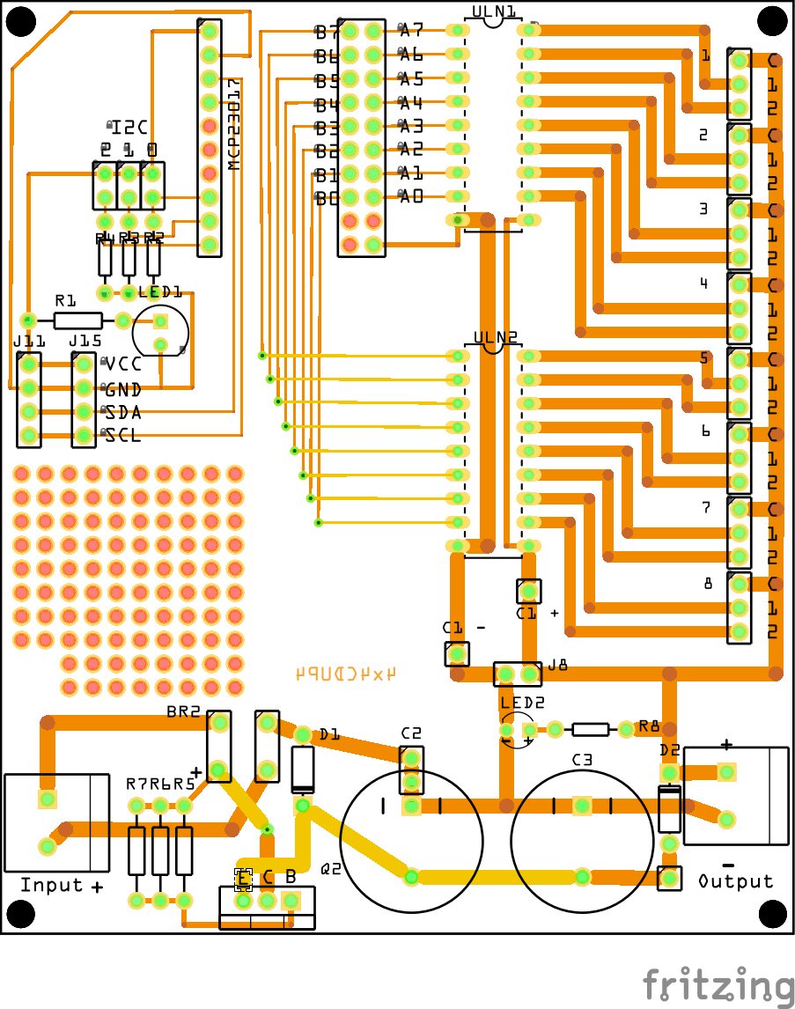

As with most pcb construction start with soldering in the lowest profile items first, eg resistors, diodes, leds, etc.

I suggest marking them of the list on the next page as you go.

As with all semiconductor items they are heat sensitive so for the ULN2803 optionally use an 18 pin IC socket. With the TIP41C a heatsink clip (bulldog clip) on the leads is a good idea.

The 24V zener diode is optional and is only required if the power supply voltage is greater than the voltage of the electrolytic capacitors (C2 and C3). eg. 30V DC power supply with 25V capacitors.

Recommended soldering order:

Done
R1 220Ω resistor
R2, R3, R4 10K resistor
R5, R6, R7 820Ω resistor
R8 1K resistor

D1 24V zener (optional see previous page)
D2 1N4001 diode

ULN1 ULN2803 (or IC socket see previous page) NOTE orientation
ULN2 ULN2803 (or IC socket see previous page)

LED1 3 mm led
LED2 3 mm led

BR2 2W10 bridge rectifier NOTE orientation

I2C 6 pin (3 x 2) male header
J15 4 pin female header

MCP23017 10 pin female header
20 pin (10 x 2) female header

J11 4 way 2.54mm (0.1”) screw terminal
1 3 way 2.54mm (0.1”) screw terminal
2 3 way 2.54mm (0.1”) screw terminal
3 3 way 2.54mm (0.1”) screw terminal
4 3 way 2.54mm (0.1”) screw terminal
5 3 way 2.54mm (0.1”) screw terminal
6 3 way 2.54mm (0.1”) screw terminal
7 3 way 2.54mm (0.1”) screw terminal
8 3 way 2.54mm (0.1”) screw terminal

input 2 way 5.08mm (0.2”) screw terminal or pluggable terminal

Q2 TIP41C npn power transistor. NOTE orientation.
The mounting tab goes to the edge of the PCB
so that a heatsink can be added if needed.

C2 4700uF 35V electrolytic capacitor
C3 4700uF 35V electrolytic capacitor

Insert the MCP23017 module into the headers. NOTE orientation however it really can only go in one way.

Other information.

Additional components.

Connector J8 is only required if you are not building the CDU part of the board. This is where you connect the power supply to drive the solenoids. It could be a 2 way 2.54mm (0.1”) screw terminal or a 2 pin stackable female header if you intend stacking boards.

Connector J15 is only required if you need to expand the I2C connection. This also could be a 4 pin stackable header if you are stacking boards.

C1+ C1- this is for adding an electrolytic capacitor if you are not using the CDU but find the solenoid drive voltage dropping too low to have multiple successive drives. It smooths the voltage but does not replace a CDU.

Optional components.

C2 the original design had two 4700uf electrolytic capacitors. C2 can be replaced with any electrolytic capacitor that will fit. There are holes for 7.5, 10 and 12.5mm pitch on the PCB. eg a 10000uF 35V electrolytic capacitor will fit the 12.5mm pitch holes. It’s up to you to determine if the electrolytic capacitor will fit.

D2 can be changed to a larger amperage diode if needed. eg 1n4007 there is an additional hole for longer leads if needed.

ULN1 ULN2 it is recommended to use an ic socket for both of these. I recommend the turned pin IC sockets or strip headers.

In use.

This board was designed as an add on to an Arduino Mega 2560 running DCC++EX, http://dcc-ex.com

The macro to use this for dual solenoid turnouts in EX-RAIL is:

#define SOLENOID_PULSE 5 //5 mSec // should be less than 50mSec
#define SOLENOID_TURNOUT(id,pc,pt,desc,ali,shadow)\
ALIAS(ali,id)\
PIN_TURNOUT(id,0,desc)\
PIN_TURNOUT(shadow,0,HIDDEN)\
DONE\
ONCLOSE(id)\
SET(pc)\
DELAY(SOLENOID_PULSE)\
RESET(pc)\
CLOSE(shadow)\
DONE\
ONTHROW(id)\
SET(pt)\
DELAY(SOLENOID_PULSE)\
RESET(pt)\
THROW(shadow)\
DONE

This was developed by “DavidMorph“ as per here:
https://discord.com/channels/713189617066836079/873794422993727568/1004923697586511954

Then add a declaration of the turnout like this, in myAnimation.h file:

SOLENOID_TURNOUT(1000, 164, 165, "Entry to parking track 1", TRN_PARK_1_ENTRY, 1001)

Connecting the turnouts

A basic dual solenoid is wired like this:

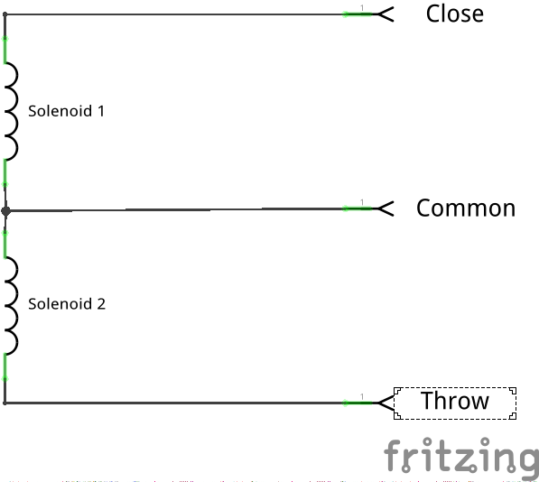

To connect a turnout to the RT CDU P4.

RT CDU P4 Turnout
1 - C Common wire
1 - 1 Close wire
1 - 2 Throw wire

The close and throw wire can be wired either way around to suit your layout. The common wire must be connected to the C terminal.

The following table describes all vpins (on I2C modules) in DCC-EX to the relevant connections on the 4x4 CDU P4 board.

I2C Addr | 1 |  | 2 |  | 3 |  | 4 |  | 5 |  | 6 |  | 7 |  | 8
I2C Addr | 1 | 2 | 1 | 2 | 1 | 2 | 1 | 2 | 1 | 2 | 1 | 2 | 1 | 2 | 1 | 2
0x20 | 179 | 178 | 177 | 176 | 175 | 174 | 173 | 172 | 171 | 170 | 169 | 168 | 167 | 166 | 165 | 164
0x21 | 195 | 194 | 193 | 192 | 191 | 190 | 189 | 188 | 187 | 186 | 185 | 184 | 183 | 182 | 181 | 180
0x22 | 211 | 210 | 209 | 208 | 207 | 206 | 205 | 204 | 203 | 202 | 201 | 200 | 199 | 198 | 197 | 196
0x23 | 227 | 226 | 225 | 224 | 223 | 222 | 221 | 220 | 219 | 218 | 217 | 216 | 215 | 214 | 213 | 212
0x24 | 243 | 242 | 241 | 240 | 239 | 238 | 237 | 236 | 235 | 234 | 233 | 232 | 231 | 230 | 229 | 228
0x25 | 259 | 258 | 257 | 256 | 255 | 254 | 253 | 252 | 251 | 250 | 249 | 248 | 247 | 246 | 245 | 244
0x26 | 275 | 274 | 273 | 272 | 271 | 270 | 269 | 268 | 267 | 266 | 265 | 264 | 263 | 262 | 261 | 260
0x27 | 291 | 290 | 289 | 288 | 287 | 286 | 285 | 284 | 283 | 282 | 281 | 280 | 279 | 278 | 277 | 276

I2C address 0x20, 0x21 are the default MCP23017 modules built in to the DCC-EX software.
I2C addresses 0x22 - 0x27 can be installed by you and therefore the vpins can also be defined by you. The vpins in the above table is a suggestion only.

Other Uses

The RT CDU P4 can also be used for other purposes.

Some suggestions are:

Sensor input.

Replace the ULN2803 ic’s with an 8 way dip switch in pins 1-8 and 11-18 of ULN1 and/or ULN2. Wire links between pin 1-18, 2-17 ... 8-11 could also be used for a permanent connection.

The sensors could then be wired:

RT CDU P4 Sensor
1 - C VCC
1 - 1 Output
output - GND

also connect the following for power supply to the sensors
output + VCC for the sensors
output - GND

Sensors are then accessed using the AT(vpin) in EX-RAIL.

Lighting output.

RT CDU P4 Lighting
1 - C +ve supply
1 - 1 GND

also connect the following for power supply to the lighting
output + VCC for the sensors
output - GND

Lighting circuits are then accessed using SET(vpin) to turn on or RESET(vpin) to turn off in EX-RAIL

Addendum

This applies to boards with product code 4X4CDUP4 on the bottom of the board.

The initial batch of the PCB has a track missing. If you have created or purchased boards from gerbers after 7 July 2023 with product code RT CDUP 4 xxxx then this is not required.

It is a simple fix by adding one jump wire.

The wire goes from the cathode of diode D2 to the base of transistor Q2.

The image below shows it on the bottom of the printed circuit board.

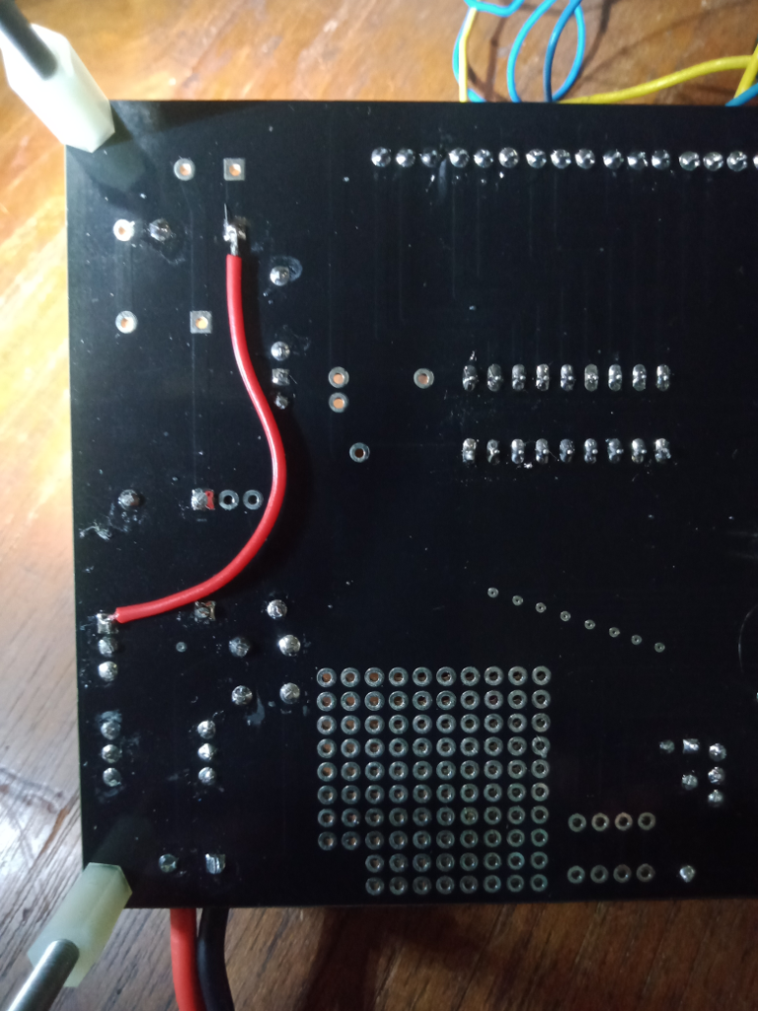

References.

DCC-EX https://dcc-ex.com

EX-RAIL https://dcc-ex.com/ex-rail/

Solenoid Turnout macro by DavidMorph
https://discord.com/channels/713189617066836079/873794422993727568/1004923697586511954

RT CDU P4 pcb on PCBway
https://pcbway.com/project/shareproject/DCC_EX_Solenoid_Turnout_Driver_with_Capacitor_Discharge_Unit_8274534c.html

MCP23017 I2C Serial Interface - 16 bit I/O Expander Module example
https://ebay.com.au/itm/265734933121
https://www.aliexpress.com/item/32865063393.html

