ROSSEZ Arno, DELOULME Jean-Christophe, MATHIEU Hervé
GIN, Grenoble Institut des Neurosciences
25/07/2025
SpasTract Tutorial Step-by-step
Part 2 : "Connectomics & Volumetry" - V1.0

A. Prerequisites :
- Have a station equipped with a screen, a keyboard and a mouse.
- Know how to navigate session files, how to use a terminal (Here Linux, Ubuntu).
- Have the SpasTract tutorial folder on your station.
- Python installed (recommended 3.8+)
- SpasTractRequirements.txt conditions met
- [Optional for Compressed Sensing] MATLAB installed
- Note for the reader: The terminal location is shown in blue, and the commands used are shown in red italics.
- The '\' show the line return in this protocol but are not part of the command lines.

B. Method :
- Setting up
  - Make sure to have the following Python scripts : "SpasTract_AtlasRemapping_V1_Arno_202507.py", "SpasTract_Connectomics_V1_Arno_202507.py" and "SpasTract_Volumetry_V1_Arno_202507.py".
  - Retrieve a mouse brain atlas, its parcellation and a text file containing informations about its parcellation. Here we take the example of the P56 AllenBrain mouse atlas available as NIfTI files (atlas template called P56_Atlas.nii, renamed to P56_Atlas_Template.nii and atlas parcellation called P56_Annotation.nii, renamed to P56_Atlas_Parcellation.nii) alongside its LookUpTable (LUT) as a txt file at : https://scalablebrainatlas.incf.org/mouse/ABA_v3*
  - *To retrieve the LUT you need a few extra steps than simply downloading : click on "label index mapper" hyperlink then in the new tab select for "Map index to :" "all of the above" and for "Output format :" "matlab cell array". You should also have by default the proper atlas selected for "Atlas template :" "Mouse – ABA_v3 (Allen Mouse Brain Common Coordinate Framework version 3)". Once all this completed press "Show result" and then copy paste the list into a text file. NB : for AllenBrain the LUT is in the format {'12','1F9C59','MO','Somatomotor areas'} where you have each region between brackets with its value, its hexadecimal color, its acronym and its full name.

- Compressed Sensing [Optional]
  - Compressed Sensing images are already provided but if you want to try looking into it and generating some, then raw Bruker MRI scans are also provided alongside functions in the reference elements folder, you should have the following functions as well : ApplyHeaderCS.m ; Arno_3DCSFLASHPRONE_Reconstruction_BARTV9_202506.m (the main script to run for CS) ; ClicArno_3DCSFLASHPRONE_Reconstruction_BARTV9_202506.m (a click-based selection version of the main script) ; conventionalCSReconstruction_V5.m ; readAcquisitionFileV2.m ; readParavisionUndersampledRawFIDV3.m ; undersampledDataReconstructionFromMultiChannelRawFIDV4.m ; zeroPaddingReconstruction_V3.m.
  - Make sure to follow instructions inside the main script as well as putting the undersamplingPattern.txt and acquisitionParameters.txt text files in each of the CS MRI scans if not done already.
  - Once set, you can run the main script with all its functions in one of your MATLAB paths or in the same folder as the main script. NB: you might have to change the path to the BART toolbox depending where you installed it ; also you will have to change the path or select manually the path to the CS MRI scans...

- Remapping the atlas
  - Once the atlas and its LUT in your possession, you now "only" need to remap the atlas to make sure that two points are respected for MRtrix : 1) values needs to be continuous and 2) values need to start at 1 (what can be done for that is simply to remove the "root" region of the LUT which matches the background with 0)
  - For this you will simply have to run the Python script entitled "SpasTract_AtlasRemapping_V1_Arno_202507.py" which will ask for two inputs : the atlas parcellation and the original LUT
  - When prompted by the script please tick whether you wish to also remap or not the parcellation to : 1) group small regions together and/or 2) lateralize the parcellation left-right. By clicking yes to these options you will thus generate more parcellations that are grouped/lateralized/grouped&lateralized on top of the reformatted one with continuous values. The script will also make sure to generate the matching LUTs for those new parcellations.
  - You should end up with : an atlas, new parcellations and their matching LUTs ; you can then proceed onto the next steps.
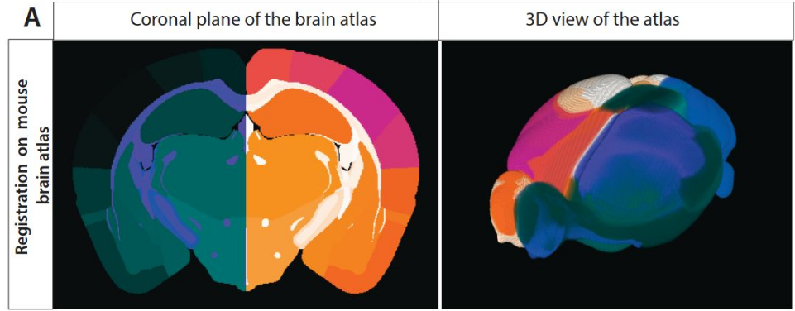
Example of a remapped parcellation with grouped small regions and lateralized sides left-right

- Connectome creation and Structural Connectivity matrices
  - To proceed further into the connectomics part of the tutorial : make sure to have an atlas (.nii), its remapped parcellation(s) (.nii) and its(their) matching LUT(s) (.txt) as well as the preprocessed DWI of the sample of interest (usually "dwi_den_unr_N4biascat.mif"), its matching whole-brain tractogram(s) (.tck) and optionally its matching T1-anatomical CS image (aligned on the DWI).
  - Once this is done you can run the Python script entitled "SpasTract_Connectomics_V1_Arno_202507.py", it will first ask whether you want to 1) Generate connectomes and plot structural connectivity matrices or 2) Average different samples' connectomes (for example for WT and Spastin-KO conditions) and then compute the differences and significant differences connectomes, 3) Plot only structural connectivity matrices, 4) Analyze the symmetry of two conditions connectomes (AvgWT vs Avg Spastin-KO for example), 5) Plot only connectograms based on connectomes or X) Abort the script.
  - With 1) it will prompt you to choose each input required from the previous step as well as asking you whether you want to use the CS image or not (the higher resolution the better the atlas coregistration). It will then coregister the atlas to the CS and combine this with the tck tractogram file to generate a connectome (.csv) based on tck2connectome MRtrix function. Following this it will also generate tractograms based on the connectome and the tractogram using connectome2tck MRtrix function as well as the matching voxels, for that however it currently needs a single integer or a comma-separated list of integers written manually in the script.
  - After that or if you choose 3), it will generate the different structural connectivity matrices based on the different connectomes generated or in the selected folder (default, invnodevol, scalelength, scaleinvlength) as well as the different submatrices (white matter, grey matter, intra-L, intra-R, inter-LR) in a subfolder bearing the current date and time.
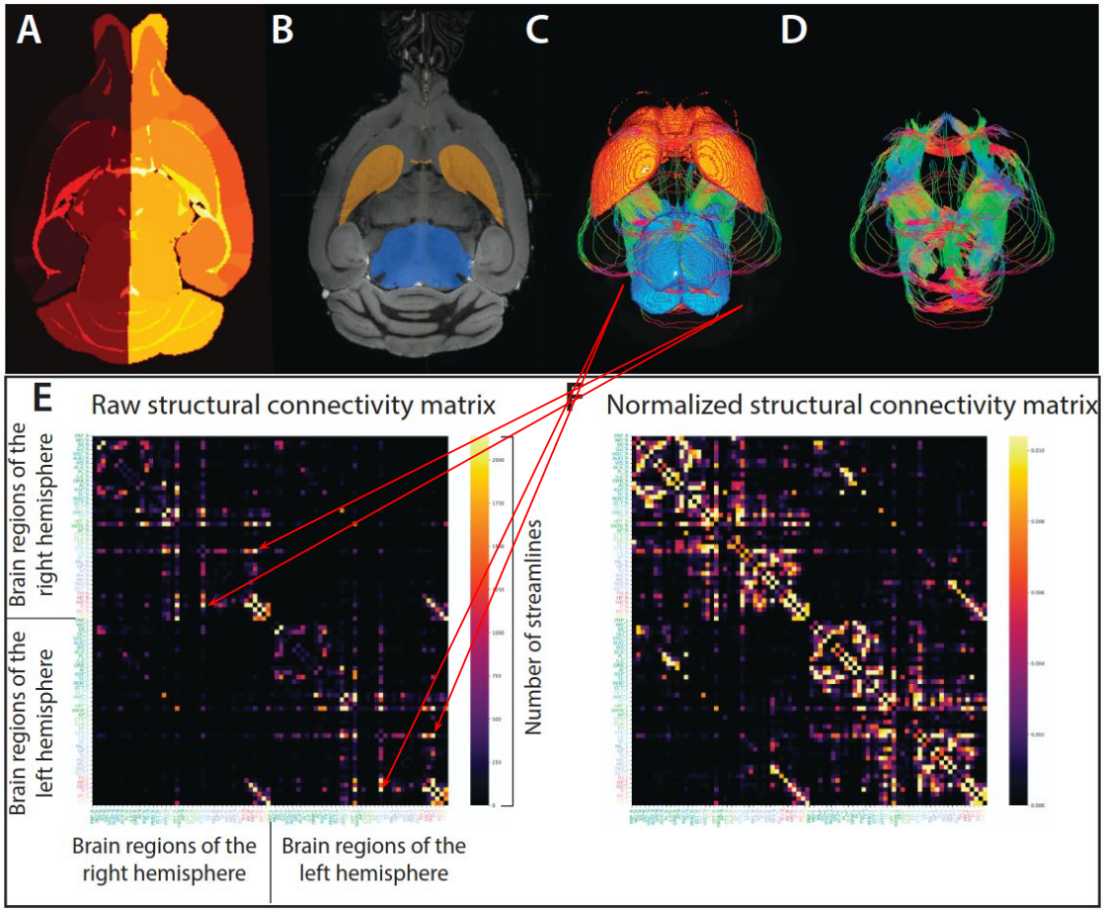
Example of the process to make connectome and then structural connectivity matrices
  - If you choose 2) after running the script with 1) at least once for one sample WT and one sample Spastin-KO, then you will have to select the WT folder (upstream of for example F1023A such as WT/F1023A) and the Spastin-KO folder (such as Spastin-KO/M974). The script will proceed to compute the average connectomes of both conditions (here as a sanity check you should have the same connectome as before since it's the average of 1 sample for both conditions), then the difference connectome Spastin-KO minus WT then extract the significant differences following a Welch t-test (you will have significant differences connectomes and their p-values). Afterwards the structural connectivity matrices for these new .csv connectomes will be generated.
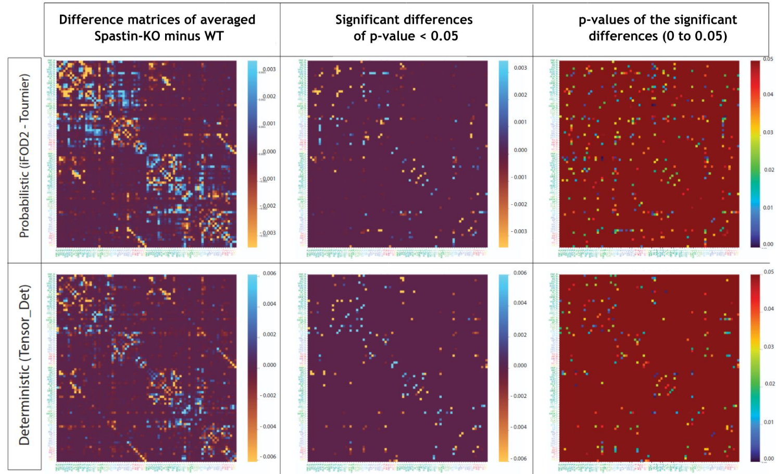
Example of differences, significant differences and p-values between Spastin-KO and WT conditions
  - You can also try testing the modes 4), for symmetry analysis to see if it works and if you see any striking symmetry issues in samples, and 5), for connectograms plotting in a similar fashion as the mode 3).
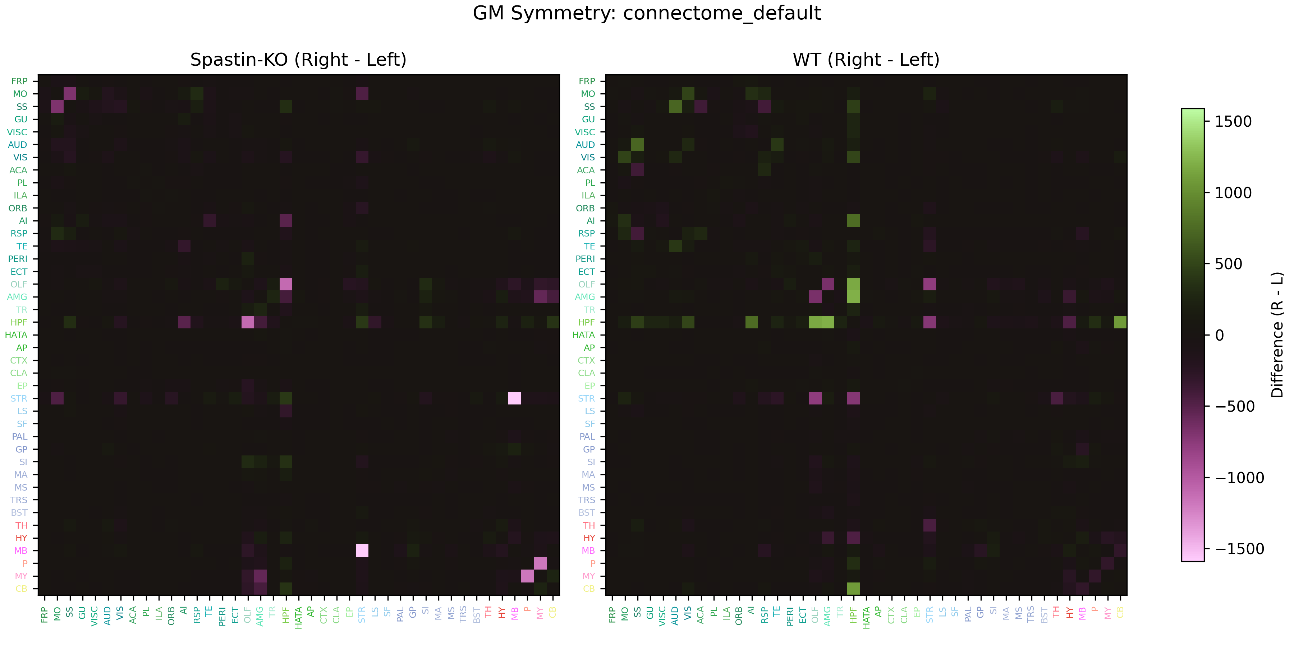
Example of symmetry analysis of the grey matter between Spastin-KO and WT conditions

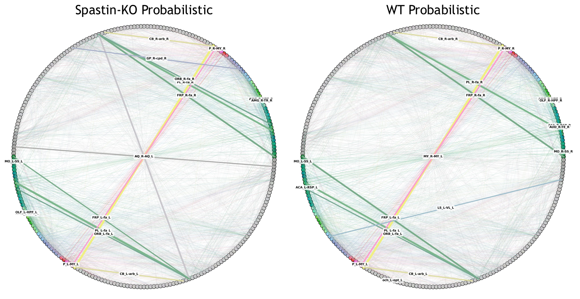
Example of connectograms between Spastin-KO and WT conditions, following probabilistic tractography

- Brain Volumetry
  - To end the tutorial with the volumetry section : make sure to have the remapped parcellation(s) (.nii) coregistered onto the CS or DWI for each sample thanks to the connectomics section where we coregistered the atlas on the dataset ("1)"). You will also need the matching LUT(s) (.txt) of these coregistered parcellations.
  - Ensure that each sample folder are in their respective WT/Spastin-KO (similarly as "3)" in the connectomics section) and that in each of them there is a subfolder with the coregistration in the format : "ConnectomeProject_YYMMDD_HHMMSS".
  - Now you can safely run the Python script entitled "SpasTract_Volumetry_V1_Arno_202507.py". It will ask for the WT, Spastin-KO folders and the LUT text file to start the volumetry with significance based on a Welch t-test. Before the volumetry it will prompt the user to specify any number(s) in the range of the parcellation values to extract the voxels of the regions matching the number(s). Once done it will save the volumetry figures in a subfolder containing the current date and time and then extract each specified region and significant region as NifTI files (.nii).
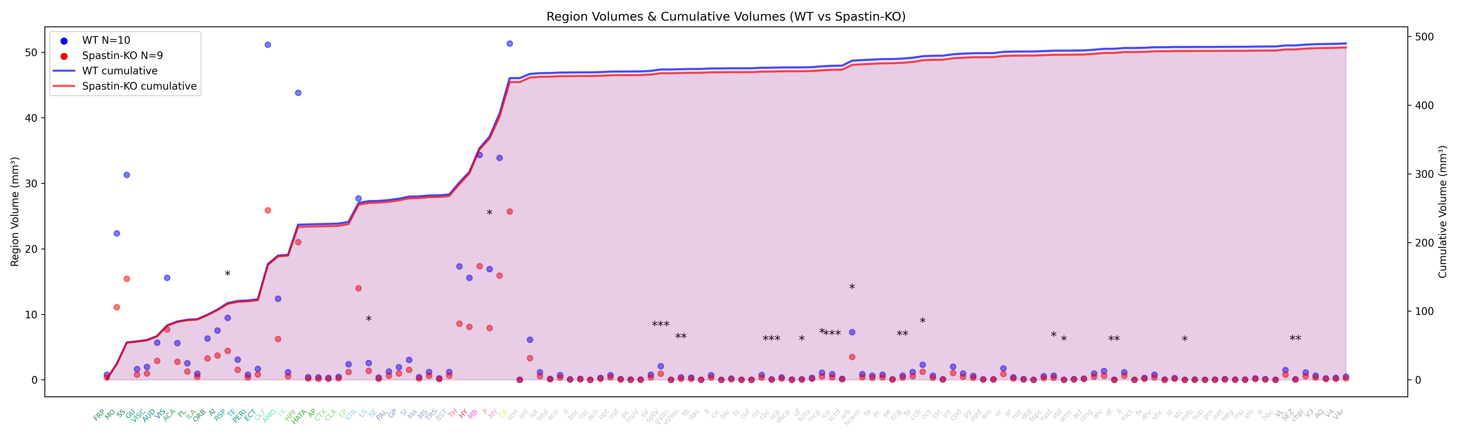
Example of what is obtained from brain volumetry

- You have successfully completed the SpasTract tutorial in its entirety, Congratulations ! Now you can start applying it to more data and improve some aspects such as : evaluating SD_Stream or other deterministic algorithms that make use of fODFs ; implement fixel-based analysis ; implement the combination of FA,MD,.. maps with tractograms ; evaluate if NullDist2 enhances iFOD2 algorithm ; tackle different pathologies...

