Database Table and Field Descriptions

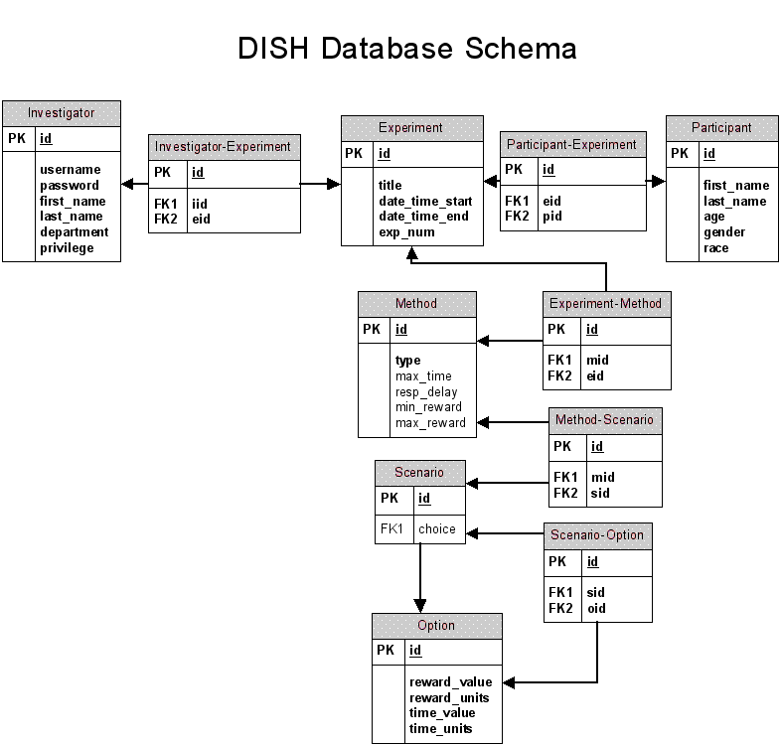

Database Table and Field Descriptions

Investigator

This table stores the data for the investigators (experimenters, administrators, experiment creators). The following data are stored for each experimenter:
- id -- This field is a numeric code generated automatically which acts as the primary key for this table. All tables contain a field of this name, and for all tables, the id field is the primary key.
- username -- This is the login name the investigator provides when logging in to the system.
- password -- This is the password the investigator provides along with username to log in.
- first_name -- This is the investigator’s first name.
- last_name -- This is the investigator’s last name.
- department -- This is the department for which the investigator works
- privilege -- This is a numeric code which indicates the investigator’s level of permission in the system; 0 indicates a non-administrator user, and 1 indicates an administrator.

Investigator-Experiment

This table stores ID numbers linking a specific investigator to a specific experiment.

- id --This is a numeric code generated automatically which acts as the primary key for this table.
- iid -- This is a foreign key that points to a table which stores the data for the investigator who presided over a given experiment.
- eid -- This is a foreign key that points to a table which stores the data for a given experiment.

Experiment

This table stores the data for a given experiment. The following data are stored for each experiment:

- id -- This field is a numeric code generated automatically which acts as the primary key for this table.
- title -- This is the name that is given to a particular experiment.
- date_time_start -- This is the date and time that the given experiment began.
- date_time_end -- This is the date and time that the given experiment ended.
- exp_num -- This is a foreign key that points to a table which stores the ID number for a given experiment and the ID numbers of any methods that experiment included.
Experiment-Method

This table stores ID numbers linking a given experiment to it included.

- id -- This field is a numeric code generated automatically which acts as the primary key for this table.
- eid -- This is a foreign key that points to a table which stores the data for a given experiment.
- mid -- This is a foreign key that points to a table which stores the data for a specific method.

Method

This table stores the data for a method. The following data are stored:

- id -- This field is a numeric code generated automatically which acts as the primary key for this table.
- type -- This is the method type. The type of method may be double limit (DL), decreasing adjustment (DA), real time (RT), multiple choice (MC), or a combination thereof.
- max_time -- This is the maximum amount of time that is allotted for a method to be carried out; for example, the maximum amount of time for a participant may spend reading in a RT scenario. This is not a required field.
- resp_delay -- This is the amount of time that elapses between the moment a scenario is presented and the moment a response is submitted. This is not a required field.
- min_reward -- This is the minimum reward value that a method will present to the participant. This is not a required field.
- max_points -- This is the maximum reward value that a method will present to the participant. This is not a required field.

Method-Scenario

This table stores the ID numbers for a scenario and the method through which that scenario was presented.

- id -- This field is a numeric code generated automatically which acts as the primary key for this table.
- mid -- This is a foreign key that points to a table which stores the data for a specific method.
- sid -- This is a foreign key that points to a table which stores the data for a specific scenario.

Scenario

This table stores a reference to another table which stores the participant’s response to a given scenario. The following data are stored:

- id -- This field is a numeric code generated automatically which acts as the primary key for this table.
- choice -- This field is a foreign key which points to a table that stores the data for the answer choice that was chosen by the participant. This is not a required field.

Scenario-Option

This table stores the ID numbers for a scenario and the option that was selected.

id -- This field is a numeric code generated automatically which acts as the primary key for this table.
sid -- This is a foreign key that points to a table which stores the data for a specific scenario.
oid -- This is a foreign key that points to a table which stores the data for the answer choice that was chosen by the participant.

Option

A scenario in a DL, DA or MC method will present the participant with more than one response choice; these choices are called options. This table stores the following data for each option the participant selects:

id -- This field is a numeric code generated automatically which acts as the primary key for this table.
value -- This is the numeric value of the reward offered in the option the participant selected.
units -- This is the unit value (such as minutes) of the reward offered in the option the participant selected.

Participant-Experiment

This table stores the ID numbers for a given experiment and the individual(s) who took part in it.

id -- This field is a numeric code generated automatically which acts as the primary key for this table.
eid -- This is a foreign key that points to a table which stores the data for a given experiment.
pid -- This is a foreign key that points to a table which stores the demographic data for a participant in a given experiment.
Participant

This table stores demographic information for each participant. The following data are stored:

id -- This field is a numeric code generated automatically which acts as the primary key for this table.
first_name -- This is the participant’s first name.
last_name -- This is the participant’s last name.
age -- This is the participant’s age (in years).
gender -- This is the participant’s gender (male or female).
race -- This is the participant’s race (Caucasian, Black or African American, Hispanic or Latino, American Indian or Alaskan Native, Asian or Pacific Islander, Other).

