Contents
Demographics 2
Menu 3
Queries 4
Query Builder 4
Advanced Query Builder 4
Query Library 5
User 6
Edit Users 6
Create Users 6
Delete Users 6
Results 7
Modifying/Creating an Experiment 7
Changing The Number of Times a Method Occurs 7
To change The Reward Type 8
Methods 8
Multiple Choice: 8
Real Time 9
Decreasing Adjustment 9
Double Limit 10
Completion 11

Login

To begin the experiment the following screen will appear:
This screen prompts the experimenter to enter his or her username and password in the following text fields. In case the experimenter forgets their username /password, they should contact the administrator regarding that information. After the username and password has been entered, select the “sign in button” to proceed to the next screen.

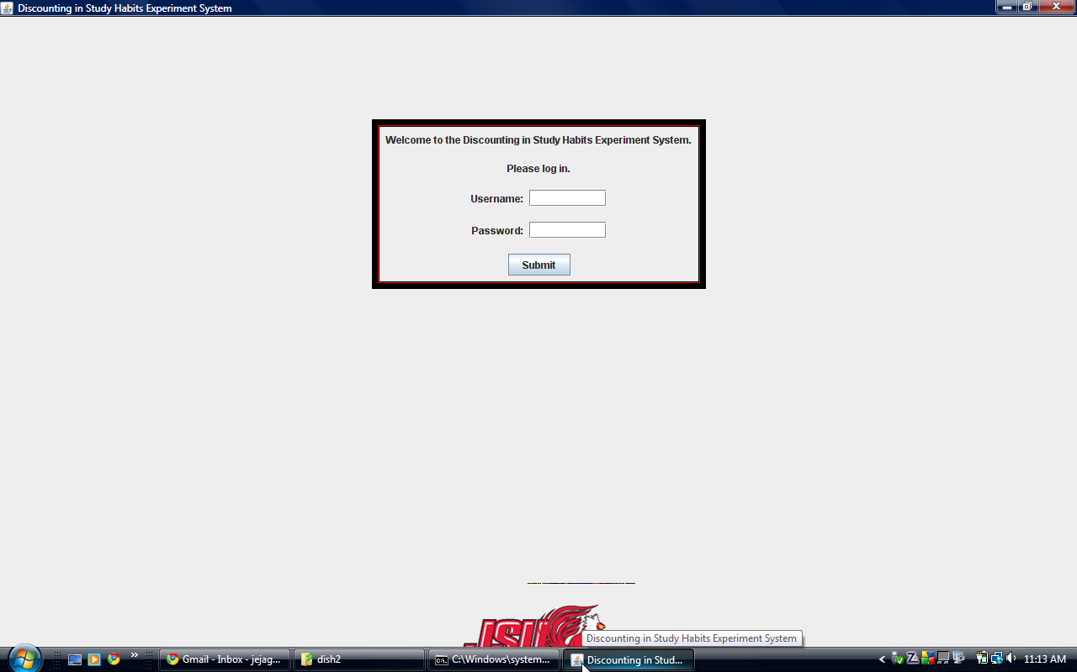

Demographics

After the experimenter has logged in, new participants will be directed to enter their demographic information. The screen will resemble the following:

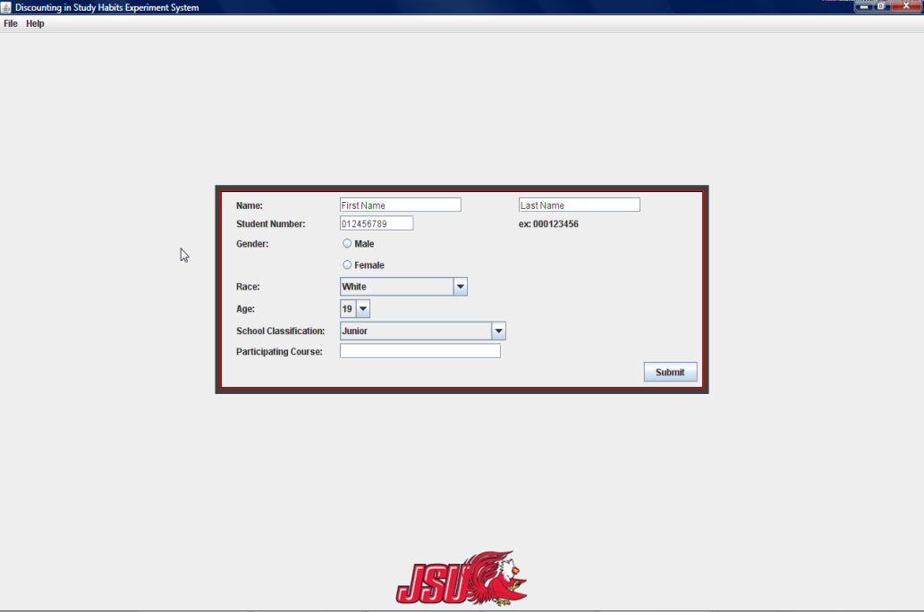
- Name is represented by two text boxes. The participant should enter his or her first and last name in the corresponding text boxes.

- Student Number should be typed using dashes just as the example indicates.

- Gender is represented by two radio buttons; one for male and one for female. The participant should select the radio button that corresponds to his or her gender.

- Race is represented as a drop -down list. The down button will reveal more choices that the participant can choose from. The choice that best fits the participant should be selected.

Menu
The menu screen will include a file menu and an administration menu.
File menu:
- Can only be accessed by an administrator or an experimenter
- Load experiment allows the administrator/experimenter to access the XML template file. The xml file can be modified to meet the needs of the experiment.
- The exit command allows the administrator/experimenter to exit the program.
Administration menu:
- Can only accessed by the administrator
- The user administrator window is used to add, modify, or delete users.
- Data administration will allow the administrator to create a query or select a query that has already been made. This allows specified data to be extracted.
The following screen is an example of the menu screen:
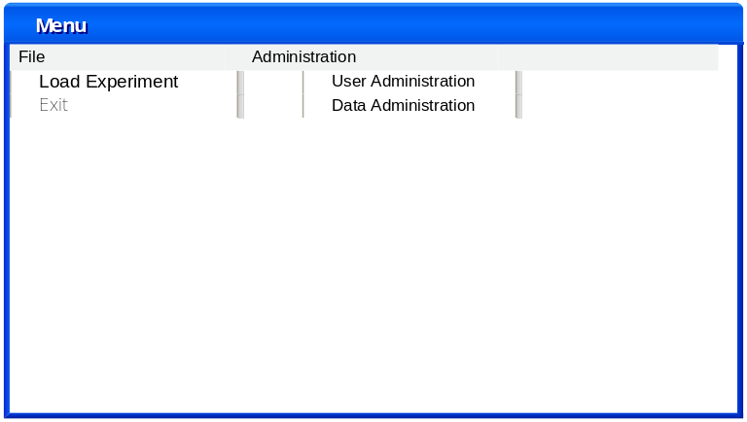

Queries

The administrator will be able to build or create queries and then extract the information from the query library.

Query Builder
Example of the query builder screen:
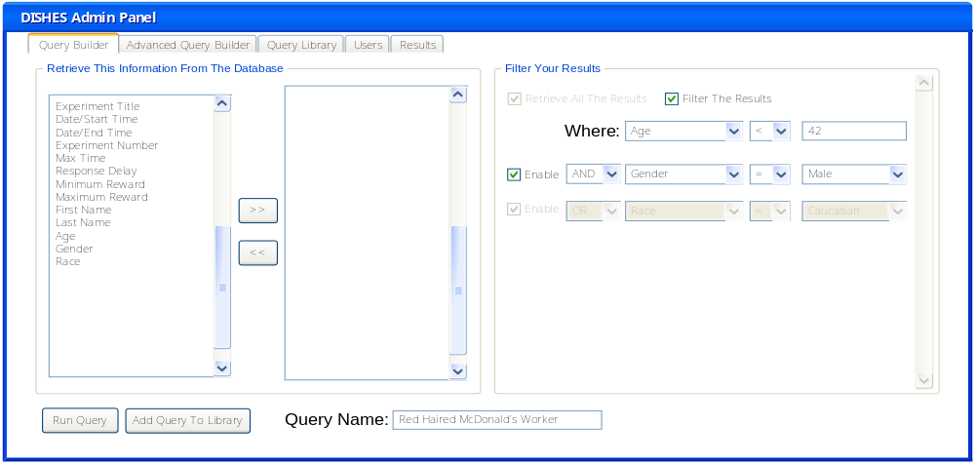
The query builder is where the administrator can build a report to retrieve data from the database. The list boxes, located on the left side of the screen, contain information that can be extracted from the database. The administrator selects the information he wants to extract and uses the arrows to move the selected item to the empty box and vice versa. The results may be filtered using the check box on the right side of the screen. As the bottom row of fields are enabled, an additional row of fields will be added but not enabled. This allows the administrator to add multiple filter levels. The administrator can then run the query or name it and save it to the query library for later use.

Advanced Query Builder

The advanced query builder should only be used if the administrator knows SQL well enough to create his own query. After the administrator has created the query, he can then run the query or name and save the query to the library for later use. The screen below is an example of the advanced query builder:
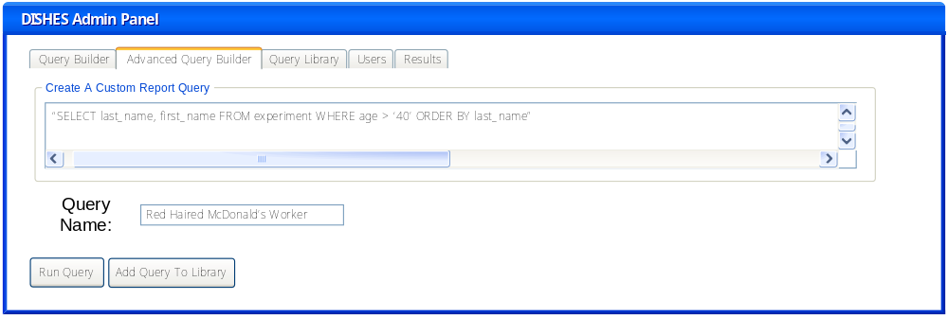

Query Library

The library is a collection of previously created queries that can be selected and ran by selecting “Run Query.” A query may also be deleted by selecting it and clicking the “Delete from Library” button. To edit the query the administrator can select the “show code” button; the code will then appear in the bottom box. The administrator can then click the “copy code” button and copy it to the custom code space to make changes. The screen below is an example of how the query library will be displayed.
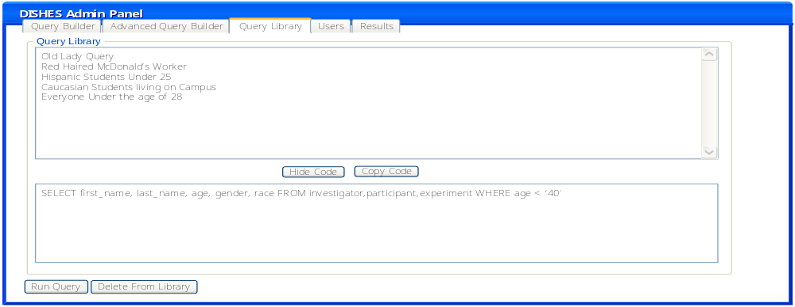

User

The user tab is where the administrator can see all of the current users of the system. The administrator can edit, add, or delete users from this screen. The screen will appear as follows:
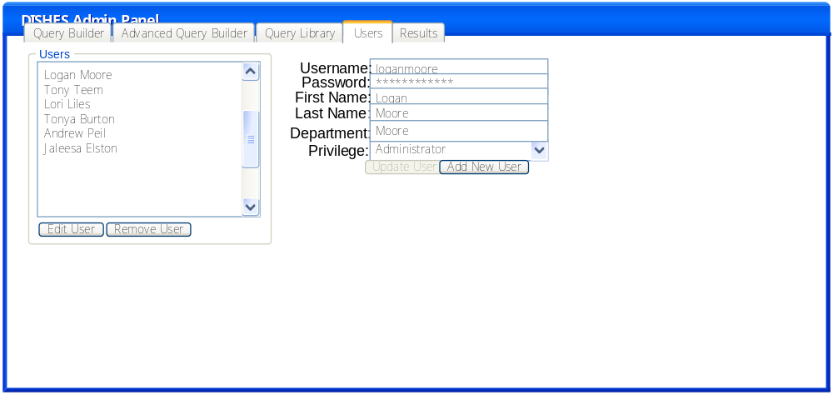

Edit Users

By selecting a user on the left side and selecting the “Edit User” button, the user’s information will populate the fields on the left. At this point the administrator can make changes to the users.

Create Users

To create a new user, the administrator can type in his or her appropriate information on the left side of the screen. Then select the “Add User” button.

Delete Users

To delete a user, the administrator should select the users name and then click the “Remove user” button.

Results

Once the data has been extracted from the database, the results are then displayed in the results tab, with the appropriate characteristics for each field. If the data needs further calculation it can be sent to the CSV (comma separated value) file, by selecting the command button in the bottom left corner. An example of the results tab is shown as follows:
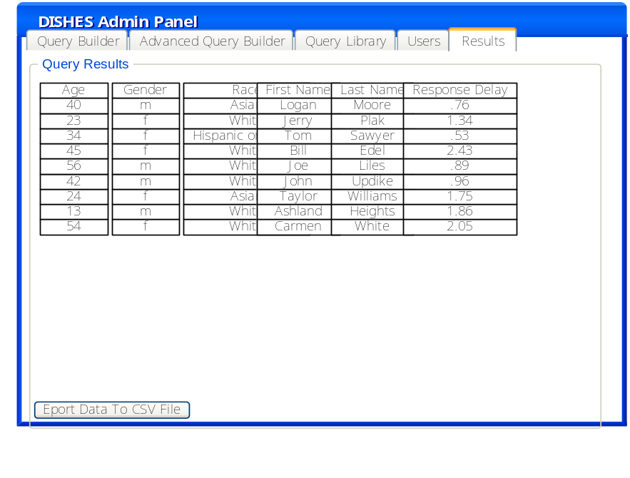

Modifying/Creating an Experiment

To create or change an experiment, an experimenter or administrator must change the xml file. To do this, simply navigate to the folder where the DiSH experiment is located. Once the xml file is located, click on it once to highlight it. Next, right-click it and select "Edit" from the right-click menu. Once the xml file is opened, make any changes you deem necessary to change the experiment. A new experiment is now ready to be loaded.

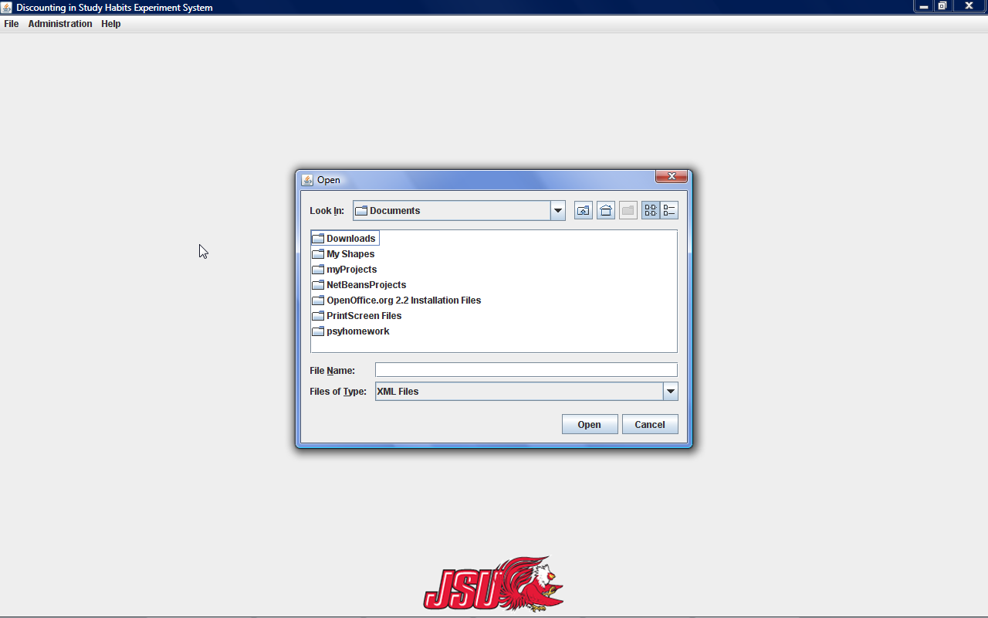

Changing The Number of Times a Method Occurs

To change the number of times the decreasing adjustment method occurs in the experiment, simply change the "numTrials" tag's value. For example, to change the number of trials from 3 to 5,
<numTrials> 3 </numTrials> would be changed to <numTrials> 5 </numTrials>.

To change the number of multiple choice questions, copy from one "mc" tag the next "\mc" tag and paste it right after the previous "\mc" tag. This also applies to the real time method; simply copy from one “rt” tag to the next “\rt” tag to have another real time method in the experiment.

It should be noted that the number of times the double limit method can occur is only controlled by the participant.

To change The Reward Type

To change the reward type, simply change the "rewardType" tag's value. This can be done for any method. For example, to change the double limit's reward type from apples to doughnuts,
<rewardType> apples </rewardType> would be changed to <rewardType> doughnuts </rewardType>.

Methods

There are four methods: multiple choice, real time, decreasing adjustment, and double limit. Each method will begin with a set of instructions that can be edited by the administrator via the XML form. The participant should read the instructions for each method before beginning the experiment.

Multiple Choice:

The Multiple Choice method will contain a question “Would You Rather:” followed by multiple scenarios to choose from, which are displayed vertically. Once the participant has made a choice, he should select his answer choice, which will be displayed as a pushed in button. To confirm his answer and move to the next page the participant should select the “Confirm Choice” button located at the bottom of the page.

Example of the Multiple Choice screen:
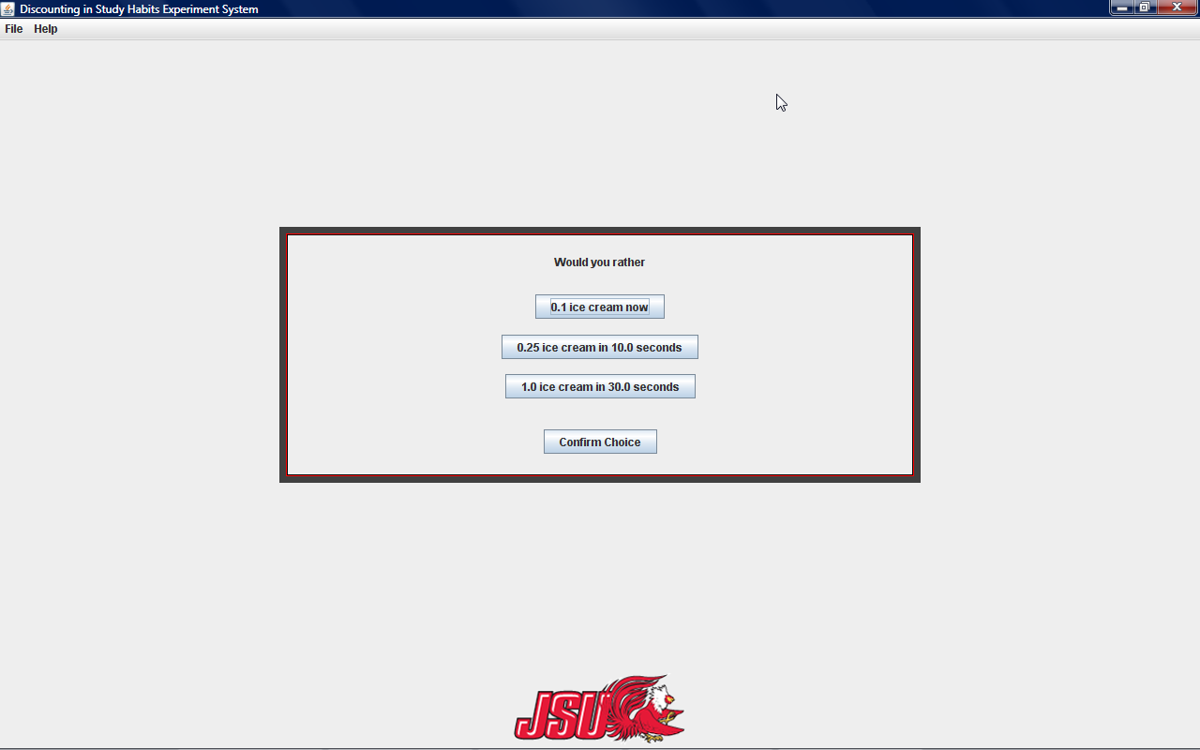

Real Time

The real time method will allow the participant to read aloud until he feels it is time to quit or until the maximum amount of points have been reached. After reading the instructions for real time, the participant will be prompted with another screen that will allow them to click “Begin” when he is ready to start reading. The next screen will look like the following:
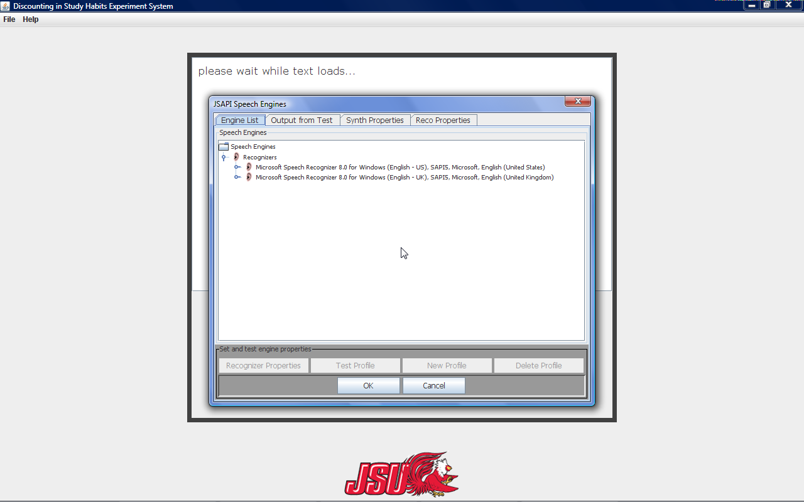

- The ruler is displayed on the left side of the screen. It represents the number of points and the amount of minutes it takes to reach each point. There are eleven notches on the ruler, which are the amount of points the participant could possibly gain.
- The voice widget is represented in the center of the page. Text will be displayed here for the participant to read aloud. The number of words skipped, read, and number of times stopped reading will be detected through the widget.
- The clock in the upper right hand corner shows the participant the current time.
- The “Quit Session” button located at the bottom of the screen allows the participant to stop the session, when he feels he has reached his limit.
Note: The ruler and the clock may be turned off by the experimenter.

Decreasing Adjustment

The decreasing adjustment method will ask the participant a question, “Which Would You Rather:” followed by two scenarios, which are displayed horizontally. When the participant selects his answer it will be shown as a pushed in button. Once the participant is sure about his answer, he should select the “Confirm Choice” button located at the bottom of the screen. The decreasing adjustment screen will look like the following:

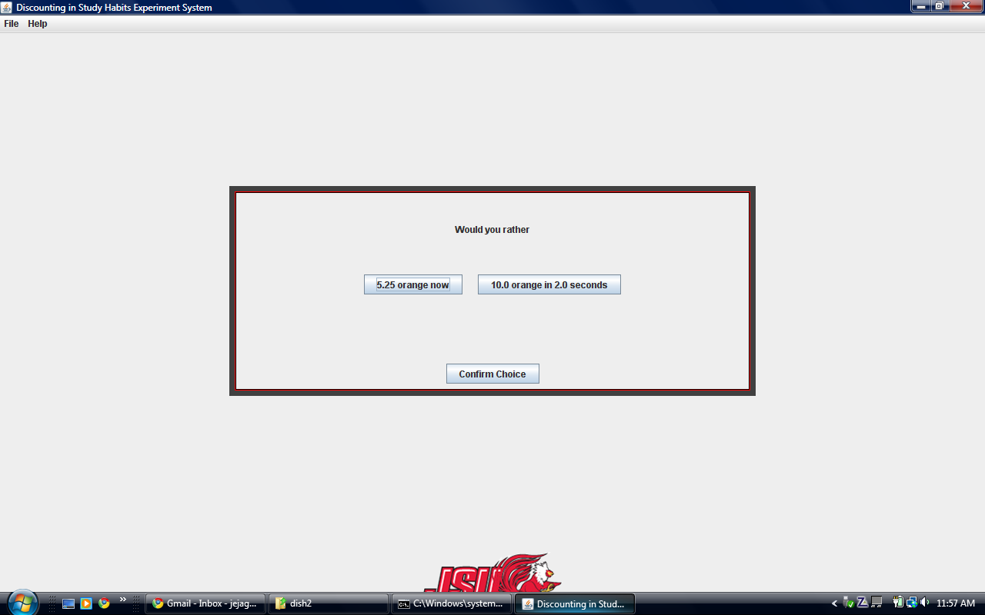

Decreasing adjustment will increase or decrease the amount of points by 50% based on the participant’s answer. After a specified number of scenarios have converged, the algorithm will terminate. The indifference point is calculated using the answers provided by the participant, after the specified number of scenarios have converged.

Double Limit

The double limit method will ask the question “Which Would You Rather:” followed by two scenarios, which are represented horizontally. The participant should select his answer, which will be displayed as a pushed in button. Once the participant is sure about his answer, he should select the “Confirm Choice” button located at the bottom of the screen. The double limit screen will look like the following:
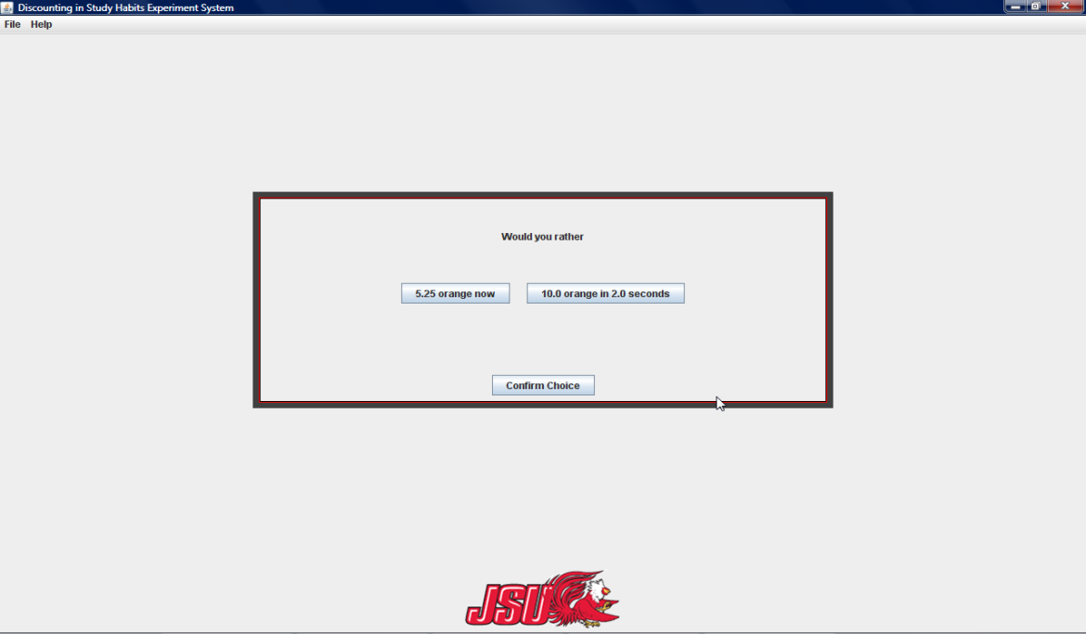

The participant’s response to the first question will determine the changes in the next screen. The range of points will be determined by consistent choices. If the answers chosen are inconsistent, the algorithm will continue until it reaches 20% of the maximum value.

Completion

Once the participant has finished the assessment, the completion screen will be displayed. The experimenter can exit the program or return to the menu. The completion screen will look like the following screen:
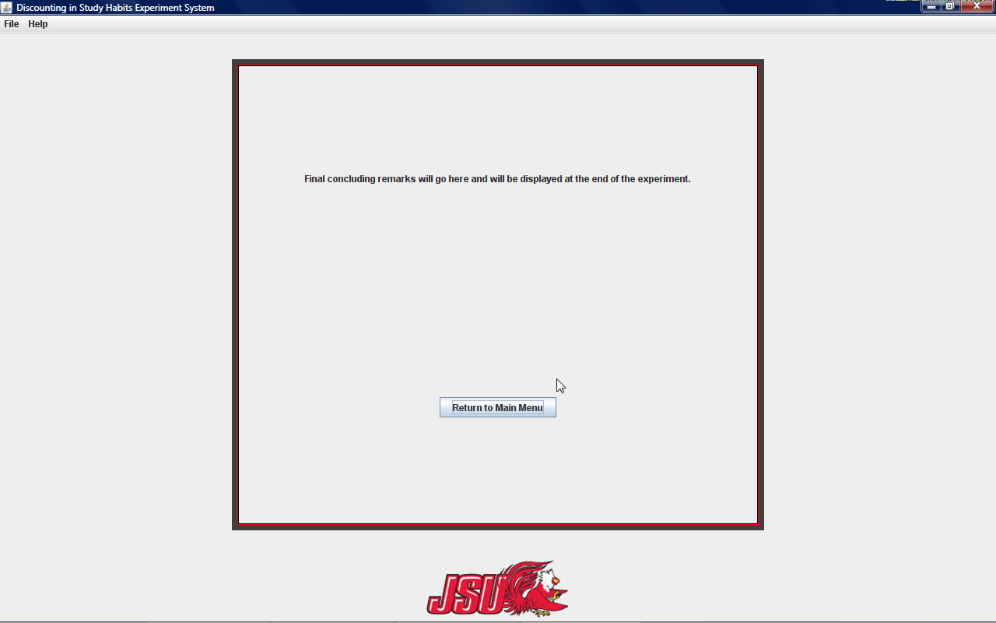

Note: The completion statement may be changed by the administrator.

