The preparation of a general journal
The preparation of a general journal
THE PREPARATION OF A GENERAL MAGAZINE
(The Preparation of a General Journal)
Leila Barbara, M. Aparecida Caltabiano & Sumiko N. Ikeda
(PUCSP/DELTA)
This report aims to present the experience of the Executive Committee of D.E.L.T.A. in the preparation of this scientific journal. We will talk about the general characteristics of the Journal in terms of information about the authors, the editorial board, costs, as well as difficulties and successes.
The magazine D.E.L.T.A., considered one of the oldest uninterrupted Brazilian periodicals, was planned in 1984, within the Postgraduate Program in Applied Linguistics, by a group of professors, at the time all belonging to PUC in São Paulo: Kanavillil Rajagopalan, Mary A. Kato, Fernando Tarallo and Leila Barbara. Launched as a PUC publication, the Magazine was designed to fill a gap: the area did not have a national journal. In 1986, at the invitation of ABRALIN, the Magazine became an official publication of this Association.
The Journal's primary objective was to be a publication with national representation, serving the country's community of linguists, and not just a PUCSP magazine. This goal was achieved, with D.E.L.T.A. recognized by the linguistics and applied linguistics community in the country. In 1996, a consultation carried out by the CNPq, which in the area of ​​Literature and Linguistics was coordinated by prof. Marcuschi, pointed out the best Brazilian journals in each area in the researchers' opinion. With this data in hand, FAPESP selected, in 1997, the 35 most nominated candidates, who entered the Scielo Project. D.E.L.T.A. magazine was the only one in the area of ​​Linguistics and Literature, and is available
online (www.scielo.br).
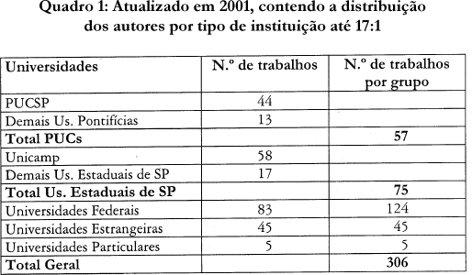
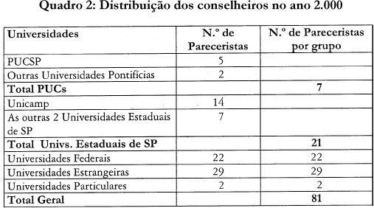
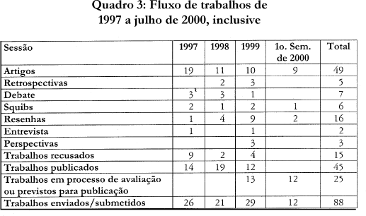
The table above shows the institutions to which the authors of the works published in D.E.L.T.A. are affiliated. We can see that federal universities are the most represented in the magazine, followed by PUCs and the 3 State Universities of the State of São Paulo, with the number of collaborations from foreign universities also being high (45 works). As for state universities, 58 of the 75 works in the sector were developed at UNICAMP. Of the PUCs, with 57 works, 44 originate from the PUC in São Paulo. These indexes highlight the magazine's policy and point to the relevance of it being sponsored by ABRALIN: it is published in Brazil, by a specific institution, but it is a clearly national magazine, not a local one. Colleagues from all institutions are invited to submit their work and forward news of their publications.
Another significant evidence of the national character of D.E.L.T.A. is its Editorial Board, with a diverse constitution, both in terms of institutional representations and with regard to the areas of specialization of the advisors and with a good international representation ¾ with the representation of these advisors being constant in terms of academic recognition. Of the 57 current Councilors, there are 7 representatives from Pontifical universities, 5 from PUC in São Paulo; of the 21 from Universities in the State of S.Paulo, 14 are from Unicamp; From foreign universities we have 17 European representatives, 10 Americans (covering North America, with the majority, Venezuela, Colombia) and 2 from Asia.
The Journal attaches great importance to the choice of Editorial Board members and the procedures used to select works. It seeks to propose to Council members researchers from different institutions, both Brazilian and foreign, recognized in their area of ​​research and specialists in the various areas of investigation developed by its collaborators - which probably corresponds to the most investigated areas in Brazil - seeking to adapt the number of specialists per area to the current demand in each period. Regarding the procedures for choosing advisors, the Journal lists the names of researchers; informally consults postgraduate programs, advisors, collaborators and ABRALIN management and forwards the list for approval by the ABRALIN Council, which, as a rule, approves it without changes.
The main function of the Council is to evaluate the works proposed for publication – perhaps the most difficult, but undoubtedly fundamental, part of organizing a scientific journal. It has been widely shared by the advisors who contribute or have contributed to the Magazine, the initial and permanent objective of maintaining the high level of D.E.L.T.A. and carry out what we consider to be the function of a good scientific journal: serving the community, publishing only good works and sharing experience and knowledge with the authors, and thus contributing to the improvement of published works and the development of those that are not yet in a position to be published. In addition to filling out a detailed form, the counselors, in their evaluations, have been generous with suggestions for improving the work, not shying away from issuing opinions on more than one version of some of them.
The appointment of reviewers ¾ two ¾ for the evaluation of a specific work is made by the Executive Editor; when a counselor thinks it is necessary to subsume a work to another specialist, he, and only he, can do so, following a procedure similar to those that lead to the appointment of a counselor and informing the Editorial Board to carry out the substation; The inclusion of these ad hoc advisors in lists of proposals for new advisors has been frequent. For each work, we seek to indicate at least one specialist in the area or a nearby area, and given the high quality of the advisors and the breadth of the Journal's audience, it is unnecessary for the two reviewers to be specialists in the specific area of ​​the work. Once the work has received a favorable opinion from the two reviewers, it is published; If there is a discrepancy between the reviewers, the work is sent to a 'tertius'. After evaluation, the work is returned to the author for modifications that may be minimal or substantial.
The General Editor is currently occupied by Leila Barbara and Kanavillil Rajagopalan and, directly linked to the editors, there is a secretary and a treasurer who have the services of secretarial and formatting assistants. The Executive Committee, made up of academics, including the general editors, the secretary, the treasurer, is responsible for the execution of the Journal. The Retrospective section is the responsibility of the ABRALIN presidency, since we joined it and, in this case, at least formal contact with authors is made by the President of ABRALIN, or someone appointed by him/her. Works presented at meetings by experts invited to ABRALIN plenary sessions are frequently published; other times, proposals are made by the Editorial Board to the Board, in addition to examining proposals from authors.
The table above summarizes the workflow in recent years. Of 88 received, 50 were published and, of the remaining 30, 15 were rejected. The low number of categorical refusals is evidence of the careful work of the counselors - detailed opinions are drawn up, and when the work shows potential, it is allowed to be reformulated as mentioned above. The rejected work, if resubmitted, extensively reformulated, will be re-analyzed following the entire previous process; We have already had the opportunity to see some rejected works published in other outlets, with a note of thanks to the D.E.L.T.A. reviewer. for the feedback received. The backlog of work in progress includes a reserve of material for one and a half years; This is also the time that pre-publication procedures tend to consume even though, whenever possible, correspondence is exchanged via email, to speed up the process.
The largest group of works proposed without induction are articles; in the last 3 years, of the 88 works evaluated, 49 were Articles. The other sections of the Journal generally require induction. Retrospectives, as already mentioned, are usually invited by ABRALIN. Reviews are also generally obtained by request; Our community seems to still not be open to the importance of the review, which has the advantage of quick publication and providing a lot of information to the community: new bibliography, evaluation of this bibliography. Debates and Squibs are very sectorized ¾ there really seems to be a lot of resistance to their proposition. Very few institutions or colleagues send information or notes about events and new publications ¾ those published have been the result of explicit request or collection from the editors; these are the only sections of the magazine that are not submitted to advisors.
We still have a word to say about special numbers. Its origin was due to the large quantity of articles that, at a given moment, we had in our portfolio. But new openings came; they are an opportunity for specific themes, special voices, special events and tributes. The Magazine can delegate their organization or can organize them itself; can respond to requests, in which case it consults extensively with Counselors. So far we have had two issues in honor of Fernando Tarallo ¾ founder of the Magazine; one in honor of Ataliba de Castilho, who revived the Norma Urbana Culta project; a number in honor of ABRALIN’s 30th anniversary. This issue, organized by Ataliba Teixeira de Castilho, contains material that he intended to publish on linguistic research in Brazil to which, with his consent, we added some guests in the area of ​​Applied Linguistics, which resulted in a volume of 450 pages, corresponding to more than 2/3 of what the Journal proposes to publish per year. The 2000 special issue, organized by Charlotte G., Jairo Nunes and Eduardo Raposo, pays homage to Mary Kato, one of the magazine's founders and an internationally recognized linguist, and contains articles by Kato's partners in his work at Unicamp. A number in honor of Mattoso Câmara Jr. is already planned, on the occasion of the centenary of his birth, organized by Cristina Altman. There was a special issue intended to summarize the works published in the first 10 years of D.E.L.T.A Magazine. and another that was dedicated to the arrival of Noam Chomsky in Brazil ¾ a bilingual edition containing the conferences of the great linguist in the country, in 1996.
The circulation of D.E.L.T.A. is 1000 copies. Dos 570 sócios previstos pela ABRALIN, 180 estavam em dia com suas anuidades em 1999. Há um número razoável de assinaturas avulsas, 120 no momento, por volta de 100 exemplares em permuta nacional e internacional e um número semelhante de doações principalmente a bibliotecas e associações, além dos volumes encaminhados a Autores e Conselheiros. O total de saída previsto é de 890 exemplares por número. São freqüentes as campanhas para conseguir novos leitores ¾ quer sócios da ABRALIN, a meta principal, quer assinantes diretos.
The magazine began with the help of Fapesp, which, in its second year, was replaced by CNPq, the main agency to subsidize Brazilian scientific journals. This subsidy was never interrupted and in the year 2,000 it corresponded to R$20,000.00 annually. Direct subscriptions and individual sales currently correspond to around R$4,800.00; ABRALIN subscriptions are expected to cost R$4,662.00 ¾ corresponding to half of each member's annual fee plus half of the postage cost. This means a revenue of R$29,468.00, based on the year 2,000. The contribution of PUCSP is essential for the implementation of the Magazine, which, in various ways, direct and indirect, bears the largest portion of the costs: these expenses include contractual hours of teachers and employees dedicated to the Magazine, consumables - a large number of photocopies, printing of various versions of the articles and the magazine itself, mail and correspondence in general, as well as equipment and location. The Magazine's direct revenue usually covers graphic services, with 1999 being an exceptional year given the size of the special issue, which far exceeded the budget.
Thus, the average cost per volume corresponds to R$70.00, with the projection of selling the entire print run, which does not happen even considering the balance of volumes and the volumes donated and those distributed to authors and advisors.
The difference between income and expenses is covered by PUCSP and included in the budget of the Applied Linguistics Program, which is responsible for the Journal. All of this is offset by the service that, it is believed, D.E.L.T.A. is providing support to Brazilian linguistics and applied linguistics, both in the publication of works by Brazilian researchers and by colleagues from other countries and also in the dissemination of these works in the best international indexers ¾ LLBA (Linguistics and Language Behavior Abstracts), Linguistics and Language Behavior Abstracts Database, MLA (Modern Language Association) Directory of Periodical, International Bibliography, Sociological Abstracts, ULRICH's International Periodicals Directory ¾ to which ERIC joins this year.

