**Criterion E: Evaluation**

The product was sent to the client on Feb 21st 2018 (See Appendix). I asked my client Ms. Huiting Chen to try all functions against the test plan we agreed on earlier as soon as possible. The next day, Ms. Chen texted me and said she has managed to use all the functions in the final product and sent the test plan with note back in an excel spreadsheet.

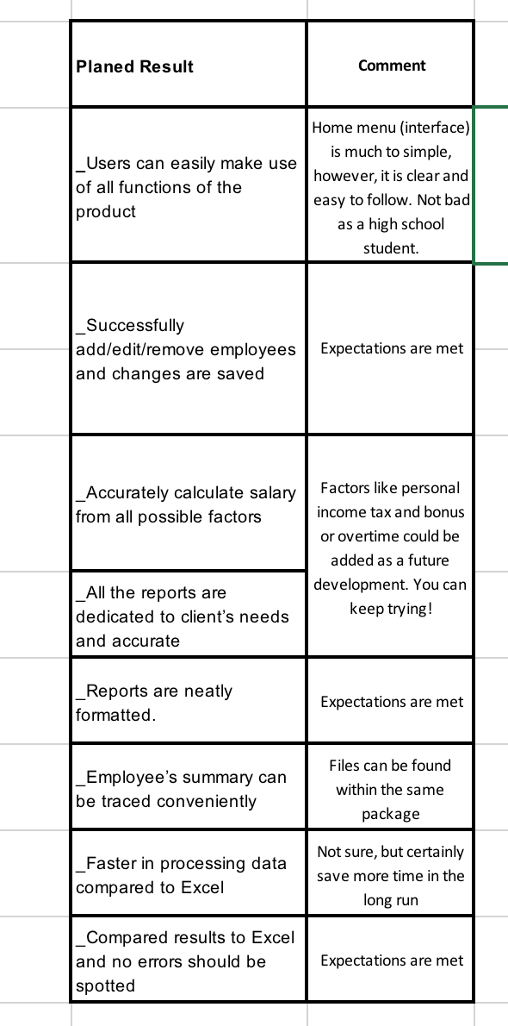

**Recommendations for Further Development**

Ms. Chen suggests that there can be an additional function to record the total overtime in the given month of the employee, which will result in positive adjustment of final salary. More importantly, she mentioned that a lot of elements could be added to the home menu. For instance, the logo of the company could be set as the background. Final, she asked if it is possible to automatically save the file from the previous month and create new files for the current month. The product of solution would make her job much more convenient that way.

Word count: 170