Criterion B: Design
Table of Contents:
- Flow Chart
- UML diagrams
- Data Flow Diagram
- Transaction with Client
- Gantt Chart
- Test Plan

Flow chart of the purposed product:
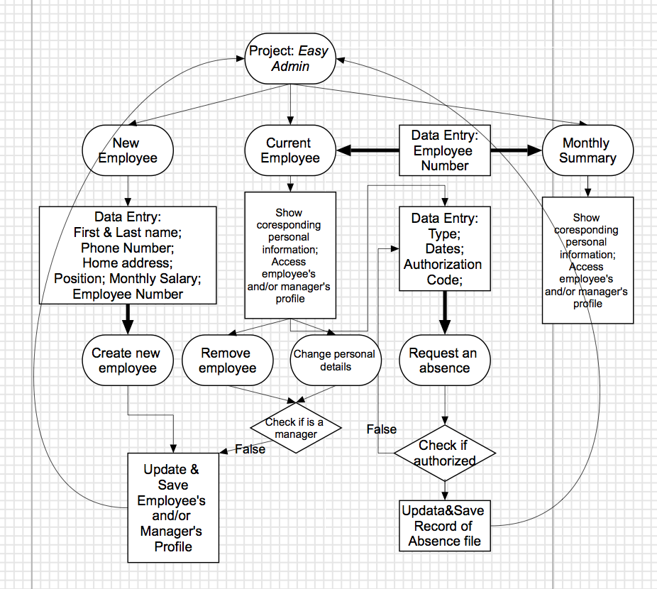
Above is a graphic illustration of how interaction with user is being done. The client will be able to access a variety of functions including adding or delete an employee or manager, change personal information of the selected employee and separate button that will display the monthly summary of an employee.

UML diagrams:
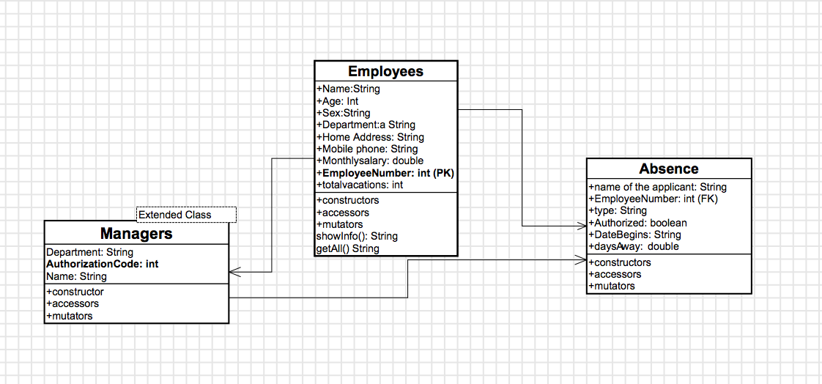
The use of class objects builds up the skeleton of this product of solution. An employee class will hold information of an employee in my client’s company. It can only be accessed through sub-methods because variables are declared as private or by its extended class, Managers. Two classes are all assigned multiple instances of the Absence class.

Data Flow Diagram:
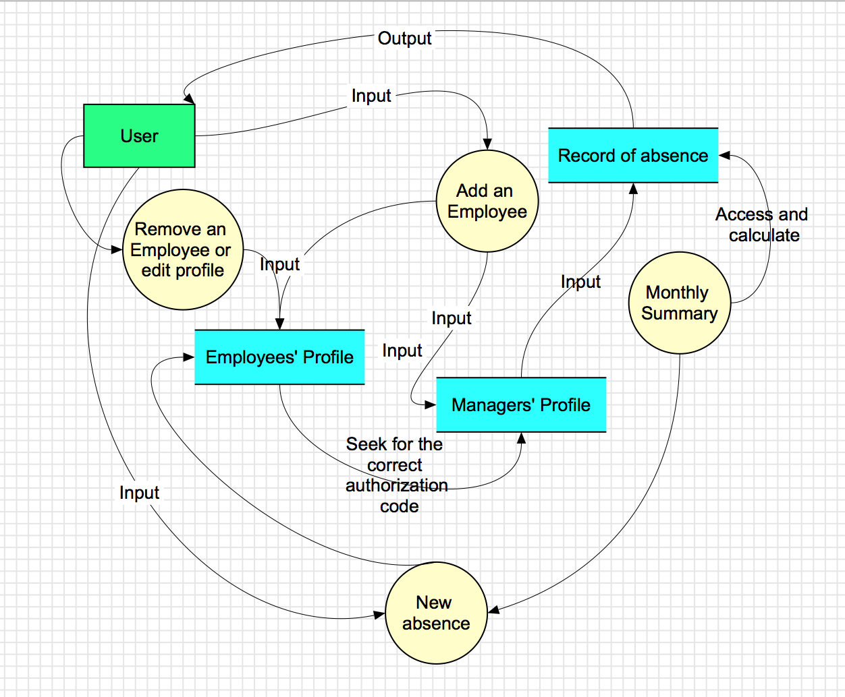
The data flow diagram represents a graphic summary of how data inputs, transfers and outputs are planed out in my solution. Data will be written to three different files for later access enabled by a primary key, Employee Number.

Transactions with Client:
Purposed Home Menu (first version):
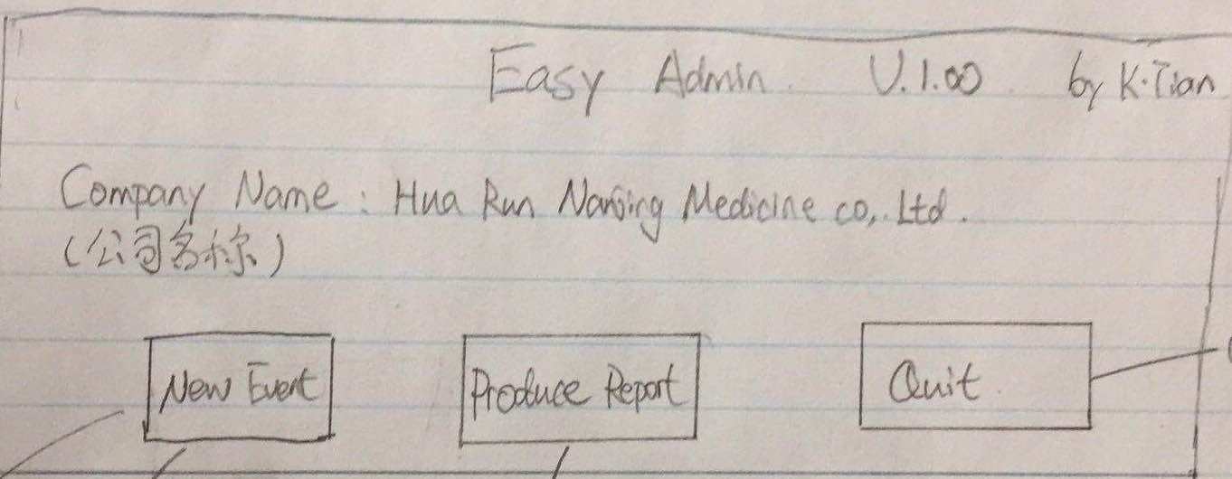
Revised Home Menu: Independent Summary Interface:
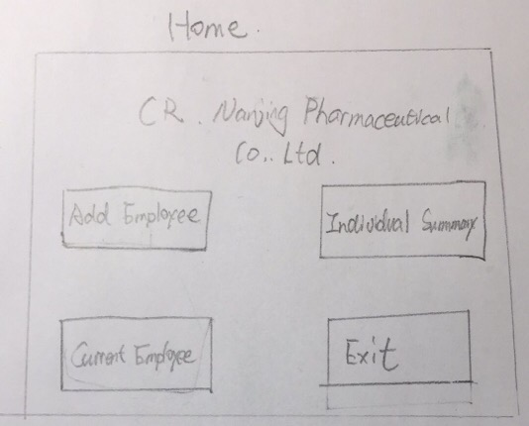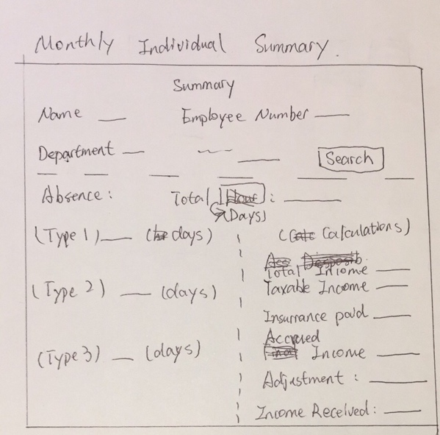
Add an Employee Current Employee 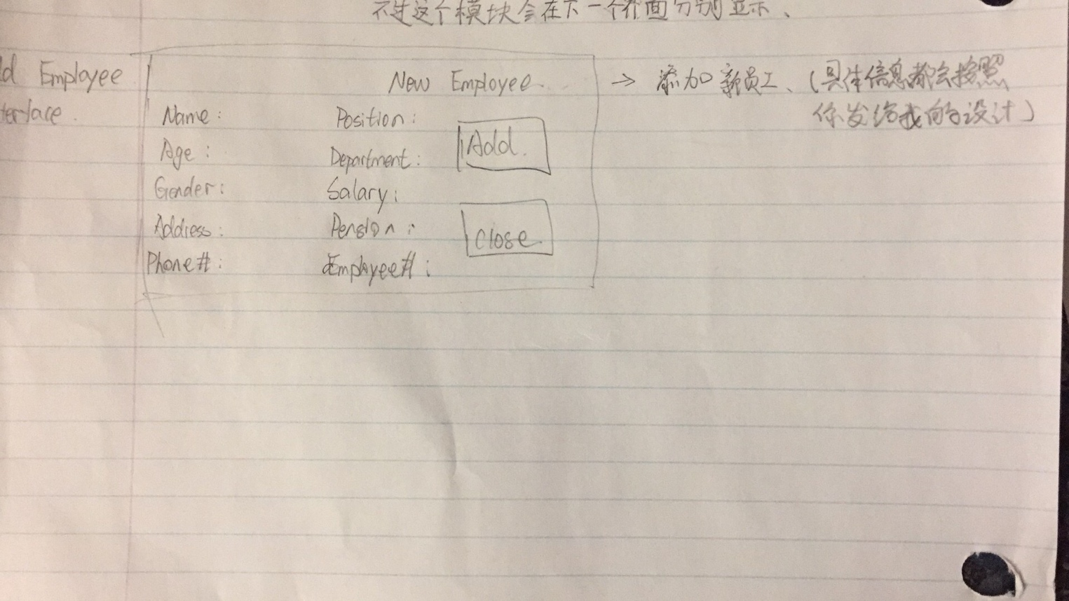 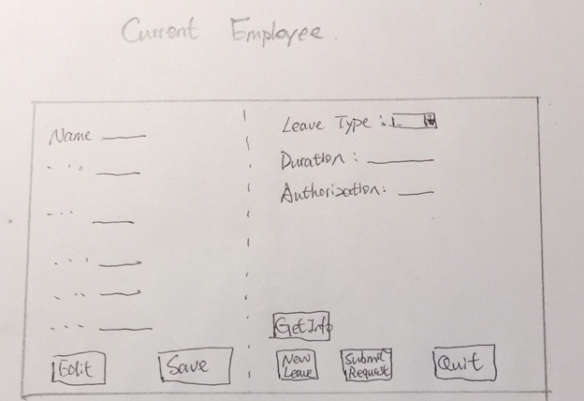

Gantt Chart:
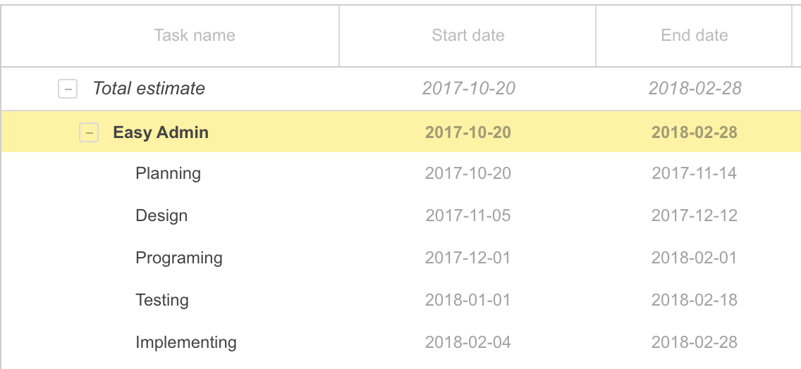
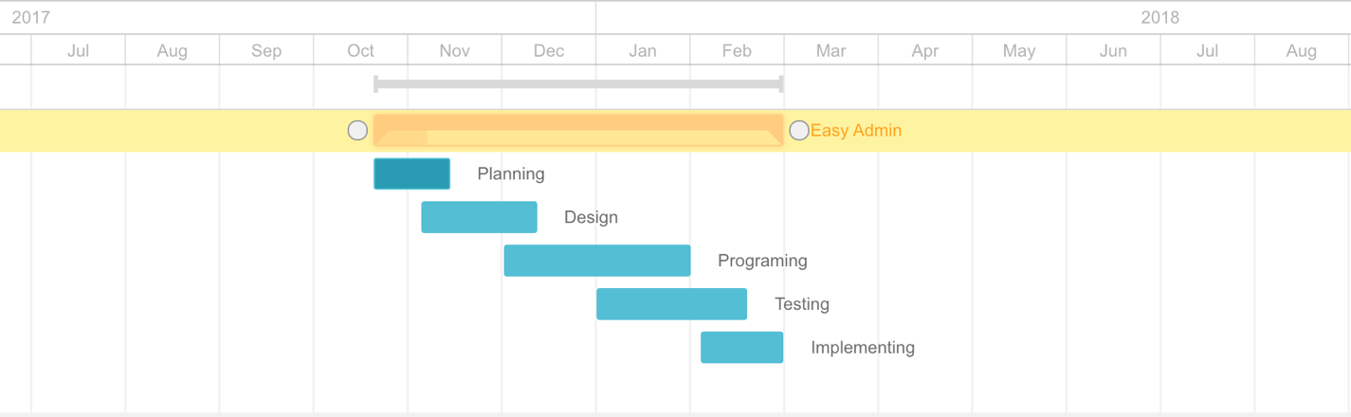

Test Plan:
Success Criteria: | Actions to test
Easy-to-use interfaces with buttons | _Users can easily make use of all functions of the product
Be able to access and edit the information of the employee selected also allows user to delete or add employees. | _Successfully add/edit/remove employees and changes are saved
Calculate the month salary for selected employee. | _Accurately calculate salary from all possible factors
Produce a monthly summary of an employee of user’s choice in a neat format. | _All the reports are dedicated to client’s needs and accurate  _Reports are neatly formatted.
Shortening the work time for tracking the schedule of employees and produce a salary report accordingly. | _Employee’s summary can be traced conveniently  _Faster in processing data compared to Excel
Ensure no errors in calculations. | _Compared results to Excel and no errors should be spotted
Word Count: 182

