Criterion C: Development
List of Techniques used:
- Inheritance
- Random Access File
- Data Input
- Files Writing Methods
- One dimensional array
- Text field focus lost
Inheritance:
Super class
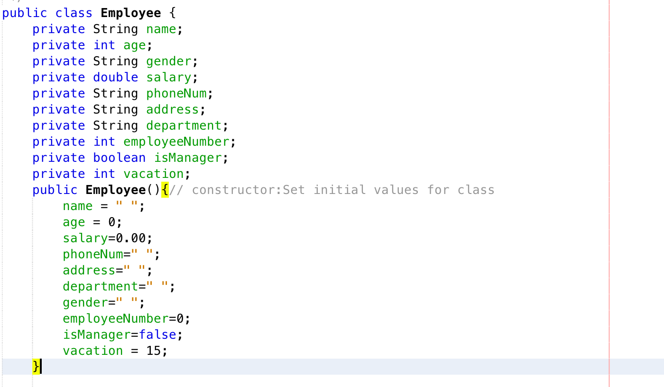
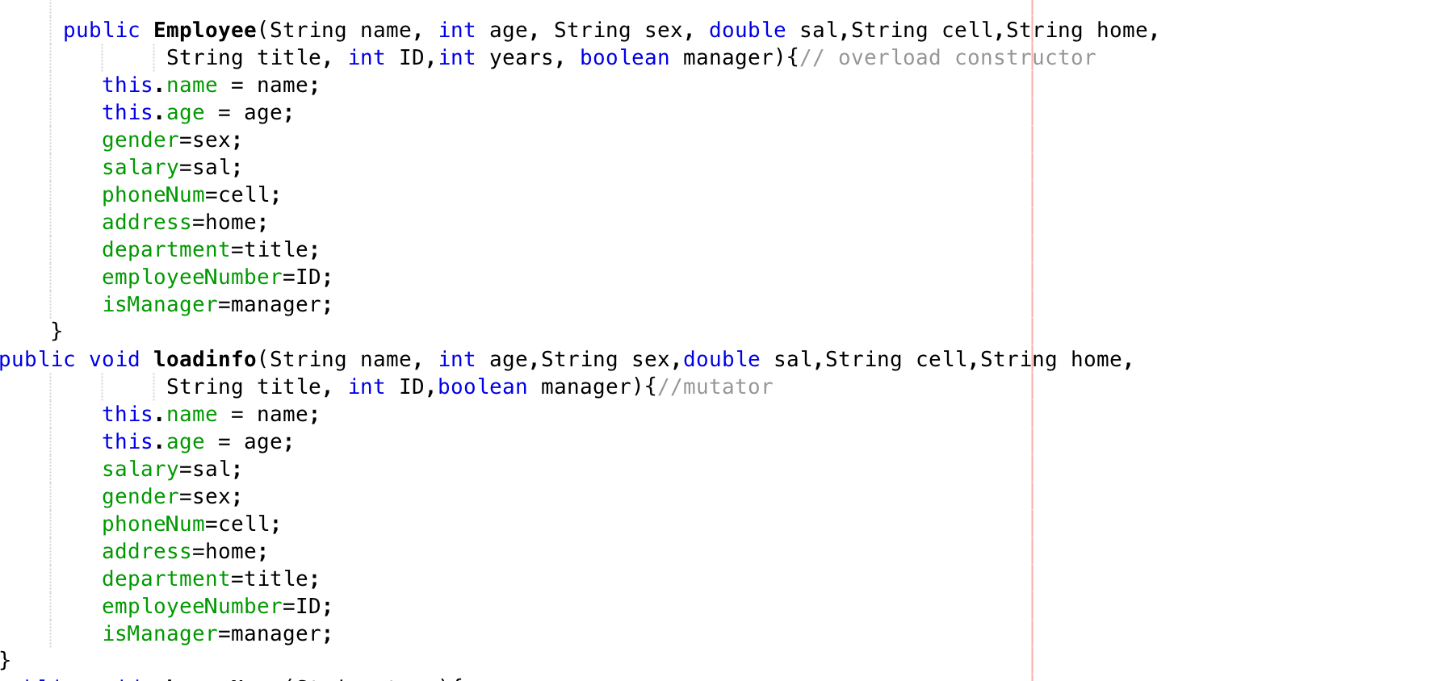

Extended class:
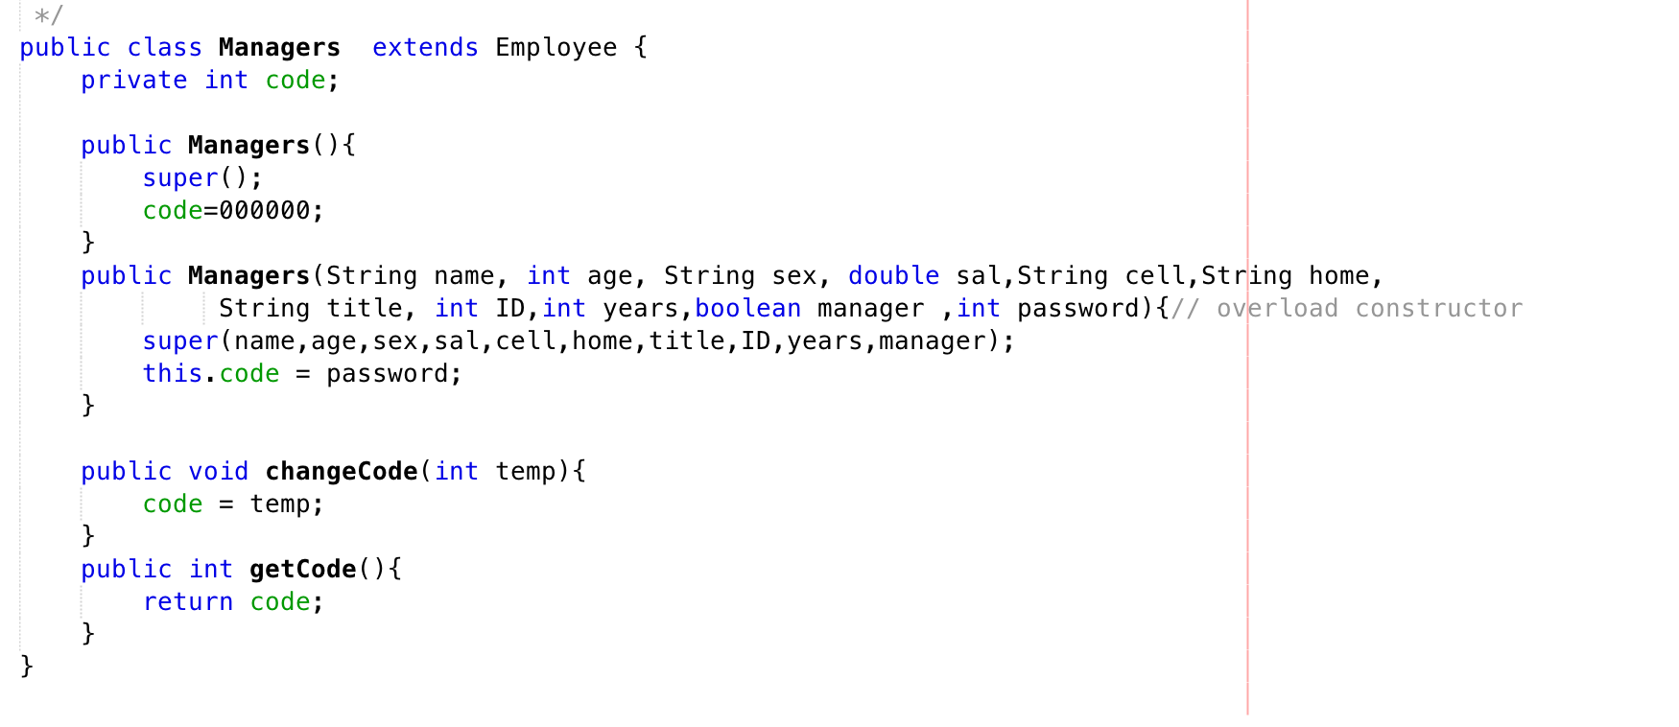
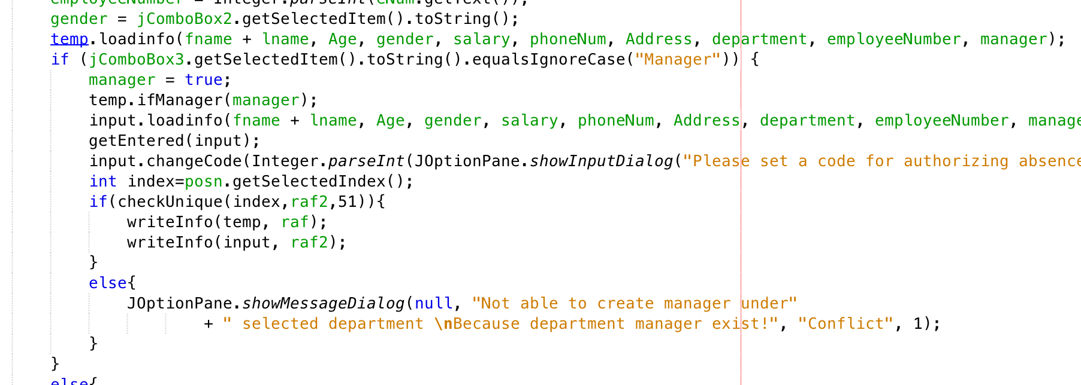

Every instance of the Employee class will hold the data of an employee while its extended class, Manager, holds one additional integer property. The program will detect the item selected for ComboBox3 assigned for position in the department and create a corresponding instance of class object and will create an additional Manager instance if the item selected is Manager.
Inheritance is integrated in programing because it applies closely to the situation. In my client’s company, managers and employees have a lot of information in common. But managers have an additional piece called authorization code which is used to grant employees in his/her department absences of occupation, having a separate extended class to hold information of a manager allows users to have a clear view of the human resource in the company.

Source:
Thakur, D. Multilevel Inheritance. Retrieved April 4, 2018, from http://ecomputernotes.com/java/inheritance/multilevel-inheritance-in-java

Random Access File:
Declaring File Instance: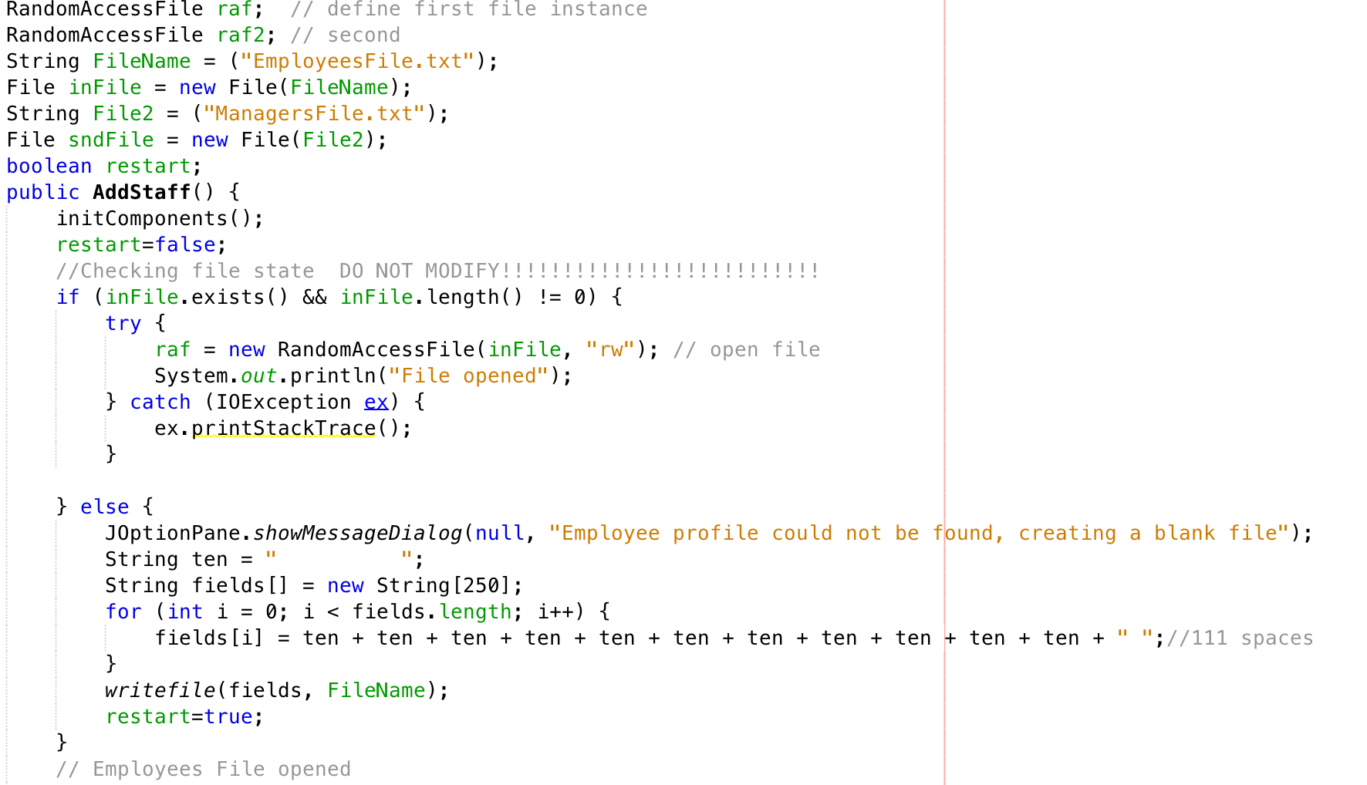
With any interface opened, the program with attempt to open the files that were created before, or if any file is not spotted, it will create blank files and initialize them accordingly. For EmployeesFile, the program will initialize 250 lines of record with equal length of spaces, which was calculated to be long enough to hold all necessary personal details of an employee or a manager. Same with ManagersFile.

RAF access method:
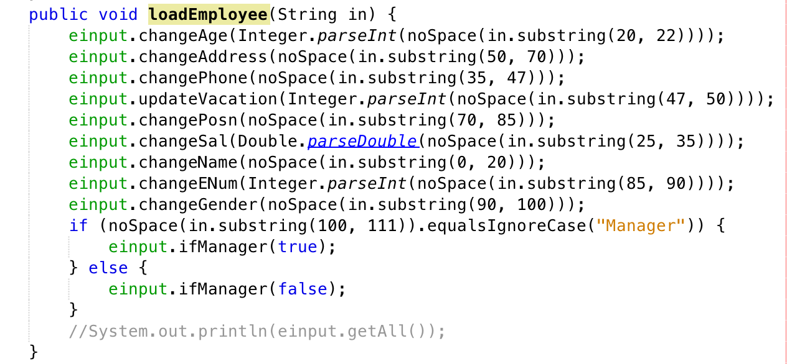
Random Access File is the method chosen for data storage and access. In this very project, data pulling method must have the capacity to output the record as needed. Instead of outputting the whole file. It must also be capable of being written at any given address. Compare to using a Java Database, using random access file is better and more convenient in terms of record keeping.

Source:
Thakur, D. Random Access File. Retrieved April 4, 2018, from http://ecomputernotes.com/java/stream/randomaccessfile
File Access:
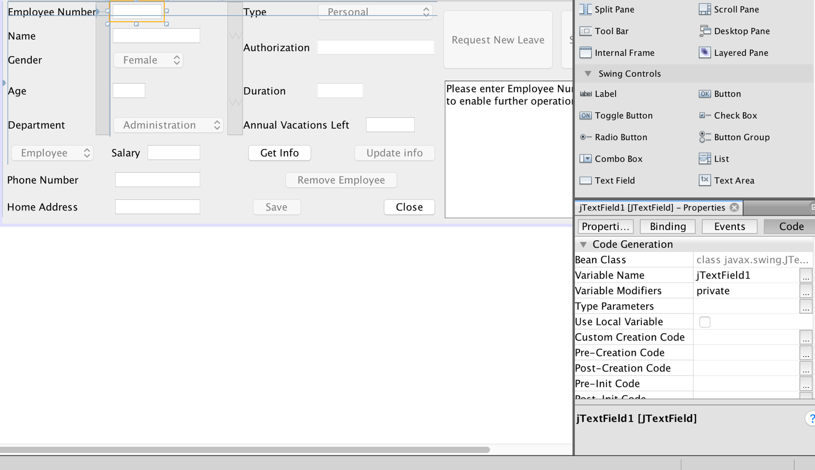
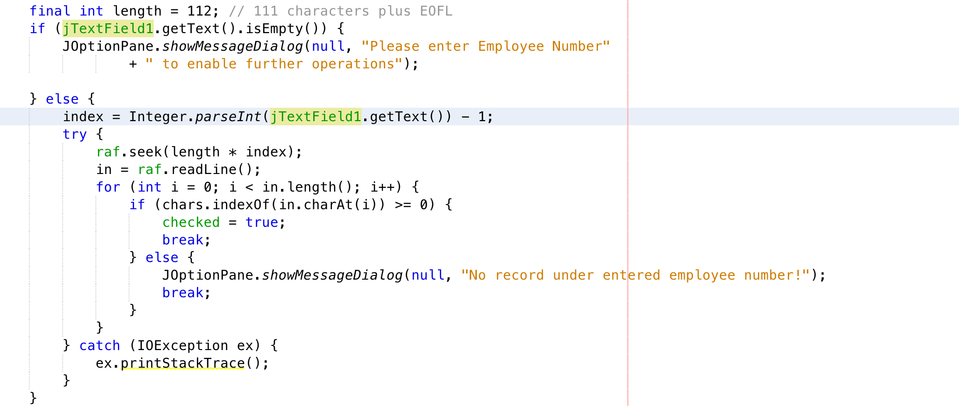
If a valid employee number, x, is enter, the program will fetch the xth record in the EmployeesFile and put the whole line into a String variable for later processes. Otherwise, there will be an error message displayed through JOptionPane message dialogue. The same technique is used to access ManagersFile when an authorization code is required for approving an absence request. It is used again to get all records of the desired employee and process it in the Individual Summary interface.
Having different files that can be identified by the same primary key enables connections between data storages. The idea of information hiding and arrangement is represented.

Source:
Thakur, D. Random Access File. Retrieved April 4, 2018, from http://ecomputernotes.com/java/stream/randomaccessfile
File Writing Methods:
Sequential File Writer:
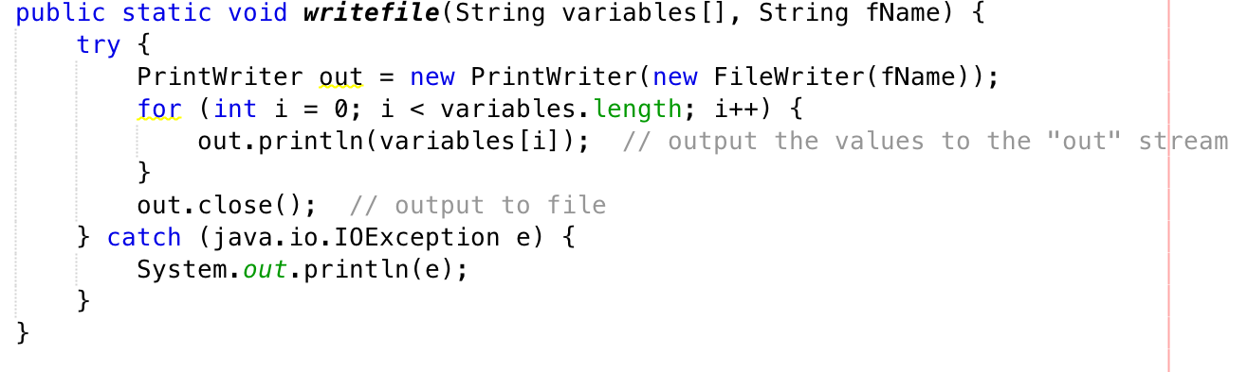
Sequential File Writer is used when writing blank file with equal length of space for records. Therefore an initialized file can be created with least amount of code.

Source:
Thakur, D. FileReader and FileWriter. Retrieved April 4, 2018, from http://ecomputernotes.com/java/stream/filereaderwriter

RAF writing method:
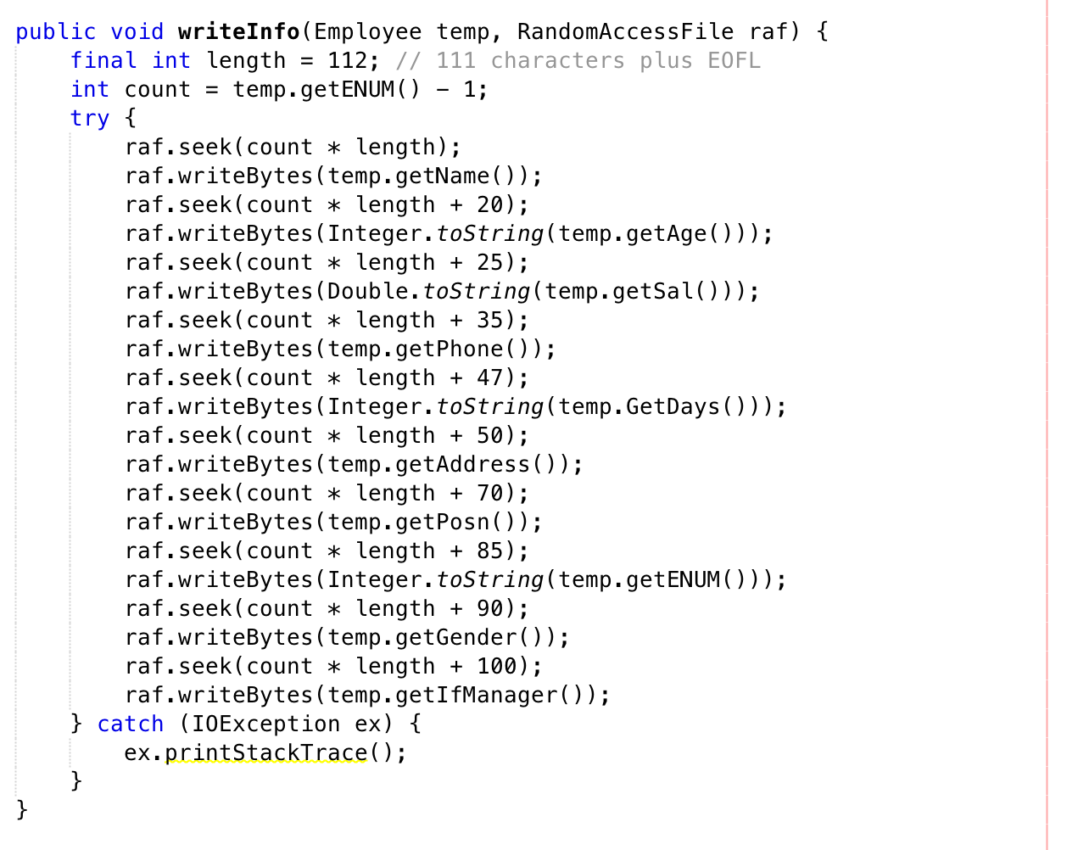
Once data is entered and processed correctly, a series of raf.writeBytes will output data to the desired position as schemed. The use of sub-method reduces repetition of coding, which shortens the time it takes to complete the program. The idea of encapsulation and isolating errors should also be highlighted.
Initializing Record of Absence File:
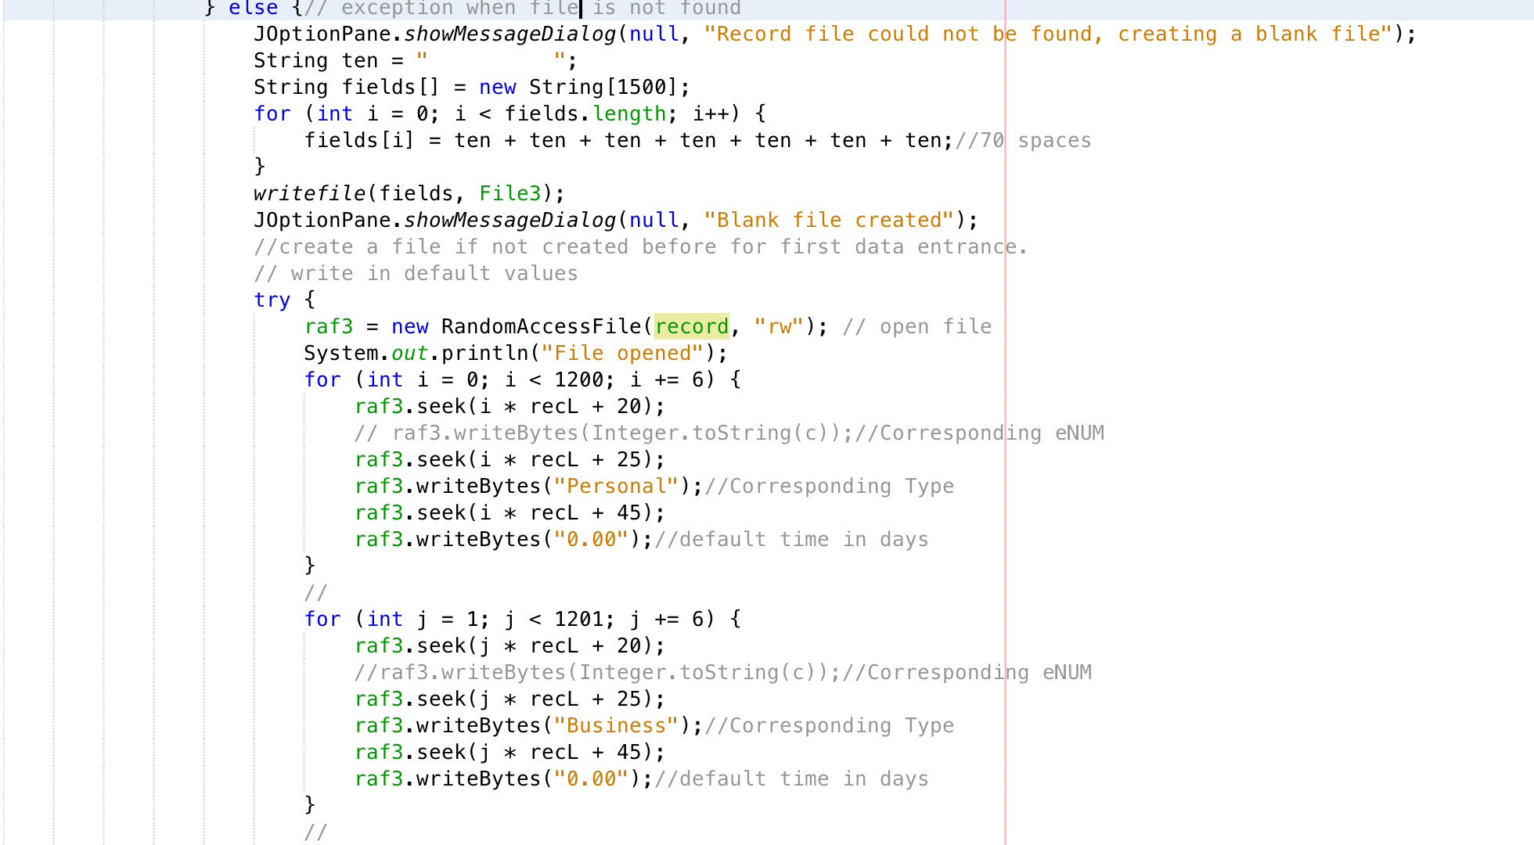
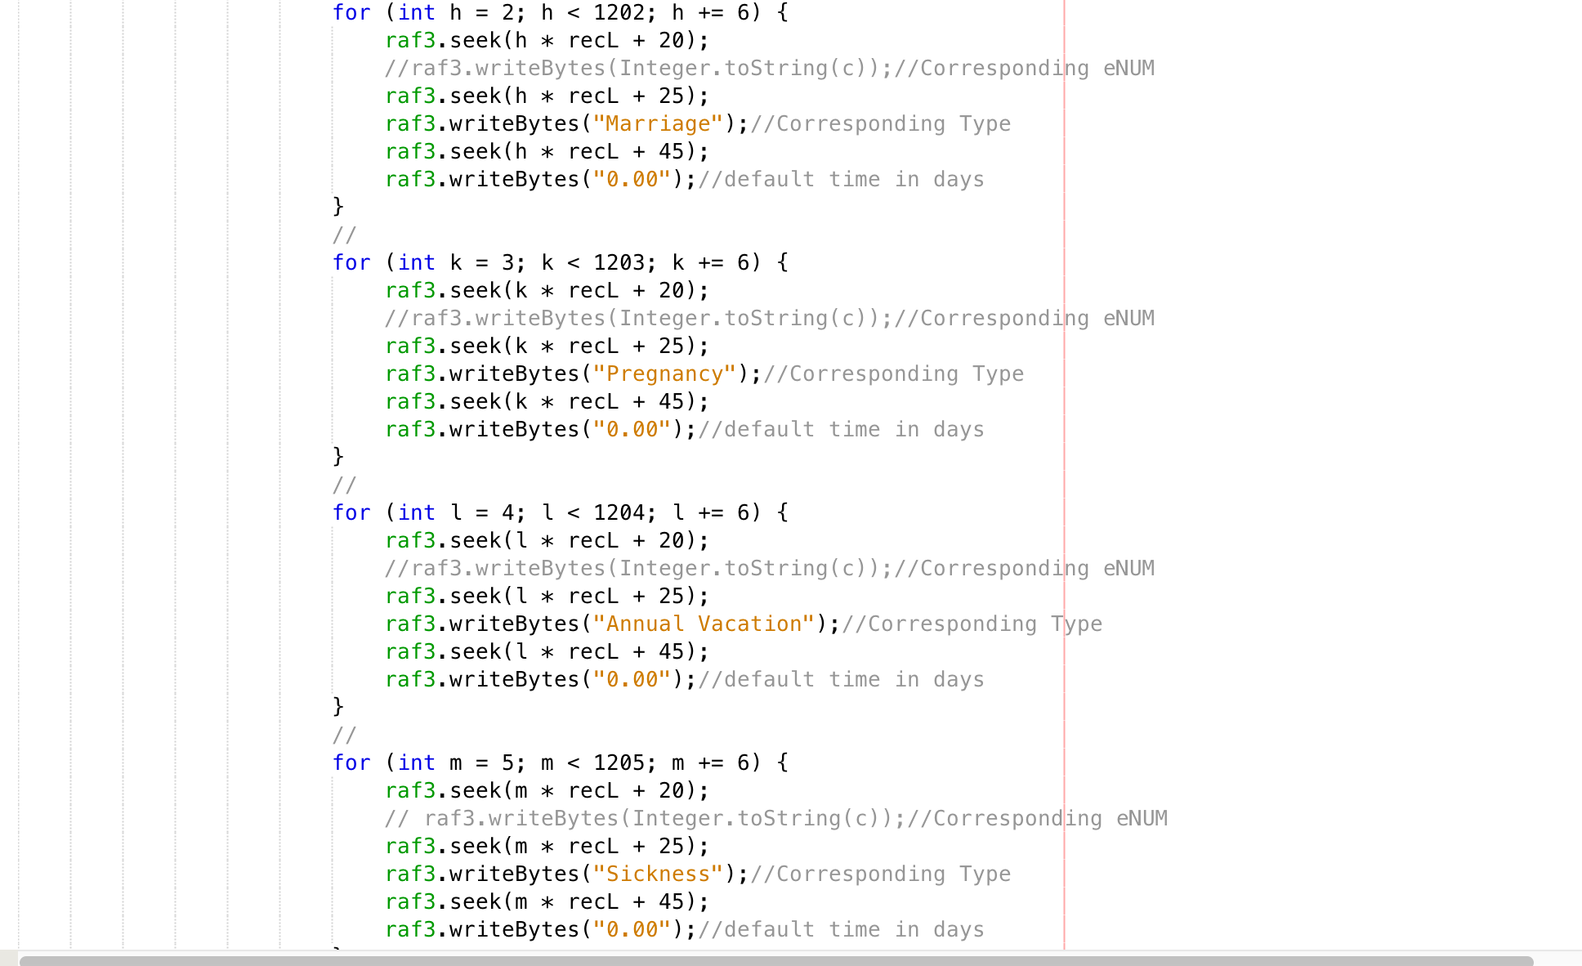
Record of Absence file will be set to default values by the method above, which is for every employee, there will be six lines of records with 0.00 days of absence in place.
It is easier to keep track of the total length of absence in days regardless of what type it is. The program will automatically update the double value whenever the user inputs a new data entry. If an employee is on duty every working day, he/she should receive all disposable income after taxation and adjustment due to insurance paid by the company.
Record of Absence Update method:
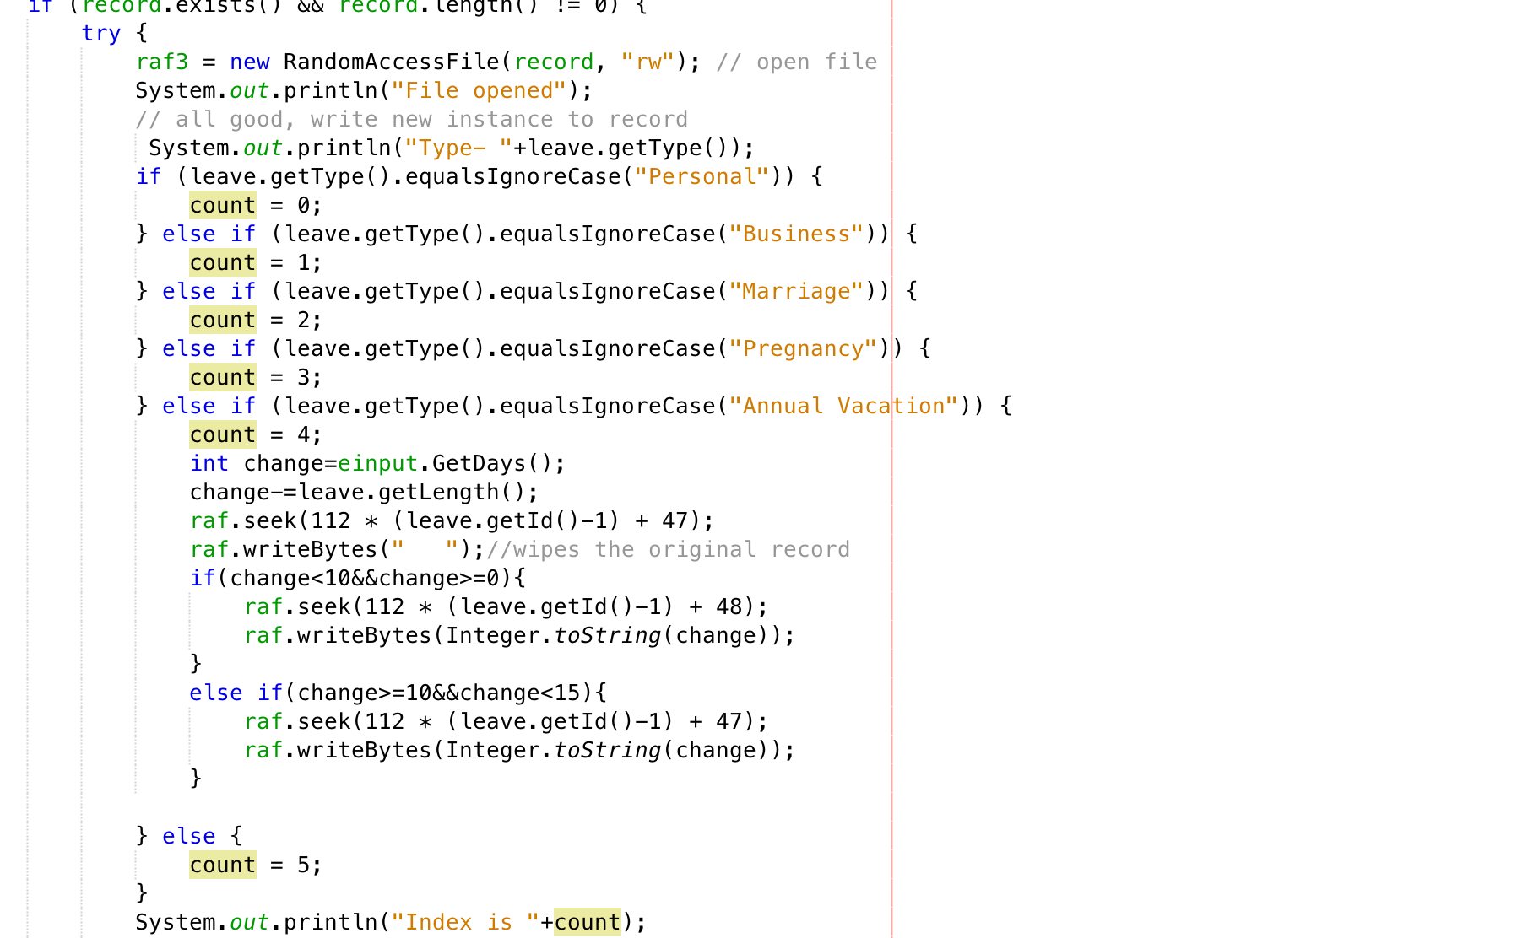
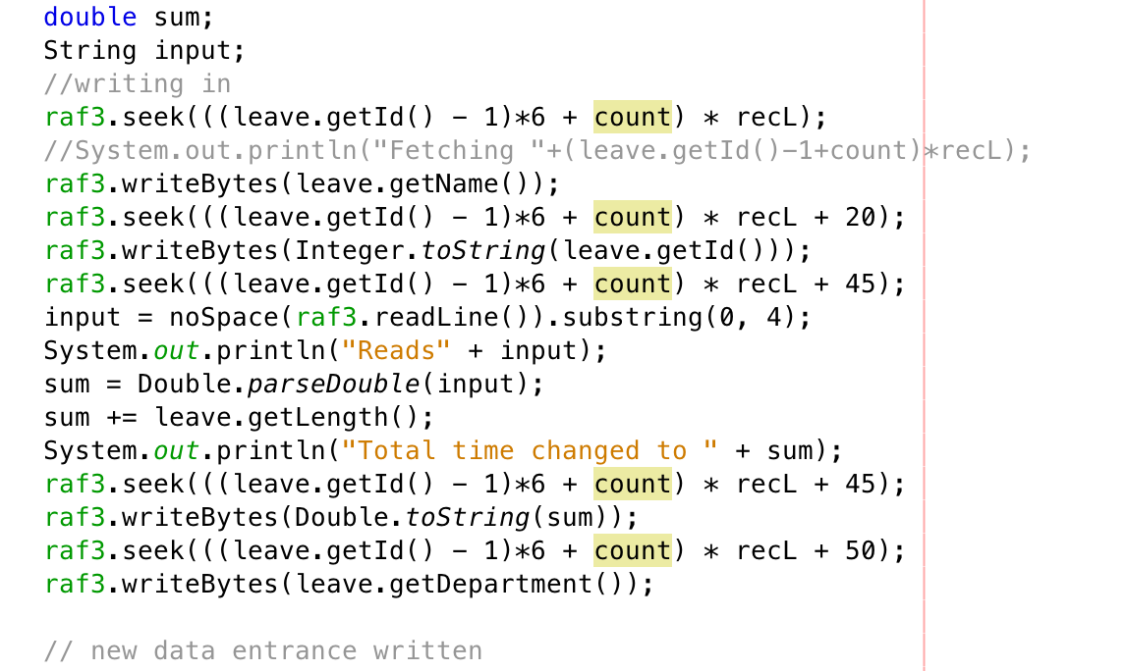
After an absence request is authorized, the program will first match the type selected by the user with the line of record assigned to the select employee’s employee number. I used an integer counter and a combination of if statements to convert String values into an instruction setting the pointer to the intended position in file so that data can be updated to the file accurately with raf.writeByte statement with a complex position parameter.

One dimensional array:
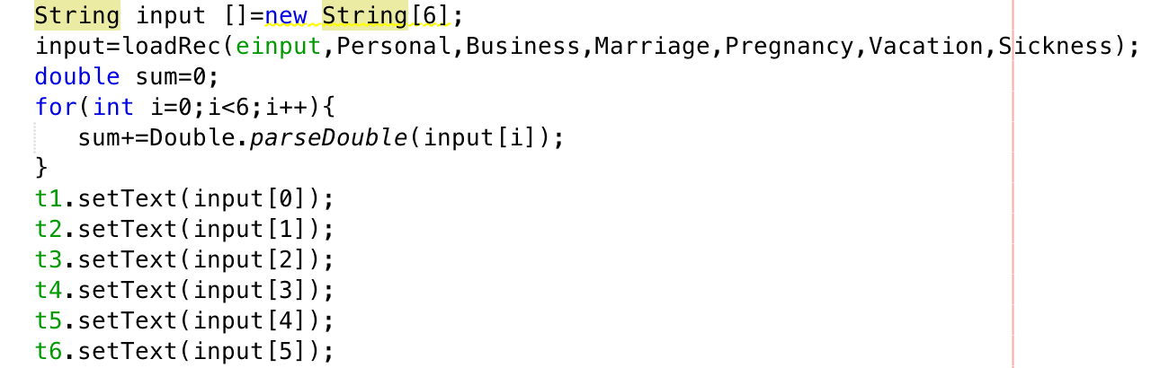

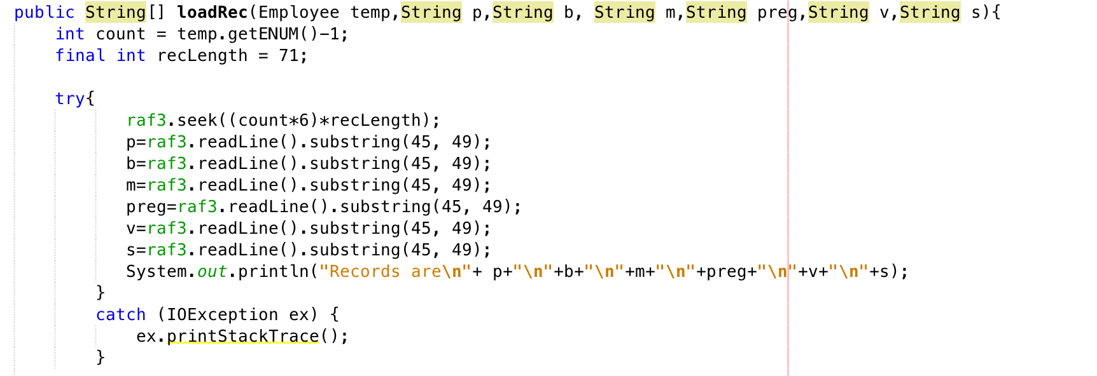
A one dimensional array holds all the absence records relevant to the employee reached when user click on search in Individual Summary interface. Once that is done, the loadRec method will process the array and returns another array with absence duration of all types in the format of Strings.

Source:
Thakur, D. One Dimensional Array. Retrieved April 4, 2018, from http://ecomputernotes.com/java/array/one-dimensional-array

Text Field Focus Lost:
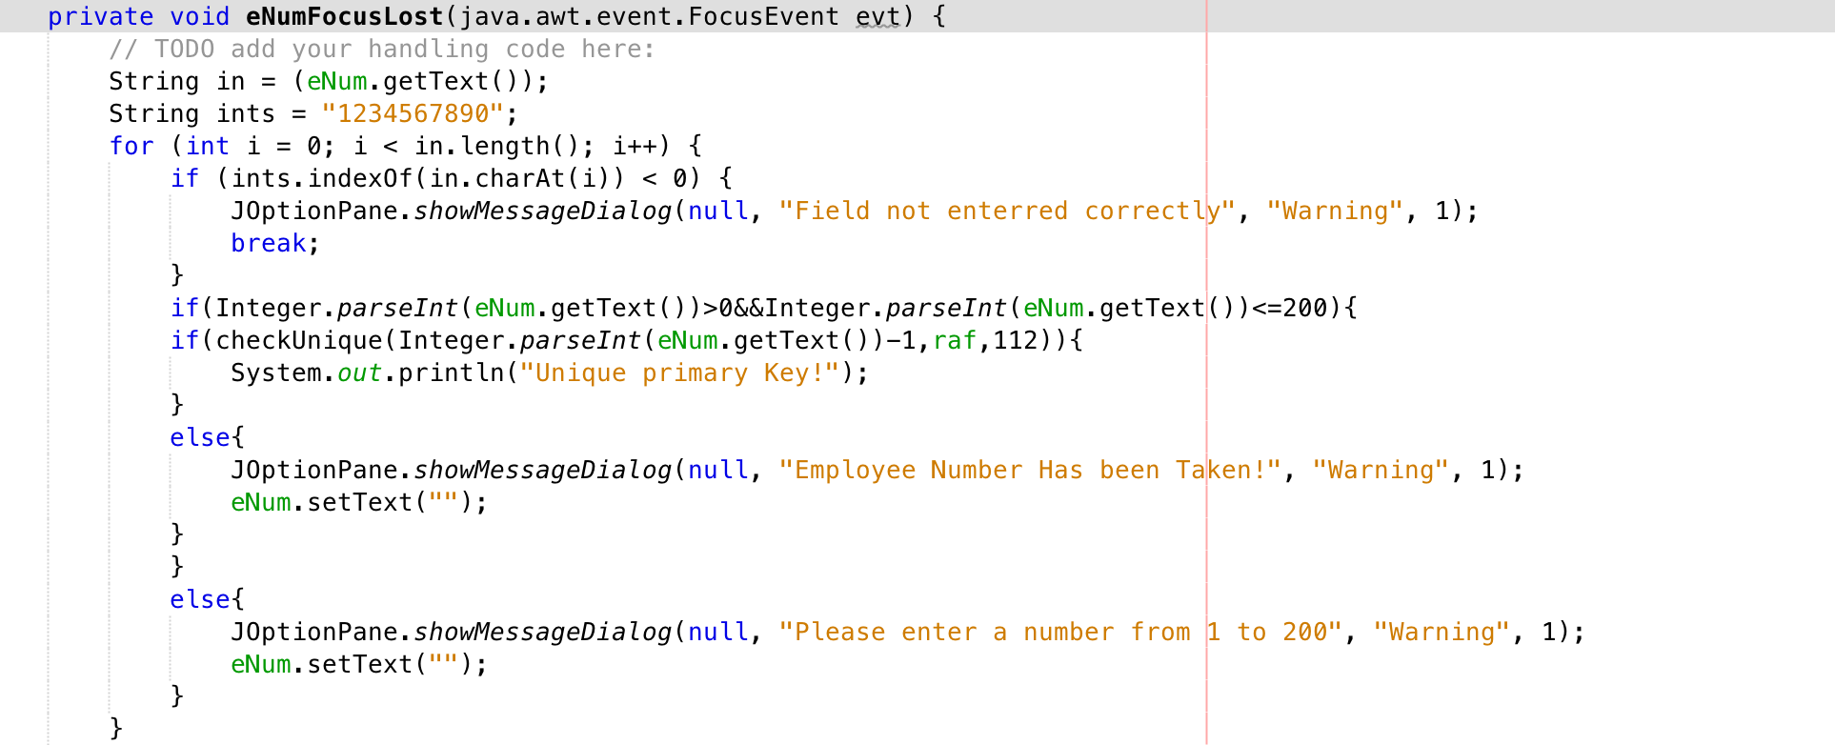
Focus Lost event of the applied text field enables a mandatory comparison between the entered information and desired information. In this particular case, it will check if the employee number has been taken. If so, it will display an error message and clear the text box.
The use of this technique makes sure that inputs entered by the user are valid and ready to be processed. Thus, possible errors, failure of functioning could be eliminated.

Word Count: 795

