CSC1010H Assignment
Ball Maze on the Raspberry Pi Sense HAT

Description
In this assignment, you will create a game, ball maze, on the Raspberry Pi Sense HAT. This assignment is primarily about selection statements (if-else statements). It will also test the use of lists and 2-dimensional lists.

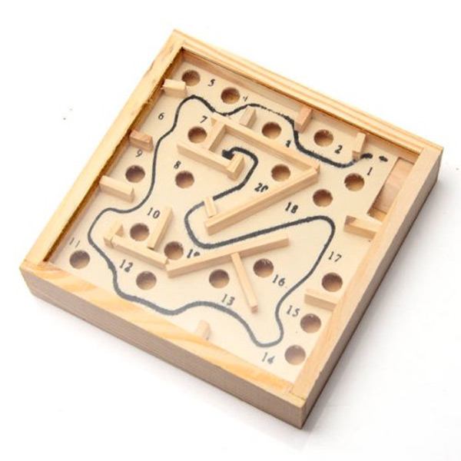
The Ball Maze Game
The ball maze game (sometimes also called marble maze) is a handheld game where the goal is to get a ball from one side of a box to another by tilting the box to make the ball roll. There are walls that enforce the maze, and holes that the ball can fall into.
In our Sense HAT LED matrix version, the ball is represented by an orange LED, the walls are blue LEDs, the target LED is green, and the holes are red.
By reading the Sense HAT’s inertial measurement unit (IMU) sensor, we can determine the angle that the Sense HAT is being held at, and make the LED ball “roll” accordingly.
When the player wins, their time taken to complete the maze is displayed. If it is the best tiem for that maze, it is saved in a text file.

The Scaffolding Code
You have been provided with some scaffolding code in a file called ballMaze_Scaffold.py, and a module called bm.py. bm.py provides functions for reading the maze configuration from a file, and saving the time taken to complete the maze in a file. Your task is to complete a few of the methods in ballMaze_Scaffold.py in order to make the game play properly. The provided code reads in the maze configuration from a file and displays it on the LED matrix (you can run the code to check this out).
Some important parts of the code ballMaze_Scaffold.py are explained here:
First some variables for types of moves are defined (you will need these later) and some variables for colours are defined. Then there are several functions, which we will return to later.
Then the Sense Hat instance is set up and the maze configuration is read from a file. (change the value of the variable mazeFileName to that of another file (maze1.txt, maze2.txt, ...) to try a different maze.
The maze layout is stored in a list of lists, called maze. The lists inside maze represent the colour of a given LED. The maze variable can be used for determining if the ball hits a wall, reaches the target, etc.
The point where the ball starts is stored in a list called start, the target pixel (end of the maze) is stored in a list called end, and the ball’s position is stored in a list called ball. The 3 lists start, end, ball all have just two elements: the first being the x-position (i.e. along the long side of the RPi) of the LED on the LED matrix, and the second being the y-position (i.e. along the short side of the RPi). Recall that (0,0) is the top left corner of the LED matrix.
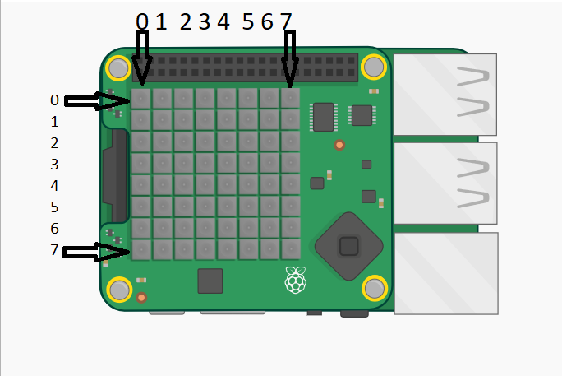
Then the game play starts. A while loop runs until the user presses the middle joystick button. In the loop, the play method is called. play handles the actual gameplay: it displays a countdown, then displays the maze, and then another while loop runs, reading the IMU (there is a short IMU tutorial at the end of this document) and calling functions as appropriate.

What you have to do

Task 1: Moving the ball left and right
The first thing you have to do is provide the code to make the ball move left or right. You code should be added in the play function. The IMU has been read and the pitch angle is in the variable pitch. Depending on the angle of the pitch, move the ball either left or right (i.e. call either the moveBallLeft or moveBallRight function). If the pitch is between 185º and 355º, make the ball roll left. If it is between 5º and 175º, make it roll to the right.
When you have done this correctly, you can run the code and see the ball move left or right depending o which way you tilt the RPi.

Task 2: Moving the ball up and down
The next task is similar to the first, but you need to move the ball up and down the LED matrix now. This is done inside an if statement because the player might die (roll into a hole or off the edge of the LED matrix) at the previous stage. First read the gyroscope and get the roll angle. Use the angle values as previously.

Task 3: Determining the type of move
Once you have completed the first two tasks, you can run the code and move the ball around by tilting the RPi, but you will see that the ball rolls through the walls, and if it rolls off the edge of the LED matrix the program crashes with an error. In order to prevent this, we need to determine the type of move that has just occurred.
The third task is to write the getMoveType function. The parameter to the function is the position of the ball as a list with 2 elements, the x co-ordinate and the y co-ordinate. Use the ball’s position to determine the type of move that has occurred. Return the appropriate variable describing the move.
As you can see from some the variables defined, there are 5 types of moves:
- LEGAL: If the element in maze at the same position as ball is on the LED matrix, is a blank list (look through the code for where colours are defined, and you will see a list named blank), the ball has moved into a blank LED, and thus it is a legal move. So return the LEGAL variable. Hint: You can get the element in maze that is at the same position as ball with the following snippet of code: maze[8*ball[1] + ball[0]]. This “flattens” the ball co-ordinates from 2 dimensions to 1 dimension (maze is a normal 1 dimensional list).
- DIE: when the ball moves off the LED matrix, the player dies, and the function should return DIE.
- HOLE: when the ball moves into a hole, the function should return HOLE. Check if the element in maze is a hole, similar to checking for a legal move.
- WALL: when the ball moves into a wall (blue LED).
- WIN: when the ball moves onto the target LED (end).
For now, print out the type of move as well so we can see what the ball is doing.
If you run the code once this task is completed, the type of move (“LEGAL”, “WALL”, etc) should be printed to the screen.

Task 4: Moving according to the type of move
Finally, complete the 4 functions for moving the ball: moveBallUp, moveBallDown, moveBallLeft, and moveBallRight. Call the getMoveType function and perform an appropriate action(s) depending on the type of move. If the player dies or moves into a hole, call the die function. If they win, call the win function. Do similar appropriate action(s) for legal moves and moves into walls (i.e. display the ball on its new position, or do not make the ball move).

Inertial Measurement Unit Tutorial
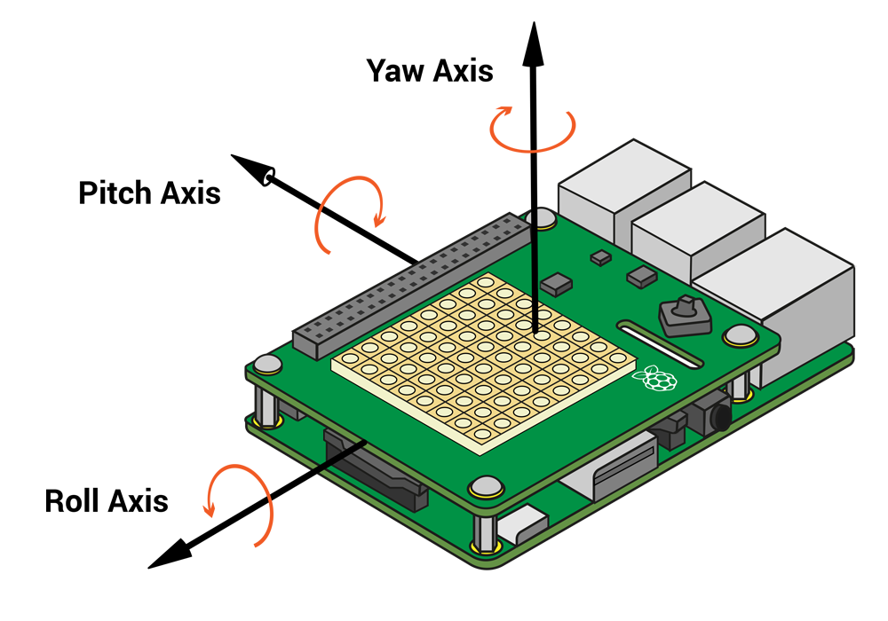
The inertial measurement unit consists of an accelerometer, gyroscope, and magnetometer. It can be used to detect movement and the orientation of Sense Hat. For this assignment, we are only interested in detect orientation.
The orientation of an object is given by three angles: the roll, pitch, and yaw angles. These are the angle of rotation around three axes, as seen in the picture above.
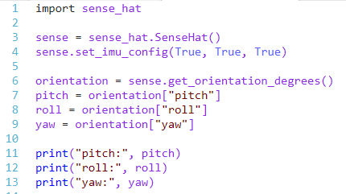
The angle measurements can be obtained with the get_orientation() method:
get_orientation() returns a dictionary object with three key-value pairs: one each for the roll, pitch, and yaw angles. They can be accessed using the keys (“roll”, “pitch”, and “yaw”) similar to the way a list is accessed. Running the above code should output something like this:
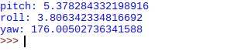
So depending on the pitch angle, the ball would roll in the direction of the long side of the RPi, and the roll angle would determine in which direction the ball rolls along the short side of the RPi.
If you need more help with understanding the IMU, another tutorial can be found here: https://github.com/raspberrypilearning/astro-pi-guide/blob/master/sensors/movement.md

The Sense HAT Library
The Raspberri Pi Foundation provides a library with function for interacting with the SH. There are functions for settting the colours of the LED matrix, reading the sensors, and specifying what happens when the joystick is moved. We will now provide a few code examples, and some pictures of example ouput.
In order to use the SH functions, we need to import the sense_hat library. We then create a variable that is of type SenseHat. This variable (usually called sense, but it can be called any valid name) is used to call the SH functions.
Example code | Picture of output (these pictures made using an emulator)
#import the library, and create a #SenseHat variable  import sense_hat  sense = sense_hat.SenseHat()  #display text that moves across the LED #matrix  sense.show_message("Hello World!") | 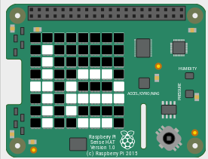  Part of the text moving across the LED matrix
#define colours. Colours are normally lists with #3 elements: first the amount of red, then #green, then blue. 0 is the minimum value, 255 #the maximum  red = [255, 0, 0]  green = [0, 255, 0]  blue = [0, 0, 255]  white = [255, 255, 255]  #set pixels to a certain colour  # column first, then row  sense.set_pixel(0, 0, red)  sense.set_pixel(7, 7, green)  sense.set_pixel(1, 3, blue)  sense.set_pixel(4, 6, white) | 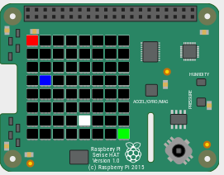
# read gyroscope.  # get_orientation_degrees returns a dictionary  # with 3 entries.  orientation = sense.get_orientation_degrees()  pitch = orientation["pitch"]  roll = orientation["roll"]  yaw = orientation["yaw"]  print("pitch:", pitch)  print("roll:", roll)  print("yaw:", yaw) | pitch: 351.98974624047946  roll: 17.892698229034732  yaw: 271.98435186451815

