CSC1010H Assignment:
Snake on the Raspberry Pi
and Sense HAT

Introduction
In this assignment, we will be creating the classic game snake for the Raspberry Pi Sense HAT. This assignment focuses on for and while loops.
Snake is a simple game that was popular on early cell phones. On the screen is a snake which the player controls. The goal is to eat as much food as possible and grow as long as possible. If the snake hits the edges of the screen or its own body, it dies. You can play snake online here: http://patorjk.com/games/snake/
Our version will use the LED matrix and be controlled using the joystick. The snake will start off with 2 segments (i.e. 2 LEDs long). The snake’s head will flash. The “food,” or target LED will be green, and every time the snake “eats” the food (the head of the snake is on the same LED as the food), it grows one segment longer.

The Scaffolding code
You have been provided with two files: snake_scaffolding.py, in which you will write your code, and SnakeClass.py, which provides a class representing the snake. You do not need to change or write any code in SnakeClass.py

Snake_Scaffolding.py
The Snake_Scaffolding.py file is where you will write your code.
At the top of the file are the usual imports we require to use functions from the sense_hat, time, and random libraries. Also imported is the SnakeClass file, which will allow us to create an instance of the class in the snake_scaffolding.py file.
Next, some constants for representing the directions of movement are defined, as well as the normal lists representing colours.
Then several functions are defined. We will return to these later when you have to implement them.
In the main, we perform all the standard initializations for using the Sense HAT.
Now the actual game play starts. Inside a while loop, an instance of SnakeClass is created (it is called snake). Then a countdown is displayed and the food is generated. Following this, the main loop starts: in every iteration of the loop, the LED matrix is updated, and the snake moves. If the snake eats the food or dies, the appropriate function is called.

What You Have to do

Task 1: Show the snake and food on the LED matrix
When you run the scaffolding code, you should see a countdown appear on the LED matrix, and then stop at 1. The food LED and the snake do not appear on the LED matrix.
Your first task is to implement the updateMatrix function to make them appear on the LED matrix. Show the food LED and the snake’s body. If one of the snake’s pixels is out of bounds, (i.e. greater than 7 or less than 0), call the die() function.
When you do this correctly, you should see a short snake appear, with its head flashing, and a green LED below the snake (the food). The snake will move down towards the food, eat it, grow, and then hit the edge of the LED matrix and die. The food LED will remain on the matrix. Nothing happens if you move the joystick.

Task 2: Make the snake change direction
The next thing to do is to implement the joystick functions that will change the snake’s direction: up(event), down(event), right(event). They are very similar to left(event) function.
Once you have done this, you should be able to move the snake around by moving the joystick. However, you will see that the food always stays in the same place.

Task 3: Generate the food
Have a look at the generateFood function. It always returns the same thing. You have to rewrite it so the food is generated to be in a random position each time. Take care to ensure the food is not placed on an LED that the snake is occupying. You can check if the 2-element list you create is in the snake body pixels with the following snippet of code: newFood in snakePixels (where newFood is the new position of the food, and snakePixels is the list of pixels (2-element lists) that make up the snake’s body, which you can obtain with the function snakePixels = snake.getPixels()).
The function random.randint(minimum, maximum) will be useful. It returns a random integer x such that minimum <= x <= maximum.
When this is complete, the food LED should appear in a new place everytime the snake eats it. But when the snake dies, the food stays on the LED and the game does not start again.

Task 4: Die
Next is the die() function. This function is called when the snake dies. It should stop the game (read the code under MAIN to figure out how to do this. Pay attention to the while loops), and then display a relevant message to the player.
When after this is implemented, a message should be displayed after dying, and a new game should start.

Task 5: Stop the game
After the snake dies and the message is displayed, a new game will start. Complete the stopGame(event) function so that when the middle joystick button is pressed, the game stops and a new game does not start again. Read the code under MAIN to figure out how to do this (again, pay attention to the while loops).

The Sense HAT Library
The Raspberri Pi Foundation provides a library with function for interacting with the SH. There are functions for settting the colours of the LED matrix, reading the sensors, and specifying what happens when the joystick is moved. We will now provide a few code examples, and some pictures of example ouput.
In order to use the SH functions, we need to import the sense_hat library. We then create a variable that is of type SenseHat. This variable (usually called sense, but it can be called any valid name) is used to call the SH functions.
Example code | Picture of output (these pictures made using an emulator)
#import the library, and create a #SenseHat variable  import sense_hat  sense = sense_hat.SenseHat()  #display text that moves across the LED #matrix  sense.show_message("Hello World!") | 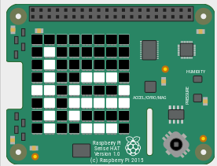  Part of the text moving across the LED matrix
#define colours. Colours are normally lists with #3 elements: first the amount of red, then #green, then blue. 0 is the minimum value, 255 #the maximum  red = [255, 0, 0]  green = [0, 255, 0]  blue = [0, 0, 255]  white = [255, 255, 255]  #set pixels to a certain colour  # column first, then row  sense.set_pixel(0, 0, red)  sense.set_pixel(7, 7, green)  sense.set_pixel(1, 3, blue)  sense.set_pixel(4, 6, white) | 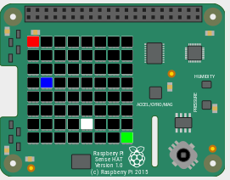
blk= [0, 0, 0]  #define a list with 64 elements, each  # a list of 3 elements  grid = [blk, blk, blk, blk, blk, blk, blk, blk,  blk, blue, blue, blue, blk, blk, green, blk,  blk, blue, blk, blk, blk, blk, blk, blk,  blk, blue, blk, blk, blk, blk, blk, blk,  blk, blue, blue, blue, blue, blue, blk, blk,  blk, blk, blk, blk, blk, blue, blk, blk,  blk, blk, blk, blk, blk, blue, blk, blk,  blk, blk, blk, blk, blk, blk, blk, blk]  #set all the pixels (LEDs) at once  sense.set_pixels(grid) | 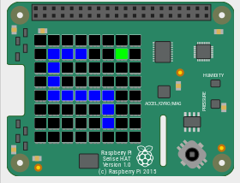
#function that executes when joysitck is pushed #up  def pushed_up(event):  if event.action == sense_emu.ACTION_RELEASED:  sense.clear()#all LEDs off  sense.show_letter("U")  # set the function up to run when  # joystick is pushed up  sense.stick.direction_up = pushed_up  #similar for down, left, right, middle, any | 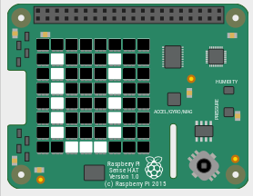  After joystick pushed up

