CSC1010H Assignment
if Statements

Description
In this assignment, you will create a game, ball maze, on the Raspberry Pi Sense HAT. This assignment is primarily about selection statements (if-else statements). It will also test the use of lists and 2-dimensional lists.

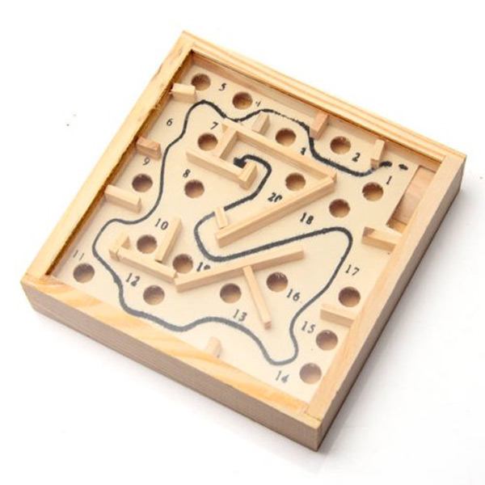
The Ball Maze Game
The ball maze game (sometimes also called marble maze) is a handheld game where the goal is to get a ball from one side of a box to another by tilting the box to make the ball roll. There are walls that enforce the maze, and holes that the ball can fall into.
In our Sense HAT LED matrix version, the ball is represented by an orange LED, the walls are blue LEDs, the target LED is green, and the holes are red.
By reading the Sense HAT’s inertial measurement unit sensor, we can determine the angle that the Sense Hat is being held at, and make the LED “roll” accordingly.

The Scaffolding Code
You have been provided with some scaffolding code in a file called ballMaze_Scaffold.py. You task is to complete a few of the methods in order to make the game play properly. The provided code reads in the maze configuration from a file and displays it on the LED matrix (you can run the code to check this out)
You can ignore most of the code, but some important parts are explained here:
First, the Sense HAT instance is set up. Next some variables for types of moves are defined (you will need these later), some variables for colours are defined, and the maze layout is read from a file.
The maze layout is stored in a list, called maze, the point where the ball starts is stored in a list called start, the target pixel is stored in a list called end, and the ball’s position is stored in a list called ball. The 3 lists start, end, ball all have just two elements: the first being the x-position (i.e. along the long side of the RPi) of the LED on the LED matrix, and the second being the y-position (i.e. along the short side of the RPi). Note that (0,0) is the top left corner of the LED matrix.
Then the game play starts. A while loop runs until the user presses the middle joystick button. In the loop, the play method is called. play handles the actual gameplay: it displays a countdown, then displays the maze, and then another while loop runs, reading the IMU (there is a short IMU tutorial at the end of this document and calling functions as appropriate.

What you have to do

Task 1: Moving the ball left and right
The first thing you have to do is provide the code to make the ball move left or right. You code should be added in the play function, at line 91. The IMU has been read and the pitch angle is in the variable pitch. Depending on the angle of the pitch, move the ball either left or right (i.e. call either the moveBallLeft or moveBallRight function).

Task 2: Moving the ball up and down
The next task is similar to the first, but you need to move the ball up and down the LED matrix now. This is done inside an if statement because the player might die (roll into a hole or off the edge of the LED matrix) at the previous stage.

Task 3: Determining the type of move
Once you have completed the first two tasks, you can run the code and move the ball around by tilting the RPi, but you will see that the ball rolls throughthe walls, and if it rolls of the edge of the LED matrix the program crashes with an error. In order to prevent this, we need to determine the type of move that has just occurred
The third task is to write the getMoveType function. The parameter to the function is the position of the ball. Use the ball’s position to determine the type of move that has occurred. Return the appropriate constant describing the move.
As you can see from some the variables defined, there are 5 types of moves:
- DIE: when the ball moves off the LED matrix, the player dies, and the function should return DIE.
- HOLE: when the ball moves into a hole, the function should return HOLE.
- WALL: when the ball moves into a wall (blue LED).
- WIN: when the ball moves onto the target LED
- LEGAL: any other move

Task 4: Moving according to the type of move
Finally, complete the 4 functions for moving the ball: moveBallUp, moveBallDown, moveBallLeft, and moveBallRight. Call the getMoveType function and perform an appropriate action(s) depending on the type of move. If the player dies, call the die function. If they win, call the win function. If they move into a hole, first show the ball “in the hole,” then the player dies. Do similar appropriate action(s) for legal moves and moves into walls.

Inertial Measurement Unit Tutorial
Describe the IMU, what it does, why, how to read it, and the axes

