Tic-Tac-Toe

There are a few tasks for you to complete. The instructions are given below. There is a short Sense Hat tutorial after the instructions.

Task 1: Moving the marker around
Your first task will be to move the marker (blue LED) around the LED matrix when one of the players presses the joystick. The purpose of the marker to to show the players where they can make their square (X or O).
Let’s have a look at the pushed_right function. This function executes when the joystick is moved to the right. When the joystick is moved, a joystick event occurs. This event data is passed to the function as a parameter (called event here) and contains some information about what happened.
In the function, we first check if the action was a release. The SH library provides a constant for this purpose, accessed by sense_hat.ACTION_RELEASED. If it was a release, we set the pixel were the marker currently is to the colour of the rest of the grid square. We obtain this colour by getting the colour of the pixel just to the right of the marker (i.e. adding 1 to the marker’s current column).
Then we update the marker to have its new position. Since the marker is moving to the right, we only change its first element (its column in the matrix, marker[0]) . We always want the marker to bein the top left corner of a grid square, so it will always be in column 0, 3, or 6 (see picture below). We add 3 to move it to the next grid square, and then modulo 9 to get the value to wrap around back to 0 if it is greater than 7, as a value greater than 7 (or less than 0) will cause an error.
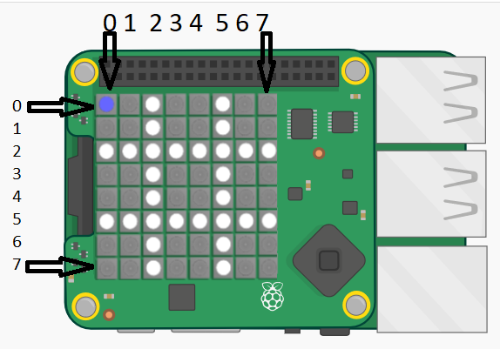
We then set the LED at the marker’s new position to be blue.
It is up to you to implement the code for the pushed_left, pushed_up, and pushed_down methods. They are very similar to pushed_right. There are only one or two small changes. Only the direction of movement changes. (i.e. you only need to change either the marker’s column or row)

Task 2: Placing a red or green square on the grid
Next, we will implement the functionality for placing an “X” or “O”. The “X” has been placed with a red square and the “O” with a green square. When the user presses the middle joystick button, we want the grid square that the marker is currently in to be coloured completely red or green, depending on whose turn it is.
Part of this has been provided: the buttonPushed function will execute when a player presses the middle button on the joystick. The function will call another function, colourSquare, if the grid square containing the marker is not coloured yet.
You have to implement the colourSquare function. The function has 3 parameters:
- x: the x co-ordinate of the pixel (the column)
- y: the y co-ordinate of the pixel (the row)
- colour: a list of 3 elements specifying the colour to make the grid square
The (x, y) co-ordinate pair is the co-ordinates of the top left pixel in the grid square that is to be coloured. You have to ensure the given pixel is set to the given colour, as well as the pixel just to the right, just below, and just diagonally right and below of the given pixel.
Make use of the set_pixel(x, y, colour) function used elsewhere in the code. (see tutorial for an explantion)
For example: if the marker is at (3, 3) and colourSquare is called with colourSquare(3, 3, [255, 0, 0]), the following should happen:
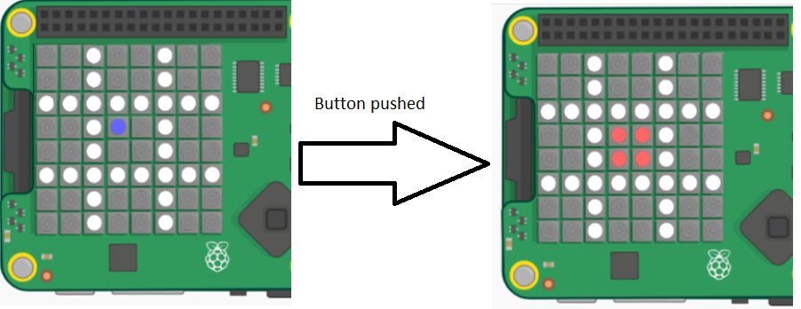

Task 3: Starting again
The playAgain function runs once the game has ended (someone won or it was a tie). It gets things ready for a new game.
You have to implement this method. it must do the follwing:
- Display the (empty) grid on the LED matrix. Have a look in the tutorial below for an appropriate function.
- Display the marker on the LED matrix. Make the marker LED blue.

Sense HAT Library Tutorial
The sense_hat library provides functions for interacting with the SH. There are functions for settting the colours of the LED matrix, reading the sensors, and specifying what happens when the joystick is moved. We will now provide a few code examples, and some pictures of example ouput.
In order to use the SH functions, we need to import the sense_hat library. We then create a variable that is of type SenseHat. This variable (usually called sense, but it can be called any valid name) is used to call the SH functions.
Example code | Picture of output (these pictures made using an emulator)
import sense_hat  sense = sense_hat.SenseHat()  #define colours. Colours are normally lists with #3 elements: first the amount of red, then #green, then blue. 0 is the minimum value, 255 #the maximum  red = [255, 0, 0]  green = [0, 255, 0]  blue = [0, 0, 255]  white = [255, 255, 255]  #set pixels to a certain colour  # column first, then row  sense.set_pixel(0, 0, red)  sense.set_pixel(7, 7, green)  sense.set_pixel(1, 3, blue)  sense.set_pixel(4, 6, white) | 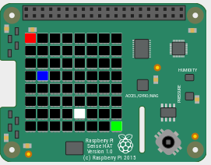
#function that executes when joysitck is pushed #up  def pushed_up(event):  if event.action == sense_emu.ACTION_RELEASED:  sense.clear()#all LEDs off  sense.show_letter("U")  # set the function up to run when  # joystick is pushed up  sense.stick.direction_up = pushed_up  #similar for down, left, right, middle, any | 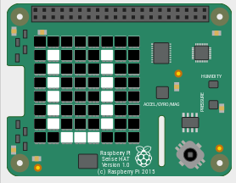  After joystick pushed up
blk= [0, 0, 0]  #define a list with 64 elements, each  # a list of 3 elements  grid = [blk, blk, blk, blk, blk, blk, blk, blk,  blk, blue, blue, blue, blk, blk, green, blk,  blk, blue, blk, blk, blk, blk, blk, blk,  blk, blue, blk, blk, blk, blk, blk, blk,  blk, blue, blue, blue, blue, blue, blk, blk,  blk, blk, blk, blk, blk, blue, blk, blk,  blk, blk, blk, blk, blk, blue, blk, blk,  blk, blk, blk, blk, blk, blk, blk, blk]  #set all the pixels (LEDs) at once  sense.set_pixels(grid) | 