Ball Maze on the Raspberry Pi Sense HAT

In this assignment, you will create a game, ball maze, on the Raspberry Pi Sense HAT. This assignment is primarily about selection statements (if-else statements). It will also test the use of lists and 2-dimensional lists.

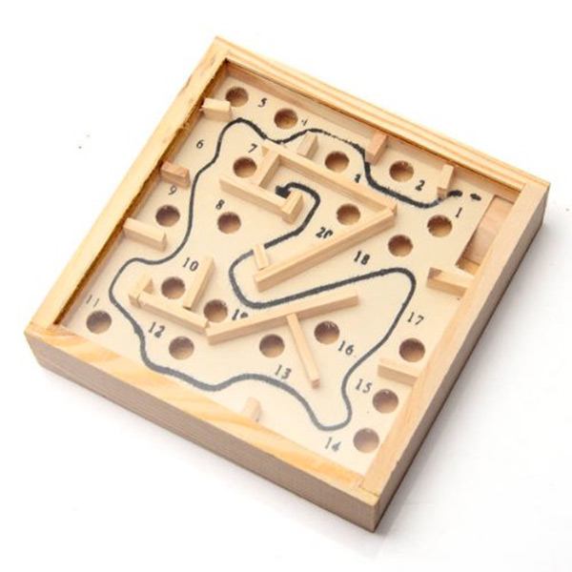
The Ball Maze Game
The ball maze game (sometimes also called marble maze) is a handheld game where the goal is to get a ball from one side of a box to another by tilting the box to make the ball roll. There are walls that enforce the maze, and holes that the ball can fall into.
In our Sense HAT LED matrix version, the ball is represented by an orange LED, the walls are blue LEDs, the target LED is green, and the holes are red.
By reading the Sense HAT’s inertial measurement unit (IMU) sensor, we can determine the angle that the Sense Hat is being held at, and make the LED ball “roll” accordingly. There is an IMU tutorial after the task instructions.

What you have to do

Task 1: Moving the ball left and right
The first thing you have to do is provide the code to make the ball move left or right. You code should be added in the play function. The IMU has been read and the pitch angle is in the variable pitch.
If the pitch is between 185º and 355º, make the ball roll to the left. If the pitch is between 5º and 175º, make it roll to the right.
If you run the code after completing this, and you tilt the Raspberry Pi to the left or right, the ball (orange LED) should move to the side. However, it will roll through walls.

Task 2: Moving the ball up and down
The next task is similar to the first, but you need to move the ball up and down the LED matrix now. This is done inside an if statement because the player might die (roll into a hole or off the edge of the LED matrix) at the previous stage.
Read the gyroscope and obtain the roll angle (similar to how the pitch was read, or read the Sense Hat library tutorial below), and if it is between 185º and 355º, make the ball roll downwards. If the pitch is between 5º and 175º, make it roll upwards.

Task 3: Determining the type of move
Once you have completed the first two tasks, you can run the code and move the ball around by tilting the RPi, but you will see that the ball rolls through the walls, and if it rolls of the edge of the LED matrix the program crashes with an error. In order to prevent this, we need to determine the type of move that has just occurred.
The third task is to write the getMoveType function. The parameter to the function is the position of the ball as a list with 2 elements: the first is the ball’s x co-ordinate (column) and the second is the y co-ordinate (row).
Use the ball’s position to determine the type of move that has occurred. The maze variable (a 2 dimensional list) to see what is at the position where the ball is:
- If the element in maze at the same position as ball is a blank list, the ball has moved into an blank LED, and thus it is a legal move. So print the word “legal” to the screen, and return the LEGAL constant.
- If the element in maze at the same position as ball is a blue list, the ball has moved into a wall. So print the word “wall” to the screen, and return the WALL constant.
- If the ball has moved off the LED matrix, print the word “Die” and return the DIE constant.
- If the element in maze at the same position as ball is a red list, the ball has moved into a hole. Print the word “hole” to the screen, and return the HOLE constant.
- If the ball is at the end position, print the word “win” and then return the WIN constant.
If you run the code once this task is completed, the type of move (“LEGAL”, “WALL”, etc) should be printed to the screen.
Hint: You can get the colour in maze that is at the same position as ball with the following snippet of code: maze[8*ball[1] + ball[0]]. This “flattens” the ball co-ordinates from 2 dimensions to 1 dimension.

Task 4: Moving according to the type of move
Finally, complete the 4 functions for moving the ball: moveBallUp, moveBallDown, moveBallLeft, and moveBallRight. Call the getMoveType function and perform an appropriate action(s) depending on the type of move.:
- If the player dies, call the die function.
- If they win, call the win function.
- If they move into a hole, call the die function
- If they move into a wall, do not move the ball
- If it is a legal move, move the ball as normal.

Inertial Measurement Unit Tutorial
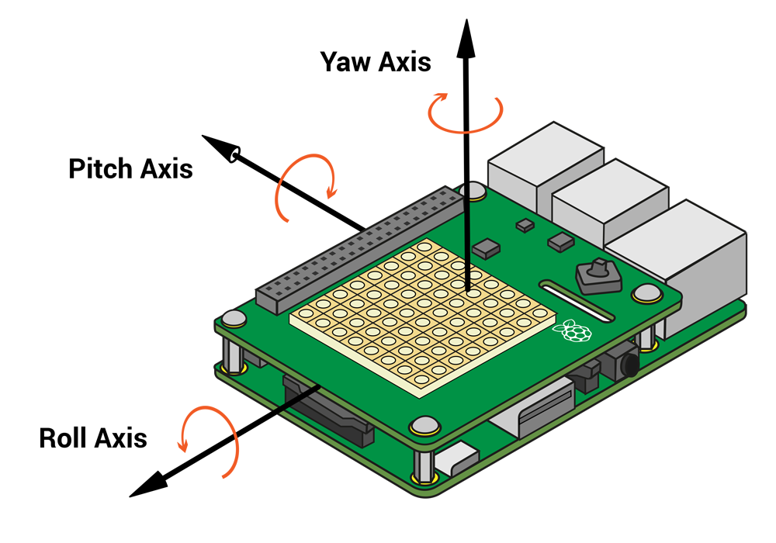
The inertial measurement unit consists of an accelerometer, gyroscope, and magnetometer. It can be used to detect movement and the orientation of Sense Hat. For this assignment, we are only interested in detecting orientation.
The orientation of an object is given by three angles: the roll, pitch, and yaw angles. These are the angle of rotation around three axes, as seen in the picture above. For example: if the RPi is perfectly horizontal, the pitch angle will be 0º. If the USB ports are pointing vertically upwards, the pitch would be -90º.
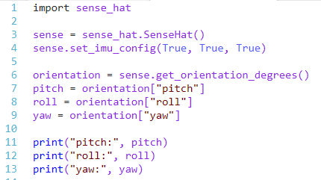
The angle measurements can be obtained with the get_orientation() method:
get_orientation() returns a dictionary object with three key-value pairs: one each for the roll, pitch, and yaw angles. They can be accessed using the keys (“roll”, “pitch”, and “yaw”) similar to the way a list is accessed. Running the above code should output something like this:
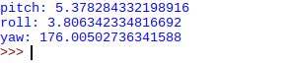
So depending on the pitch angle, the ball would roll in the direction of the long side of the RPi, and the roll angle would determine in which direction the ball rolls along the short side of the RPi.
If you need more help with understanding the IMU, another tutorial can be found here: https://github.com/raspberrypilearning/astro-pi-guide/blob/master/sensors/movement.md

The Sense HAT Library
The Raspberri Pi Foundation provides a library with function for interacting with the SH. There are functions for settting the colours of the LED matrix, reading the sensors, and specifying what happens when the joystick is moved. We will now provide a few code examples, and some pictures of example ouput.
In order to use the SH functions, we need to import the sense_hat library. We then create a variable that is of type SenseHat. This variable (usually called sense, but it can be called any valid name) is used to call the SH functions.
Example code | Picture of output (these pictures made using an emulator)
#define colours. Colours are normally lists with #3 elements: first the amount of red, then #green, then blue. 0 is the minimum value, 255 #the maximum  red = [255, 0, 0]  green = [0, 255, 0]  blue = [0, 0, 255]  white = [255, 255, 255]  #set pixels to a certain colour  # column first, then row  sense.set_pixel(0, 0, red)  sense.set_pixel(7, 7, green)  sense.set_pixel(1, 3, blue)  sense.set_pixel(4, 6, white) | 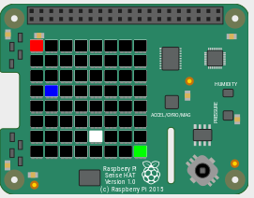
blk= [0, 0, 0]  #define a list with 64 elements, each  # a list of 3 elements  grid = [blk, blk, blk, blk, blk, blk, blk, blk,  blk, blue, blue, blue, blk, blk, green, blk,  blk, blue, blk, blk, blk, blk, blk, blk,  blk, blue, blk, blk, blk, blk, blk, blk,  blk, blue, blue, blue, blue, blue, blk, blk,  blk, blk, blk, blk, blk, blue, blk, blk,  blk, blk, blk, blk, blk, blue, blk, blk,  blk, blk, blk, blk, blk, blk, blk, blk]  #set all the pixels (LEDs) at once  sense.set_pixels(grid) | 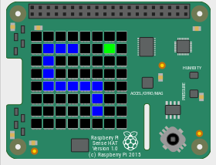
# read gyroscope.  # get_orientation_degrees returns a dictionary  # with 3 entries.  orientation = sense.get_orientation_degrees()  pitch = orientation["pitch"]  roll = orientation["roll"]  yaw = orientation["yaw"]  print("pitch:", pitch)  print("roll:", roll)  print("yaw:", yaw) | pitch: 351.98974624047946  roll: 17.892698229034732  yaw: 271.98435186451815

