Ball Maze on the Raspberry Pi Sense HAT

Introduction
This is an abridged version of an assignment that may be used in the CSC1010H course in the future. This assignment is mostly about if statements. We are using an abridged version so you have the chance to complete some of the tasks and get a better feel for what sort of thing you can do with the RPi and SH.
You will be creating a version of the game ball maze. Much of the code is completed already, and it is up to you to implement certain parts to make the game work correctly.
We will make extensive use of the Sense Hat library functions, but these will be clearly explained in these instructions. There is also a short tutorial at the end.

The Ball Maze Game
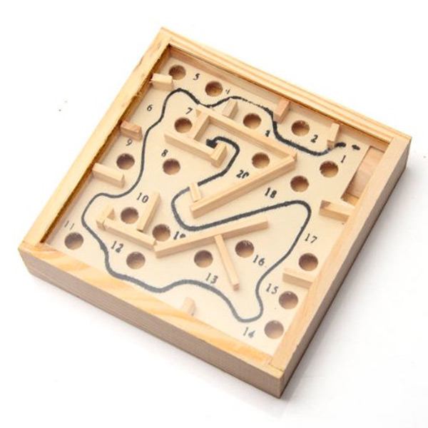
The ball maze game (sometimes also called marble maze) is a handheld game where the goal is to get a ball from one side of a box to another by tilting the box to make the ball roll. There are walls that enforce the maze, and holes that the ball can fall into.
In our Sense HAT LED matrix version, the ball is represented by an orange LED, the walls are blue LEDs, the target LED is green, and the holes are red. (there are no holes in the maze used in this assignment, but we will take them into account anyway)
By reading the Sense HAT’s inertial measurement unit (IMU) sensor, we can determine the angle that the Sense Hat is being held at, and make the LED ball “roll” accordingly.

Task 1: Move the ball up and down
When you run the given code, the maze should appear on the LED matrix, as well as the orange “ball” LED and the green “end” LED. When you tilt the Pi, the ball will roll left or right (along the long side of the Pi), but not up or down. Your first task is to make the ball roll up and down.
Add your code just below the comment that says “Task 1”. Get the orientation (use the sense.get_orientation_degrees() function) and extract the roll value, similar to how the pitch value is obtained a few lines above. The sense.get_orientation_degrees() function returns a dictionary with the keys “pitch”, “roll”, and “yaw”. If the roll is between 185º and 355º, call the moveBallDown() function. If it is between 5º and 175º, call the moveBallUp() function.

Orientation explanation
The orientation of the RPi is given by three angles: pitch, roll, and yaw. By reading the pitch angle, we can tell in which direction the ball should roll along the long side of the RPi. By reading the roll angle, we can tell in which direction the ball should roll along the short side of the RPi.

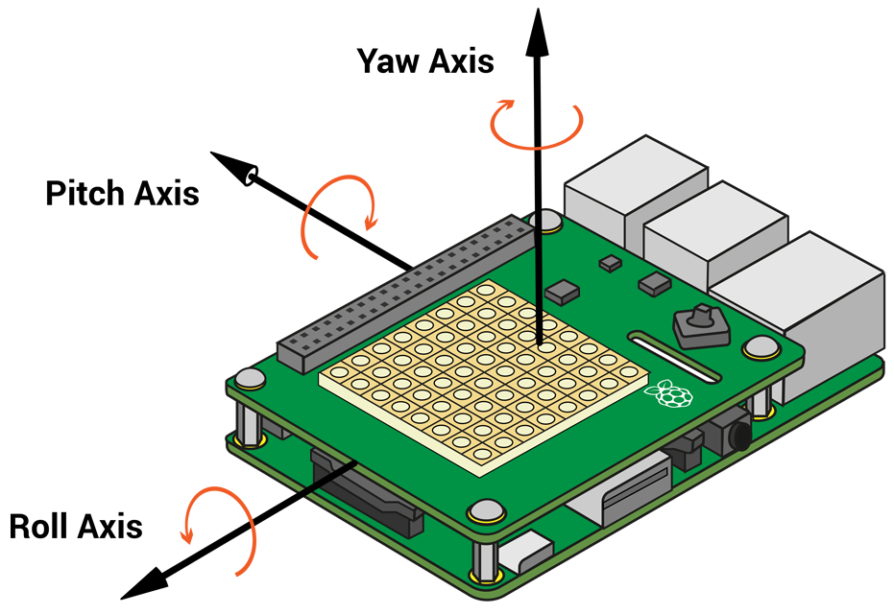

Task 2: Moving the ball correctly.
Once you have completed the first task, you can run the code and move the ball around by tilting the RPi, but you will see that the ball rolls through the walls, and if it rolls of the edge of the LED matrix the program crashes with an error. In order to prevent this, we need to determine the type of move that has just occurred.
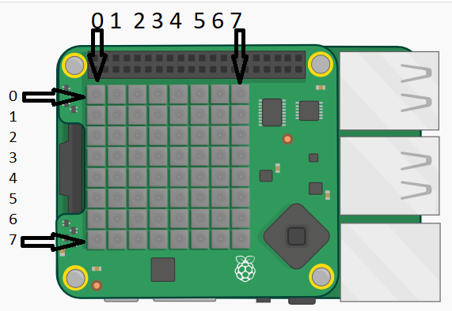
The second task is to write the getMoveType(ball) function. The parameter to the function is the position of the ball as a list with 2 elements: the first is the ball’s x co-ordinate (column) and the second is the y co-ordinate (row). (0, 0) is in the top left corner of the LED matrix.The function returns an int specifying the type of move: it can be a legal move, die move, hole move, win move, or a move into a wall. Some variables have been defined to represent the types of moves.
Currently the getMoveType function always returns LEGAL, which is why the ball rolls through walls, and it causes an error if it rolls off the edge.
Use the ball’s position to determine the type of move that has occurred. The maze variable can be used to see what is at the position where the ball is:
- If the element in maze at the same position as ball is on the LED matrix, is a blank list (look through the code for where colours are defined, and you will see a list named blank), the ball has moved into an blank LED, and thus it is a legal move. So return the LEGAL variable. Hint: You can get the element in maze that is at the same position as ball with the following snippet of code: maze[8*ball[1] + ball[0]]. This “flattens” the ball co-ordinates from 2 dimensions to 1 dimension (maze is a normal 1 dimensional list).
- If the element in maze at the same position as ball is a blue list, the ball has moved into a wall. Return WALL.
- If the ball has moved off the LED matrix, print the word “Die” and return DIE. See the image above for the values that define the edges of the LED matrix.If one of ball’s co-ordinates is greater then or less than the maximum and minimum values for valid co-ordinates, it is out of bounds.
- If the element in maze at the same position as ball is a red list, the ball has moved into a hole. Return the variable HOLE.
- If ball is the same as the end position, return the WIN variable.
If you run the code once this task is completed, the ball should behave correctly (i.e. if it rolls off the edge, the game ends and a message is displayed, it can’t roll through walls, etc)

Sense HAT Library tutorial
The Raspberri Pi Foundation provides a library with function for interacting with the SH. There are functions for settting the colours of the LED matrix, reading the sensors, and specifying what happens when the joystick is moved. Here are a few examples of the functions you will need.
In order to use the SH functions, we need to import the sense_hat library. We then create a variable that is of type SenseHat. This variable (usually called sense, but it can be called any valid name) is used to call the SH functions.
Example code | Picture of output (these pictures made using an emulator)
#import the library, and create a #SenseHat variable  import sense_hat  sense = sense_hat.SenseHat()  #define colours. Colours are normally lists with #3 elements: first the amount of red, then #green, then blue. 0 is the minimum value, 255 #the maximum  red = [255, 0, 0]  green = [0, 255, 0]  blue = [0, 0, 255]  white = [255, 255, 255]  # set pixels to a certain colour  # column first (x co-ordinate), then row (y co-  # ordinate)  sense.set_pixel(0, 0, red)  sense.set_pixel(7, 7, green)  sense.set_pixel(1, 3, blue)  sense.set_pixel(4, 6, white) | 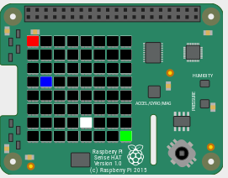
blk = [0, 0, 0]  #define a list with 64 elements, each  # a list of 3 elements  grid = [blk, blk, blk, blk, blk, blk, blk, blk,  blk, blue, blue, blue, blk, blk, green, blk,  blk, blue, blk, blk, blk, blk, blk, blk,  blk, blue, blk, blk, blk, blk, blk, blk,  blk, blue, blue, blue, blue, blue, blk, blk,  blk, blk, blk, blk, blk, blue, blk, blk,  blk, blk, blk, blk, blk, blue, blk, blk,  blk, blk, blk, blk, blk, blk, blk, blk]  #set all the pixels (LEDs) at once  sense.set_pixels(grid) | 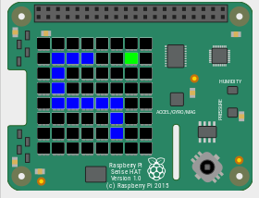
# read gyroscope.  # get_orientation_degrees returns a dictionary  # with 3 entries.  orientation = sense.get_orientation_degrees()  pitch = orientation["pitch"]  roll = orientation["roll"]  yaw = orientation["yaw"]  print("pitch:", pitch)  print("roll:", roll)  print("yaw:", yaw) | pitch: 351.98974624047946  roll: 17.892698229034732  yaw: 271.98435186451815

