CSC1010H Assignment
Introduction To The Sense HAT

Introduction: The Raspberry Pi and Sense HAT
The Raspberry Pi (RPi) is a single board computer (about the size of a credit card) created for teaching programming and electronics. The RPi runs a version of Linux called Raspbian and it can run many pieces of software (web browser, word processor, spreadsheet software, IDEs, etc) that have been adapted for the operating system. It also provides general purpose input-output pins for connecting LEDs, sensors, motors, and other hardware.
The Sense HAT (Hardware Attached on Top) is an add-on board for the RPi. It provides an 8x8 LED matrix, temperature, humidtity, and pressure sensors, an accelerometer, gyroscope, and magnetometer, and a joystick. The Sense HAT (SH) plugs directly into the GPIO pins, eliminating the need for wires and other electronics components.
We will be using the RPi and SH in this course as part of the assignments, to bring an new and exciting aspect to learning programming. We will be implementing some simple games on the LED matrix as additional assignments.
This tutorial is an introduction to working with the SH.

VNC
Ideally, one would plug in a monitor, keyboard, and mouse into the RPis and use it like a normal desktop computer, but as for various reasons we can’t provide everyone with all the peripherals, we will be using software called VNC, which provides remote access from one computer to another, to awork on the RPi.

Connecting to the RPi
- Download VNC Viewer from https://www.realvnc.com/en/ and install it on your laptop. The Rpi has been set up to start its version of VNC on start up.
- Connect your RPi to your laptop will the USB cable (for power) and Ethernet cable (provides communication between RPi and laptop) you have been given. Press the button on the USB cable and you should see the LED matrix light up in a rainbow.
- Open VNC Viewer on your laptop and create a new connection (File -> New Connection)
- Enter “169.254.0.100” at the VNC Server text field and a name of your choice for the connection, and click “create”.
- Open the connection and enter the password “raspberry”
- You should then see a window that shows the desktop of the RPi.
Feel free to explore the interface and software provided, but for this tutorial we will be focusing on writing Python with IDLE (start menu -> Programming -> Python 3 (IDLE))

Implementing tic-tac-toe on the Sense HAT
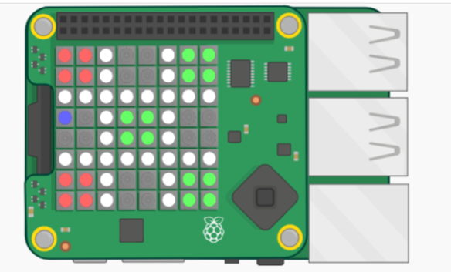
As an introduction to the SH, we will be implementing the game tic-tac-toe (also called XO or noughts and crosses). Here is a picture how it will look once we have completed:

Due to the limited space on the LED matrix, we can’t make an actual “X” or “O”, and have replaced these with coloured squares.
You have been given two files: tictactoe_scaffold.py, and ttt.py. tictactoe_scaffold.py has some code on which we will build the tic-tac-toe game. ttt.py is a module that contains functionality for determing if a player has won, or the game is a tie, or there is no result yet. We will start with an explanation of the code given and some of the functions from the SH library, then move on to what you need to do.

The scaffolding code
At the top of the file, from line 5, you will see some import statements. We need to import some modules in order to use functions that they provide. There are two important imports to note here: first, the sense_hat library, which provides functions for setting the colours of the LEDs, reading the sensors, and other SH functionality. The second important one is ttt, the module that was provided.
Then several functions are defined. Many of them do not have code inside, and it will be up to you to complete them. We will skip these functions for now and return to them later.
Moving down to the main part of the code, we start by creating an instance of the Sense Hat, called sense, which we use to access the SH functions (towards the end of this document there is a list of useful functions). We then set the low_light property to True (this dims the LEDs slightly. It is not absouletly necessary to do this), and then we specify functions that will execute when the joystick buttons are pressed.
Next we define some lists that act as colours. In the SH library, colours are represented as lists of three elements, where the first element corresponds to the amount of red in the colour, the second is the amont of green, and the thrid the amount of blur. So for example, [255,0,0], means there are 255 parts of red in the colour, and no green or blue. 255 is the maximum amount and 0 is the minimum. [255,255,255] corresponds to white and [0,0,0] corresponds to an LED that is switched off. Having these lists defined here makes it easy to use them in other parts of the code.
Next we define a list (this is in fact a 2-dimensional list) that can be used to set the colours of the LED matrix. Each element in the list (called grid) is one of the colour lists we defined eariler. Using the set_pixels function, the contents of grid is used to set the LED on the LED matrix.
Then we define a list, called marker, which represents a single LED on the LED matrix. This marker will indicate to the players where they will make their next X or O, and they will be able to move it around using the joystick. The first element of the list is the marker’s row on the LED matrix, and the second is the column. [0,0] is the top left corner of the LED matrix.
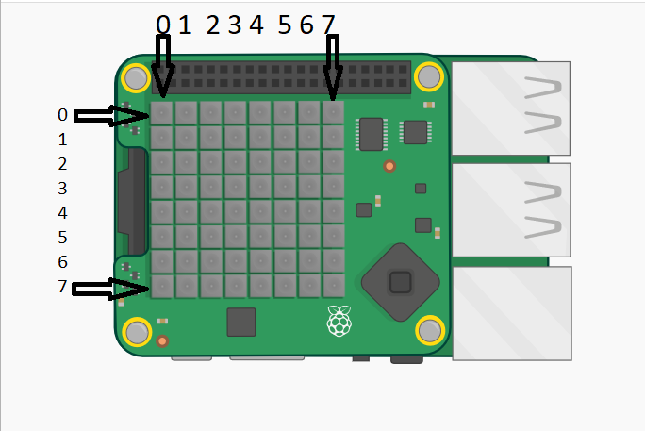
Then we create a boolean variable, redTurn, which we will use to know whose turn it is (red or green). Red will play first, so it is set to True.
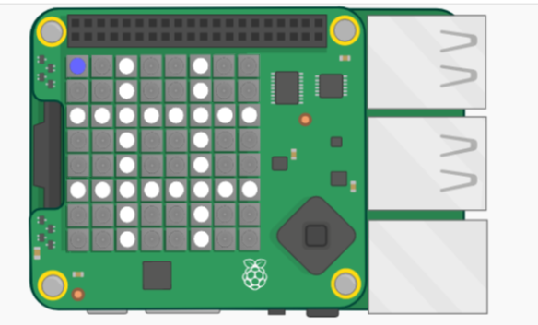
Then we call the pause function, imported from the signal library. This will pause the code execution until one of the joystick buttons are pressed. Run the code to check that the “Get ready” message is shown, the tic-tac-toe grid is displayed on the LED matrix, and the marker LED is lit in blue in the top left corner (see picture below). If you push the joystick to the right, the LED should move to the next grid square on the right. Moving the joystick in the other directions will just print out the direction. Making the make move in these directions is up to you. If you press the middle jostick button, the text “colour square” should be printed.

What you have to do

Task 1: Moving the marker around
Your first task will be to move the marker (blue LED) around the LED matrix when one of the players presses the joystick. Recall that we set several functions that would execute when the joystick is pressed.
Let’s have a look at the pushed_right function. This function executes when the joystick is moved to the right. When the joystick is moved, a joystick event occurs. This event data is passed to the function as a parameter (called event here) and contains some information about what happened: the direction ("up", "down", "left", "right", "middle"), the timestamp of the event, and the action ("pressed", "released", "held").
So in the function, we first check if the action was a release. The SH library provides a constant for this purpose, accessed by sense_hat.ACTION_RELEASED. If the action was not a release, we don’t do anything. If it was a release, we set the pixel were the marker currently is to the colour of the rest of the grid square. We obtain this colour by getting the colour of the pixel just to the right of the marker (i.e. adding 1 to the marker’s current column).
Then we update the marker to have its new position. Since the marker is moving to the right, we only change its first element (its column in the matrix, marker[0]) . Since we always want the marker to bein the top left corner of a grid square, it will always be in column 0, 3, or 6. We add 3 to move it to the next grid square, and then modulo 9 to get the value to wrap around back to 0 if it is greater than 7, as a value greater than 7 (or less than 0) will cause an error.
We then set the LED at the marker’s new position to be blue.
It is up to you to implement the code for the pushed_left, pushed_up, and pushed_down methods. They are very similar to pushed_right. Only the direction of movement changes.

Task 2: Placing a red or green square on the grid
Next, we will implement the functionality for placing an “X” or “O”. As mentioned earlier, the “X” has been placed with a red square and the “O” with a green square. When the user presses the middle joystick button, we want the grid square that the marker is currently in to be coloured completely red or green, depending on whose turn it is.
Part of this has been provided: the buttonPushed function will execute when a player presses the middle button on the joystick. The function will call another function, colourSquare, if the grid square containing the marker is not coloured yet. It also specifies the colour to make the grid square and changes which player’s turn it is. colourSquare has 3 parameters: the colour to make the grid square, and the marker’s co-ordinates.
After the square has been coloured, the ttt.checkForWinner function is called. This function determines if a player has won (i.e. there is a row, column, or diagonal that is all one colour).
You have to implement the colourSquare function (line 12). Make use of the set_pixel function used elsewhere in the code.
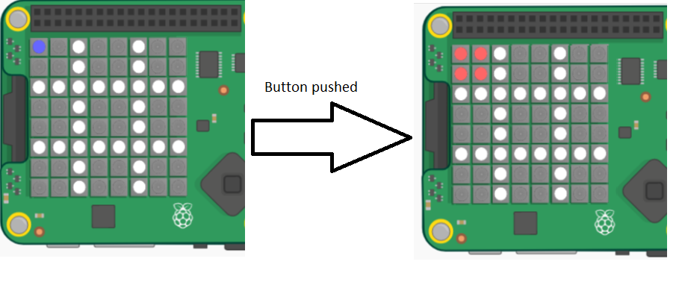

Task 3: Starting again
Everytime after a square has been coloured, the ttt.checkForResult function is called. It returns True if player has won (and displays a message on the LED matrix) or there is a tie. It returns False if there is no result yet. If someone has won or it is a tie, the playAgain function is called. You have to implement the playAgain function.
The playAgain method should clear the LED matrix, and display the grid and the marker, as in the very beginning of the game.
Once this function is complete, you should be able to play the game against a friend.

Some useful functions
After the sense_hat module has been imported, and a SenseHat instance has been created (e.g. sense = sense_hat.SenseHat()), you can use the sense variable to call certain functions. Here is a list of functions that may be useful:
- sense.set_pixels(pixels): set the LED matrix to display the colours in the given list. The parameter is a list of 64 small lists, each with 3 elements representing the amounts of red, green, and blue in the colour
- sense.set_pixel(x, y, colour): set the LED at the given coordinates (x is the column, y is the row). 0 <= x, y <= 7. colour is a list specifying the colour, e.g. [255, 0, 0] for red.
- sense.get_pixel(x, y): returns a list of 3 elements representing the colour at the given pixel. x and y are the same as in set_pixel. Note that this may return slightly different values to what the pixel was set to.
- sense.clear(): switch off all the LEDs.
- sense.show_message(text), sense.show_message(text, text_colour=[255, 51, 0]): display a message that scrolls across the LED matrix. text is a string, text_colour is list representing a the colour of the text. If no text_colour is given, the default white is used.
These functions were found in the Sense HAT API: https://pythonhosted.org/sense-hat/api/, which also lists all the other SH functions.

Further Reading
More information about the Raspberry Pi here: https://www.raspberrypi.org/
You can find more information about the SH here: https://astro-pi.org/about/hardware/sense-hat/
Here is an introduction to the SH: https://projects.raspberrypi.org/en/projects/getting-started-with-the-sense-hat
The complete documentation for the SH (using the LED matrix, joystick, reading sensors, etc) can be found here: https://pythonhosted.org/sense-hat/api/

