Snake on the Raspberry Pi
and Sense HAT

Introduction
In this assignment, we will be creating the classic game snake for the Raspberry Pi Sense HAT. This assignment focuses on if statements, and for and while loops.
Snake is a simple game that was popular on early cell phones. On the screen is a snake which the player controls. The goal is to eat as much food as possible and grow as long as possible. If the snake hits the edges of the screen or its own body, it dies. You can play snake online here: http://patorjk.com/games/snake/
Our version will use the LED matrix and be controlled using the joystick. The snake will start off with 2 segments (i.e. 2 LEDs long). The snake’s head will flash. The “food,” or target LED will be green, and every time the snake “eats” the food (the head of the snake is on the same LED as the food), it grows one segment longer.

Intro to the Raspberry Pi and Sense HAT
The Raspberry Pi (RPi) is a single board computer (about the size of a credit card) created for teaching programming and electronics. The RPi runs a version of Linux called Raspbian and it can run many pieces of software (web browser, word processor, spreadsheet software, IDEs, etc) that have been adapted for the operating system. It also provides general purpose input-output pins for connecting LEDs, sensors, motors, and other hardware.
The Sense HAT (Hardware Attached on Top) is an add-on board for the RPi. It provides an 8x8 LED matrix, temperature, humidtity, and pressure sensors, an accelerometer, gyroscope, and magnetometer, and a joystick. The Sense HAT (SH) plugs directly into the GPIO pins, eliminating the need for wires and other electronics components.

IDLE, the preffered IDE on the RPI
The default IDE for Python on the RPi is called IDLE. It is very basic compared to Wing. Opening a Python file will open the file in IDLE by default. You can run your code by going to the menu bar: Run →Run Module (or, press the F5 key). If want to open the Python Shell, Run→Python Shell

The Sense HAT Library
The Raspberri Pi Foundation provides a library with function for interacting with the SH. There are functions for settting the colours of the LED matrix, reading the sensors, and specifying what happens when the joystick is moved. We will now provide a few code examples, and some pictures of example ouput.
In order to use the SH functions, we need to import the sense_hat library. We then create a variable that is of type SenseHat. This variable (usually called sense, but it can be called any valid name) is used to call the SH functions.
Example code | Picture of output (these pictures made using an emulator)
#import the library, and create a #SenseHat variable  import sense_hat  sense = sense_hat.SenseHat()  #display text that moves across the LED #matrix  sense.show_message("Hello World!") | 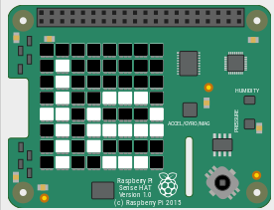  Part of the text moving across the LED matrix
#define colours. Colours are normally lists with #3 elements: first the amount of red, then #green, then blue. 0 is the minimum value, 255 #the maximum  red = [255, 0, 0]  green = [0, 255, 0]  blue = [0, 0, 255]  white = [255, 255, 255]  #set pixels to a certain colour  # column first, then row  sense.set_pixel(0, 0, red)  sense.set_pixel(7, 7, green)  sense.set_pixel(1, 3, blue)  sense.set_pixel(4, 6, white) | 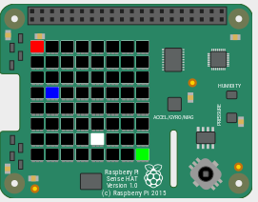
blk= [0, 0, 0]  #define a list with 64 elements, each  # a list of 3 elements  grid = [blk, blk, blk, blk, blk, blk, blk, blk,  blk, blue, blue, blue, blk, blk, green, blk,  blk, blue, blk, blk, blk, blk, blk, blk,  blk, blue, blk, blk, blk, blk, blk, blk,  blk, blue, blue, blue, blue, blue, blk, blk,  blk, blk, blk, blk, blk, blue, blk, blk,  blk, blk, blk, blk, blk, blue, blk, blk,  blk, blk, blk, blk, blk, blk, blk, blk]  #set all the pixels (LEDs) at once  sense.set_pixels(grid) | 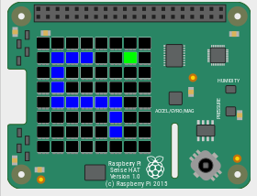
#function that executes when joysitck is pushed #up  def pushed_up(event):  if event.action == sense_emu.ACTION_RELEASED:  sense.clear()#all LEDs off  sense.show_letter("U")  # set the function up to run when  # joystick is pushed up  sense.stick.direction_up = pushed_up  #similar for down, left, right, middle, any | 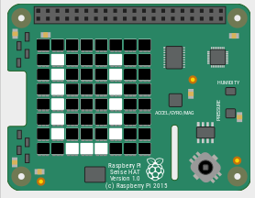  After joystick pushed up
# read gyroscope.  # get_orientation_degrees returns a dictionary  # with 3 entries.  orientation = sense.get_orientation_degrees()  pitch = orientation["pitch"]  roll = orientation["roll"]  yaw = orientation["yaw"]  print("pitch:", pitch)  print("roll:", roll)  print("yaw:", yaw) | pitch: 351.98974624047946  roll: 17.892698229034732  yaw: 271.98435186451815

The Scaffolding Code
You have been provided with two files that provide scaffolding code on which you will build: snake_scaffolding.py, in which you will write your code, and SnakeClass.py, which provides a class representing the snake. You do not need to change or write any code in SnakeClass.py

SnakeClass.py
The snake class represents the snake on the LED matrix. The snake is a list of pixels, where each pixel consists of a list of 2 elements, the x and y co-ordiantes, and an integer constant representing the direction (up, dow, left, or right) that the pixel is moving in.
All the functions you will need to interact with the snake are provided. We will provide a short explanation of each here:
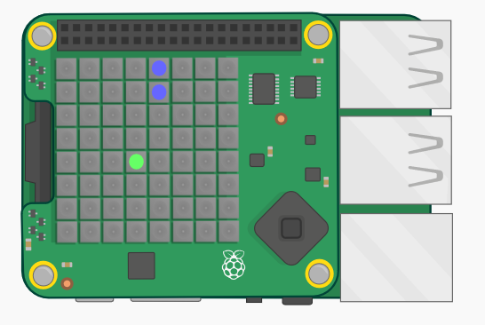
__int__(self): This creates an instance of the snake class. An instance behaves like a normal variable that you can call functions on. The snake is also created at the same place on the LED matrix (the head on the LED at [4, 1] and the “tail” on [4, 0]) with the same direction of movement (down). See below for an image.

head(self): This function returns a tuple (x, y) with the co-ordinates of the snake’s head (front of the snake).
slither(self, food): This function moves the snake one LED in the direction that it is pointing. It does not update the LED matrix. For example, if the snake was occupying the LEDs at [4, 2], [4, 1], and [4, 0] and it is moving downwards, after slither is called it will now be occupying the LEDs [4, 3], [4, 3], and [4, 1]. The function takes 1 parameter: food, a 2 element list [x, y] containing the co-ordinates of the food. The function returns a string depending on what happened: if the snake eats the food, it returns “eat”. If the snake dies by bumping into itself, it returns “die”. If the snake does not eat or die, it returns “none”.
You call this function as follows:
snake = SnakeClass.SnakeClass() #create instance of SnakeClass
result = snake.slither(food) #call slither and store
#result in a variable
changeDirection(self, newDirec): Changes the direction that the snake is moving in. The newDirec parameter is an integer representing the new direction of movement.
getPixels(self): Returns a list of the pixels that the snake is occupying. The pixels are lists with the co-ordinates of the pixel. So if you call getPixels() just after creating an instance of snake, it will return [[4, 1], [4, 0]]. The head of the snake is always the first element of the list.
getLength(self): Returns the length of the snake (number of pixels that make up the snake body).

Snake_Scaffolding.py
The Snake_Scaffolding.py file is where you will write your code.
At the top of the file are the usual imports we require to use functions from the sense_hat, time, and random libraries. Also imported is the SnakeClass file, which will allow us to create an instance of the class in the snake_scaffolding.py file.
Then several functions are defined. We will return to these later when you have to implement them.
In the main, we perform all the standard initializations for using the Sense HAT.
Next, some constants for representing the directions of movement are defined.
Now the actual game play starts. Inside a while loop, an instance of SnakeClass is created (it is called snake). Then a countdown is displayed and the food is generated. Following this, the main loop starts: in every iteration of the loop, the LED matrix is updated, and the snake moves. If the snake eats the food or dies, the appropriate function is called.

What You Have to do

Task 1: Show the snake and food on the LED matrix
When you run the scaffolding code, you should see a countdown appear on the LED matrix, and then stop at 1. The food LED and the snake do not appear on the LED matrix.
Your first task is to implement the updateMatrix function to make them appear on the LED matrix. Show the food LED, the snake, and then make the snake’s head blink a couple of times. Be sure to avoid errors that could occur if one of the snake’s pixels is out of bounds.
When you do this correctly, you should see a short snake appear, with its head flashing, and a green LED below the snake (the food). The snake will move down towards the food, eat it, grow, and then hit the edge of the LED matrix and die. The food LED will remain on the matrix. Nothing happens if you move the joystick.

Task 2: Make the snake change direction
The next thing to do is to implement the joystick functions that will change the snake’s direction: up(event), down(event), right(event), left(event).
Once you have done this, you should be able to move the snake around by moving the joystick. However, you will see that the food always stays in the same place.

Task 3: Generate the food
Have a look at the generateFood function. It always returns the same thing. You have to rewrite it so the food is generated to be in a random position each time. Take care to ensure the food is not placed on an LED that the snake is occupying.
When this is complete, the food LED should appear in a new place everytime the snake eats it. But when the snake dies, the food stays on the LED and the game does not start again.

Task 4: Die
Next is the die() function. This function is called when the snake dies. It should stop the game (read the code under MAIN to figure out how to do this), and then display a relevant message to the player, including how long the nake was at the time of death.
When after this is implmented, a message should be displayed after dying, and a new game should start.

Task 5: Stop the game
After the snake dies and the message is displayed, a new game will start. Complete the stopGame(event) function so that when the middle joystick button is pressed, the game stops and a new game does not start again. Read the code under MAIN to figure out how to do this.

