Tic-Tac-Toe on the Raspberry Pi Sense HAT

Introduction
This is an abridged version of an assignment that may be used in the CSC1010H course in the future. We are using an abridged version so you have the chance to complete some of the tasks and get a better feel for what sort of thing you can do with the RPi and SH.
We will be creating a version of the pen-and-paper game tic-tac-toe. Most of the code is complete already, and it is up to you to implement certain parts to make the game work properly. Do not concern yourself with all the other code, you only need to complete some functions.
We will make extensive use of the Sense Hat library functions, but these will be clearly explained in these instructions. There is also a short tutorial at the end.

Task 1: Moving the marker around
If you run the code you have been given, the tic-tac-toe grid will appear on the LED matrix. There is also a blue LED in the top left corner. This blue LED, the marker, shows the players where they can play. The X and O normally used in tic-tac-toe have been replaced with red and green squares.
The marker can be moved around using the joystick, and when it is in the square in which the player wants to play, they can press the middle joystick button to make their mark. You will see that the marker can only move to the right. You have to make it move in the other directions.
The marker is represented by the variable marker, which is a list with 2 elements: marker[0] is the x co-ordinate (or column) and marker[1] is the y co-ordinate (or the row). (0, 0) is in the top left corner.
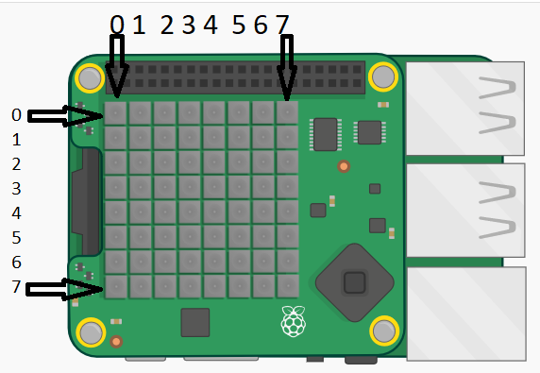
The function pushed_right is responsible for moving the marker to the right. You have to complete the functions pushed_left, pushed_up, and pushed_down. They are very similar to the pushed_right function, with just 1 or 2 changes. Detailed instructions:
- Determine if the joystick button has been released, pressed, or held. See pushed_right for the relevant if statement and condition.
- After moving the marker, we want to set the pixel it was on to the same colour as the rest of square, so we need to obtain the colour of the rest of the square. We do this by using the sense.get_pixel(x, y) function to get the colour of the pixel just to the right of the marker pixel. x and y are the co-ordinates of the pixel (LED) whose colour we want to get. By adding 1 to the marker’s x co-ordinate (marker[0]), we can get the co-ordinates of the pixel just to the right of the marker.
- We then set the marker pixel to this colour with the sense.set_pixel(x, y, colour) function.
- This is where you need to make a change. In moving right, we add 3 to the marker’s column, then modulo 9 to make it wrap around the edge of the LED matrix. To make it move another another direction, you will need to change either the row or column of the marker in a similar way.
  - To make it move left: subtract 3 from the marker’s current column, then modulo 9
  - To make it move up: subtract 3 from the marker’s current row, then modulo 9
  - To make it move down: add 3 to the marker’s current row, then modulo 9
- Now set pixel at the marker’s new position to blue.
Now, when you run the code, you should be able to mve the marker in all directions.

Task 2: Colouring grid squares
Now we need to implement the colourSquare function, which is responsible for filling the square with the given colour. This function is called when the user presses the middle joystick button. It has 3 parameters: x, the the x co-ordinate (or column), y, the y co-ordinate (or the row) of the marker, and colour, a list representing the colour to make the grid square.
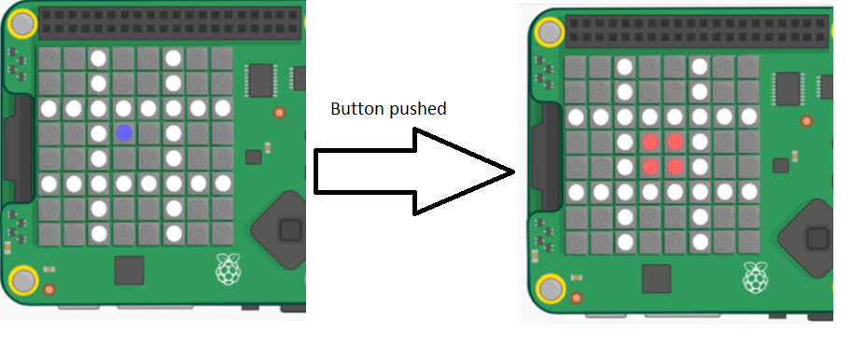
The entire square must be filled with the given colour. For example, if the values of the x and y parameters are 3 and 3, the pixels at (3, 3), (3, 4), (4, 3), and (4, 4) all need to be set to the given colour. You need to use the sense.set_pixel(x, y, colour) function.
You can get the co-ordinates of the three other pixels by adding 1 to the marker’s co-ordinates. For example, to set the pixel just below the marker, use sense.set_pixel(marker[0], marker[1]+1, colour), where colour is the parameter to colourSquare.

Task 3: Restarting the Game
The code that you have been given checks for a result (win/loss or tie), after everytime the middle joystick button is pressed. If there is a result, the playAgain function is called. The playAgain function clears the LED matrix, and displays the grid so a new game can be started. You have to write this function.
- Display the grid on the LED matrix. Make use of the sense.set_pixels(list) function. This function takes a list of lists: the smaller lists are list representing the colours to make the LEDs. Use the grid variable as the parameter to this function.
- Set the marker pixel (where ever it may be at the moment) to be blue. The sense.set_pixel(x, y, colour) function will be useful again

Sense HAT Library tutorial
The Raspberri Pi Foundation provides a library with function for interacting with the SH. There are functions for settting the colours of the LED matrix, reading the sensors, and specifying what happens when the joystick is moved. Here are a few examples of the functions you will need.
In order to use the SH functions, we need to import the sense_hat library. We then create a variable that is of type SenseHat. This variable (usually called sense, but it can be called any valid name) is used to call the SH functions.
Example code | Picture of output (these pictures made using an emulator)
#import the library, and create a #SenseHat variable  import sense_hat  sense = sense_hat.SenseHat()  #define colours. Colours are normally lists with #3 elements: first the amount of red, then #green, then blue. 0 is the minimum value, 255 #the maximum  red = [255, 0, 0]  green = [0, 255, 0]  blue = [0, 0, 255]  white = [255, 255, 255]  # set pixels to a certain colour  # column first (x co-ordinate), then row (y co-  # ordinate)  sense.set_pixel(0, 0, red)  sense.set_pixel(7, 7, green)  sense.set_pixel(1, 3, blue)  sense.set_pixel(4, 6, white) | 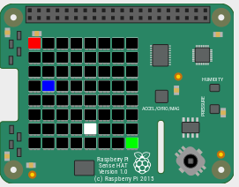
blk = [0, 0, 0]  #define a list with 64 elements, each  # a list of 3 elements  grid = [blk, blk, blk, blk, blk, blk, blk, blk,  blk, blue, blue, blue, blk, blk, green, blk,  blk, blue, blk, blk, blk, blk, blk, blk,  blk, blue, blk, blk, blk, blk, blk, blk,  blk, blue, blue, blue, blue, blue, blk, blk,  blk, blk, blk, blk, blk, blue, blk, blk,  blk, blk, blk, blk, blk, blue, blk, blk,  blk, blk, blk, blk, blk, blk, blk, blk]  #set all the pixels (LEDs) at once  sense.set_pixels(grid) | 