Snake on the Raspberry Pi
and Sense HAT

Introduction
This is an abridged version of an assignment that may be used in the CSC1010H course in the future. In this assignment, we will be creating the classic game snake for the Raspberry Pi Sense HAT. This assignment focuses on if statements, and for and while loops.
Snake is a simple game that was popular on early cell phones. On the screen is a snake which the player controls. The goal is to eat as much food as possible and grow as long as possible. If the snake hits the edges of the screen or its own body, it dies.
Our version will use the LED matrix and the snake will be controlled using the joystick. The snake will start off with 2 segments (i.e. 2 LEDs long). The snake’s head will flash. The “food,” or target LED will be green, and every time the snake “eats” the food (the head of the snake is on the same LED as the food), it grows one segment longer.

Task 1: Show the food on the LED matrix
When you run the scaffolding code, you should see a countdown appear on the LED matrix, and then the (very short) snake appears. It moves down on the LED matrix. The food LED does not appear.
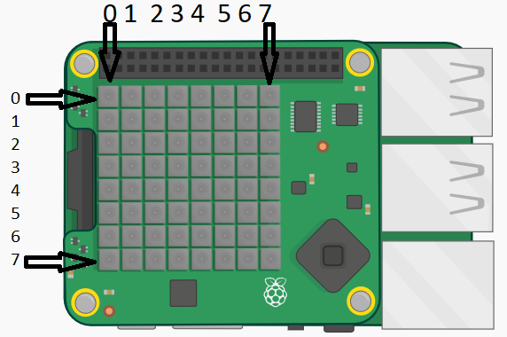
Your first task is to add a bit of code to the updateMatrix function to make the food appear on the LED matrix. The function has a parameter called food, which is a list with 2 elements representing the postion of the food on the LED matrix. The first element (food[0]) is the x co-ordinate (or column) of the food, and the second element (food[1]) is the y co-ordinate (or row) of the food. The co-ordinate pair (0, 0) is in the top left corner.
You can set the colour of and LED on the matrix by using the sense.set_pixel(x, y, colour) function. This function takes the x and y co-ordinates of the LED and the colour to make it as parameters. Use the variable gre, defined earlier in the code, as the colour parameter.
When you do this correctly, you should see a short snake appear, with its head flashing, and a green LED below the snake (the food). The snake will move down towards the food, eat it, grow, and then hit the edge of the LED matrix and die. The food LED will remain on the matrix. If you move the joystick to the left, the snake will turn to the left, but nothing happens if you move the joystick in another direction.

Task 2: Make the snake change direction
The next thing to do is to implement the joystick functions that will change the snake’s direction: up(event), down(event), and right(event). These functions execute when the joystick is moved in the given direction. The function left(event) has been completed already.
You have to do the same in the other 3 functions, but make sure to given the snake.changeDirection(direction_constant) the correct direction constant (the direction constants have been defined earlier in the code).
No you hsould be able to make the move in any direction, but you will see that the food LED always stays in the same place.

Task 3: Generate the food
Have a look at the generateFood function. It always returns the same thing. You have to rewrite it so the food is generated to be in a random position each time. The function returns a list with 2 elements: the first being the x co-ordinate of the food pixel, and the second is the y co-ordinate.
Take care to not generate a food pixel that is inside the body of the snake. You can check if the 2-element list you create is in the snake body pixels with the following snippet of code: newFood in snakePixels (where newFood is the new position of the food, and snakePixels is the list of pixels (2-element lists) that make up the snake’s body, which you can obtain with the function snakePixels = snake.getPixels()).
The function random.randint(minimum, maximum) will be useful. It returns a random integer x such that minimum <= x <= maximum.

The Sense HAT Library
The Raspberry Pi Foundation provides a library with function for interacting with the SH. There are functions for settting the colours of the LED matrix, reading the sensors, and specifying what happens when the joystick is moved. We will now provide a few code examples, and some pictures of example ouput.
In order to use the SH functions, we need to import the sense_hat library. We then create a variable that is of type SenseHat. This variable (usually called sense, but it can be called any valid name) is used to call the SH functions.
Example code | Picture of output (these pictures made using an emulator)
#import the library, and create a #SenseHat variable  import sense_hat  sense = sense_hat.SenseHat()  #display text that moves across the LED #matrix  sense.show_message("Hello World!") | 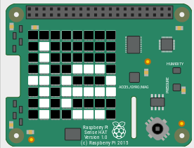  Part of the text moving across the LED matrix
#define colours. Colours are normally lists with #3 elements: first the amount of red, then #green, then blue. 0 is the minimum value, 255 #the maximum  red = [255, 0, 0]  green = [0, 255, 0]  blue = [0, 0, 255]  white = [255, 255, 255]  #set pixels to a certain colour  # column first, then row  sense.set_pixel(0, 0, red)  sense.set_pixel(7, 7, green)  sense.set_pixel(1, 3, blue)  sense.set_pixel(4, 6, white) | 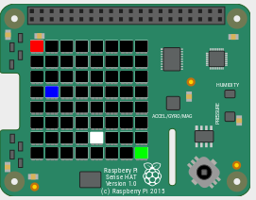
blk= [0, 0, 0]  #define a list with 64 elements, each  # a list of 3 elements  grid = [blk, blk, blk, blk, blk, blk, blk, blk,  blk, blue, blue, blue, blk, blk, green, blk,  blk, blue, blk, blk, blk, blk, blk, blk,  blk, blue, blk, blk, blk, blk, blk, blk,  blk, blue, blue, blue, blue, blue, blk, blk,  blk, blk, blk, blk, blk, blue, blk, blk,  blk, blk, blk, blk, blk, blue, blk, blk,  blk, blk, blk, blk, blk, blk, blk, blk]  #set all the pixels (LEDs) at once  sense.set_pixels(grid) | 