Machine learning cybersecurity

**iris DATASET classification**

# LAB 1: Writing a classifier for iris plant

**Lab Description:** This lab is to classify the class of iris plants based on their features.

* The dataset contains 150 instances for iris plants with 4 features and 3 classes

sepallength sepalwidth petallength petalwidth class
5.1 3.5 1.4 0.2 Iris-setosa

* Use WEKA to input the iris dataset and perform the classification
* Write a python script based on sklearn library to implement the classifiers
* Write a python script based on Tensorflow framework to implement the classifier.

**Lab Environment:**

* The students should have access to a machine with Linux system or Windows system
* WEKA should be installed
* The environment for python is required as well as some packages such as numpy, tensorflow and sklearn.

**Lab Files that are Needed:**

* For this lab you will need only one file (iris.csv) for both WEKA and python script.
* The last column is the class value, others are the features.

### **Lab exercise 1**

* Import data into WEKA (explorer), the files of type should be specified (csv).

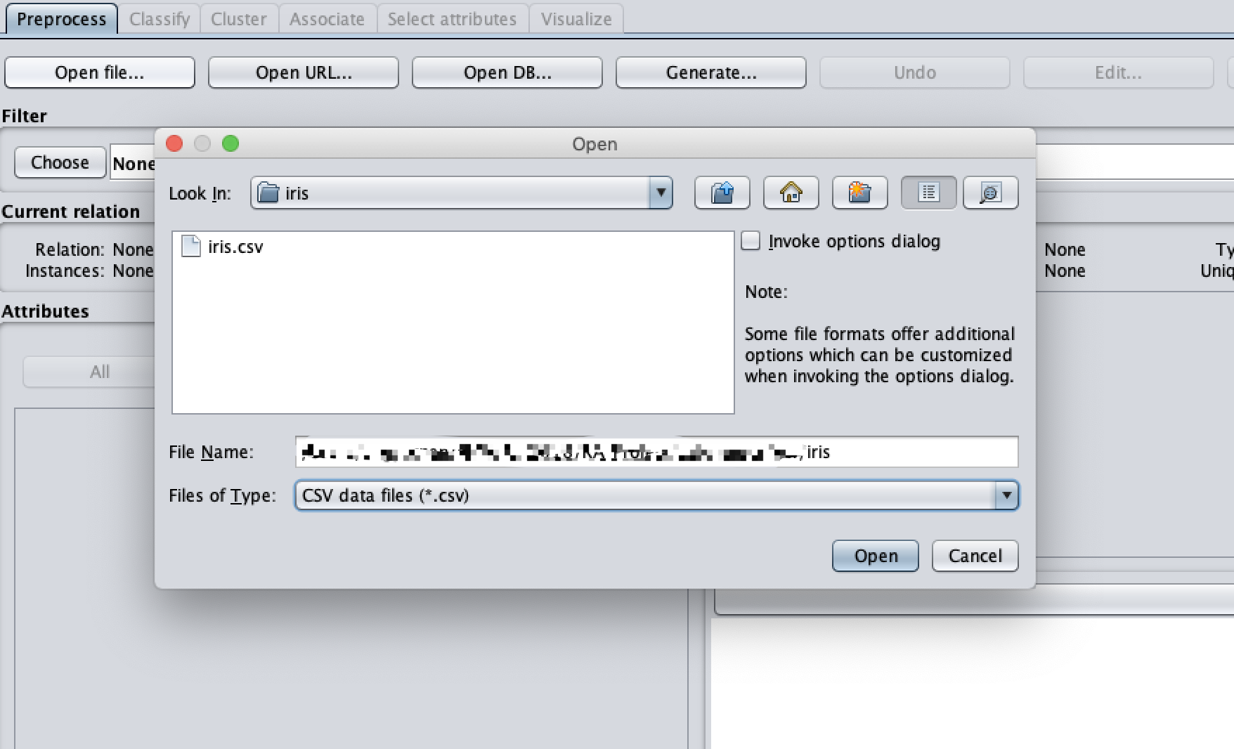

* Choose a proper classifier, such as RandomForest

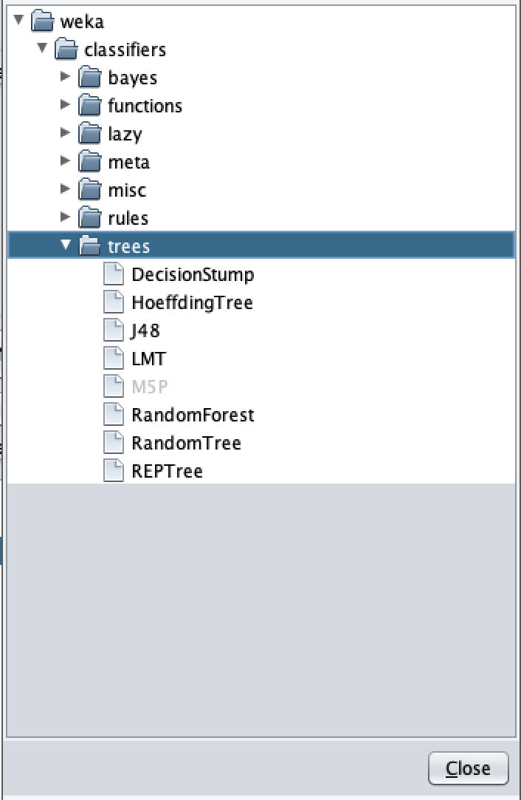

* Specify the test option and the column of class

