
Coordinator Guide
Knox Church Waitara
April 2026

Contents
Introduction 6
Who Can Do What 7
1. Getting Started with Rostas 8
The Rostas Views 8
Reading Results 12
The Roster Cycle 13
3. Step 0 — Refresh the Seasons Calendar 14
Step 2 — Role Preferences 17
Option A — Volunteers Set Their Own Preferences 17
Option B — You Set Preferences on Their Behalf 17
Volunteer Frequency Settings 19
To set or update frequency: 20
6. Step 3 — Send Availability Emails 22
What if someone missed the email? 23
Step 4 — Build the Roster 24
The Four Priority Tiers 25
Reviewing the Result — The Traffic Light System 25
Editing the Roster Before Sending 25
Step 5 — Preview Communications 27
Step 6 — Send Notifications 29
Manual Replacement 31
11. The SMS Replacement Chain 33
What happens automatically: 33
12. Checking the Status Dashboard 34
Common things to look for: 35
Step 1 — Volunteer Sync from Infoodle 36
Run a manual sync when: 37
Adding a New Volunteer 37
Settings and Configuration 38
When to Contact Tech Support 40
Adding a New Roster Type 41
Step 1 — Add the Roster Type in Rostas 42
Step 2 — Wait 1 Minute 42
Step 3 — Add Roles in Edit Roles 43
Step 4 — Add a Season 43
Step 5 — Refresh Calendar and Buttons 43
Step 6 — Import Historical Data (if applicable) 43
Step 7 — Set Preferences and Run 43
Removing a Roster Type 44
Option A — Via Rostas Run Commands (Recommended) 44
Option B — Via Apps Script Menu 45
Coordinator-Triggered Decline and Replace 46
Via the Global Roster View 46
Via the Commands Tab (Advanced) 46
Comparison: Manual Replacement vs Decline and Replace 47
A1. Import Existing Roster Data 48
When to Use Import 48
Prerequisites 48
Step-by-Step: Pivot Format (Recommended) 48
Alternative: Flat Format 49
After the Import 49
Managing the Nickname Map 49
Troubleshooting — Import 49
A2. After a Webapp Redeployment — Sync Preview URLs 51
A3. Audit Log Pruning 52
One-Time Setup 52
Manual Prune 52
A4. Clean VolunteerRoles Tab 53

A complete guide to building rosters, managing replacements, and protecting your volunteers' energy.
Knox Church Waitara

Introduction
Rostas is the coordinator app for managing Knox Church Waitara's volunteer rosters. It builds rosters for Sunday services, Music team, and Nourish (fortnightly), connects to Infoodle for volunteer data, and handles notifications, reminders, and SMS replacements automatically.
This guide covers everything you need: from collecting availability through to handling replacements. Part B covers Roster Coordinator tasks. Part C covers additional Overall Coordinator tasks (Lisa & Sharon).

Who Can Do What
Part B covers all tasks marked ✓ for Roster Coordinators. Part C covers the additional tasks available to Overall Coordinators only.

1. Getting Started with Rostas
Rostas is built primarily for desktop access, though it can also be used on a tablet or mobile phone. Your coordinator will send you a link or invite when you are set up.

The Rostas Views
When you open Rostas you will see these views in the left-hand sidebar. Tap the relevant view to navigate to that area of the system.
View: Run Commands • Seasons Dashboard • Global Roster • Volunteers Roles • Individual Details • Communications • Roles List • Settings Dashboard • Status Dashboard

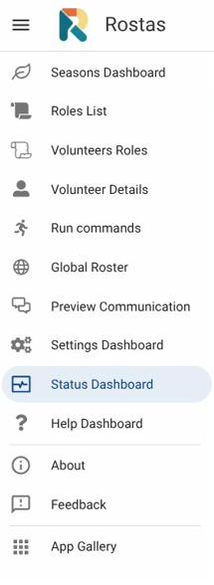
The Rostas left-hand sidebar — tap any view to navigate to that area.

The Run Commands view is your main working area. This is where you trigger all roster actions — sending emails, building the roster, and sending notifications. Each button runs a single action and shows you the result when it is done. After tapping a button, Rostas queues the action and runs it within a minute. A Complete message appears in the Result column when done — always check this before moving on.

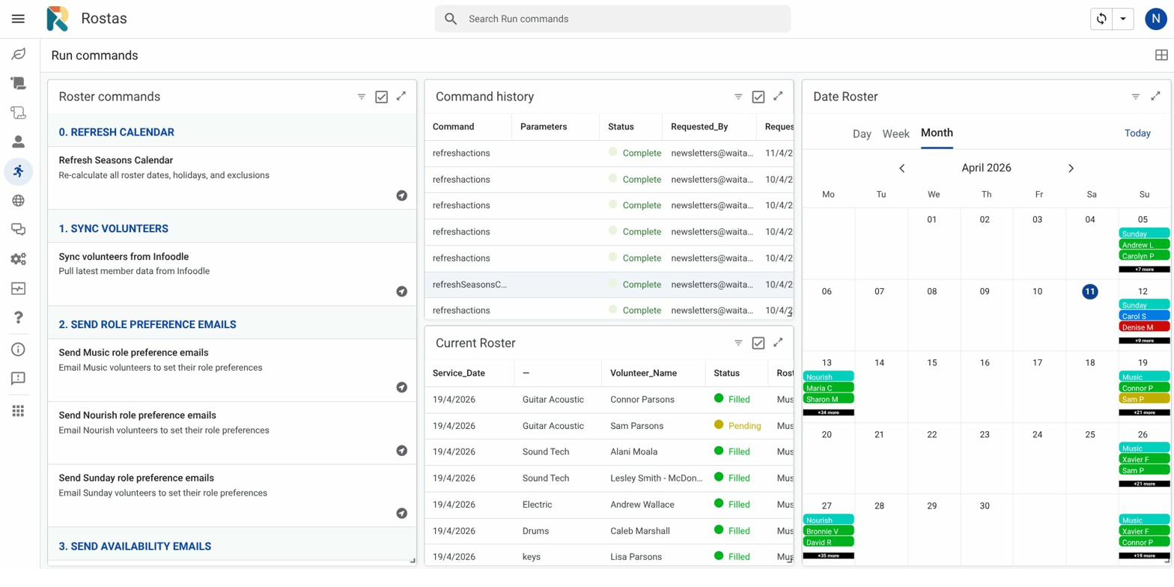
Run Commands — your main working area. Each button triggers one roster action. The Command history panel shows results.

Reading Results
Every action writes a result message in the Command history panel. Common results:
- Filled: 12, Pending: 3, Unfilled: 0 — roster built successfully. Pending means a volunteer marked Unsure but has been provisionally assigned.
- Unfilled: 2 — two slots could not be filled. Review the roster and handle manually.
- Sent to: 14 volunteers — notification emails dispatched.
- Error: … — something went wrong. Note the message and contact tech support if it repeats.

The Roster Cycle
Each roster follows the same sequence of steps. Run them in order — skipping a step or running them out of order can produce unexpected results.

Timing tip: Send availability emails at least 2–3 weeks before the first date of the new season. Allow volunteers 5–7 days to respond before building the roster.

Normal roster workflow: Step 1 (Sync) → Step 3 (Availability emails) → Step 4 (Build roster) → Step 5 (Preview — check before sending) → Step 6 (Send notifications). Steps 0 and 2 are run at the start of a new season, not every week.

3. Step 0 — Refresh the Seasons Calendar
View: Run Commands • Seasons Dashboard
Run this at the start of each roster build and any time you make changes to season dates. It recalculates all roster dates, overlays NZ public holidays and school holidays, and updates the calendar view.

Step 0 — Refresh calendar
In Rostas → Run Commands, tap 0. Refresh calendar. Wait for the result message to confirm completion. Check the Seasons Calendar view to confirm dates look correct.

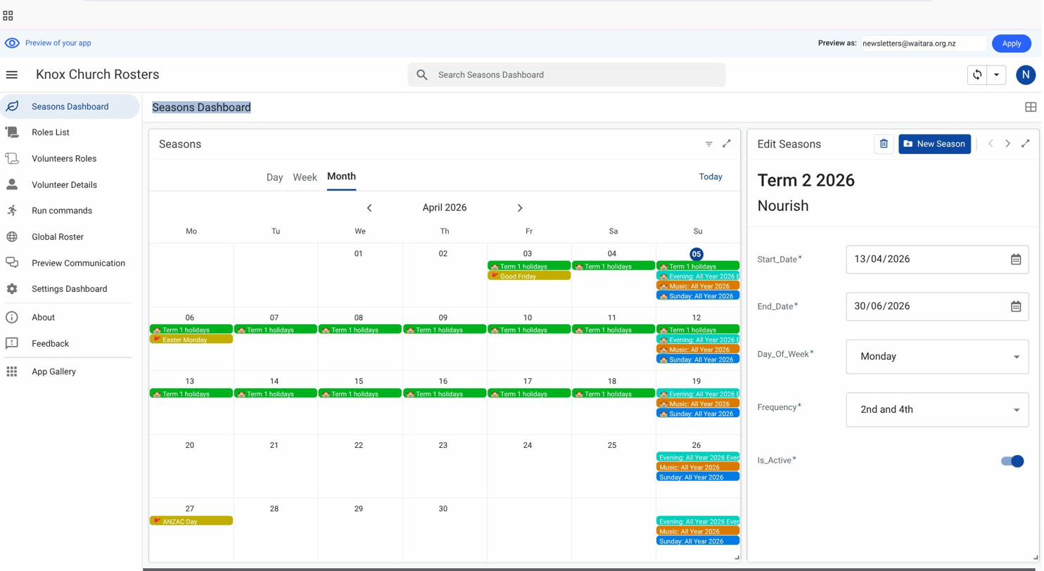
Seasons Dashboard — calendar view with season dates, public holidays, and school holidays overlaid. The right panel shows season details for editing.

Always run Step 0 after editing season start/end dates, adding a new season, or at the beginning of a new roster cycle.

Step 2 — Role Preferences
View: Volunteers Roles • Roles List
Role preferences tell the system which roles each volunteer is willing to do. The system needs this information before it can build the roster.

Option A — Volunteers Set Their Own Preferences
Volunteers receive a personalised link and tap through each role, choosing 'Yes I do this', 'Happy to fill in', or 'Not for me'.

Step 2 — Send role preference emails
In Rostas → Run Commands, tap 2. Send role preference emails. Volunteers receive an email with a personalised link. Allow a few days for responses before building the roster. Check who has responded in the Volunteers Roles view.

Option B — You Set Preferences on Their Behalf
If a volunteer is not comfortable using the link, or for new volunteers who have not yet set preferences, you can set their roles directly in Rostas.
Open the Volunteers Roles view. Select the volunteer on the left, then review and edit their role assignments on the right.

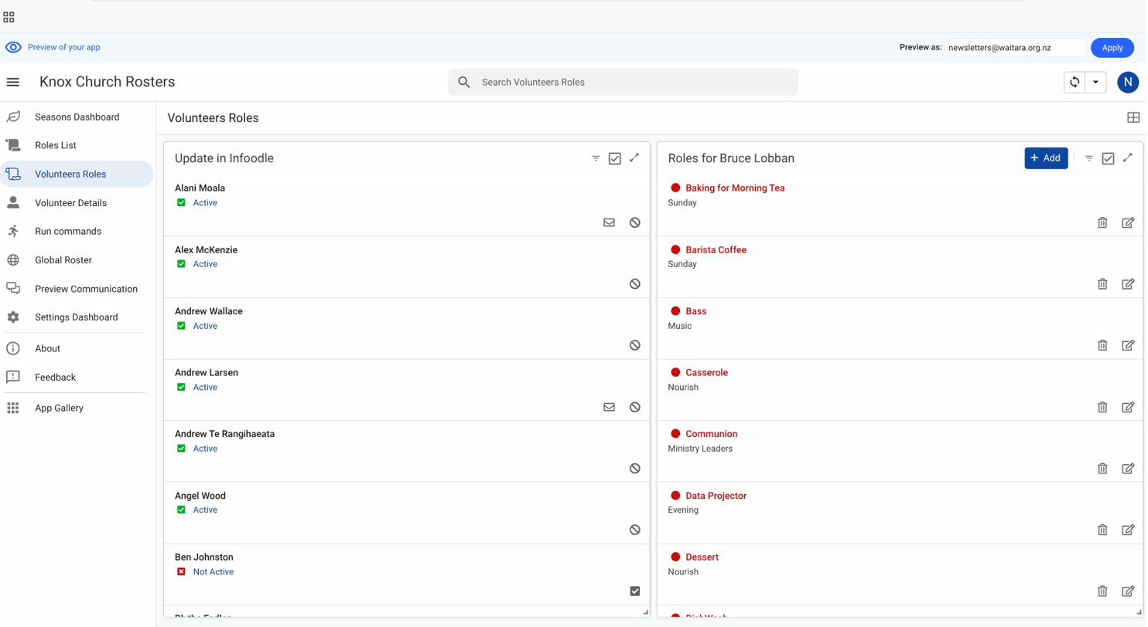
Volunteers Roles view — select a volunteer on the left to see and edit their role assignments on the right.

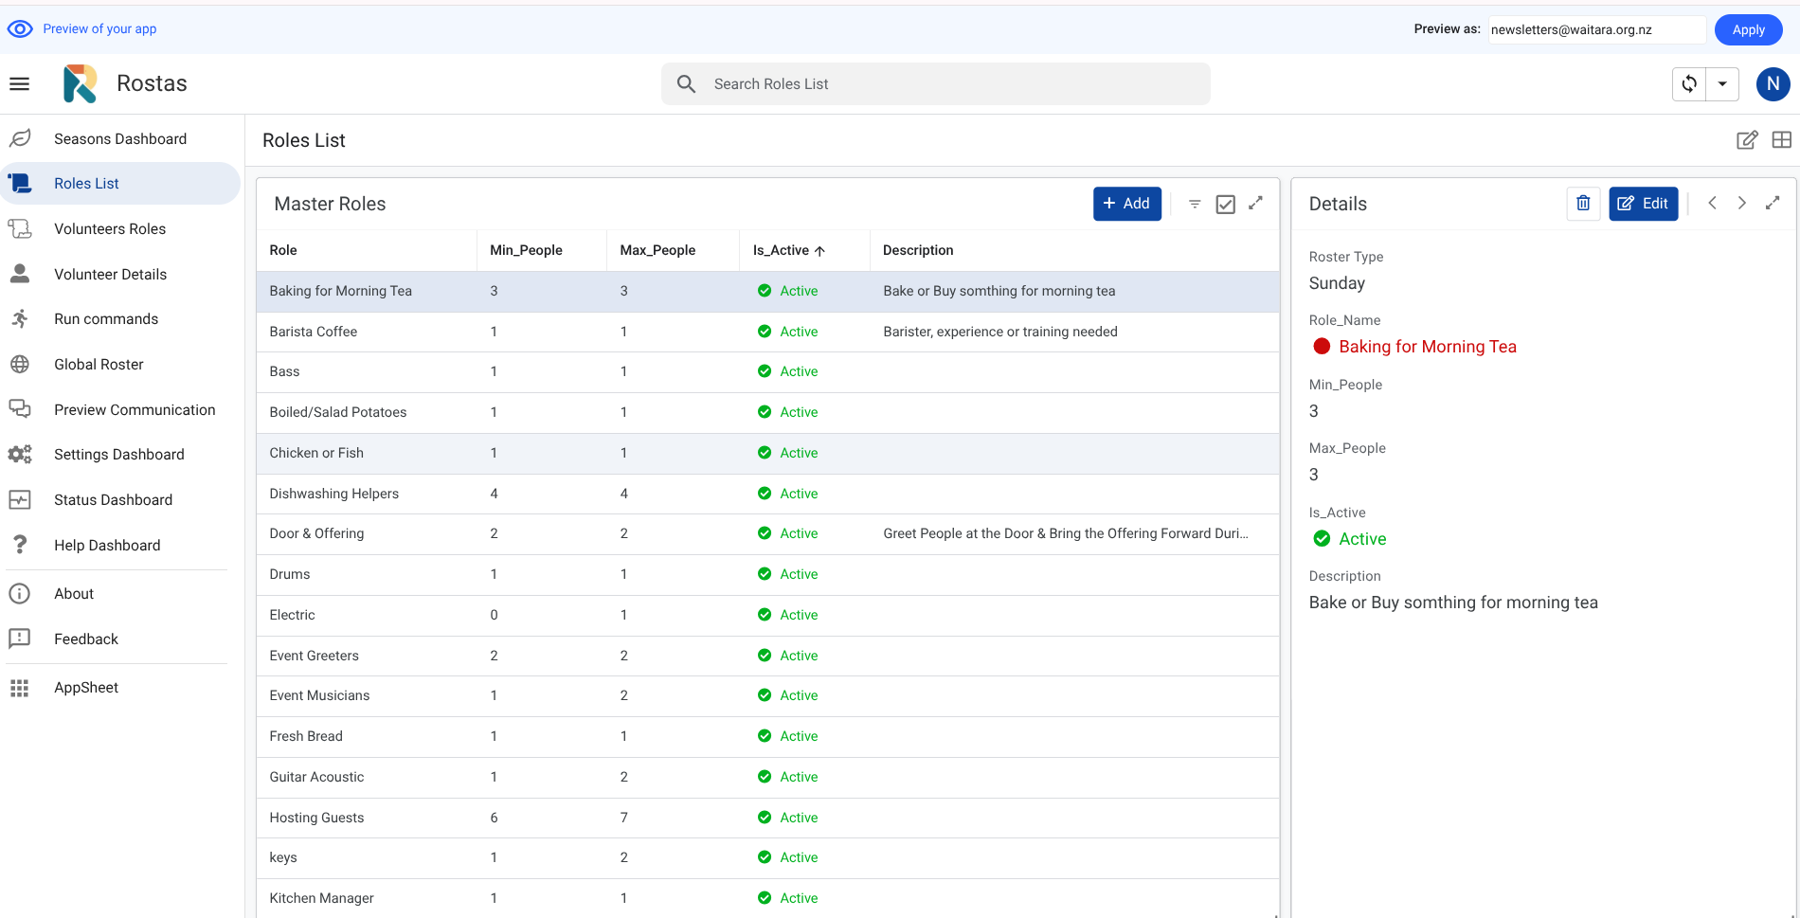
Roles List view — all active roles with minimum and maximum people required. Tap a role to view or edit its details.

When to use each option: The Roles List view shows all active roles and their settings. The Volunteers Roles view shows per-volunteer assignments. Send the email link at the start of a new season; set preferences directly in Rostas for day-to-day adjustments or less tech-confident volunteers.

Volunteer Frequency Settings
View: Individual Details
Frequency settings control how many times per month a volunteer can be rostered for a given roster type. The roster engine strictly enforces these caps.

To set or update frequency:
- In Rostas, go to the Individual Details view. Select the volunteer from the left panel.
- Use the arrow buttons (‹ ›) to switch between roster types if the volunteer serves in more than one.
- In the Max Days Rostered panel (bottom centre), tap 1, 2, 3, or 4 to set the monthly maximum. The default is 4 for weekly rosters, 2 for fortnightly rosters.
- Add a note if helpful (e.g. '4th Monday only' or 'family commitments').
- Save. The change takes effect at the next roster build.

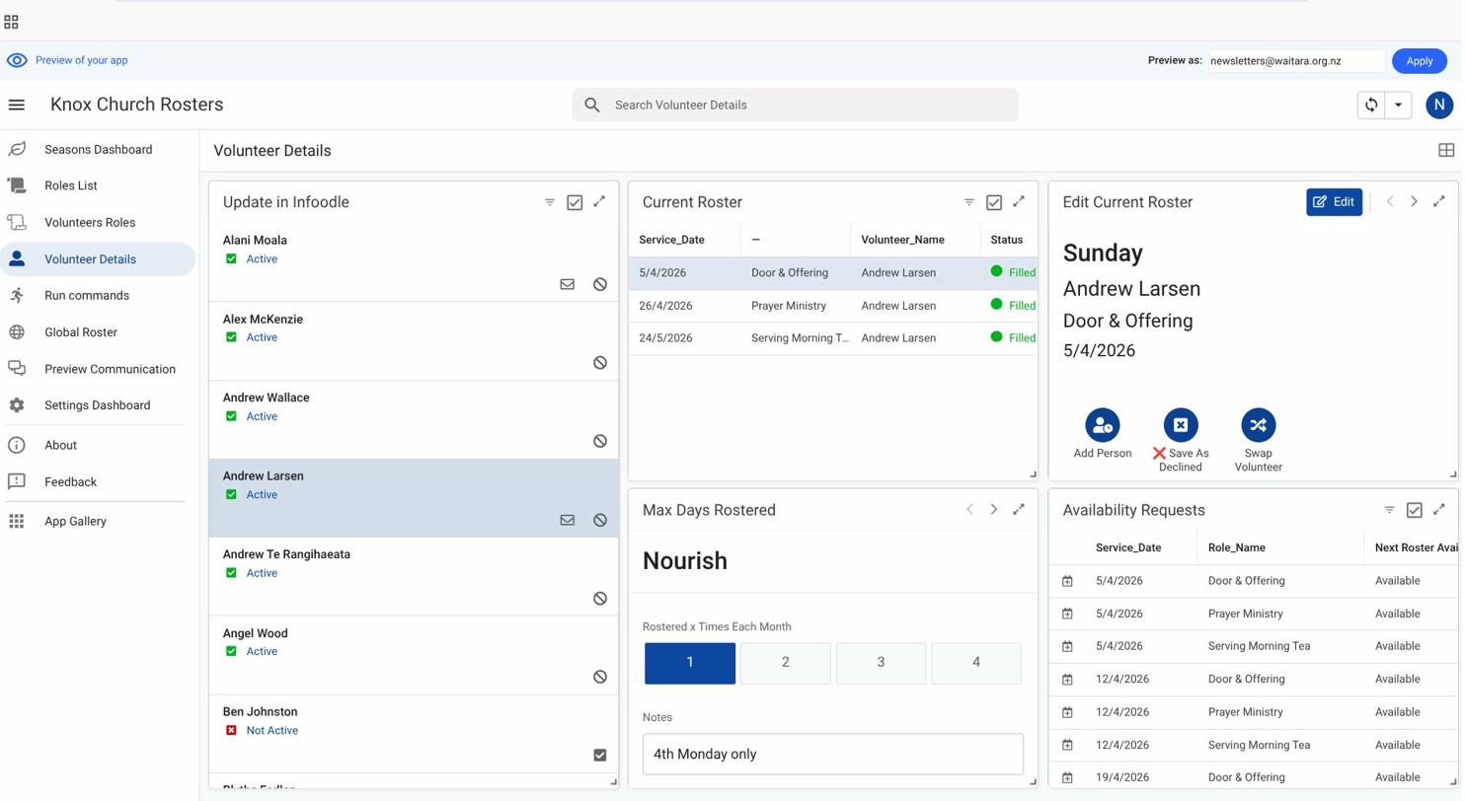
Individual Details view — Current Roster (centre), Max Days Rostered (bottom centre), and Availability Requests (right).

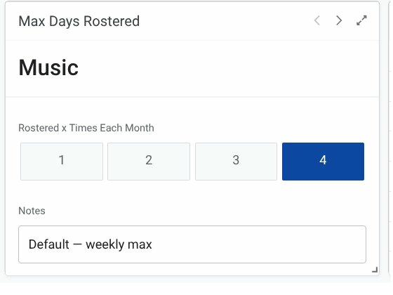
Max Days Rostered panel — tap a number to set the monthly cap for that roster type. Use the arrows to switch between roster types.

Frequency caps are enforced automatically at roster build time. A volunteer who has already reached their monthly cap will not be assigned to any further dates in that month, even if they are marked Available.

6. Step 3 — Send Availability Emails
View: Run Commands
Availability emails go to all active volunteers for your roster type. Each volunteer receives a personalised link showing the upcoming dates. They tap each date to mark themselves Available, Unsure, or Can't make it, then tap Save.

Step 3 — Send availability emails
In Rostas → Run Commands, tap 3. Send availability emails. The result confirms how many emails were sent. Allow 5–7 days for volunteers to respond. Volunteers who do not respond are treated as Unavailable at roster build time.


Run Commands — Step 3 (Send availability emails) and Step 4 (Build roster) buttons. The Command history panel on the right shows completed actions.

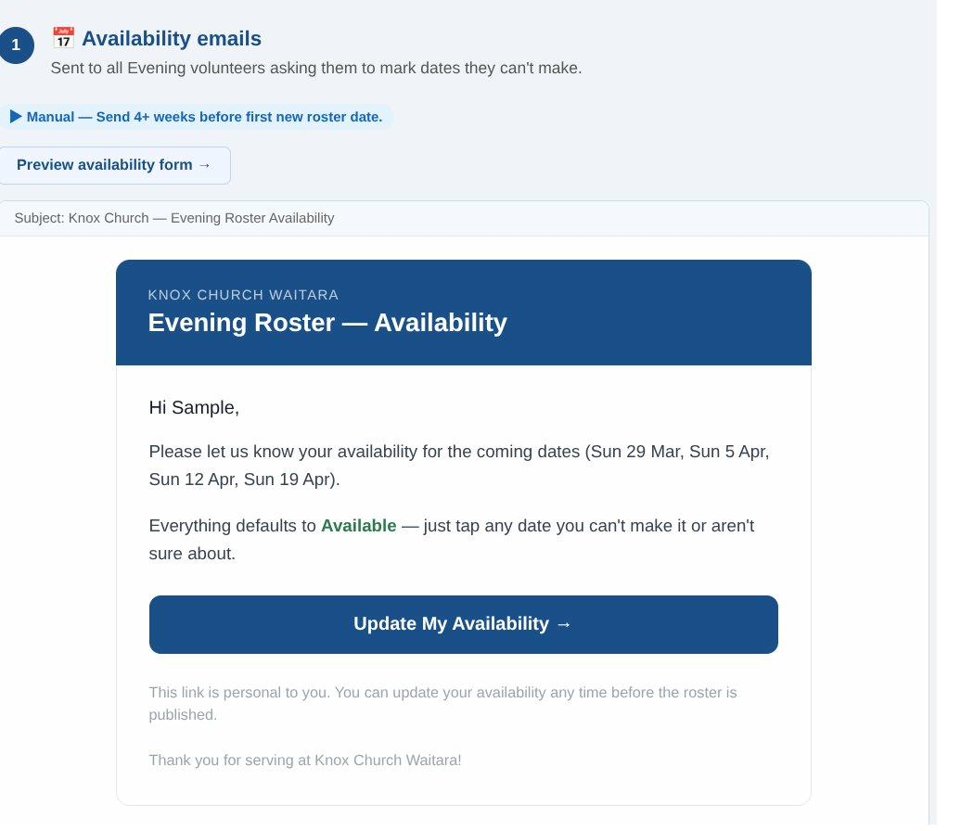
The availability email volunteers receive — a personalised link takes them straight to the form.

The Three Availability States
✅ Available — The default starting state for all dates.
❓ Unsure — Signals caution. The volunteer may be provisionally assigned.
❌ Can't make it — Immediately removes them from the scheduling pool for that date.
Everything starts as Available — volunteers only spend time changing the dates they cannot make.

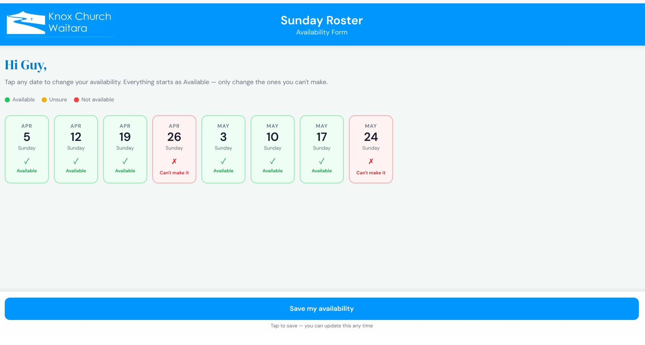
The availability form — volunteers tap each date card to cycle through Available, Unsure, and Can't make it, then tap Save.

What if someone missed the email?
You can update a volunteer's availability directly in Rostas via the Individual Details view. Select the volunteer from the left panel, then use the Availability Requests panel (bottom right) to find the date and update their status.

Step 4 — Build the Roster
View: Run Commands • Global Roster
The roster engine assigns volunteers to roles based on their availability and role preferences. It works through four priority tiers and within each tier selects the volunteer who has been rostered least recently.

The Four Priority Tiers

Step 4 — Build roster
In Rostas → Run Commands, tap 4. Build roster. The Music roster can take up to 10 minutes — this is normal. The system builds the next 8 weeks of dates by default (configurable per roster type in Settings — ROSTER_BUILD_WEEKS_{Type}). Check the result message: Filled, Pending, and Unfilled counts. Review the roster in the Global Roster view before sending.

Reviewing the Result — The Traffic Light System

Do not send notifications until you have reviewed the roster. Check for Unfilled slots and any obvious problems first. Once notifications are sent, volunteers receive their assignments immediately.

Editing the Roster Before Sending
In the Global Roster view, tap or click any assignment to open the edit panel on the right. You will see three options:
- Replace Volunteer — a dropdown offers a list of suitable replacement volunteers.
- Save as Filled — manually confirm a Pending (Unsure) assignment.
- Save as Declined — this automatically starts the SMS replacement chain to find a substitute.

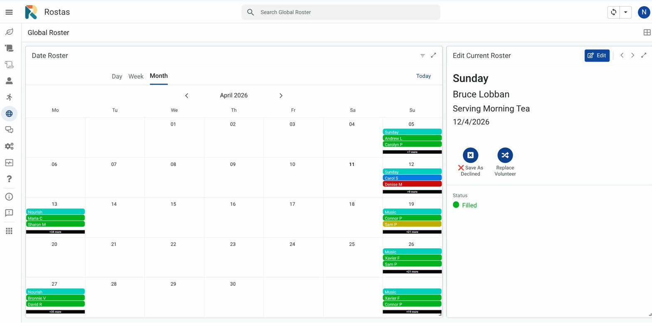
Global Roster Day view — tap any assignment to open the edit panel on the right. Use Save as Declined to start the automated SMS replacement chain.

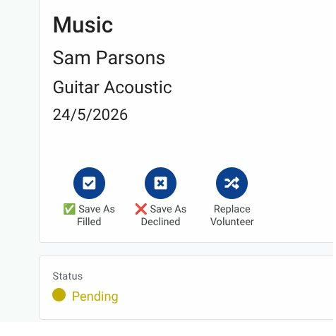
The assignment edit panel — Save As Filled confirms a Pending assignment; Save As Declined starts the SMS replacement chain; Swap Volunteer lets you manually select a replacement.

Step 5 — Preview Communications
View: Communications
Before sending notifications, use the Preview button to see exactly what the notification email and SMS will look like. This is the same view volunteers will see.

Step 5 — Preview communications
In Rostas → Run Commands, tap 5. Preview communications. A browser page opens showing the notification email template. Check volunteer names, roles, dates, and links all look correct. You can also adjust the wording of SMS messages here. Close the preview and proceed to Step 6 when satisfied.

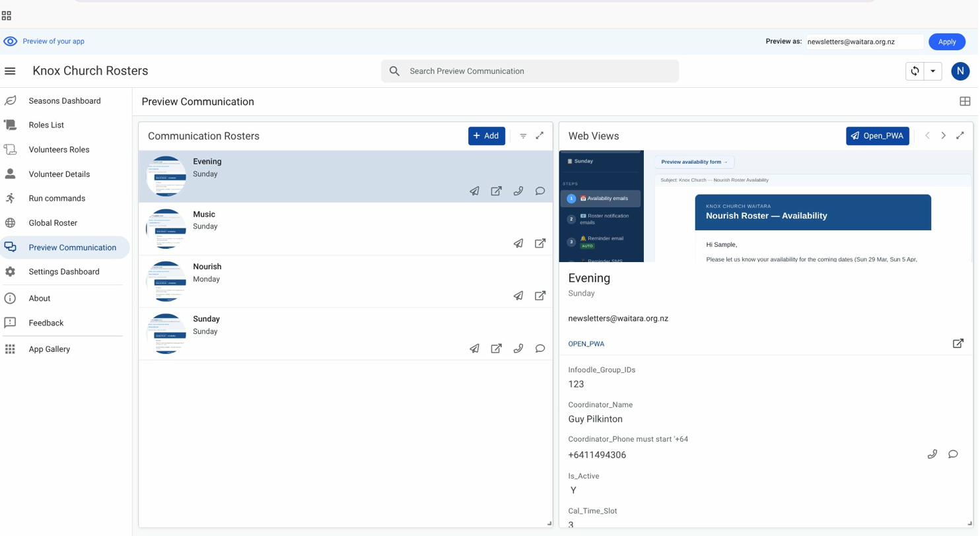
Preview Communication view — select a roster on the left, then tap Open PWA to see the full email template. Check names, roles, dates, and the Can't make it button.

Keep any wording changes generic and appropriate for all roster types, or revert changes afterwards so the next coordinator does not encounter problems.

Step 6 — Send Notifications
View: Run Commands • Communications
Notifications go to every volunteer with a Filled or Pending assignment. Each volunteer receives an email with their role and date, and a link to confirm (for pending) or decline. An SMS is also sent.

Step 6 — Send notifications
In Rostas → Run Commands, tap 6. Send notifications. The result confirms how many volunteers were notified. Volunteers receive their email and SMS within a few minutes.

What volunteers receive: Each volunteer gets an email showing their name, role, and dates rostered. The email includes a Can't make it link. If they tap it, the SMS replacement chain runs automatically — coordinators do not need to do anything when this happens. There is also a link to a simplified printable roster. For Pending (Unsure) assignments, volunteers are shown Yes, I can make it and Can't make it buttons so they can confirm or decline.

Manual Replacement
View: Global Roster • Individual Details
Use manual replacement when a volunteer contacts you directly — for example, they phone to say they cannot make it and suggest someone else, or you need to make a swap yourself without waiting for the SMS chain.

Manual replace
Go to Rostas → Global Roster or Individual Details view. Select the assignment you want to change. Tap Swap Volunteer, then select the replacement from the dropdown. Save. The system processes the swap within 1 minute. Check the Status column — it changes from Pending to Done when complete.

The replacement volunteer receives an automatic notification after a manual swap, with the usual links to the "I can't make it" button, roster view, and print roster.

11. The SMS Replacement Chain
When a volunteer taps 'Can't make it' in their notification email, the system automatically begins contacting other available volunteers by SMS. You do not need to do anything.

What happens automatically:
- The system finds the next suitable available volunteer for that role and date.
- It sends them an SMS with a link to accept or decline.
- If they accept → they are added to the roster and the chain stops.
- If they decline or do not respond within 2 hours (standard) or 15 minutes (urgent/imminent events) → the next volunteer is contacted.
- If no one accepts → the coordinator receives an email letting you know the slot is still unfilled.

Quiet Hours: SMS messages are not sent between 9:00 PM and 7:00 AM NZ time. If the chain is running overnight, it pauses and resumes in the morning. Quiet hours can be adjusted in Settings — search for 'Quiet'.

Fairness — Being replaced doesn't count against you: When a volunteer is replaced — whether they tapped Can't make it or were manually swapped by a coordinator — the system remembers. The next time a replacement is needed for a role they can do, they are given gentle priority to be contacted first. This gives them the chance to step up when they're free. They can always decline, no explanation needed. Once they serve in any capacity, this priority is automatically cleared. There's no ongoing obligation — just a quiet nudge to give willing volunteers a chance to contribute again.

12. Checking the Status Dashboard
View: Status Dashboard
The Status Dashboard shows the status of all notifications sent from Rostas — emails, SMS reminders, and replacement requests. Check it after running any notification step to confirm delivery. If an error appears, use the Email Tech Support button to send an error report to Guy automatically.
Note: the full Audit Log is accessible to Technical Support only. If something does not look right, contact Tech Support and quote the error message.

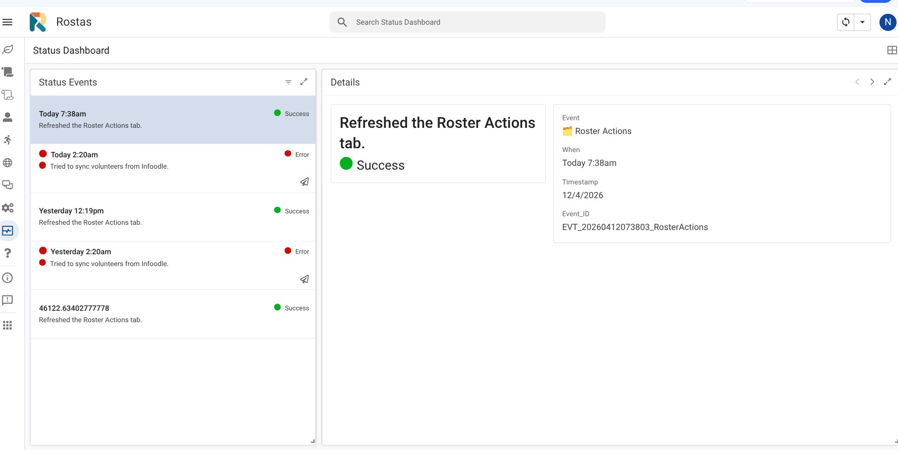
Status Dashboard — all notification events with timestamps. Green dot = Success, Red dot = Error. Tap any row to see full details in the right panel.

Common things to look for:
- SMS FAILED — a text message did not deliver. Usually a Twilio issue. Note the error and contact Tech Support if it persists.
- Chain exhausted — no volunteer accepted the replacement. The slot is still unfilled.
- Assignment not found — a Manual Replace request used an incorrect assignment. Check and resubmit.

If you see repeated errors, do not keep retrying. Note what you were doing and the error message, and contact tech support. Retrying a failed action can sometimes create duplicate assignments.

Step 1 — Volunteer Sync from Infoodle
View: Run Commands
Infoodle is the church's main membership database. Rostas syncs volunteer data from Infoodle every morning at 2am automatically. You can also run a manual sync at any time.

Run a manual sync when:
- A new volunteer has been added to Infoodle and needs to appear in Rostas immediately.
- A volunteer's contact details (email or mobile) have changed in Infoodle.
- You are about to build a roster and want to make sure you have the latest data.

Step 1 — Sync volunteers from Infoodle
In Rostas → Run Commands, tap 1. Sync volunteers from Infoodle. The sync runs in two steps and takes about 1–2 minutes. The result confirms how many volunteers were updated. Check the Volunteers view to confirm new or updated records appear.

Important: Volunteer name changes and Group/Roster membership are made in Infoodle, not in Rostas. Any changes made directly to the Volunteers tab in the spreadsheet will be overwritten by the next sync. Always update volunteer details in Infoodle first, then run a sync.

Adding a New Volunteer
New volunteers must be added to Infoodle first and assigned to the correct Infoodle group for their roster type. Once in Infoodle, run a manual sync and they will appear in Rostas. You will then need to set their role preferences before they can be included in a roster build.

Settings and Configuration
View: Settings Dashboard
System settings control how Rostas behaves — coordinator email addresses, reminder timing, and which features are active. Managed through the Settings Dashboard view in Rostas.

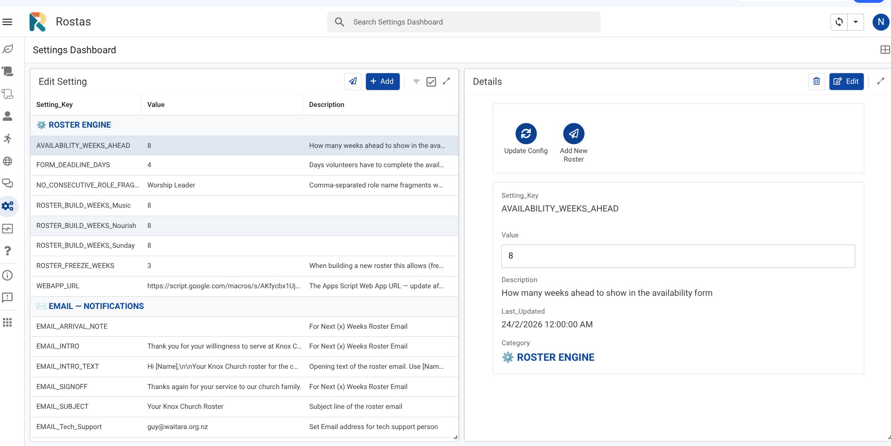
Settings Dashboard — settings are grouped by category. Tap a row to view details and use Edit to change a value. Use Add New Roster to add a new roster type.

If you are not sure whether a setting is safe to change, contact Guy first. Some settings affect the whole system across all roster types. An incorrect value can prevent roster builds or stop emails and SMS from sending.

When to Contact Tech Support
Most day-to-day operations are fully self-contained in Rostas. The situations below require more technical involvement:
- The volunteer web app URL has changed and needs updating (after a system redeployment).
- Repeated errors appear in the Status Dashboard that do not resolve on their own.
- SMS messages stop delivering to volunteers.
- The system triggers need to be reinstalled (e.g. after a technical issue).
- Any change to Infoodle connection settings or API credentials.
- Anything that requires opening the Apps Script editor.

Adding a New Roster Type
View: Settings Dashboard
New roster types (e.g. an Evening service) can be added by an Overall Coordinator directly through Rostas without needing to contact Tech Support. The process takes about 5 minutes and the system scaffolds all required Config keys automatically.

Before you start: Confirm the Infoodle group for the new roster type exists and you have its numeric Group ID. If the group has not been created yet, create it in Infoodle first, add the relevant volunteers to it, then come back here.

Step 1 — Add the Roster Type in Rostas

Step 1 — Add the Roster Type in Rostas
Go to Rostas → Settings Dashboard → Add New Roster. Fill in the form:
- Roster Name — the internal name (e.g. Evening). Title case, no spaces in the middle.
- Coordinator Name, Email, Phone — the coordinator for this roster type.
- Calendar Time Slot — display order on the Seasons Calendar. Use 3 or 4 for a new type.
- Infoodle Group ID — the numeric group ID. If unsure, run Knox Roster → Developer tools → List all groups.
Save the row. This automatically queues an addRosterType command in the Commands tab.

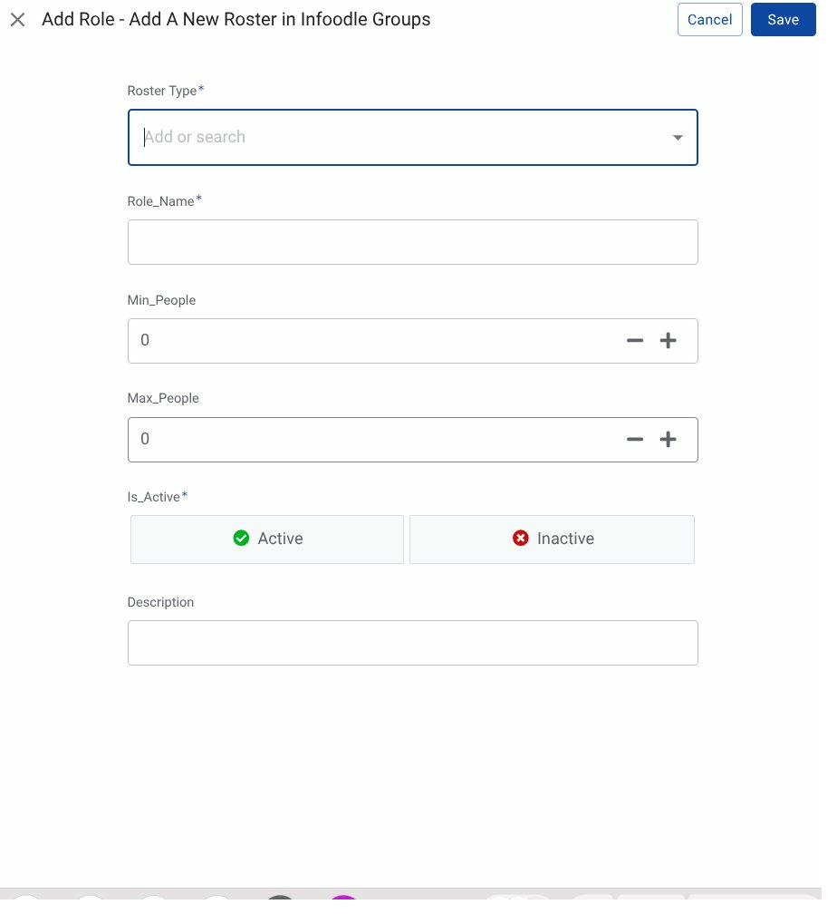
Add Role form — fill in all required fields when adding a new roster type or role.

Step 2 — Wait 1 Minute

Step 2 — Wait 1 Minute
The command poller picks up the addRosterType command and scaffolds all Config keys:
- COORDINATOR_{TYPE}, COORDINATOR_{TYPE}_EMAIL, COORDINATOR_{TYPE}_PHONE
- SEASONS_SLOT_{type}, ROSTER_BUILD_WEEKS_{type}
- Adds the type to ROSTER_TYPES and INFOODLE_GROUP_MAP
Check the Command history panel — the result shows the number of keys added.

Step 3 — Add Roles in Edit Roles

Step 3 — Add Roles
Go to Rostas → Edit Roles. Add each role for the new roster type — set Roster_Type to the new name exactly. Set Is_Active = Active, and set Min/Max People as needed.

Step 4 — Add a Season

Step 4 — Add a Season
Go to Rostas → Seasons Dashboard. Add a new season — set start and end dates, frequency (Weekly or Fortnightly), day of week, and Is_Active = TRUE.

Step 5 — Refresh Calendar and Buttons

Step 5 — Refresh Calendar and Buttons
In Rostas → Run Commands:
- Run 0. Refresh calendar — rebuilds the Seasons Calendar to include the new roster type's dates.
- Run 7. Maintenance → Refresh command buttons — new Build, Send, and Preview buttons appear for the new type.

Step 6 — Import Historical Data (if applicable)

Step 6 — Import Historical Data
If you have an existing spreadsheet with past assignments for this roster type, import it now. This gives the fairness engine accurate history from day one so it won't re-roster the same people. See Appendix A1 — Import Existing Roster Data for full instructions. If there is no existing history, skip this step.

Step 7 — Set Preferences and Run

Step 7 — Set Preferences and Run
Set Ministry_Pref for volunteers (via Individual Details or after Volunteer Sync once the Infoodle group is populated). Send role preference emails if the roster type uses specialist roles. Then follow Steps 3, 4, 5, and 6 of the Roster Cycle to collect availability, build, preview, and send.

Refresh command buttons: Run 7. Maintenance → Refresh command buttons any time the Run Commands panel looks wrong — missing buttons, wrong labels, or buttons for inactive types still appearing. Safe to run at any time.

Removing a Roster Type
If a roster type is no longer needed, it can be removed. This deactivates its roles and seasons, removes its Config keys, and rebuilds the Run Commands buttons. Historical assignment records are not deleted — they remain in RosterAssignments for reference.

This cannot be undone automatically. Make sure you genuinely want to remove the roster type. If you might need it again, set its season Is_Active = FALSE instead — that stops it appearing in builds without removing any data.

Option A — Via Rostas Run Commands (Recommended)

Delete via Run Commands
Go to Rostas → Run Commands → Step 7 Maintenance. A Delete [Type] roster type button appears for each active roster type. Tap the button for the type you want to remove. The system processes the deletion within 1 minute. Check Command history for the result — it confirms Config keys, roles, seasons, and frequency rows removed.

Option B — Via Apps Script Menu

Delete via Menu
In the spreadsheet menu: Knox Roster → Delete a roster type. A numbered list of active roster types appears. Enter the number of the type to delete and confirm. The menu version shows a detailed confirmation dialog before proceeding.

Coordinator-Triggered Decline and Replace
View: Global Roster
The standard Manual Replacement (Section 10) lets you pick a specific replacement volunteer directly. Decline and Replace is different — it marks a volunteer as declined and hands control to the automated SMS chain, which contacts available volunteers one by one until someone accepts.
Use this when a volunteer contacts you to say they cannot make it, but you do not have a specific replacement in mind and prefer the system to find one.

Via the Global Roster View

Decline and Replace — Global Roster
Go to Rostas → Global Roster. Find the assignment. Tap Save as Declined in the assignment edit panel. The system marks the assignment Declined and immediately starts the SMS replacement chain — the same chain that runs when a volunteer taps 'Can't make it' in their notification email.

Via the Commands Tab (Advanced)

Decline and Replace — Commands Tab
An Overall Coordinator can also write a command row to the Commands tab directly:
- Command: declineAndReplace
- Parameters: the Assignment_ID (e.g. RA_1234567890) — find this in the RosterAssignments tab.
The poller picks it up within 1 minute, marks the assignment Declined, and starts the SMS chain.

Comparison: Manual Replacement vs Decline and Replace

Quiet hours apply: If you trigger Decline and Replace between 9pm and 7am NZ time, the SMS chain queues until 7am. For urgent same-day slots, contact potential replacements directly in parallel.

A1. Import Existing Roster Data
The Import Existing Roster function loads a manually-made roster into Rostas. It is used in two situations: bootstrapping a brand-new roster type from a spreadsheet the coordinator has already been running, or seeding historical data before go-live so the fairness engine has accurate assignment history from day one.

Access required: This function is only accessible from the Apps Script editor — it is not available in the Rostas AppSheet app. It requires the Google account that owns the spreadsheet and (for AI cleaning) an OpenAI API key stored in Script Properties.

When to Use Import
Use Import when:
- Setting up Rostas for the first time and you have an existing roster spreadsheet to carry over.
- Adding a new roster type (e.g. Evening) and you want to give the system historical assignment data so it applies fairness rotation from the start.
- A previous roster season was managed manually and you want it visible in the Roster Assignments history.
Do not use Import to:
- Fix or edit existing assignments — use Manual Replacement or edit directly in Rostas instead.
- Re-import data that is already in RosterAssignments — the script skips rows with duplicate Assignment IDs but will add rows if you paste fresh data with new IDs.

Prerequisites

Step-by-Step: Pivot Format (Recommended)
All steps are run from the Knox Roster menu in the spreadsheet menu bar. Pivot format is recommended when your existing roster is a grid (dates across the top, roles down the side).

Step A — Open the Apps Script Editor
In the Rostas spreadsheet: Extensions → Apps Script. The Knox Roster project opens. You do not need to edit any code. All actions are run from the Knox Roster menu at the top of the spreadsheet.

Step B — Create the ImportPivot Tab
In the spreadsheet menu: Knox Roster → Import Existing Roster → Setup — Create Pivot tab. This creates an ImportPivot tab with sample data showing the expected format. Delete the sample rows (rows 2–4) before pasting your data.

Step C — Paste Your Existing Roster
Open your source spreadsheet. Copy the roster grid — including the header row with dates and the role column. Paste it into cell A1 of the ImportPivot tab. Expected layout:
- Row 1: Roles │ 13/04/2026 │ 27/04/2026 │ …
- Row 2+: Soup │ Jane Smith │ Bronnie H │ …
Volunteer names can include informal names, initials, and pairs (e.g. "Bruce & Cole"). The AI cleaning step resolves these.

Step D — Run AI Cleaning (Recommended)
In the spreadsheet menu: Knox Roster → Import Existing Roster → 1. Clean roster with AI. The AI reads your pasted roster and compares every volunteer name and role name against the Volunteers tab and Master_Roles tab. It resolves: nicknames and informal names (e.g. "Bronnie" → "Bronwyn Harrison"), last-name-only references, minor role name variations, and pairs listed in one cell. The cleaned version is written back into ImportPivot. New nickname mappings are saved to the Nickname_Map tab. Review the cleaned ImportPivot tab before importing.

If AI cleaning fails: Check that the OPENAI_API_KEY is present in Apps Script → Project Settings → Script Properties. You can proceed without AI cleaning — names that do not match will be flagged in the import result as "Unmatched names". Fix them in ImportPivot and re-run.

Step E — Run the Import
In the spreadsheet menu: Knox Roster → Import Existing Roster → 2. Import (Pivot format). A dialog asks you to confirm the Roster Type. Select the correct type and confirm. The import shows a results dialog:
- ✅ Written — assignments successfully added to RosterAssignments.
- ⏭ Skipped — rows already present in RosterAssignments — safe to ignore.
- ⚠️ Unmatched names — volunteer names that could not be resolved. Cells highlighted red in ImportPivot.
- ❓ Unknown roles — role names not found in Master_Roles. Add and re-run.
Correct any highlighted cells and re-run until zero unmatched names and zero unknown roles.

Step F — Seed Volunteer Roles from Import
In the spreadsheet menu: Knox Roster → Import Existing Roster → 4. Seed volunteer roles from import. Reads the imported RosterAssignments and creates VolunteerRoles entries for each volunteer-role pairing found. Does not overwrite any existing VolunteerRoles entries.

Step G — Seed Volunteer Frequency from Import
In the spreadsheet menu: Knox Roster → Import Existing Roster → 5. Seed volunteer frequency from import. Counts how many times each volunteer appears in the imported data and creates VolunteerFrequency entries. Gives the fairness rotation engine a realistic starting point so the first build does not re-roster the same people who just served.

After steps F and G: The system is ready to build its first roster. Check the Individual Details view for a few volunteers to confirm their frequency counts look right before running the first build.

Alternative: Flat Format
If your source data is a simple list rather than a grid, use the flat format instead.

Setup — Create the ImportRoster Tab
Knox Roster → Import Existing Roster → Setup — Create Flat tab. Delete the example row and paste or type your data with these columns:

Then run: Knox Roster → Import Existing Roster → 3. Import (Flat format). AI cleaning is not available for flat format. Ensure names and roles are an exact match before importing. Follow Steps F and G above to seed roles and frequency after the import.

After the Import

Do not re-import: Running the import a second time with the same data is safe (existing rows are skipped) but running it with a modified copy will create duplicate assignments with new Assignment IDs. If you need to correct imported data, delete the affected rows from RosterAssignments and re-run with corrected source data.

Managing the Nickname Map
Each time AI cleaning resolves a new nickname (e.g. "Bronnie" → "Bronwyn Harrison") it saves the mapping to the Nickname_Map tab. This means the same resolution is used automatically in future imports without needing to call the AI again.
To view or edit the nickname map: Knox Roster → Import Existing Roster → Setup — Manage nickname map. The Nickname_Map tab opens. Column A is the informal name (lowercase), Column B is the resolved full name. You can add entries manually.

Troubleshooting — Import

A2. After a Webapp Redeployment — Sync Preview URLs
Every time the Apps Script web app is redeployed, Google assigns a new WEBAPP_URL. The Rosters tab stores a Preview_URL column that must be updated whenever this changes.

Symptoms of a stale URL: The Communications view in Rostas shows broken preview links, or volunteers receive broken links in notification emails. Check WEBAPP_URL in Config first — if it has not been updated since the redeployment, update it before running the sync.

Step 1 — Update WEBAPP_URL in Config
In the Apps Script editor: Deploy → Manage deployments. Copy the new web app URL. In Rostas → Update Settings, find WEBAPP_URL and paste the new URL. Save.

Step 2 — Sync Preview URLs
In the spreadsheet menu: Knox Roster → Developer tools → Sync Roster Preview URLs. Reads WEBAPP_URL and writes the correct ?view=preview&roster=X URL for every active roster in the Rosters tab. Inactive rosters have their Preview_URL cleared automatically.

Step 3 — Confirm
Open WEBAPP_URL?view=preview in a browser. The roster type selector should load. If it shows a permissions error, check the deployment is set to Anyone access.

Also runs automatically: syncRosterPreviewUrls() triggers automatically whenever a roster's Is_Active status is toggled in the Rosters tab, so manual running is only needed after a URL change.

A3. Audit Log Pruning
The Audit_Log tab records every system event. Over time this tab grows large. The pruning function trims it to a manageable size without deleting recent entries.

One-Time Setup

Install the Pruning Trigger
In the spreadsheet menu: Knox Roster → Setup — Audit Log Pruning. Installs a weekly time-based trigger that automatically prunes the Audit_Log. Run this once at go-live. Do not run again — duplicate triggers cause double-pruning.

Manual Prune

Prune Now
In the spreadsheet menu: Knox Roster → Prune Audit Log Now. Immediately trims the Audit_Log to the most recent entries. Safe to run at any time. Useful if the tab has grown very large before the trigger was installed.

What gets kept: All ERROR-level entries are always retained. INFO entries older than the configured retention window (default 90 days) are removed. The window can be adjusted in Config — search for AUDIT_LOG.

A4. Clean VolunteerRoles Tab
The VolunteerRoles tab can accumulate blank rows or duplicates over time — particularly after bulk imports or if volunteers submit the role preference form more than once. The cleanup function removes these safely.

Run Cleanup
In the spreadsheet menu: Knox Roster → (run from menu) — the function is cleanVolunteerRoles in Maintainance.gs. If it is not in the menu, open the Apps Script editor, select cleanVolunteerRoles from the function dropdown, and click Run. What it removes:
- Rows with a blank Volunteer_ID or Role_ID.
- Rows where Role_Type is not Primary or Fillable.
- Duplicate Volunteer_ID + Role_ID combinations.

Safe to re-run: The function only removes invalid or duplicate rows — it never deletes a valid, unique role assignment. A toast notification shows the count of rows kept and removed.

Knox Church Waitara · Rostas Coordinator Guide · April 2026

