GOTHIC ARCHITECTURE
Speaker script · 15-minute presentation

How to use this script
- Normal text is what you say, word for word. The same text is in the speaker notes of the PowerPoint file.
- Grey italic text in [brackets] is an action (point, wait, move your hand). Do it, but do not read it out.
- The yellow [your name] is a placeholder. Replace it with your name, and also on the first slide.
- Total time at a calm pace: about 14:00. That leaves about one minute for pauses and for the fade between slides.
- Practise three times out loud with a timer. Speak slower than you think you should, and breathe at the end of each paragraph.
- If you are running late, cut slide 5 to its last paragraph and shorten slide 10 to steps one, two and five.

Time plan
# | Slide | Time | Clock
1 | Gothic Architecture (title) | 0:45 | 0:00 – 0:45
2 | Why does it still give us chills? | 0:45 | 0:45 – 1:30
3 | Four centuries in four chapters | 1:15 | 1:30 – 2:45
4 | A heaven made of stone | 1:20 | 2:45 – 4:05
5 | From fortress-church to lantern | 0:50 | 4:05 – 4:55
6 | Three ideas that changed everything | 1:15 | 4:55 – 6:10
7 | Follow the force | 1:20 | 6:10 – 7:30
8 | Walls made of light | 1:15 | 7:30 – 8:45
9 | Reading a cathedral | 1:15 | 8:45 – 10:00
10 | Built by generations, not by one genius | 1:15 | 10:00 – 11:15
11 | The race to the sky | 1:00 | 11:15 – 12:15
12 | Spread, decline and rebirth | 1:05 | 12:15 – 13:20
13 | What Gothic teaches an architect | 0:40 | 13:20 – 14:00
 | Total | 14:00

How to pronounce the hard words
Chartres SHAR-truh | Reims RANSS | Suger soo-ZHAY
Clerestory CLEAR-story | Viollet-le-Duc vee-oh-LAY luh DUKE | Rayonnant ray-on-ONT
Sainte-Chapelle sant sha-PELL | Gaudí gow-DEE

SLIDE 1 OF 13  Gothic Architecture (title)  About 0:45 · clock 0:00 to 0:45 | 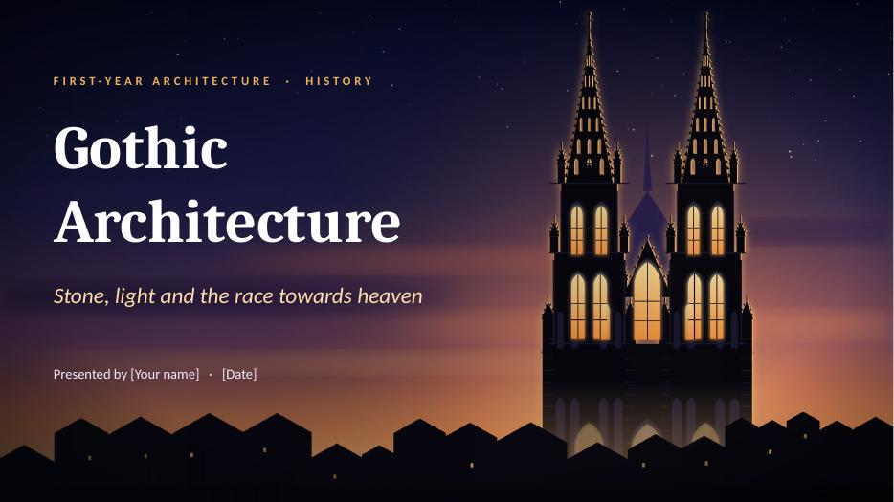

[Wait for the first slide to appear. Smile and look at the audience.]
Good morning everyone. My name is [your name], and today I will talk about Gothic architecture.
[Point to the picture.] This is Cologne Cathedral, in Germany. Imagine you are a farmer in the year 1200. You live in a small, dark house. One Sunday, you walk into a cathedral like this one. The walls seem to disappear. Coloured light falls on the floor. The ceiling is thirty metres above your head. It feels like walking into heaven. That is exactly what the builders wanted.
I will answer four questions. Where does Gothic come from? Why was it built? How does it stand up? And what did it leave us?
[Click: next slide]

SLIDE 2 OF 13  Why does it still give us chills?  About 0:45 · clock 0:45 to 1:30 | 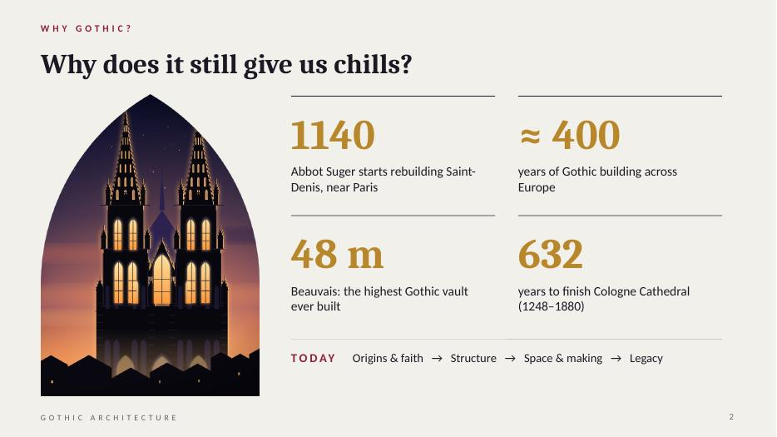

Let me start with four numbers. [Point to each number as you say it.]
1140: the year when Abbot Suger started rebuilding the church of Saint-Denis, near Paris. Most historians see it as the birth of Gothic.
About 400 years: how long Gothic dominated building in Europe. It was not a fashion. It was a whole civilisation.
48 metres: the vault of Beauvais Cathedral. That is a 16-storey building, in the 13th century, with no steel and no concrete.
632 years: Cologne Cathedral was started in 1248 and finished in 1880.
At the bottom, you can see our road map. So, let's begin. When did all this happen?
[Click: next slide]

SLIDE 3 OF 13  Four centuries in four chapters  About 1:15 · clock 1:30 to 2:45 | 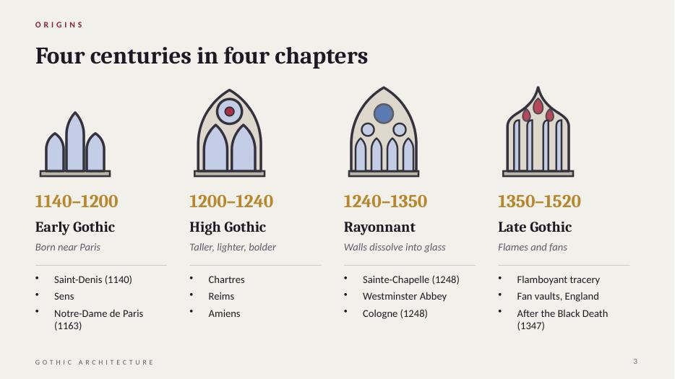

Gothic was not invented in one day. Historians divide it into four chapters. [Move your hand from left to right along the slide.]
Chapter one: Early Gothic, 1140 to 1200. It starts at Saint-Denis, and then Notre-Dame de Paris, in 1163. See the window: simple, tall and narrow.
Chapter two: High Gothic, 1200 to 1240. The golden age: Chartres [say "SHAR-truh"], Reims and Amiens. Everything becomes taller and lighter, with a round rose window above.
Chapter three: Rayonnant, 1240 to 1350. It means "radiating", like rays of light. The walls almost disappear and become glass, held by thin stone patterns called tracery. The masterpiece is the Sainte-Chapelle in Paris.
Chapter four: Late Gothic, 1350 to about 1520. Decoration explodes. In France it is called Flamboyant, because the stone looks like flames. And in 1347, the Black Death kills maybe a third of Europe's people, so many cathedrals slow down or stop.
One small fact: nobody at the time said the word "Gothic". I will come back to this at the end.
But first: why did people spend so much money on these buildings?
[Click: next slide]

SLIDE 4 OF 13  A heaven made of stone  About 1:20 · clock 2:45 to 4:05 | 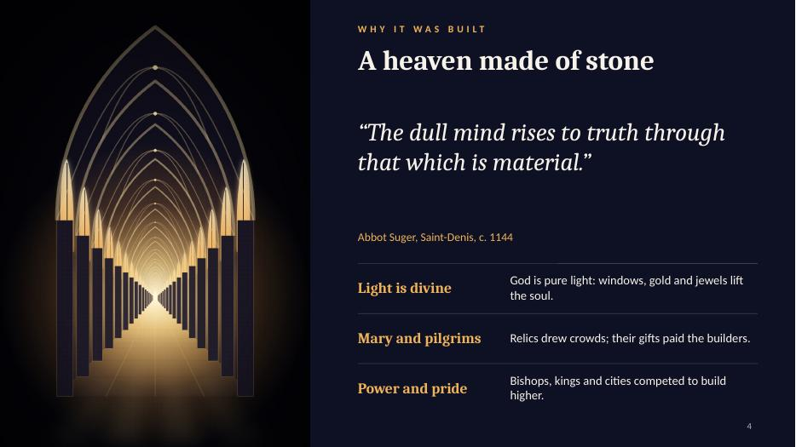

To understand Gothic, we must understand medieval faith. I will give you three ideas.
First, light is divine. [Point to the quote.] Abbot Suger [say "soo-ZHAY"] was an adviser to the kings of France. He read a philosopher who taught that God is pure light. So he rebuilt his church to be full of light. He wrote: "The dull mind rises to truth through that which is material." In simple words: beautiful things, like stone, gold and coloured glass, can lift the soul towards God.
Second, Mary and the pilgrims. Notre-Dame means "Our Lady", the Virgin Mary. Relics attracted thousands of pilgrims. They needed a lot of space, and their donations helped to pay for the building.
Third, power and pride. Bishops, kings and rich cities competed. A taller cathedral meant a more important city. It was also the meeting place, the market and the school of the town.
The Bible describes heaven as the Heavenly Jerusalem, a city of light and jewels. A Gothic cathedral tries to build this picture on earth.
So faith explains why. But what made it possible?
[Click: next slide]

SLIDE 5 OF 13  From fortress-church to lantern  About 0:50 · clock 4:05 to 4:55 | 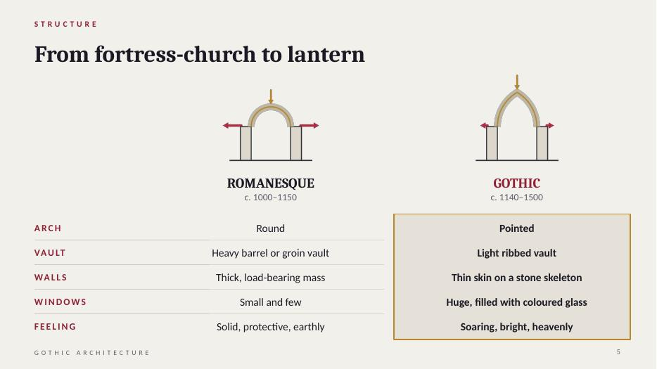

[Go quickly, row by row.]
Before Gothic, Europe built in the Romanesque style. On the left: round arches, thick walls like a fortress, and small windows, because every hole makes a thick wall weaker. The result is dark, solid and protective.
On the right, Gothic: pointed arches, light vaults, thin walls and enormous windows. The result is tall, bright and, for people at that time, heavenly.
The key point: Gothic did not use a new material. It is still stone. What changed is the logic. A Romanesque church is a heavy mass. A Gothic church is a skeleton. It is the difference between a cave and a tent with poles.
This skeleton is made of three inventions.
[Click: next slide]

SLIDE 6 OF 13  Three ideas that changed everything  About 1:15 · clock 4:55 to 6:10 | 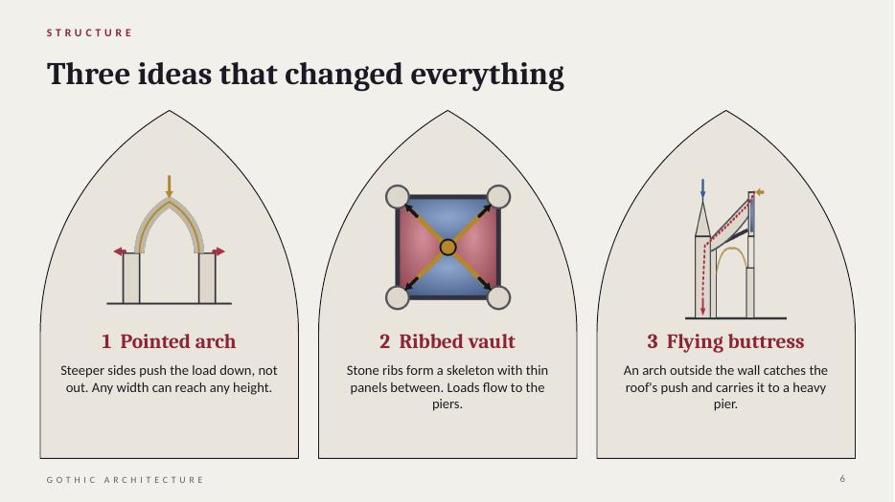

Here are the three inventions. [Point to each card as you speak.]
One: the pointed arch. A round arch pushes strongly outwards. Look at the red arrows. The pointed arch has steeper sides, so more weight goes straight down, and less pushes sideways. And you can make it as tall as you want for the same width.
Two: the ribbed vault. This is a plan seen from above. The ribs, in gold, cross diagonally. The masons built the ribs first, then filled between them with thin, light panels. The ribs send the weight down to the corners, to the piers. So the wall does not carry the roof any more. Only the points do.
Three: the flying buttress. The vault still pushes outwards at the top of the wall. The flying buttress is a half-arch, outside the church, that catches this push and carries it over the side aisle to a heavy pier.
Together, they make a stone skeleton with its bones on the outside. Now the walls are free to become windows. Let me show you all three working together.
[Click: next slide]

SLIDE 7 OF 13  Follow the force  About 1:20 · clock 6:10 to 7:30 | 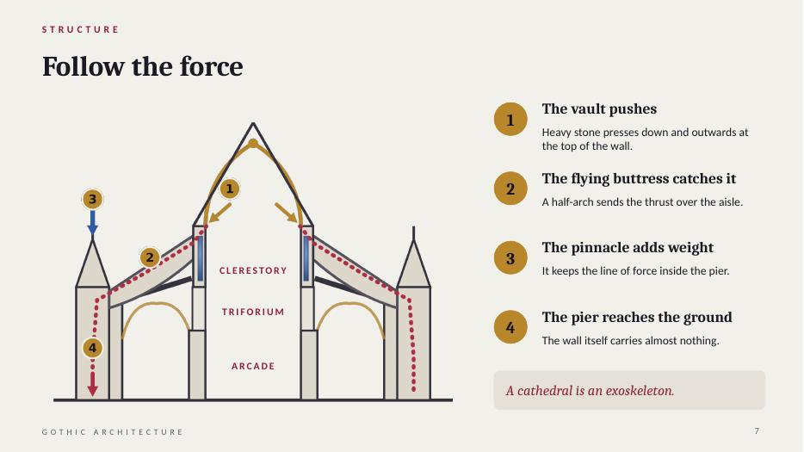

This is the technical heart of my talk, so I will go slowly. [Point to the drawing.]
This is a cross-section through the nave, like cutting the cathedral with a knife. Let's follow the force, like water running downhill.
One: the stone vault is heavy. It pushes down and outwards, at the top of the wall.
Two: at exactly that height, the flying buttress catches the push and sends it diagonally down, over the side aisle.
Three: the pinnacle, the small spire on the outer pier. It looks like decoration, but its weight presses down on the pier and keeps the force inside it, so the pier does not tip over.
Four: the pier brings everything to the ground.
So what is left for the wall to do? Almost nothing. That is why it can be filled with glass.
Look at the three levels inside: the arcade at the bottom, the triforium, a narrow passage, in the middle, and at the top the clerestory [say "CLEAR-story"], the high windows that bring in the light.
A cathedral is an exoskeleton, like a crab. And what does this skeleton give us? Light.
[Click: next slide]

SLIDE 8 OF 13  Walls made of light  About 1:15 · clock 7:30 to 8:45 | 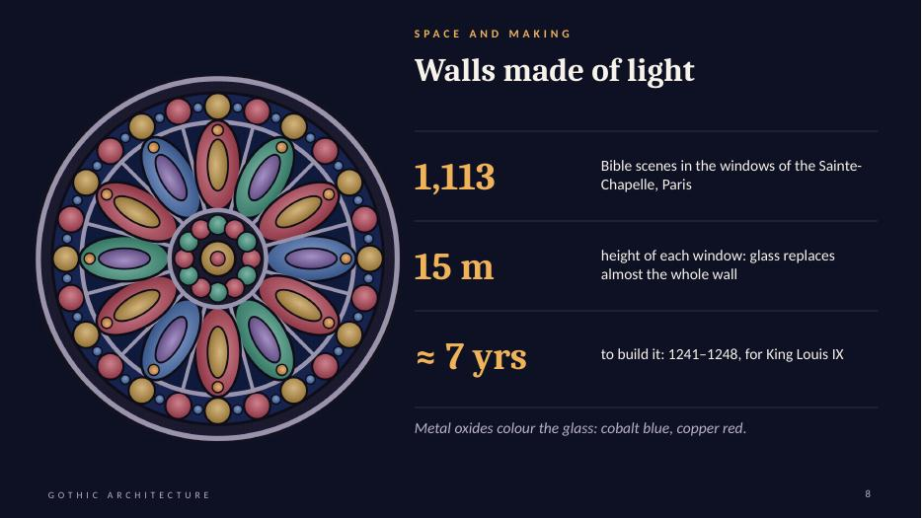

Remember Suger: light is divine. All this structure exists to give us this: walls made of light.
How is stained glass made? The glassmakers added metal oxides to melted glass. Cobalt gives blue, and copper gives red. The pieces were joined with strips of lead and held in stone patterns. When the sun shines, coloured light moves across the floor. The building changes with the hour.
The windows were also books. Most people could not read, so the glass told Bible stories in pictures.
The best example is the Sainte-Chapelle in Paris, built between 1241 and 1248 for King Louis the Ninth, to hold what he believed was the Crown of Thorns. [Point to the numbers.] Fifteen windows, fifteen metres tall, and 1,113 scenes. Inside, it feels like a jewellery box.
The round window is a rose window: a circle of stone patterns holding glass.
If you remember only one thing from my talk: in Gothic, light is a building material.
Now let's walk inside and learn how to read a cathedral.
[Click: next slide]

SLIDE 9 OF 13  Reading a cathedral  About 1:15 · clock 8:45 to 10:00 | 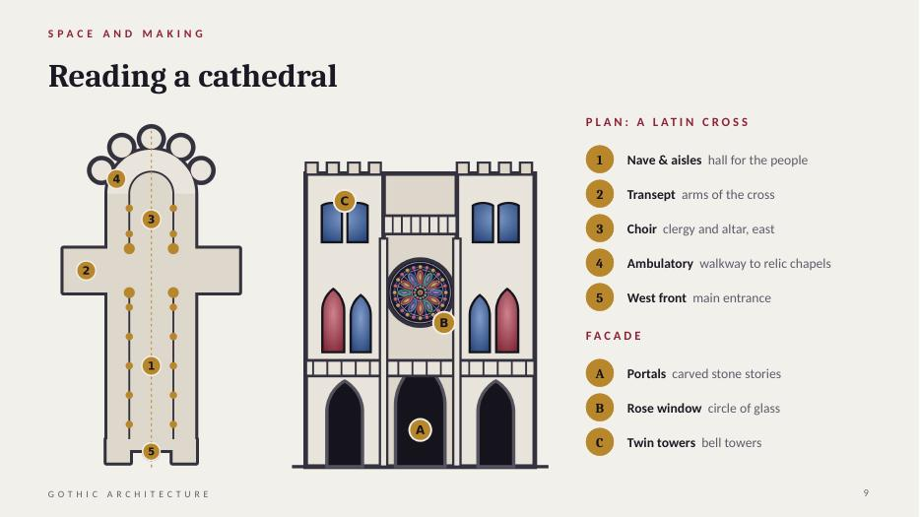

[Use your hand to "walk" on the plan.]
On the left, the plan. It is a Latin cross: a long arm and a short arm. It symbolises the cross of Christ. The altar is at the east end, towards the sunrise and Jerusalem.
Walk with me from the main door, in the west. Number five, the west front. You enter the nave, number one: the long hall for the people, with an aisle on each side. Then the transept, number two: the arms of the cross. Then the choir, number three: the place for the clergy and the altar. And around the end, number four: the ambulatory and the radiating chapels. The ambulatory lets pilgrims walk around and see the relics without disturbing the service.
Now the facade, on the right. A: three deep portals, covered with sculpture. Above the central door you often find the Last Judgement. People who could not read learned the Christian story from the stone. B: the rose window. C: the two towers, like Notre-Dame.
But who built all this, and how?
[Click: next slide]

SLIDE 10 OF 13  Built by generations, not by one genius  About 1:15 · clock 10:00 to 11:15 | 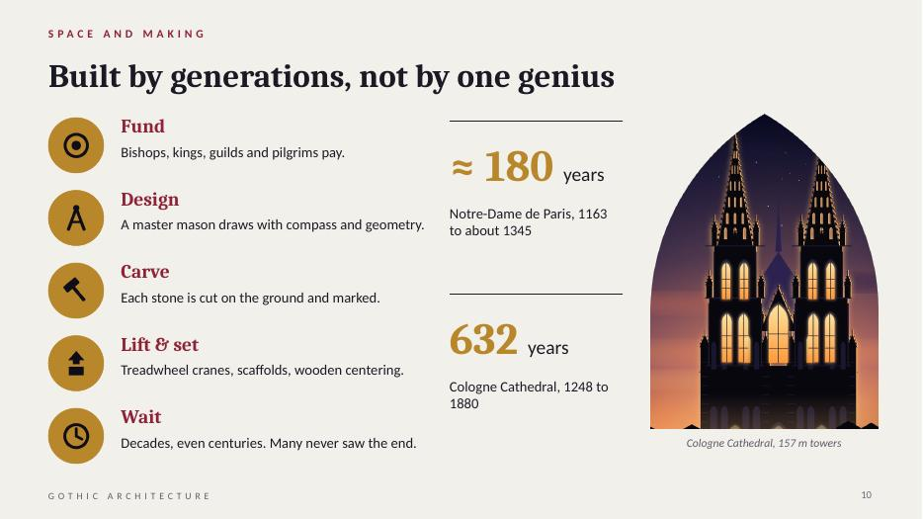

How do you build this with no computer and no engine? Five steps.
One, money. The bishop, the king, the guilds and the pilgrims paid. Often the money ran out, and work stopped for years.
Two, design. There was no architect with a diploma. There was the master mason: designer, engineer and site manager in one. He used geometry: compass, straightedge, circles, squares and triangles. The same tools we use in our drawing class! He even drew full-size templates on plaster floors.
Three, carving. The masons cut each stone on the ground and marked it with a personal sign, so they could be paid.
Four, lifting. Treadwheel cranes, like giant hamster wheels with workers walking inside. Arches were built on wooden frames, called centering, removed when the keystone was in place.
Five, time. Notre-Dame took about 180 years. Cologne, on the right, took 632. A mason who started a cathedral knew that he would never see it finished. Gothic is architecture across generations.
But sometimes, the ambition went too far.
[Click: next slide]

SLIDE 11 OF 13  The race to the sky  About 1:00 · clock 11:15 to 12:15 | 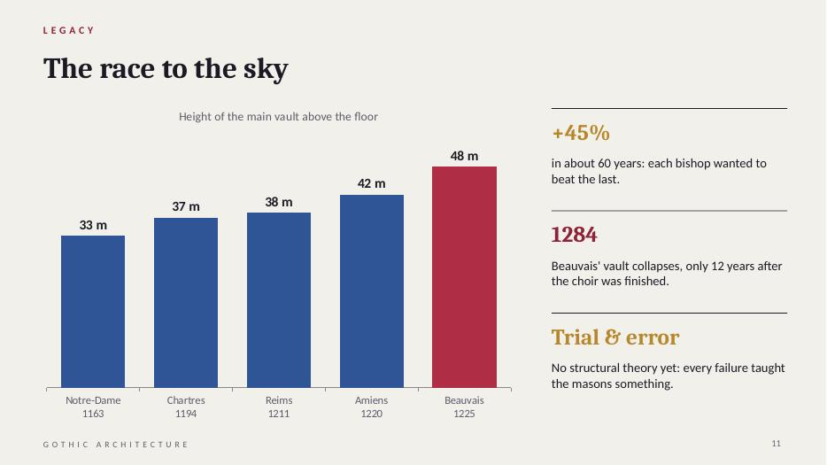

Here is the race to the sky. [Point to the chart.] The height of the main vault: Notre-Dame, 33 metres. Chartres, 37. Reims, 38. Amiens, 42. And Beauvais, 48 metres. In about 60 years, the height grew by almost half. The bishops wanted to beat each other.
But Beauvais went too far. In 1284, only twelve years after the choir was finished, part of the vault collapsed. The builders added extra piers, but the cathedral was never completed.
Why did this happen? There was no mathematics of structures yet. The masons learned by trial and error, and every collapse was a lesson. This is how structural engineering was born: building, failing, and improving.
As students, I find this inspiring: every bold idea has a risk.
So, what happened to Gothic after the Middle Ages?
[Click: next slide]

SLIDE 12 OF 13  Spread, decline and rebirth  About 1:05 · clock 12:15 to 13:20 | 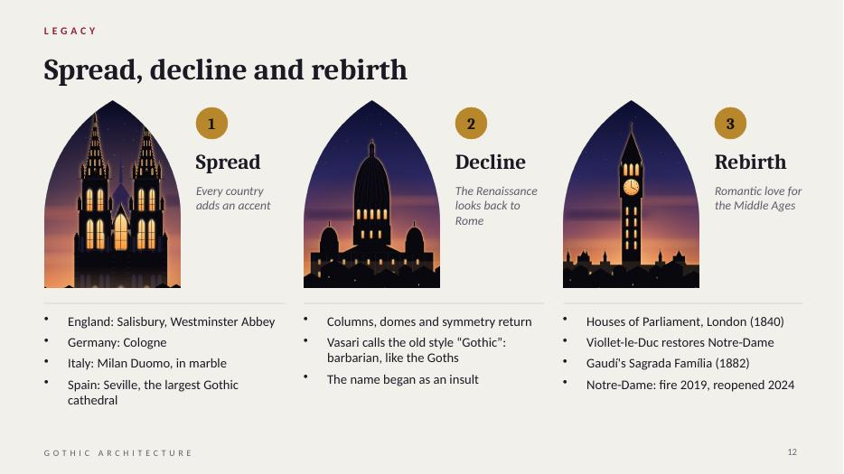

The story has three acts. [Point to the three pictures: Cologne, a Renaissance dome, and the clock tower of the Houses of Parliament.]
Act one, spread. From France, Gothic travels across Europe, and each country adds its own accent: Salisbury and Westminster in England, Cologne in Germany, the Duomo in Milan, and Seville in Spain, the largest Gothic cathedral in the world.
Act two, decline. In the 1400s, the Renaissance looked back to ancient Rome: columns, domes, symmetry. For writers like Vasari, medieval buildings were barbaric. They called them "Gothic", after the Goths who destroyed Rome. So the name we use today started as an insult!
Act three, rebirth. In the 1800s, Europe fell in love with the Middle Ages again. The Houses of Parliament in London are Gothic Revival. Viollet-le-Duc [say "vee-oh-LAY luh DUKE"] restored Notre-Dame. Gaudí began the Sagrada Família in 1882. And in April 2019, a terrible fire hit Notre-Dame. After five years of work, it reopened in December 2024.
So, what do we keep from Gothic?
[Click: next slide]

SLIDE 13 OF 13  What Gothic teaches an architect  About 0:40 · clock 13:20 to 14:00 | 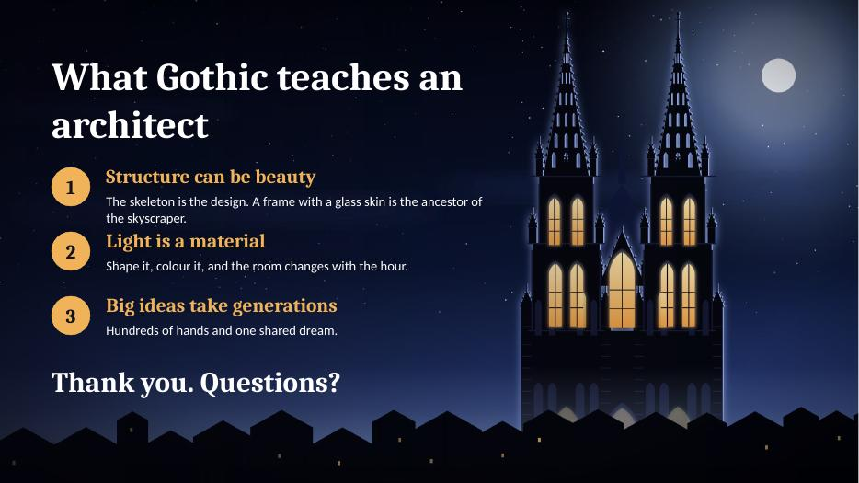

[Speak slowly and confidently.]
In one sentence: the Gothic builders took the heaviest material, stone, and turned it into light.
Three lessons for future architects.
One: structure can be beauty. In Gothic, the skeleton is the design. A frame with a glass skin is the ancestor of the modern skyscraper.
Two: light is a material. Think about how you will use light in your own projects.
Three: great architecture can take generations. It needs hundreds of hands and one shared dream.
Thank you very much for your attention. I am happy to answer your questions.

If someone asks a question
Short answers. Keep them calm and brief, then say "Does that answer your question?"
What is the difference between Gothic and Romanesque?
Romanesque has round arches, thick walls and small windows. Gothic has pointed arches, ribbed vaults, flying buttresses and big windows.
Why are there gargoyles?
They are water spouts. They throw the rainwater away from the walls. They also had a symbolic role: protecting the church from evil.
Why was the Notre-Dame fire so serious?
The roof frame, mostly 13th-century oak, burned and the spire collapsed. The stone vaults stopped most of the fire from reaching the inside.
Why did cathedrals take so long to build?
Money came slowly from donations, and building stopped in winter, during wars and after the Black Death. Many were finished by the grandchildren of the first builders.
Is the pointed arch really stronger than the round arch?
It pushes less sideways for the same span, so thinner supports can carry it. The round arch is not weak, but it needs more mass to resist its thrust.

Sources
- Otto von Simson, The Gothic Cathedral: Origins of Gothic Architecture and the Medieval Concept of Order (1956)
- Erwin Panofsky, Abbot Suger on the Abbey Church of St.-Denis and Its Art Treasures (1946)
- Jean Gimpel, The Cathedral Builders (1958)
- Georges Duby, The Age of the Cathedrals: Art and Society, 980–1420 (1976)

