TALLINN UNIVERSITY OF TECHNOLOGY

SCHOOL OF INFORMATION TECHNOLOGIES

Faculty of Computer Systems

223662MVEB

IAX0583 Programmeerimine I

Homework no.2

Supervisor: Associate Professor Vladimir Viies

Tallinn 2022

**Copyright declaration**

**I have prepared this work independently. All the work of other authors used in the preparation of the work, important points of view, data from literary sources, and the seller are cited.**

**Rostyslav Boichuk 223662MVEB**

**Signature:**

**Contents**

**Statement of the task ...........................................................................4**

**Algorithm .............................................................................................5**

**Program code .......................................................................................7**

**Output and explanation of the program.............................................9**

**Setting up the task**

Two arrays are given - an array of athletes and an array of athletes' long jump results (the jump result is given in meters; NB! choose the appropriate variable type). Write a program that outputs the names of the participants in the competition, the top three and the unsuccessful competitors (an unsuccessful jump is indicated by a score of 0)

Required output:

# **Algorithm**

**Program code:**

*#include* <stdio.h>

*#include* <stdlib.h>

*#include* <string.h>

void FindTop3(float[], int[]);

int GetFailures(float[], int[]);

void PrintResults(char *[], int[], int[], int);

int main()

{

    char *athletes[9] = {"Juku", "Meelis", "Peeter", "Ats", "Teet", "Paul", "Anti", "Peep", "Mart"};

    float results[9] = {4.98, 5.10, 4.75, 4.77, 0.00, 4.92, 5.05, 4.95, 0.00};

    int failures[9];

    int numberOfFailures;

    int top3[3];

    numberOfFailures = GetFailures(results, failures);

    FindTop3(results, top3);

    PrintResults(athletes, top3, failures, numberOfFailures);

}

void FindTop3(float results[], int top3[])

{

    float best = 0;

*for* (int i = 1; i < 9; i++)

    {

*if* (results[i] > best)

        {

            best = results[i];

            top3[0] = i;

        }

        float secondBest = 0;

*for* (int i = 1; i < 9; i++)

        {

*if* (results[i] > secondBest && i != top3[0])

            {

                secondBest = results[i];

                top3[1] = i;

            }

            float thirdBest = 0;

*for* (int i = 1; i < 9; i++)

            {

*if* (results[i] > thirdBest && i != top3[0] && i != top3[1])

                {

                    thirdBest = results[i];

                    top3[2] = i;

                }

            }

        }

    }

}

int GetFailures(float results[9], int failures[9])

{

    int i;

    int failNumber = 0;

*for* (i = 0; i < 9; i++)

    {

*if* (results[i] == 0)

        {

            failures[failNumber] = i;

            failNumber++;

        }

    }

*return* failNumber;

}

void PrintResults(char *athletes[9], int top3[3], int failures[9], int numberOfFailures)

{

    int i ;

    printf("Participants in competiotion: \n");

*for* (i = 0; i < 9; i++)

    {

        printf("%s ", athletes[i]);

    }

    printf("\n");

    printf("\nTop three: \n");

*for* (i = 0; i < 3; i++)

    {

        printf("%d. place: %s \n", i+1, athletes[top3[i]]);

    }

    printf("\nUnsuccessful during the race (DNF): \n");

*for* (i = 0; i < numberOfFailures; i++)

    {

        printf("%s ", athletes[failures[i]]);

    }

}

Program output:

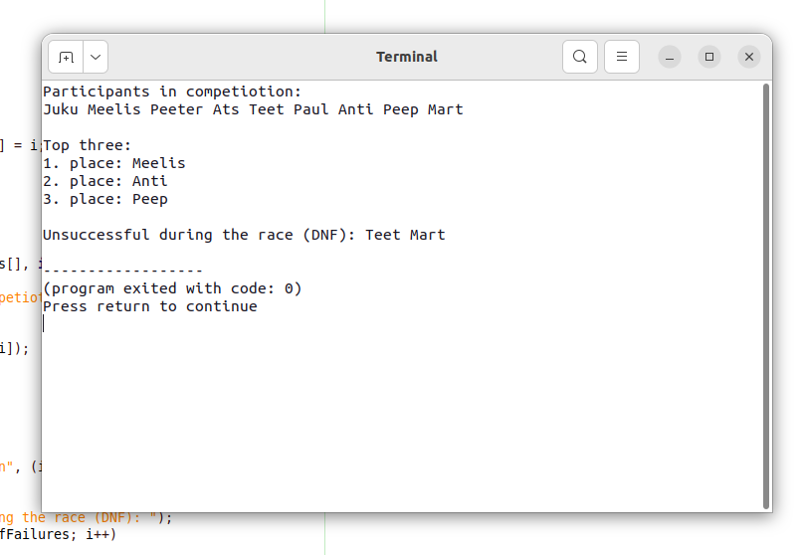

Program explenation:

* the program is devided by 3 sub functions
  + the one which defines who hasnt finished, and counts them to print exact size of arry in future
  + second, which defines top 3 playes and writes it in top3 array
  + and print function which prints everyting to termial as requitred in task defenition