**Flexbox**

**DEADLINE:** 16/11/2020

## **FOLDER STRUCTURE**

FL14_HW1/* ** - required

├─ task/

   └─ homework/ *

        └─ css/ *

└─ style.css *

        └─ img/*

└─ all images in this folder *

     └─ index.html *

## **TASK**

1) In this homework you should create the same page as shown in the picture   
(not pixel perfect) - task/example.png by using **Flexbox** as much, as possible.

2) Add a hover effect for the section 1, 2, 3.

a) Text color - #76cdd8. (see **Figure 2.B**)

b) Add triangle which should be located in the top right or left corner depend on the text. (see **Figure 2.B**)



**Figure 2.A – Sections without hover effect**



**Figure 2.B – Section with hover effect**

3) Add a hover effect for the button (background-color: rgb(118, 205, 216)) ( see **Figure 3**)



**Figure 3 – Button.**

4) Add scale effect on hover to image in section 3 (see **Figure 4**)



**Figure 4.A –** Image without effect



**Figure 4.B –** Image with effect

5)   
 a) Add a hover effect for the button (background-color: rgb(118, 205, 216)) ( see **Figure 5**)

b) Add scale effect on hover to image in section 4

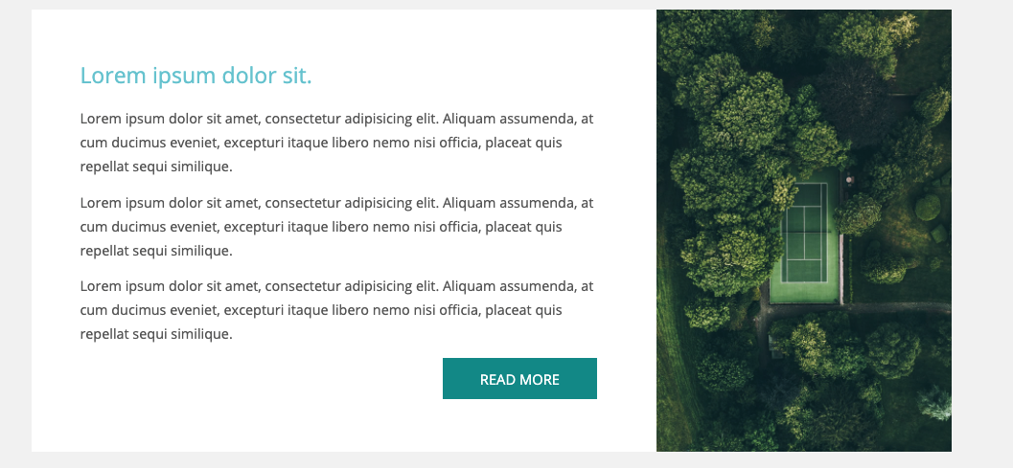

**Figure 5 – Section 5**

6) Add scale effect on hover to image in section 6 ( see **Figure 6**)

a) Add a hover effect for plan (see **Figure 6.B**) (For block: box-shadow: 0 0 0 0.2rem #24d4d4, for Button: background: #24d4d4;)

b) Show **special discount** only on hover in **Advanced** plan (see **Figure 6.C**)

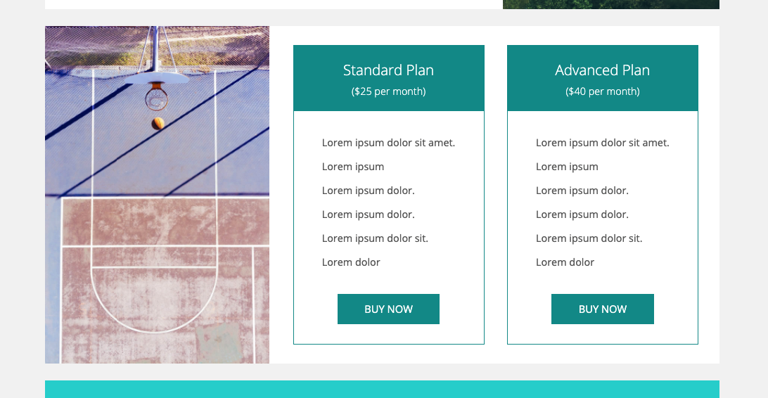

**Figure 6.A – Section 6**

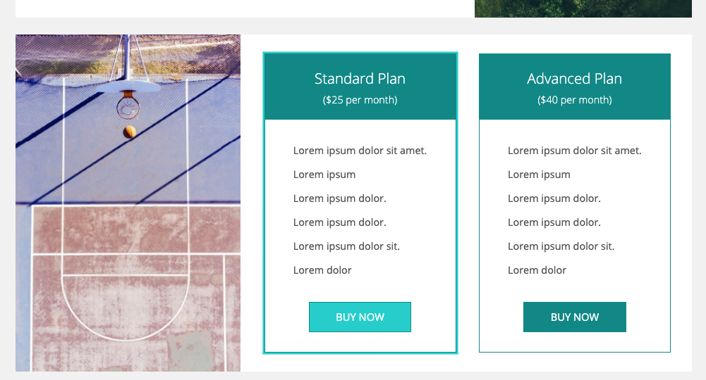

**Figure 6.B – Section 6**

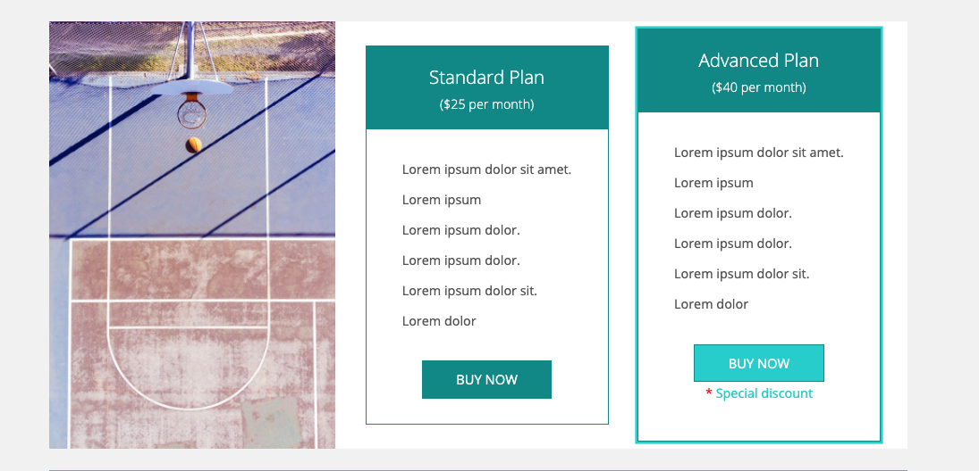 **Figure 6.C – Section 6 with special discount**

6) Style form section as shown in **Figure 7**( see **Figure 7**)

a) Add style on **focus** event for all elements ( border-color: #24d4d4; box-shadow: 0 0 0 0.2rem #24d4d4; )

( see **Figure 7.B**)

b) Add a hover effect for the submit button (background-color: rgb(118, 205, 216))

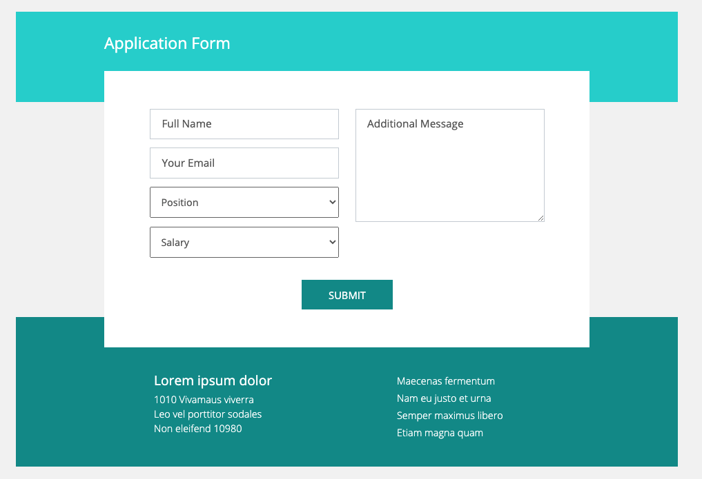

**Figure 7 - Application Form section**

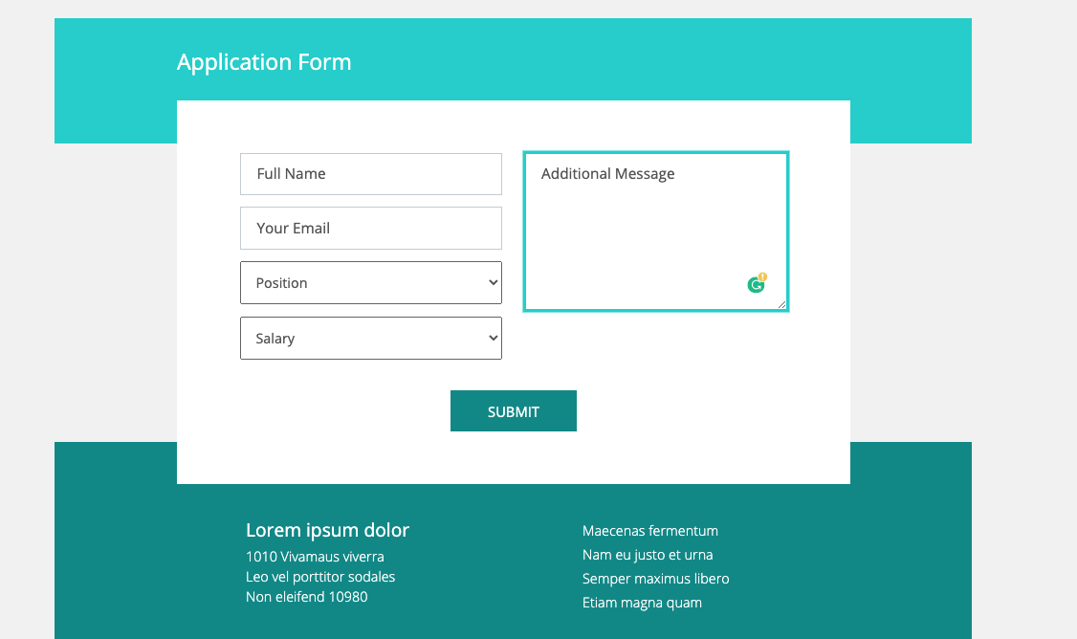

**Figure 7.B - Application Form section with focus event**

## **RESTRICTIONS**

* Usage of **JavaScript** is forbidden;
* Adding **task/** and **example/** folders is forbidden. Do not push it to repository (only homework/ folder should be pushed);
* No requirements for browser support (should work properly in Google Chrome last version).

## **BEFORE SUBMIT**

* Read requirements and compare to your homework result;
* Format the code (remove unnecessary lines of code);
* Make sure your GitLab folder structure meets the required one (without **task** and **examples** folders);
* Fix all issues which was found by w3org Markup Validation Service (<https://validator.w3.org/>) and CSS validator  [(https://jigsaw.w3.org/css-validator/](%20(https://jigsaw.w3.org/css-validator/)).

## **SUBMIT**

* The **FL14_HW1** folder should be uploaded to GitLab repository **“FL-14”** into **master** branch