NetDrive
Crowdsensed Drive Tester

TASK 5: UI DESIGN AND IMPLEMENTATION
Mobile Application Development — Group 6

Submitted by: Group 6
Course: Mobile Application Development
Date: June 2026

NAMES OF GROUP MEMBERS

CN | NAME | MATRICULE
1 | SUH BRANDON NJUIEBU | FE23A143
2 | ROSY WINKO NCHAKO | FE23A138
3 | AKUMO LUCIEN NDIFOR | FE23A010
4 | FOMIN ROLLINS NKENGUA | FE23A058
5 | BRYCE MUNONGO MUKETE JNR | FE23A099

Table of Contents
5.1 Introduction .......................................................................... 3
5.2 App Identity .......................................................................... 3
5.2.1 Name and Brand Concept ............................................3
5.2.2 Color Palette .................................................................... 3
5.2.3 Typography .......................................................................4
5.3 Visual Design System ......................................................... 5
5.3.1 Splash & Authentication Flow ....................................5
5.3.2 Dashboard Screen ............................................................6
5.3.3 Resilient Sync Hub and Privacy Settings .................6
5.4 Frontend Implementation .................................................... 9
5.4.1 Technology Stack .............................................................9
5.4.2 Screen Architecture ......................................................... 9
5.5 Implementation Verification and Demo Analysis .........9
5.6 Conclusion……………………………………………9
References ............................................................................... 10

5.1 Introduction
This report presents the UI Design and Frontend Implementation for NetDrive, a crowdsensed network testing mobile application. The application is tailored specifically to gather and analyze cellular signal data across the Buea municipality. This stage focuses on translating our defined functional criteria into a clear, cohesive frontend user interface utilizing the Flutter platform.
NetDrive turns standard mobile client devices into background network intelligence measurement tools. Non-expert community participants can seamlessly log performance metrics while our design structures information layers effectively for telemetry review. The frontend implementation relies on a strategic dark-navy scheme to optimize battery life and clarity for students and engineering teams out in the field.

5.2 App Identity

5.2.1 Name and Brand Concept
Application Name: NetDrive
Tagline: "Crowdsensed Drive Tester"
The name directly links our core network domain with standard telecom drive-testing procedures. It represents an automated, crowdsensed system designed to gather radio performance telemetry reliably across broad geographic sectors without requiring expensive field measurement hardware equipment.

5.2.2 Color Palette
The visual layout framework operates on high-contrast colors to ensure complete legibility under outdoor visibility constraints:

Color Role | Hex Code | Usage
Primary Background | #0D1B2A | Deep navy dark mode base background layer
Secondary Background | #1A2535 | Surfaces for content cards and data groups
Primary Accent (Green) | #00E676 | Active indicators and main control buttons
Secondary Accent (Blue) | #42A5F5 | Network metrics and structural readings display
Warning Accent (Orange) | #FF6D00 | Low signal alerts and network error boundaries

5.2.3 Typography
- Screen Headings: Bold, 28sp — provides clean structural markers for interface sections.
- Metric Values: Bold, 24sp — highlighted using accent tones to display clear network readings.
- Content Labels: Regular, 14sp — sets clean, descriptive parameters for operational properties.

5.3 Visual Design System
The presentation layer establishes an efficient, interface-driven layout. Content parameters are grouped inside clean cards against the primary navy dark canvas to maintain consistent visual hierarchy.

5.3.1 Splash & Authentication Flow
The frontend workflow handles user onboarding cleanly. Entry screens guide users through data awareness workflows and securely store localized profile credentials for target tracking regions like Buea.

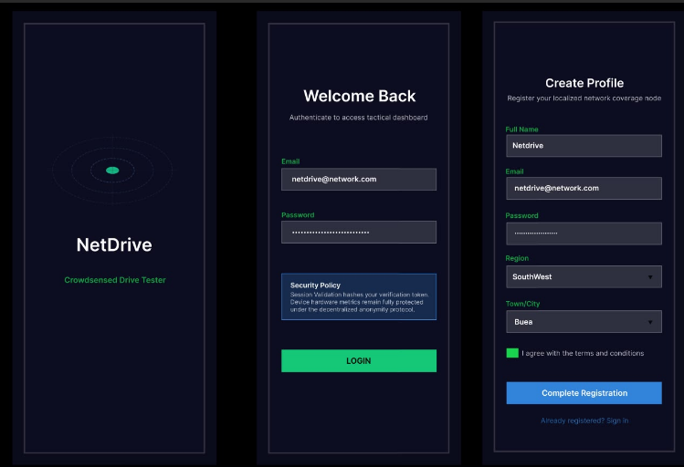
Figure 5.1 — NetDrive Splash, Login, and Registration Interface Layouts

5.3.2 Dashboard Screen
The principal interface displays system updates instantly. It groups network properties into functional blocks, ensuring quick visibility of background collection activities:
- Monitoring Status Indicator: Shows a green status marker confirming background tracking is active.
- Signal Power (RSRP): Marked clearly with amber/orange tones for immediate reading.
- Signal Quality (SINR): Displayed using clean green accents to highlight network clarity.
- Active Operator: Highlights active carrier parameters and access types like MTN Cameroon 4G.

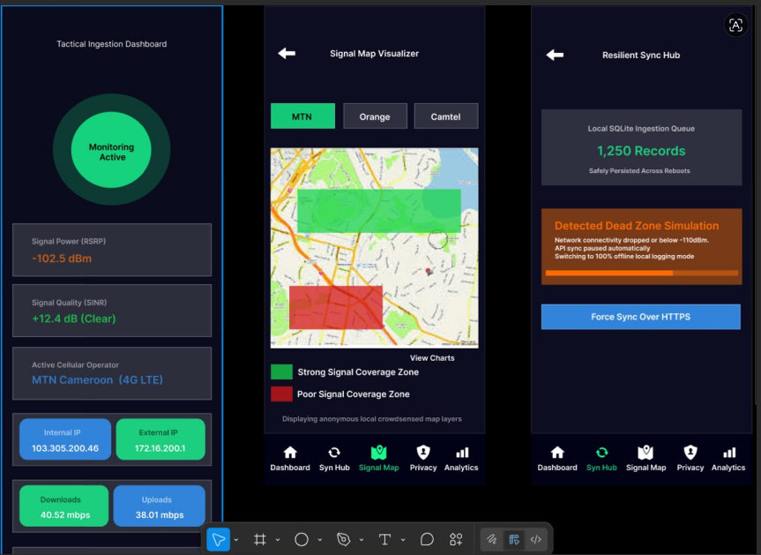
Figure 5.2 — Primary NetDrive Operations: Dashboard, Signal Map, and Core Sync Views

5.3.3 Resilient Sync Hub and Privacy Settings
The application coordinates offline data constraints directly through automated storage panels. These interfaces track data status and maintain strict local masking techniques before any remote transmissions occur.

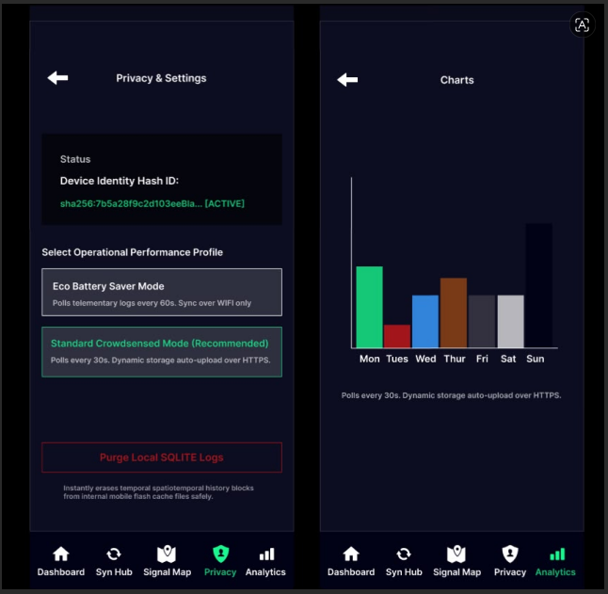
Figure 5.3 — Anonymized Security Configuration Panel and Analytics View Group

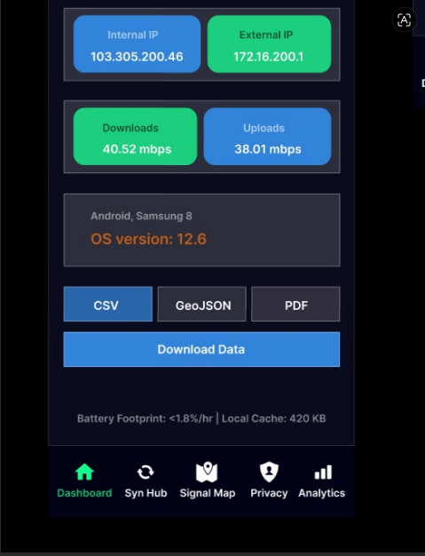
Figure 5.4 — Lower Dashboard Extension mapping technical data download controls

5.4 Frontend Implementation

5.4.1 Technology Stack
Component | Technology / Tool
Language & Framework | Dart (Flutter Mobile Framework)
State Management Engine | Provider Architecture Pattern
Offline Local Storage | SQLite Persistence via sqflite package
Hardware Channel API | Android TelephonyManager Platform Integration

5.4.2 Screen Architecture
The application follows a clean layout hierarchy. The global material properties enforce low-emissivity styles across active windows while isolated view controllers organize widget lifecycles safely without layout delays.

5.5 Implementation Verification and Demo Analysis
The application's frontend execution was verified using a real-time emulation test video. The demonstration confirms that the application successfully performs its core functional routines: capturing network session parameters, logging signal metrics through background threads, rendering geo-referenced maps smoothly, and properly storing collected samples inside the local SQLite database when connectivity drops. State transitions remain fluid across all screens while strictly respecting background execution limits.
5.6 Conclusion
In Task 5, we built and verified the frontend interface for the NetDrive mobile app using Flutter. By using a high-contrast dark navy theme, the interface stays clean and readable for users collecting data out in the field under different lighting conditions. The final layout clearly displays active tracking states for regular volunteers, handles offline data logging gracefully when cellular connection drops, and neatly organizes technical telemetry data for engineering analysis within Buea.

References
- Bass, L., Clements, P., & Kazman, R. (2012). Software Architecture in Practice (3rd Edition). Addison-Wesley.
- Fowler, M. (2004). UML Distilled: A Brief Guide to the Standard Object Modeling Language (3rd Edition). Addison-Wesley.
- National Science Foundation (NSF). (2020). Crowdsourced Mobile Network Measurement Systems [Research Publication]. Available at: NSF PAR Repository.
- Object Management Group (OMG). (2017). Unified Modeling Language (UML) Specification, Version 2.5.1.
- Pressman, R. S., & Maxim, B. R. (2019). Software Engineering: A Practitioner’s Approach (9th Edition). McGraw-Hill.
- Sommerville, I. (2016). Software Engineering (10th Edition). Pearson Education.

