Cabrera_Pablo_Cop1334C_Hw1

**Chapter 02**

**Duplicate figures:**

* **2.1**

// A simple C++ program

#include <iostream>

using namespace std;

int main()

{

cout << "Programming is great fun!";

return 0;

}

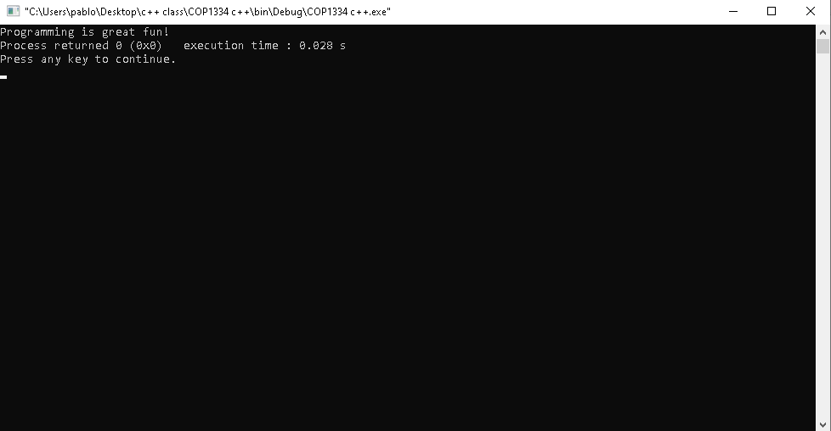

* **2.3**

// A simple C++ program

#include <iostream>

using namespace std;

int main()

{

cout << "Programming is ";

cout << "great fun!";

return 0;

}

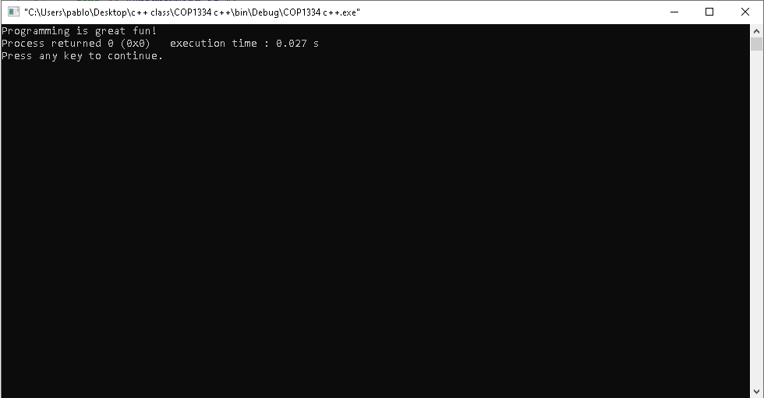

* **2.4**

// An unruly printing program

#include <iostream>

using namespace std;

int main()

{

cout << "The following items were top sellers";

cout << "during the month of June";

cout << "Computer games";

cout << "Coffee";

cout << "Aspirin";

return 0;

}

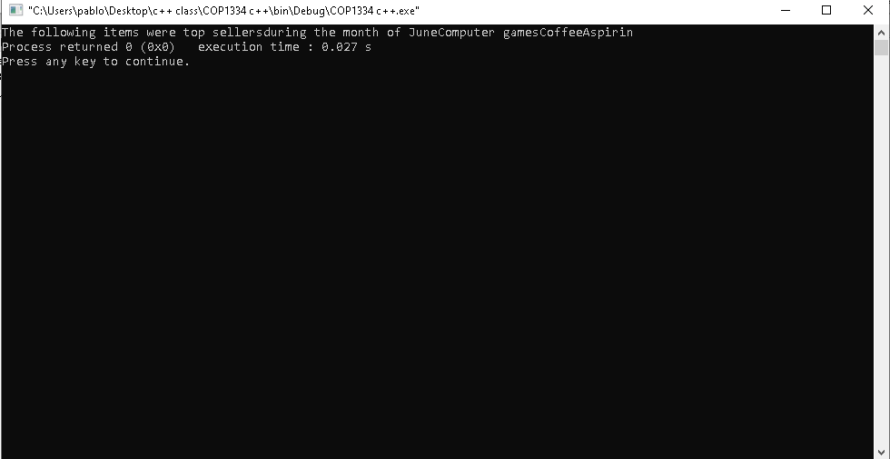

* **2.5**

// An unruly printing program

#include <iostream>

using namespace std;

int main()

{

cout << "The following items were top sellers" << endl;

cout << "during the month of June" << endl;

cout << "Computer games" << endl;

cout << "Coffee" << endl;

cout << "Aspirin" << endl;

return 0;

}

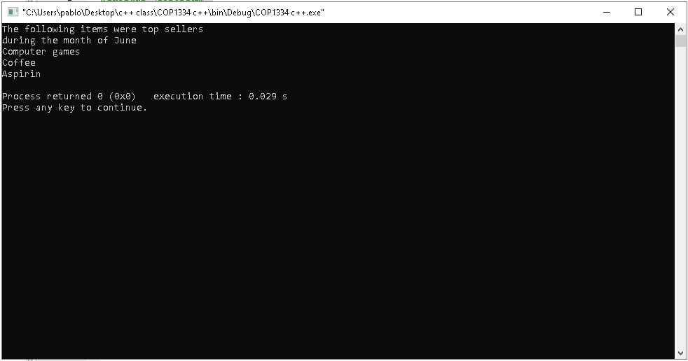

* **2.7**

// This program has a variable

#include <iostream>

using namespace std;

int main()

{

int number;

number = 5;

cout << "The value of the number is " << number << endl;

return 0;

}

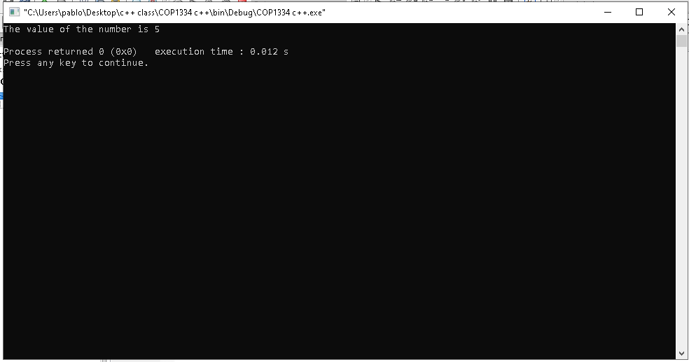

* **2.13**

// This program demonstrates the close relationship between

// characters and integers

#include <iostream>

using namespace std;

int main()

{

char letter;

letter = 65;

cout << letter << endl;

letter = 66;

cout << letter << endl;

return 0;

}

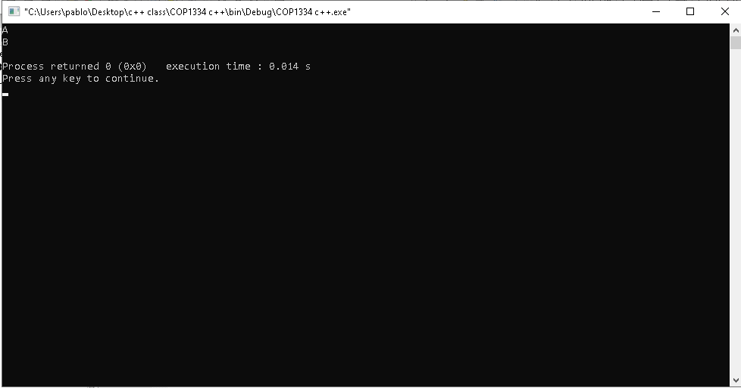

**Solve problems:**

**2.9**

**#include <iostream>**

**using namespace std;**

**int main()**

**{**

**cout << endl;**

**cout << "A char uses " << sizeof(char) << " byte." << endl;**

**cout << "An int uses " << sizeof(int) << " bytes. " << endl;**

**cout << "A float uses " << sizeof(float) << " bytes. " << endl;**

**cout << "A double uses " << sizeof(double) << " bytes. " << endl;**

**cout << endl;**

**return 0;**

**}**

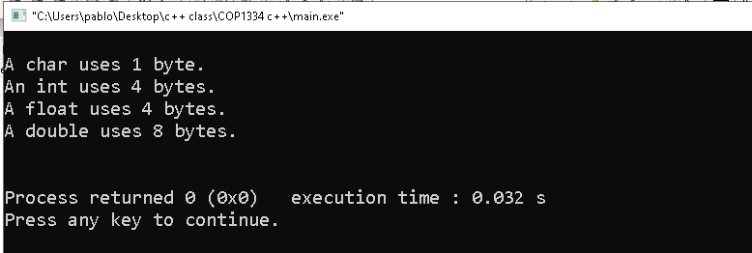

**2.12**

**#include <iostream>**

**using namespace std;**

**int main()**

**{**

**double acre, land, totalLand;**

**acre = 43560;**

**land = 391876;**

**totalLand = land / acre;**

**cout << "Your land has this many acres: " << totalLand << "." << endl;**

**return 0;**

**}**

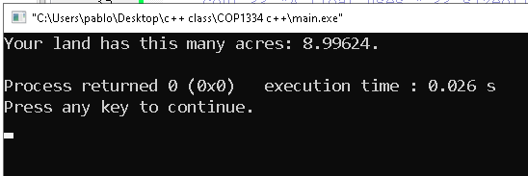

**This is 2.13**

**// $14.95 the company makes 35% profit.**

**#include <iostream>**

**using namespace std;**

**int main()**

**{**

**cout << "Your profit for the circuit board is: $" << 14.95 * 0.35 << endl;**

**return 0;**

**}**

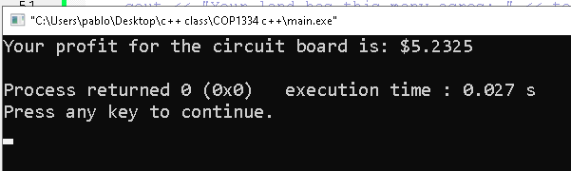

**2.15**

**#include <iostream>**

**using namespace std;**

**int main()**

**{**

**cout << " * " << endl;**

**cout << " *** " << endl;**

**cout << " ***** " << endl;**

**cout << "*******" << endl;**

**return 0;**

**}**

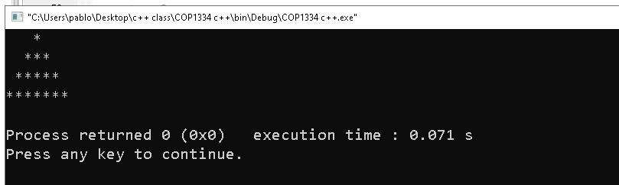

**2.17**

**#include <iostream>**

**using namespace std;**

**int main()**

**{**

**double stock = 750 * 35;**

**double commission = stock * 2 / 100;**

**double total = stock + commission;**

**cout << "The stock amount is: " << stock << ", The commission paid is: " << commission << ", so the total amount is: " << total << endl;**

**return 0;**

**}**

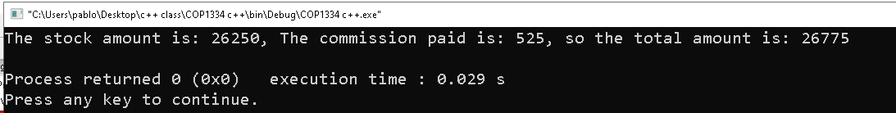

**problem 2.19**

**#include <iostream>**

**using namespace std;**

**int main()**

**{**

**double NYC, Denver, Phoenix;**

**NYC = 85;**

**Denver = 88;**

**Phoenix = 106;**

**cout << "New York city new average is: " << (NYC*1.02+NYC)/2 << endl;**

**cout << "Denver new average is: " << (Denver*1.02+Denver)/2 << endl;**

**cout << "Phoenix new average is: " << (Phoenix*1.02+Phoenix)/2 << endl;**

**return 0;**

**}**

