Cabrera_Pablo_Cop1334C_Hw2

**Duplicate figures:**

* **3.6**

// This program calculates the average

// of three test scores.

#include <iostream>

#include <cmath>

using namespace std;

int main()

{

double test1, test2, test3; // To hold the scores

double average; // To hold the average

// Get the three test scores.

cout << "Enter the first test score: ";

cin >> test1;

cout << "Enter the second test score: ";

cin >> test2;

cout << "Enter the third test score: ";

cin >> test3;

// Calculate the average of the scores.

average = (test1 + test2 + test3) / 3.0;

// Display the average.

cout << "The average score is: " << average << endl;

return 0;

}

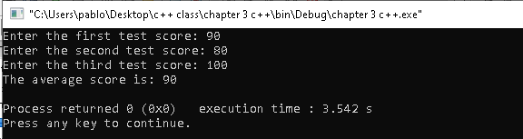

* **3.8**

// This program can be used to see how your system handles

// floating-point overflow and underflow

#include <iostream>

using namespace std;

int main()

{

float test;

test = 2.0e38 * 1000; // Should overflow test.

cout << test << endl;

test = 2.0e-38 /2.0e38; // Should underflow test.

cout << test << endl;

return 0;

}

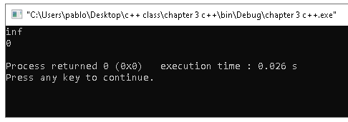

* **3.10**

// This program uses a type cast expression to print a character

// from a number.

#include <iostream>

using namespace std;

int main()

{

int number = 65;

// Display the value of the number variable.

cout << number << endl;

// Display the value of number converted to

// the char data type.

cout << static_cast<char>(number) << endl;

return 0;

}

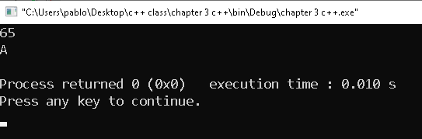

* **3.13**

// This program displays three rows of numbers

#include <iostream>

#include <iomanip> // Required for setw

using namespace std;

int main()

{

int num1 = 2897, num2 = 5, num3 = 387,

num4 = 37, num5 = 7, num6 = 1623,

num7 = 390, num8 = 3456, num9 = 12;

// Display the first row of numbers

cout << setw(6) << num1 << setw(6)

<< num2 << setw(6) << num3 << endl;

// Display the second row of numbers

cout << setw(6) << num4 << setw(6)

<< num5 << setw(6) << num6 << endl;

// Display the third row of numbers

cout << setw(6) << num7 << setw(6)

<< num8 << setw(6) << num9 << endl;

return 0;

}

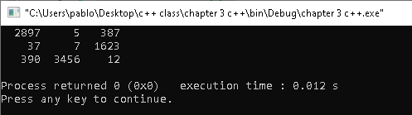

**Solve Problems:**

* **3.16**

// 3.16

#include <iostream>

using namespace std;

// Home value, tax rate for senior citizen

int main()

{

double exemption, homeVal, redVal, tax; // We create the doubles for the exemption, home value, reduced value and tax per $100.

double payTax, quarterTax; // We create the doubles for the tax pay.

exemption = 5000;

// We ask for the home value.

cout << "Please enter your home value :" << endl;

cin >> homeVal;

redVal = (homeVal - exemption); // We get the value and create the new variable for it.

// We ask for the tax rate.

cout << "Please enter your year's tax rate per $100 :" << endl;

cin >> tax;

payTax = redVal / 100 * tax; // We get to calculate now the taxes thanks to the input.

quarterTax = payTax / 4;

// We display the value of tax and quarterly tax.

cout << "Your annual tax is: " << payTax << ", and your quarterly tax pay is: " << quarterTax << ". Thank you for choosing Taxing Turbo Go." << endl;

return 0;

}

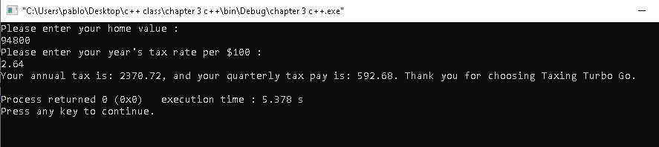

* **3.20**

// 3.20 Pizza Pi

#include <iostream>

#include <cmath>

using namespace std;

int main()

{

double diameter, radius, numSlices, pizzaArea, sliceArea; //We get the doubles to call for this problem.

sliceArea = 14.125; // We get the area of each slice so we can calculate it later on.

cout << "Please tell us the diameter of the pizza in inches." << endl;

cin >> diameter;

radius = diameter / 2;

pizzaArea = M_PI * pow(radius,2);

numSlices = pizzaArea / sliceArea;

// we round multiply by 10 and divide to get one decimal of precision to get the specific number of slices.

cout << "The number of slices for this pizza will be: " << round(numSlices*10)/10 << endl;

return 0;

}

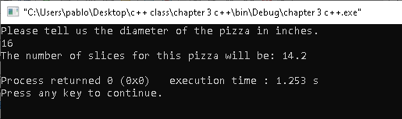 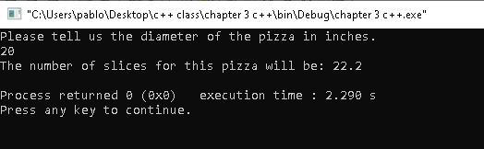

* **3.24**

// 3.24 Pizza Pi

#include <iostream>

#include <cmath>

using namespace std;

int main()

{

double numGrape, rowLenght, space, vineSpace;

// We ask for the length of the row input.

cout << "What is the length of the row, in feet?" << endl;

cin >> rowLenght;

// We ask for the space used by an end-post assembly.

cout << "What is the space used by an end-post assembly, in feet?" << endl;

cin >> space;

// We ask for the space between vines.

cout << "What is the space between vines, in feet?" << endl;

cin >> vineSpace;

// We compute the input to get the number of vines that fir the row.

numGrape = (rowLenght - 2 * space) / vineSpace;

cout << "The number of grape vines that will fit this row are: " << endl << numGrape << endl;

return 0;

}

