Cabrera_Pablo_Cop1334C_Hw3

**Duplicate figures:**

* 4.1

// This program displays the values of true and false states.

#include <iostream>

using namespace std;

int main()

{

bool trueValue, falseValue;

int x = 5, y = 10;

trueValue = x < y;

falseValue = y == x;

cout << "True is " << trueValue << endl;

cout << "False is " << falseValue << endl;

return 0;

}

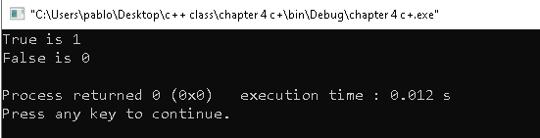

* 4.5

// This program averages 3 test scores. The if statement

// uses the = operator, but the == operator was inteded.

#include <iostream>

#include <iomanip>

using namespace std;

int main()

{

int score1, score2, score3; // To hold three test scores

double average; // To hold the average score

// Get the three test scores.

cout << "Enter 3 test scores and I will average them: ";

cin >> score1 >> score2 >> score3;

// Calculate and display the average score,

average = (score1 + score2 + score3) / 3.0;

cout << fixed << showpoint << setprecision(1);

cout << "Your average is " << average << endl;

// Our intention is to congratulate the user

// for having a perfect score. But, this doesn't work.

if (average = 100) // WRONG! This is an assigment!

cout << "Congratulations! That's a perfect score!\n";

return 0;

}

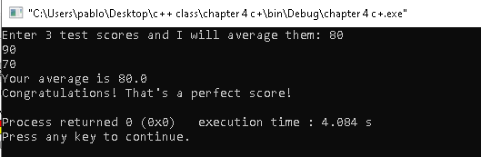

* 4.6

// This program averages 3 test scores.

// It demonstrates an if statement executing

// a block of statements.

#include <iostream>

#include <iomanip>

using namespace std;

int main()

{

const int HIGH_SCORE = 95; // A high score is 95 or greater

int score1, score2, score3; // To hold three test scores

double average; // To hold the average score

//Get the three test scores.

cout << "Enter 3 test scores and i will average them: ";

cin >> score1 >> score2 >> score3;

// Calculate and display the average score.

average = (score1 + score2 + score3) / 3.0;

cout << fixed << showpoint << setprecision(1);

cout << "Your average is " << average << endl;

// If the average is higher, congratulate the user.

if (average > HIGH_SCORE)

{

cout << "Congratulations!\n";

cout << "That's a high score.\n";

cout << "You deserve a pat on the back!\n";

}

return 0;

}

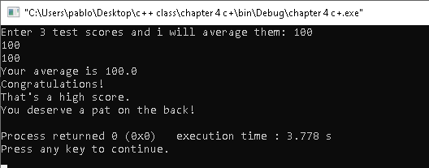

* 4.7

// This program averages 3 test scores. The braces

// were inadvertently left out of the id statement.

#include <iostream>

#include <iomanip>

using namespace std;

int main()

{

const int HIGH_SCORE = 95; // A high score is 95 or greater

int score1, score2, score3; // To hold three test scores

double average; // To hold the average score

//Get the three test scores.

cout << "Enter 3 test scores and i will average them: ";

cin >> score1 >> score2 >> score3;

// Calculate and display the average score.

average = (score1 + score2 + score3) / 3.0;

cout << fixed << showpoint << setprecision(1);

cout << "Your average is " << average << endl;

// ERROR! This if statement is missing its braces!

if (average > HIGH_SCORE)

cout << "Congratulations!\n";

cout << "That's a high score.\n";

cout << "You deserve a pat on the back!\n";

return 0;

}

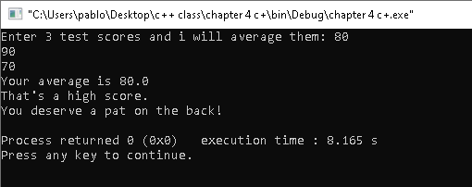

* 4.9

// This program ask the user for two number num1 and num2.

// num1 is divided by num2 and the result is displayed.

// Before the division operation, however, num2 is tested

// for the value 0. if ti contains 0, the division does not

// take place.

#include <iostream>

using namespace std;

int main()

{

double num1, num2, quotient;

// Get the first number.

cout << "Enter a number: ";

cin >> num1;

// Get the second number.

cout << "Enter another number: ";

cin >> num2;

// If num2 is not zero, perform the division.

if (num2 == 0)

{

cout << "Division by zero is not possible.\n";

cout << "Please run the program again and enter\n";

cout << "a number other than zero.\n";

}

else

{

quotient = num1 / num2;

cout << "The quotient of " << num1 << " divided by ";

cout << num2 << "is" << quotient << ".\n";

}

return 0;

}

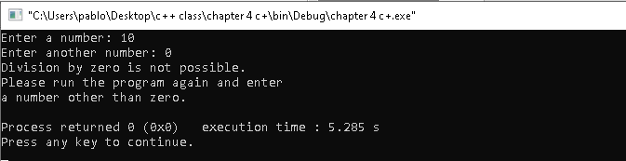

* 4.11

// This program demonstrates the nested if statement.

#include <iostream>

using namespace std;

int main()

{

char employed, // Currently employed, Y or N

recentGrad; // Recent graduate, Y or N

// Is the user employed and a recent graduate?

cout << "Answer the following questions\n";

cout << "with either Y for yes or ";

cout << "N for no.\n";

cout << "Are you employed? ";

cin >> employed;

cout << "Have you graduated from college";

cout << "in the past two years? ";

cin >> recentGrad;

// Determine the user's loan qualifications.

if (employed == 'Y')

{

if (recentGrad == 'Y') // Nested if

{

cout << "You qualify for the special ";

cout << "interest rate.\n";

}

else // Not a recent grad, but employed

{

cout << "You must have graduated from ";

cout << "college in the past two\n";

cout << "years to qualify.\n";

}

}

else // Not employed

{

cout << "You must be employed to qualify.\n";

}

return 0;

}

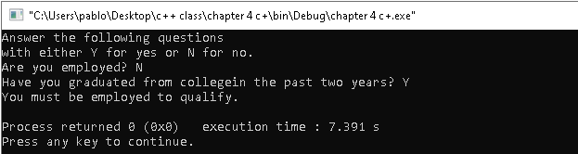

* 4.12

// This program uses nested if/else statements to assign a

// letter grade (A, B, C , D, or F) to a numeric test score.

#include <iostream>

using namespace std;

int main()

{

// Constants for grade thresholds

const int A_SCORE = 90,

B_SCORE = 80,

C_SCORE = 70,

D_SCORE = 60;

int testScore; // To hold a numeric test score

// Get the numeric test score.

cout << "Enter your numeric test score and I will\n";

cout << "tell you the letter grade you earned: ";

cin >> testScore;

// Determine the letter grade.

if (testScore >= A_SCORE)

{

cout << "Your grade is A.\n";

}

else

{

if (testScore >= B_SCORE)

{

cout << "Your grade is B.\n";

}

else

{

if (testScore >= C_SCORE)

{

cout << "Your grade is C.\n";

}

else

{

if (testScore >= D_SCORE)

{

cout << "Your grade is D.\n";

}

else

{

cout << "Your grade is F.\n";

}

}

}

}

return 0;

}

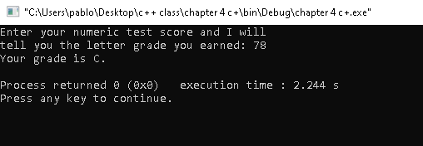

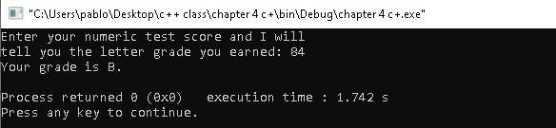

**Solve Problems:**

**4.13**

// 4.13

#include <iostream>

using namespace std;

int main()

{

const int Books0 = 0, books1 = 1, books2 = 2, books3 = 3, books4 = 4;

int books; // We will hold the books

// Get the input for the number of books

cout << "How many books have you purchased? ";

cin >> books;

// We create the conditions for the amount of points.

if (books >= 4)

{

cout << "You have obtained 60 points!";

}

else

{

if (books >= 3)

{

cout << "You have obtained 30 points! Next time buy one more book for double the points!";

}

else

{

if (books >= 2)

{

cout << "You have obtained 15 points! Thank you for you purchase, remember more books more points!";

}

else

{

if (books >= 1)

{

cout << "You have obtained 5 points! The more you buy the more points come back for more rewards! Thank you for your purchase.";

}

else

{

cout <<"You have obtained 0 points try buying some books first, no freebies for you...";

}

}

}

}

return 0;

}

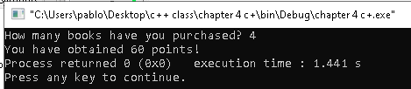

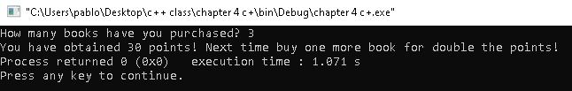 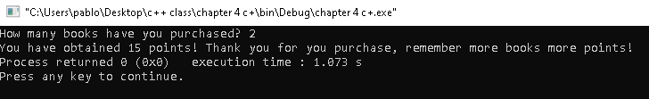

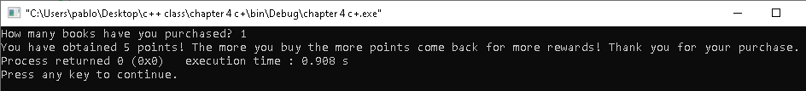

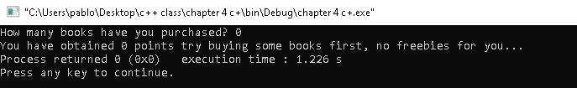

* 4.23

// 4.23

#include <iostream>

#include <cmath>

using namespace std;

int main()

{

int operat; // We hold type of operation.

double base, height, radius;

cout << "1. Calculate the area of a Circle.\n";

cout << "2. Calculate the area of a Rectangle.\n";

cout << "3. Calculate the area of a Triangle.\n";

cout << "4 Quit.\n";

cin >> operat;

if (operat >= 5)

{

cout << "ERROR!!! Learn to read instructions... You need to input a number from 1 to 4 not higher nor lower mate...";

return 0;

}

else

{

if (operat >= 4)

{

cout << "Alright time to move on chimp, press any key to close the program.";

}

else

{

if (operat >= 3)

{

cout << "Please enter the base of the triangle:\n"; // We get the base

cin >> base;

if (base <= 0)

{

cout << "Please enter a value that is not negative or zero.";

return 0;

}

cout << "Please enter the height of the triangle:\n"; // We get the height

cin >> height;

if (height <= 0)

{

cout << "Please enter a value that is not negative or zero.";

return 0;

}

double triangle = base * height * 0.5;

cout << "Your triangle area is " << triangle << ".\n";

}

else

{

if (operat >= 2)

{

cout << "Please enter the width of the Rectangle:\n"; // We get the width

cin >> base;

if (base <= 0)

{

cout << "Please enter a value that is not negative or zero.";

return 0;

}

cout << "Please enter the height of the rectangle:\n"; // We get the height

cin >> height;

if (height <= 0)

{

cout << "Please enter a value that is not negative or zero.";

return 0;

}

double rectangle = base * height;

cout << "Your rectangle area is " << rectangle << ".\n";

}

else

{

if (operat >= 1)

{

cout << "Please enter the radius of the Circle:\n"; // We get the radius

cin >> radius;

if (base <= 0)

{

cout << "Please enter a value that is not negative or zero.";

return 0;

}

double circle = radius * radius * 3.14159;

cout << "Your circle area is " << circle << ".\n";

}

else

{

if (operat <= 0)

{

cout << "ERROR!!! Learn to read instructions... You need to input a number from 1 to 4 not higher nor lower mate...";

return 0;

}

}

}

}

}

}

return 0;

}

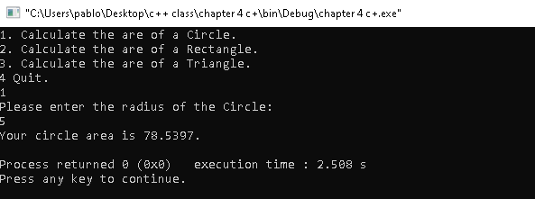

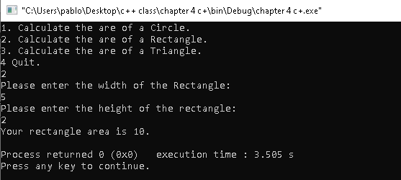

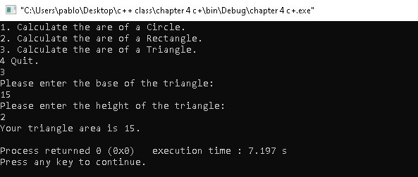

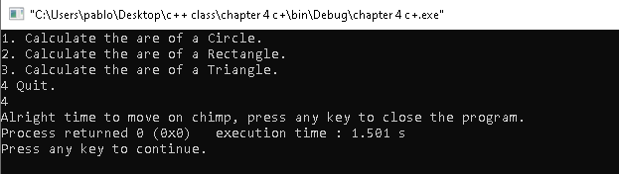

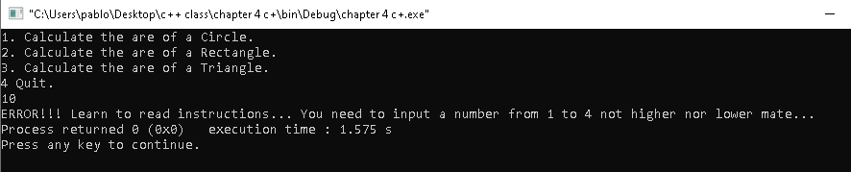

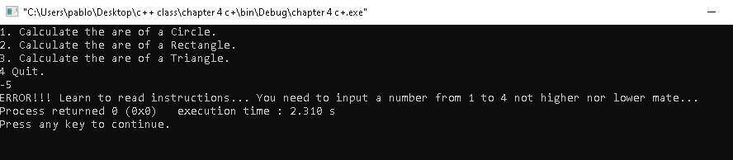

* 4.26

// 4.26

#include <iostream>

#include <cmath>

using namespace std;

int main()

{

char operat; // We hold type of operation.

double rateExtra1, rateExtra2, gigabyte,extra, total;

rateExtra1 = 10;

rateExtra2 = 5;

cout << "What is you package?\n";

cout << "You can choose between A, B or C.\n";

cin >> operat;

if (operat == 'A')

{

cout << "Please tell us the amount of extra gigabytes used.\n";

cin >> gigabyte; // forgot of character as it is null

if (gigabyte <= 0)

{

cout << "Please enter a positive number." << endl;

return 0;

}

extra = rateExtra1 * (gigabyte - 4);

if (extra <= 0) // If gigabyte is negative we do not give money back to the user to we make the input 0.

{

extra = 0;

}

// We calculate the total with the possible extra money.

total = 39.99 + extra;

if (total <= 59.999) // if total $ is less than 59.99 display the normal bill rate.

{

cout << "Your monthly bill will be $" << total << endl;

}

else if (total <= 69.999) // if total $ is less than 69.99 display the best savings option.

{

cout << "Your monthly bill will be $" << total << endl;

double savings;

savings = 69.999 - total;

cout << "You could save $" << savings << " with plan B." << endl;

}

else if (total > 70.000) // if total $ over 70 display the best savings option.

{

cout << "Your monthly bill will be $" << total << endl;

double savings;

savings = total - 69.99;

cout << "You could save $" << savings << " with plan C." << endl;

}

}

else if (operat == 'B')

{

cout << "Please tell us the amount of extra gigabytes used.\n";

cin >> gigabyte;

if (gigabyte <= 0)

{

cout << "Please enter a positive number." << endl;

return 0;

}

extra = rateExtra2 * (gigabyte - 8);

if (extra <= 0) // If gigabyte is negative we do not give money back to the user to we make the input 0.

{

extra = 0;

}

// We calculate the total with the possible extra money.

total = 59.99 + extra;

if (total <= 69.999) // if total $ less than 69.99 display the best savings option.

{

cout << "Your monthly bill will be $" << total << endl;

}

else if (total >= 70.00) // if total $ over 70 display the best savings option.

{

cout << "Your monthly bill will be $" << total << endl;

double savings;

savings = total - 69.99;

cout << "You could save $" << savings << " with plan C." << endl;

return 0;

}

}

else if (operat == 'C') // If they choose C the rate is fixed.

{

cout << "Your monthly bill is $69.99\n";

return 0;

}

else if (operat != 'A' || 'B' || 'C') // We use this last if statement to cancel other possible commands in prompt.

{

cout << "Please enter A, B or C. In caps otherwise it will not work";

}

return 0;

}

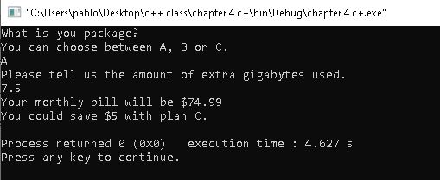

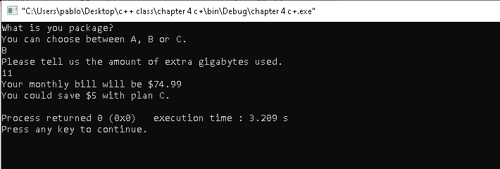

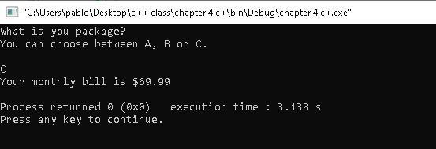

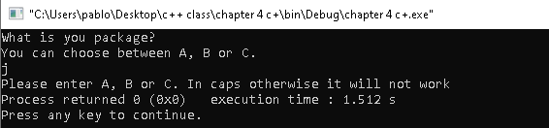

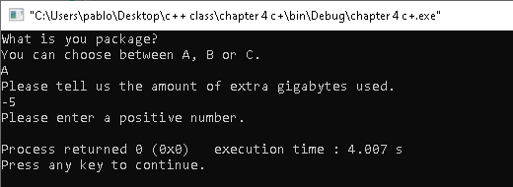

* **4.28**

#include <iostream>

#include <iomanip>

using namespace std;

int main()

{

string vegetarian, vegan, gluten_free;

cout << "Is anyone in your party vegetarian?\n";

cin >> vegetarian;

if (vegetarian == "yes")

{

cout << "Is anyone in your party vegan?\n";

cin >> vegan;

if (vegan == "yes")

{

cout << "Is anyone in your party gluten free?\n";

cin >> gluten_free;

if (gluten_free == "yes" || gluten_free == "no" )

{

cout << "These are your options Corner Cafe ,The Chef's Kitchen";

}

else

{

cout << "Error, please enter either 'yes' or 'no' as an option.";

}

}

else if (vegan == "no")

{

cout << "Is anyone in your party gluten free?\n";

cin >> gluten_free;

if (gluten_free == "yes")

{

cout << "These are your options Main Street Pizza Company ,Corner Cafe, The Chef's Kitchen";

}

else if (gluten_free == "no")

{

cout << "These are your options Main Street Pizza Company, Corner Cafe, Mama's Fine Italian, The Chef's Kitchen";

}

else

{

cout << "Error, please enter either 'yes' or 'no' as an option.";

}

}

else

{

cout << "Error, please enter either 'yes' or 'no' as an option.";

}

}

else if (vegetarian == "no")

{

cout << "Is anyone in your party vegan?\n";

cin >> vegan;

if (vegan == "yes")

{

cout << "Is anyone in your party gluten free?\n";

cin >> gluten_free;

if (gluten_free == "yes" || "no")

{

cout << "These are your options Corner Cafe, The Chef's Kitchen";

}

else

{

cout << "Error, please enter either 'yes' or 'no' as an option.";

}

}

else if (vegan == "no")

{

cout << "Is anyone in your party gluten free?\n";

cin >> gluten_free;

if (gluten_free == "yes")

{

cout << "These are your options Main Street Pizza Company ,Corner Cafe, The Chef's Kitchen";

}

else if (gluten_free == "no")

{

cout << "These are your options Joe's Gourmet Burgers, Main Street Pizza Company, Corner Cafe, Mama's Fine Italian ,The Chef's Kitchen";

}

else

{

cout << "Error, please enter either 'yes' or 'no' as an option.";

}

}

else

{

cout << "Error, please enter either 'yes' or 'no' as an option.";

}

}

else

{

cout << "Error, please enter either 'yes' or 'no' as an option.";

}

return 0;

}

