Homework chapter 5

Duplicate Figures:

* 5.6

// This program displays a list of number and

// their squares

#include <iostream>

using namespace std;

int main()

{

const int MIN_NUMBER = 1, // Starting number to square

MAX_NUMBER =10; // Maximum number to square

int num = MIN_NUMBER; // Counter

cout << "Number Number Squared/n";

cout << "-------------------------\n";

while (num <= MAX_NUMBER)

{

cout << num << "\t\t" << (num * num) << endl;

num++; //Increment the counter.

}

return 0;

}

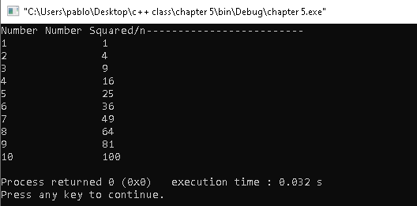

* 5.11

// This program converts the speeds 60 kph through

// 130 kph (in 10 kph increments) to mph.

#include <iostream>

#include <iomanip>

using namespace std;

int main()

{

// Constants for the speeds

const int START_KPH = 60, // Starting speed

END_KPH = 130, // Ending speed

INCREMENT = 10; // Speed increment

// Constant for the conversion factor

const double CONVERSION_FACTOR = 0.6214;

// Variables

int kph; // To hold speeds in kph

double mph; // to hold speeds in mph

// Set the numeric output formatting.

cout << fixed << showpoint << setprecision(1);

// Display the headings.

cout << "KPH\tMPH\n";

cout << "---------------\n";

// Display the speeds.

for (kph = START_KPH; kph <= END_KPH; kph += INCREMENT)

{

// Calculate mph

mph = kph * CONVERSION_FACTOR;

// Display the speeds in kph and mph.

cout << kph << "\t" << mph << endl;

}

return 0;

}

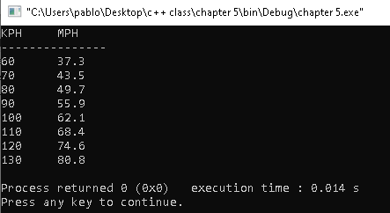

* 5.12

// This program takes daily sales amounts over a period of time

// and calculated their total.

#include <iostream>

#include <iomanip>

using namespace std;

int main()

{

int days; //Number of days

double total = 0.0; // Accumulator initialized with 0

// Get the number of days.

cout << "For how many days do you have sales amounts? ";

cin >> days;

// Get the sales for each day and accumulate a total

for (int count = 1; count <= days; count++)

{

double sales;

cout << "Enter the sales for day " << count << ": ";

cin >> sales;

total += sales; // Accumulate the running total.

}

// Display the total sales.

cout << fixed << showpoint << setprecision(2);

cout << "The total sales are $" << total << endl;

return 0;

}

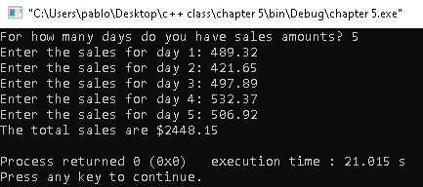

* 5.13

// This program calculates the total number of points a

// soccer team has earned over a series of games. The user

// enters a series of point values, then -1 when finished.

#include <iostream>

using namespace std;

int main()

{

int game= 1, // Game counter

points, // To hold a number of points

total = 0; // Accumulator

cout << "Enter the number of points your team has earned\n";

cout << "so far in the season, then enter -1 when finished.\n\n";

cout << "Enter the points for game " << game << ": ";

cin >> points;

while (points != -1)

{

total += points;

game++;

cout << "Enter the points for game " << game << ": ";

cin >> points;

}

cout << "\nThe total points are " << total << endl;

return 0;

}

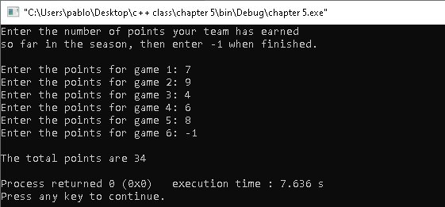

* 5.14

// This program averages test scores. It asks the user for the

// number of students and the number of test scores per student.

#include <iostream>

#include <iomanip>

using namespace std;

int main()

{

int numStudents, // Number of students

numTests; // Number of tests per student

double total, // Accumulator for total scores

average; // Average test score

// Set up numeric output formatting.

cout << fixed << showpoint << setprecision(1);

// Get the number of students.

cout << "This program averages test scores.\n";

cout << "For how many students do you have scores? ";

cin >> numStudents;

// Get the number of test scores per student.

cout << "How many test scores does each student have? ";

cin >> numTests;

// Determine each student's average score.

for (int student = 1; student <= numStudents; student++)

{

total = 0; // Initialize the accumulator.

for (int test =1; test <= numTests; test++)

{

double score;

cout << "Enter score " << test << " for ";

cout << "Student " << student << ": ";

cin >> score;

total += score;

}

average = total / numTests;

cout << "The average score for student " << student;

cout << " is " << average << ".\n\n";

}

return 0;

}

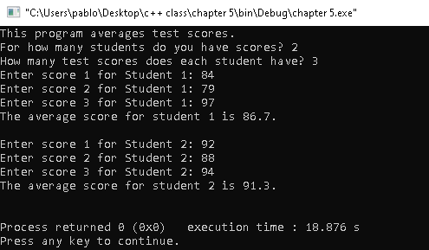

* 5.16

// This program writes data to a single line in a file.

#include <iostream>

#include <fstream>

using namespace std;

int main()

{

ofstream outputFile;

outputFile.open("demodile.txt");

cout << "Now writing data to the file. \n";

// Write four names to the file.

outputFile << "Bach";

outputFile << "Bethoven";

outputFile << "Mozart";

outputFile << "Schubert";

// Close the file

outputFile.close();

cout << "Done.\n";

return 0;

}

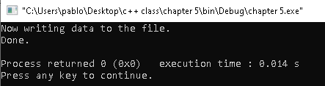

* 5.18

// This program writes user input to a file.

#include <iostream>

#include <fstream>

#include <string>

using namespace std;

int main()

{

ofstream outputFile;

string name1, name2, name3;

// Open an output file.

outputFile.open("Frinds.txt");

// Get the names of three friends.

cout << "Enter the names of three friends.\n";

cout << "Friend #1: ";

cin >> name1;

cout << "Friend #2: ";

cin >> name2;

cout << "Friend #3: ";

cin >> name3;

// Write the names to the file.

outputFile << name1 << endl;

outputFile << name2 << endl;

outputFile << name3 << endl;

cout << "The names were saved to a file.\n";;

// Close the file

outputFile.close();

return 0;

}

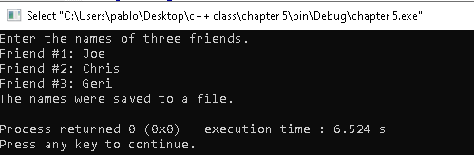

* 5.19

// This program writes user input to a file.

#include <iostream>

#include <fstream>

#include <string>

using namespace std;

int main()

{

ifstream inputFile;

string name;

// Open an output file.

inputFile.open("Frinds.txt");

cout << "Reading data from the file.\n";

inputFile >> name; // Read name 1 from the file

cout << name << endl; // Display name 1

inputFile >> name; // Read name 2 from the file

cout << name << endl; // Display name 2

inputFile >> name; // Read name 3 from the file

cout << name << endl; // Display name 3

inputFile.close(); // Close the file

return 0;

}

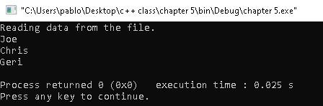

Solve problems

* 5.15
* 5.16
* 5.20
* 5.25
* 5.26