TRIP TO ROTHESAY
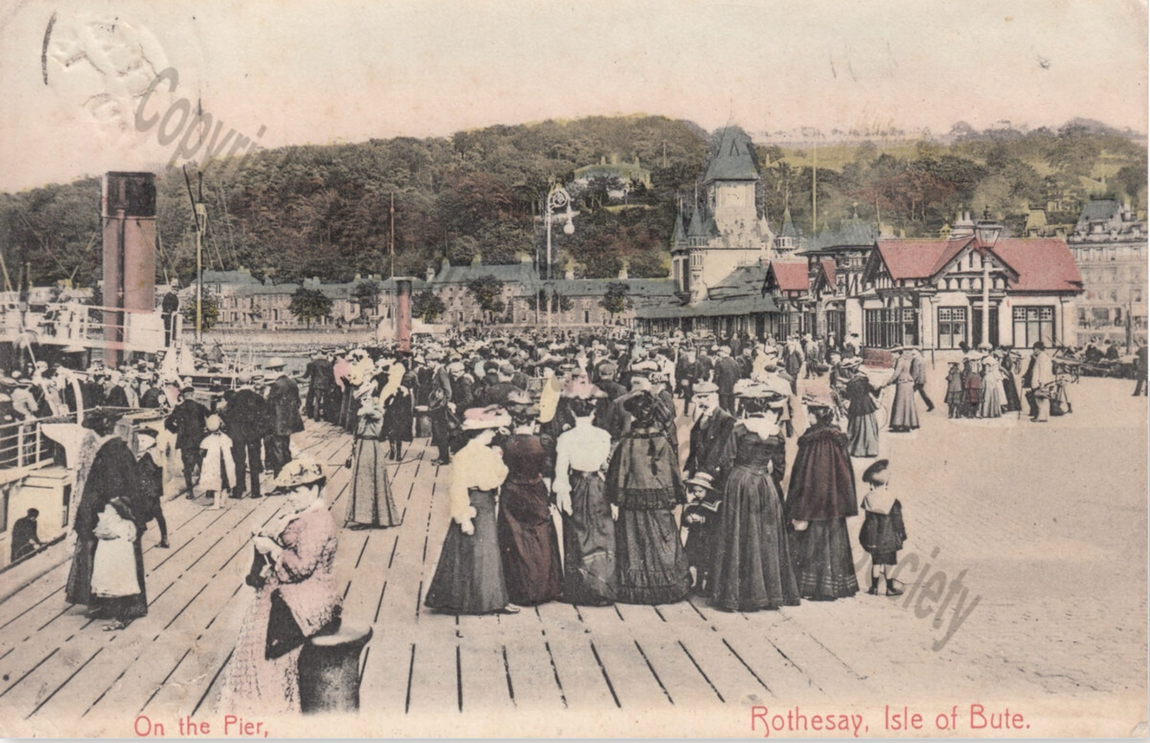

Just a brief ferry journey separates you from the opportunity to discover one of Scotland's enchanting islands. With its rugged moorlands and sandy shores, Bute is a paradise for those who appreciate the wonders of nature.
Explore the stunning Mount Stuart House, an impressive Gothic mansion surrounded by beautiful gardens and stroll along the seaside promenade of Rothesay.
This island provides a peaceful escape, making it a hidden gem for those seeking a blend of Scottish history and breath-taking landscapes. Enjoy this scenic day trip in this 16 seat small group tour from Glasgow

What's included
- Small Group Tour with maximum 16 people
- Professional Driver Guide
- Admission to Mount Stuart House and Gardens
- Transport by top of the range Mercedes mini-coach

