<base-blank></base-blank>

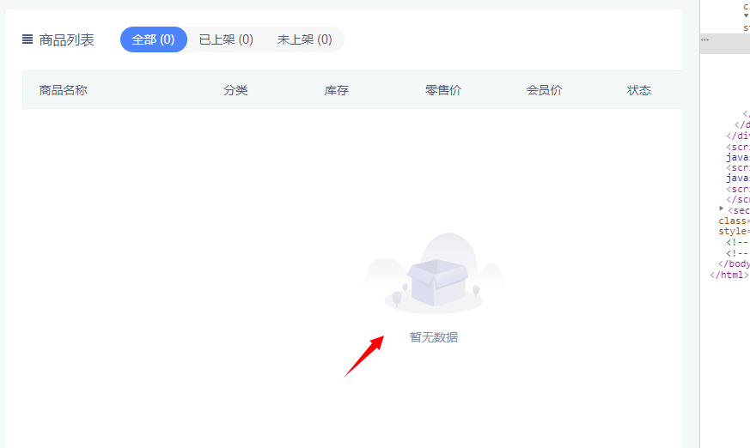

<base-button plain>新建商品</base-button>

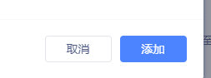

<base-date datePlaceholder="请选择时间" textName="创建时间"

:infoTime.sync="creatTime" @changeDate="changeDate"></base-date>

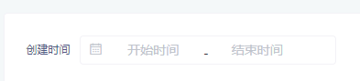

<base-footer>  
 <base-button @click="cancelBtn">取消</base-button>  
 <base-button type="primary" @click="checkBtn">审核</base-button>  
</base-footer>

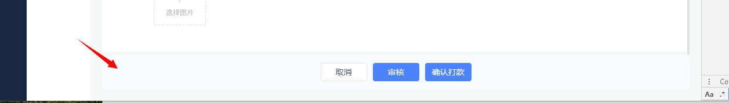

<base-form-item label="提现单号:" :required="false" class="info-item">123213213</base-form-item>



<base-form-item label="商品名称" labelMarginRight="40" labelWidth="78px" labelAlign="right">  
 <base-input v-model="edit.name"></base-input>  
</base-form-item>



<base-input v-model="edit.name"></base-input>

<base-input v-model="edit.describe" limit="50" type="textarea" placeholder="输入商品描述"></base-input>

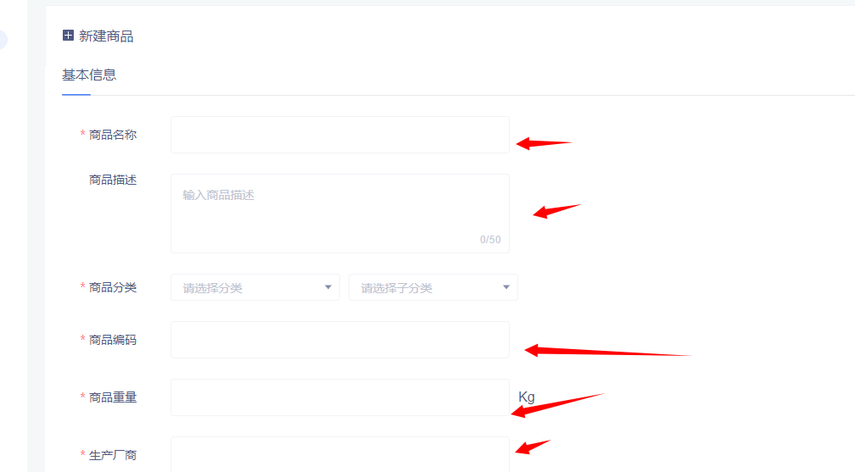

<base-layout-top class="layout-top">  
 <base-date datePlaceholder="请选择时间" textName="创建时间" :infoTime.sync="creatTime" class="date-wrap" @changeDate="changeDate"></base-date>  
 <base-search v-model="filter.keyword" placeholder="商户昵称/客户手机号" @search="searchBtn"></base-search>  
</base-layout-top>

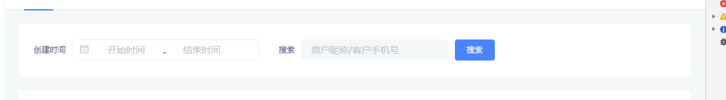

<base-modal :visible="checkVisible" width="534px" height="234px" title="审核" @close="checkVisible=false"  
 @submit="checkSubmit"  
>  
 <base-form-item label="选择审核结果" labelWidth="106px">  
 <radio v-model="edit.result" :list="radioList"></radio>  
 </base-form-item>  
 <base-form-item v-if="!edit.result" label="不通过原因" labelWidth="106px">  
 <base-input v-model="edit.reason" width="388"></base-input>  
 </base-form-item>  
</base-modal>

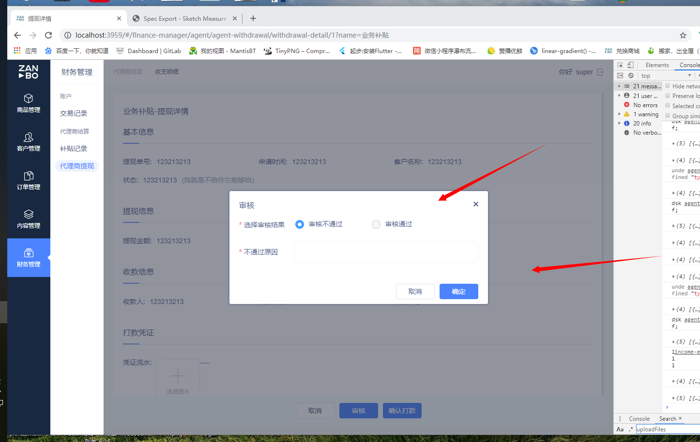

<base-pagination :total="total" :pageSize="filter.limit"

:currentPage.sync="filter.page" @pageChange="pageChange"></base-pagination>  


<base-search v-model="filter.keyword" placeholder="商户昵称/客户手机号" @search="searchBtn"></base-search>



<base-select v-model="filter.level" placeholder="账号等级" width="120" radius="2"></base-select>

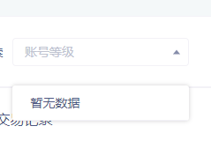

<base-table-tool :iconUrl="require('./icon-jyjl@2x.png')" title="交易记录">  
</base-table-tool>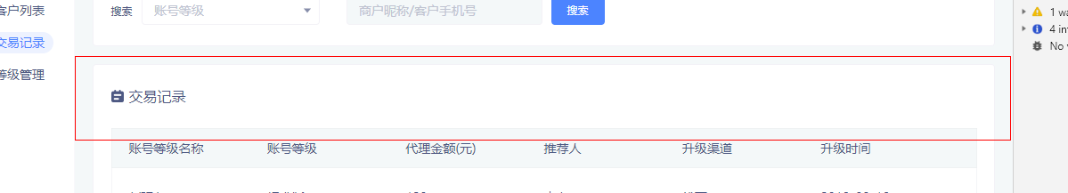

<base-table-tool :iconUrl="require('./icon-product_list@2x.png')" title="商品列表">  
 <base-status-tab slot="left" :statusList="statusList" :value.sync="filter.status" @change="statusChange"></base-status-tab>  
 <router-link tag="div" to="edit-product" append>  
 <base-button type="primary" plain addIcon>新建商品</base-button>  
 </router-link>  
</base-table-tool>



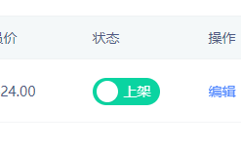<base-switch :status="item.status"@changeSwitch="changeSwitch(item,i)"></base-switch>

deleteBtn(item, idx) {  
 **this**.$confirm.confirm().then(**async** () => {  
 **await** API.Goods.deleteGoods({data: {id: item.id}, loading: **false**})  
 **this**._getList()  
 })  
},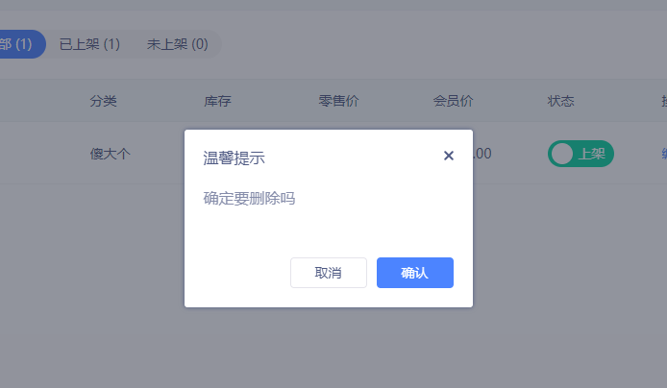

**this**.$toast.show(`会员价不能为空`)

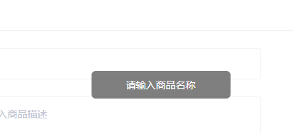

<cascade-select ref="cascadeSelect"  
 v-model="edit.category_id"  
 valueKey="id"  
 :inputStyle="{'min-width':'194px'}"  
 size="middle"  
 placeholder1="请选择分类"  
 placeholder2="请选择子分类"  
></cascade-select>



<goods-list-dialog v-if="visible" :visible.sync="visible" :otherParams="{group_id:currentGroup.id}" :limit="20" @submit="_addGoods"></goods-list-dialog>

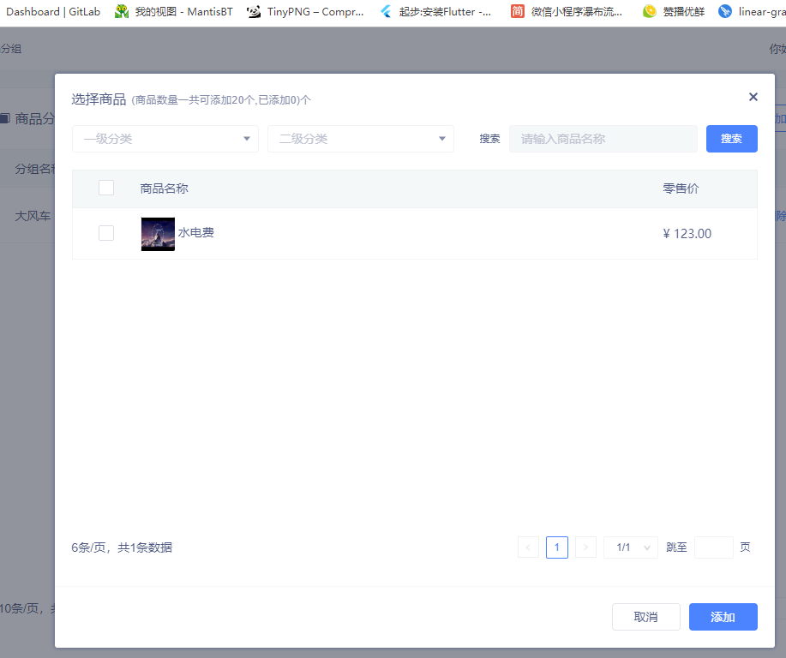

<title-line title="基本信息" class="top-title"></title-line>



<zb-checkbox :type="allCheckType" @click="selectAllGoodsBtn"></zb-checkbox>

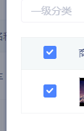

<zb-radio v-model="edit.specification_type" :list="specList" @change="changeType"></zb-radio>



<zb-tree v-if="list.length"  
 :data="list"  
 @edit-item="editItem"  
 @delete-item="deleteItem"  
 @add-item="addChildBtn"  
></zb-tree>

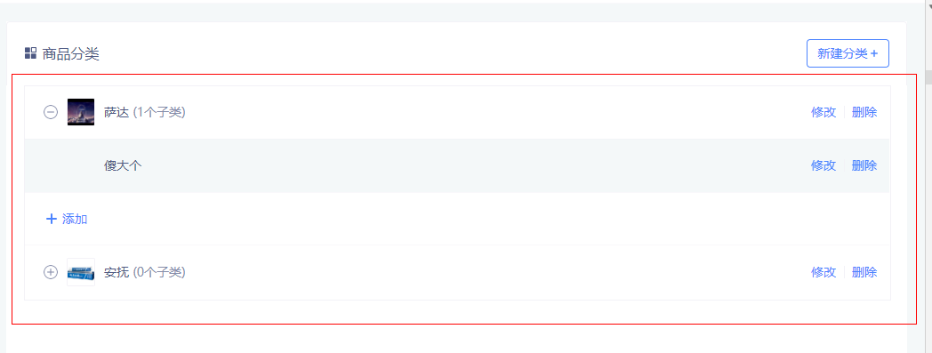<zb-upload :data.sync="edit.goods_detail_images" :addStyle="`margin:0 0 14px 0`" multiple firstTag="详情图"  
 tip="上传图片的格式png，jpeg，jpg，最多可上传15张。" :limit="15"  
 @successImage="getGoodsDetailImages"  
></zb-upload>

