17. Information Architecture and User Flows
Canonical information architecture, route system, and user-flow specification

Program | QuantPipeline - private modular portfolio decision platform
Document purpose | Canonical information architecture, route system, and user-flow specification
Status | Working baseline for design and delivery

This document defines the canonical route map, workspace hierarchy, and user flows for QuantPipeline. It is the connective tissue between product scope, UX principles, and the implementation contract used by frontend and backend teams.

1. Information architecture principles
- Organize around decisions, not around model vendors or data-source silos.
- Treat validation and operations as first-class routes, not buried utilities.
- Allow the user to move from summary to evidence to governance without breaking context.
- Preserve a stable shell so route changes feel like focus changes, not product changes.

2. Canonical sitemap
Top-level area | Representative routes | Primary purpose
Overview | /overview, /overview/watch, /overview/regime | triage, monitor, prioritize
Decision | /decision/:id, /decision/:id/challenge, /decision/:id/risk | review and challenge a thesis
Comparison | /compare/:id, /compare/matrix | compare engines and synthesize one stance
Validation | /replay/:snapshotId, /backtests, /paper | inspect historical behavior and paper decisions
Research | /news, /sentiment, /technical, /universe | contextual analysis and input discovery
Admin and ops | /ops, /ops/publication, /ops/incidents, /ops/policies | publication control and reliability

3. Route hierarchy and persistent shell
A route should determine the central canvas and its primary actions, while the surrounding shell remains familiar.
Shell zone | Persistent across routes | Route-specific behavior
Top bar | search, alerts, saved views, global filters | context subtitle and route actions change
Left nav | major sections and current location | sub-navigation adjusts to current top-level area
Center canvas | yes, but content changes by route | main analytical surface
Right context pane | confidence, risk, notes, metadata | content module stack changes by route
Bottom sheet on mobile | global action tray and context | opened context depends on current route

4. Screen inventory
Screen / module | Core objects | Default entry triggers | Must-link destinations
Overview home | recommendation summaries, regime indicators | login, daily revisit | decision, compare, risk
Decision workspace | recommendation object | overview click, alert click | comparison, replay, paper
Comparison matrix | engine outputs, disagreement analysis | decision challenge action | decision, risk, methodology
Risk workspace | portfolio exposures and constraints | risk CTA, breach alert | decision, paper, ops
Replay investigator | snapshot, events, realized outcome | incident or paper miss | ops incident, policy
Backtest lab | strategy runs, assumptions, scorecards | validation work | paper, decision, methodology
Paper portfolio | positions, proposals, drift alerts | monitoring work | decision, replay, ops
Ops command center | queues, health, incidents | operator entry | publication queue, incidents, policies

5. Primary user flows
The flows below are the minimum journeys that the design and QA process must explicitly validate.

Daily review flow
- Open overview
- Inspect top recommendation card
- Enter decision workspace
- Read evidence and risk summary
- Save, defer, or move to paper
Required outcome: A recorded decision state with timestamp and notes

Challenge flow
- Open a recommendation
- Navigate to comparison
- Inspect divergence and attribution
- Change one or more assumptions
- Return to decision workspace with delta preview
Required outcome: A revised recommendation or an explicitly deferred decision

Replay investigation flow
- Open replay from incident or paper alert
- Load historical snapshot
- Inspect inputs, state, and policy status
- Compare proposed action vs actual result
- Write ops note or create follow-up issue
Required outcome: A resolved investigation artifact

Operator publication flow
- Open ops command center
- Inspect publication queue item
- Check policy and health gates
- Approve, hold, or rollback
- Record explanation and actor
Required outcome: A controlled release action visible in audit history

6. State transitions and route hand-offs
From | To | What must persist | What may reset
Overview | Decision | selected recommendation, timeframe, universe | local sort order on overview widgets
Decision | Comparison | selected recommendation, scenario values | none unless user starts a fresh comparison
Decision | Replay | snapshot key, decision metadata | live-only transient controls
Backtests | Paper | selected strategy assumptions, comparison cohort | temporary chart toggles
Ops queue | Incident detail | item identity, current action rights | list scroll position only

7. Navigation rules and anti-patterns
- Do not create one route per data source if the user expects one decision workspace.
- Do not hide validation and replay behind admin-only patterns; they are part of core trust.
- Do not require the user to reconstruct the current recommendation when moving between comparison and risk.
- Avoid modal overload for critical flows; complex review belongs in full workspaces or drawers.

8. Mobile IA adaptation
Desktop pattern | Mobile equivalent | Reason
Persistent left nav | bottom navigation + more drawer | thumb reach and screen width
Right context rail | bottom sheet / stacked sections | preserve context without crowding
Dense comparison table | accordion rows with key metrics first | legibility
Multi-chart canvas | single primary chart per viewport | focus and performance

9. Flow instrumentation requirements
- Every key flow should emit entry, exit, and decisive action events.
- Instrumentation should distinguish passive viewing from active challenge behavior.
- Abandonment points in challenge and publication flows need explicit event markers.
- Route-level analytics should always include current persona, mode, and scope.

10. IA acceptance criteria
Question | Pass condition
Can the user find the next best action from overview? | yes, within one click
Does challenge preserve context? | yes, recommendation and assumptions persist
Can a replay investigation link back to the original decision? | yes, with stable identifiers
Are operator routes distinct but related to user routes? | yes, shared objects with role-specific actions
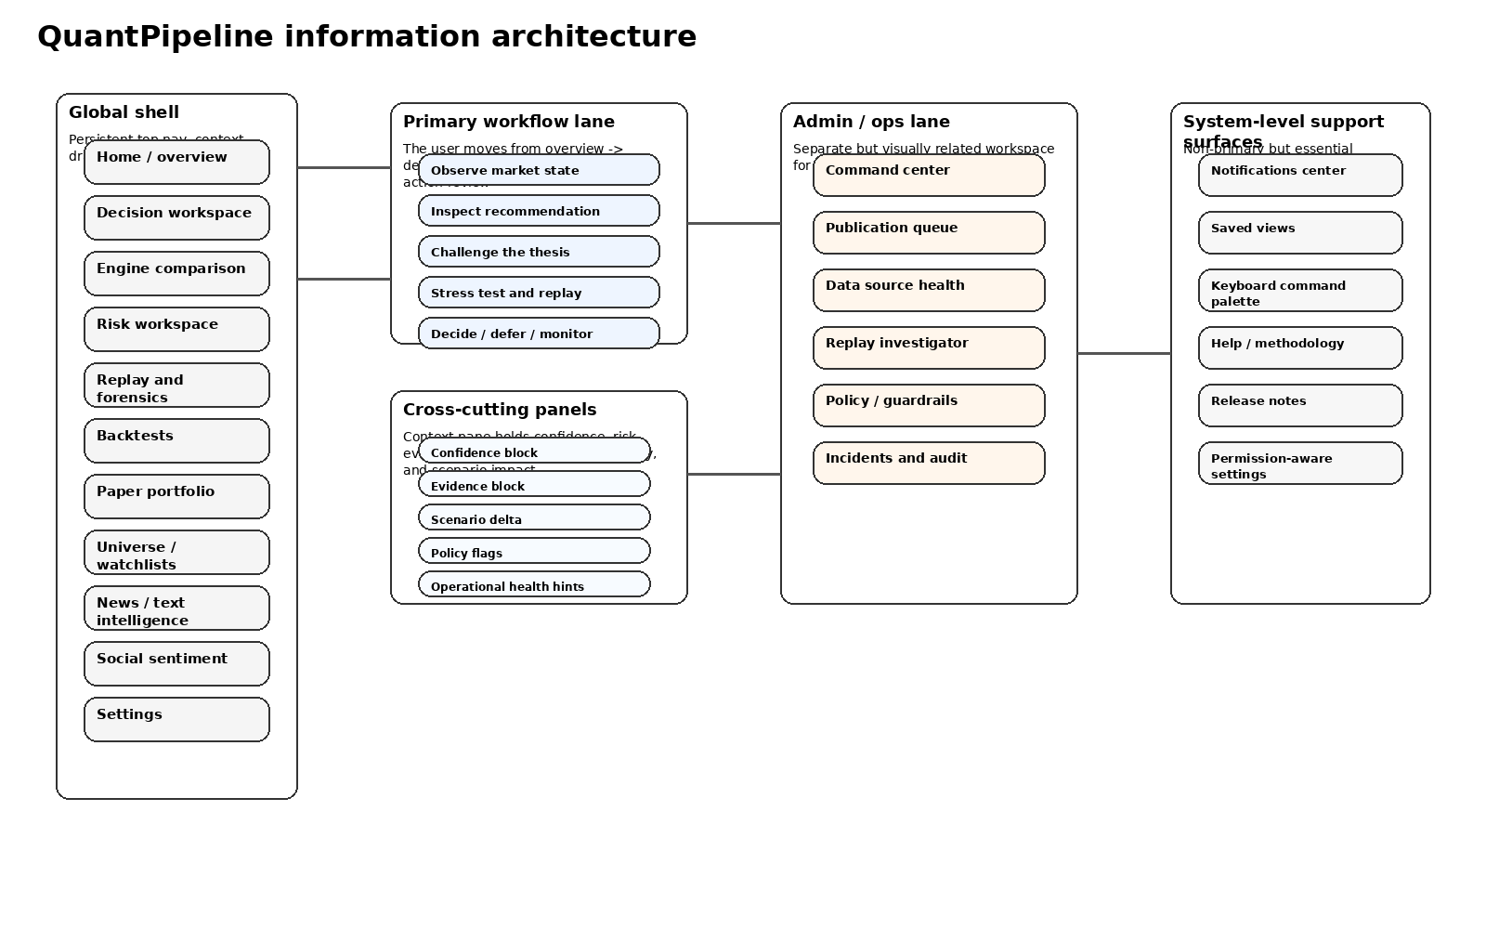
Figure 17-1. Canonical information architecture map.
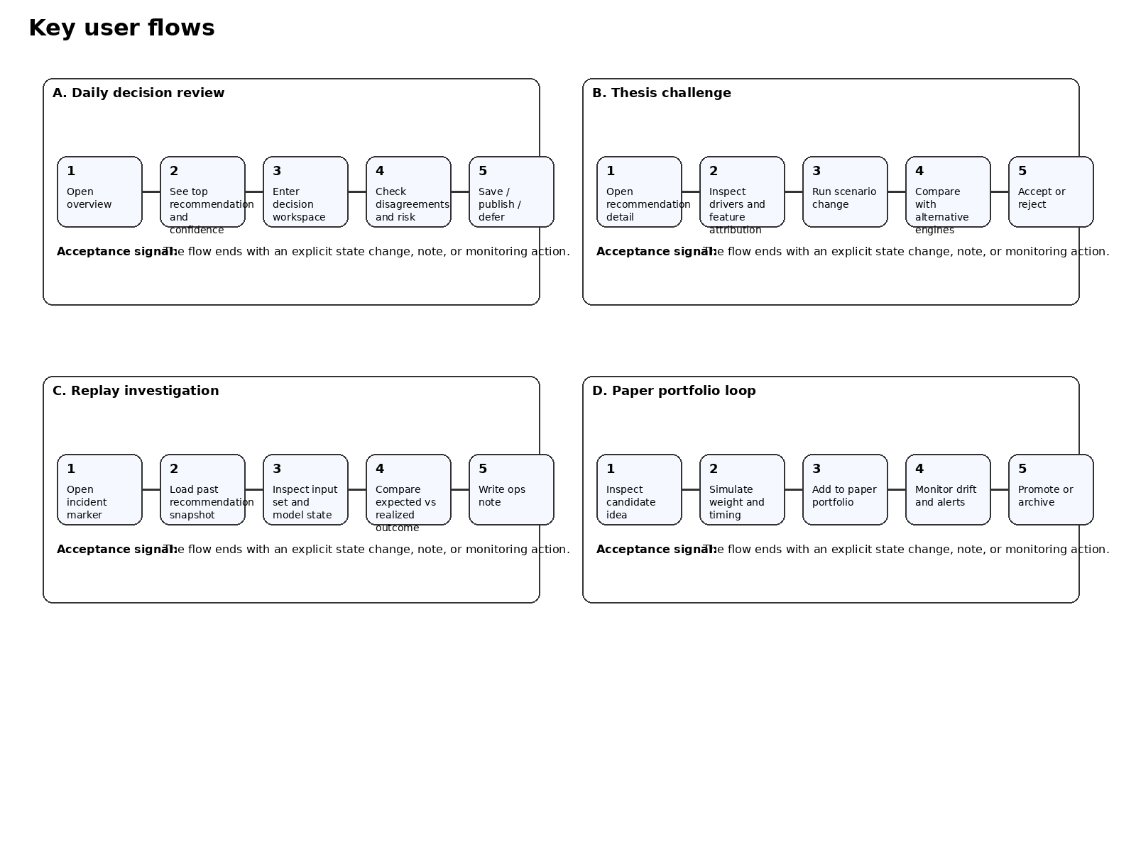
Figure 17-2. Four key flows that the product must support.

