19. Visual Design Direction
Visual language, charting posture, and interaction styling direction

Program | QuantPipeline - private modular portfolio decision platform
Document purpose | Visual language, charting posture, and interaction styling direction
Status | Working baseline for design and delivery

This document proposes the visual direction for QuantPipeline. It is not a frozen style guide but a constrained direction that should guide exploration and keep future screen work coherent.

1. Visual intent
The platform should feel credible, analytical, and calm. It should avoid both consumer-finance gamification and institutional terminal intimidation. The desired tone is high-trust, modern, and quietly sophisticated.
- Use clarity and contrast rather than ornamental intensity.
- Promote disciplined reading order through spacing and hierarchy.
- Reserve strong color for actions, risk states, and meaningful changes.
- Make dense data feel organized rather than crowded.

2. Color direction
Role | Suggested direction | Notes
Canvas and surfaces | cool neutrals and light slate backgrounds | support long sessions without glare
Primary action | clear blue family | must remain visible in both light and dark modes
Positive state | measured green | avoid neon trading-app aesthetics
Caution / review | amber | used for provisional states and needs-review flags
Failure / breach | red | reserved for policy, data, or risk breaches
Supportive accents | limited cyan or indigo | for charts and advanced analytical cues

3. Typography and rhythm
- Display typography is reserved for page titles and major metrics only.
- Section headings should be compact and unambiguous.
- Body text should stay short, especially in evidence narratives and methodology notes.
- Meta labels should be quiet but readable, never microscopic.

4. Card, table, and panel language
Element | Desired visual behavior | Avoid
Cards | soft elevation, clear title row, stable actions | shadow-heavy tiles with no hierarchy
Comparison tables | strong row striping or separators, sticky headers | low-contrast dense grids
Context panes | subtle background distinction, grouped modules | undifferentiated sidebars
Alerts | severity plus explanation plus next action | floating red badges without context

5. Charting direction
Charts should explain the recommendation, not compete with it. The default chart posture is direct labeling, minimal clutter, and explicit overlays for events, confidence ranges, and scenario changes.
- Prefer a small number of highly legible charts to many ornamental mini-charts.
- Use event markers and annotations to tie visible movements to evidence.
- When showing confidence or uncertainty, favor bands or intervals that are visually distinct but restrained.
- Legends should be minimized; direct labels or inline labels are preferred.

6. Motion and interaction styling
- Motion should reinforce structure: panel expansion, sheet emergence, state confirmation.
- Typical duration range should be fast and calm, roughly 150 to 220 milliseconds for most UI transitions.
- Hover, focus, disabled, and pressed states must be visually consistent across all controls.
- Reduced-motion accessibility support is mandatory from the start.

7. Iconography and illustration
- Use a simple line-icon family with consistent stroke weight.
- Icons help scanning but never replace textual meaning for high-stakes actions.
- Illustration should be reserved for empty states and guidance moments, not for analytical surfaces.

8. Light and dark mode posture
Theme rule | Implementation implication
Light mode is default baseline | optimize charts and dense tables here first
Dark mode is not inversion-only | re-tune contrast and semantic colors separately
Semantic states must map across modes | green, amber, and red must stay distinguishable
Charts need theme-specific tuning | gridlines, labels, and bands require separate values

9. Visual QA criteria
Criterion | Pass condition
Readability | Key metric, recommendation, and action visible at first glance
Restraint | No screen relies on more than a few strong color accents
Consistency | Cards, panes, and tables look like one system
Trust | Serious warnings and uncertainty cues are unmistakable
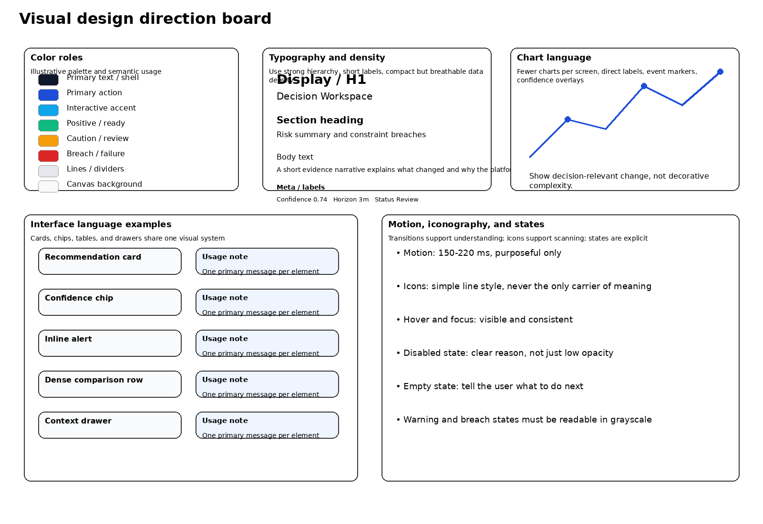
Figure 19-1. Visual design direction board with semantic palette, typography, and chart posture.

10. Composition rules for analytical screens
Composition rule | Explanation
One focal message per screen zone | Each zone should answer one question clearly instead of competing for attention
Visible breathing room around critical numbers | Key metrics and actions need separation from dense evidence
Narrative and chart adjacency | The user should not have to mentally reconnect a chart to the note that explains it
Stable action placement | Primary actions remain in predictable positions across screens

11. Brand expression and anti-goals
- The product should not imitate meme-stock, gaming, or casino-like financial apps.
- The product should not look like an engineering prototype held together by generic admin templates.
- A restrained premium tone is preferred over loud futurism.
- Brand presence should appear through consistency, confidence, and exactness rather than decoration.

12. Handoff guidance for future visual exploration
- Explore at least two density levels for desktop before locking the final system.
- Validate chart legibility in grayscale and reduced-width layouts early.
- Create paired light and dark examples for one decision screen and one ops screen before scaling the full library.

