20. Component Specification
Component inventory, states, behaviors, and accessibility rules

Program | QuantPipeline - private modular portfolio decision platform
Document purpose | Component inventory, states, behaviors, and accessibility rules
Status | Working baseline for design and delivery

This document defines the first component baseline for QuantPipeline. It is intentionally product-specific: components are described not only by appearance but by the analytical and operational jobs they must support.

1. Component system principles
- Components should encode product meaning, not just generic layout.
- Every component must define states, empty conditions, loading behavior, and error behavior.
- Keyboard and accessibility requirements are part of the component contract.
- Permissions and role differences should be handled through configuration, not ad-hoc duplication.

2. Component taxonomy
Category | Representative components | Primary responsibility
Shell and navigation | App shell, top bar, left nav, tabs, bottom nav | orientation and movement
Decision primitives | Recommendation card, confidence block, disagreement module, scenario controls | decision understanding and challenge
Data display | Metric strip, comparison table, chart container, timeline | evidence presentation
Operational controls | Queue item, approval bar, incident card, policy panel | admin and release control
Feedback | Inline alert, toast, empty state, skeleton, error panel | state communication
Inputs | search, filters, segmented controls, date range, sliders, multi-select | user control of scope and assumptions

3. Detailed component contracts

Recommendation card
Purpose: Presents one recommendation summary in overview or mobile contexts.
Required states: default, highlighted, provisional, saved, stale, unavailable
- Must define a compact variant and a full-detail variant where relevant.
- Must expose explicit status labels; color alone is insufficient.
- Must specify loading, empty, and failure behavior.
- Must define analytics events for decisive interactions.

Confidence block
Purpose: Separates model confidence, data quality, and operational readiness.
Required states: healthy, low-confidence, stale-data, degraded-ops
- Must define a compact variant and a full-detail variant where relevant.
- Must expose explicit status labels; color alone is insufficient.
- Must specify loading, empty, and failure behavior.
- Must define analytics events for decisive interactions.

Disagreement block
Purpose: Explains divergence across analytical engines.
Required states: aligned, mixed, severe divergence, unavailable
- Must define a compact variant and a full-detail variant where relevant.
- Must expose explicit status labels; color alone is insufficient.
- Must specify loading, empty, and failure behavior.
- Must define analytics events for decisive interactions.

Scenario control set
Purpose: Lets the user vary assumptions and preview deltas.
Required states: default, modified, validating, failed
- Must define a compact variant and a full-detail variant where relevant.
- Must expose explicit status labels; color alone is insufficient.
- Must specify loading, empty, and failure behavior.
- Must define analytics events for decisive interactions.

Comparison table
Purpose: Structured side-by-side view of engine outputs and dimensions.
Required states: normal, filtered, row-expanded, empty, loading
- Must define a compact variant and a full-detail variant where relevant.
- Must expose explicit status labels; color alone is insufficient.
- Must specify loading, empty, and failure behavior.
- Must define analytics events for decisive interactions.

Queue item
Purpose: Represents one publishable artifact in ops.
Required states: pending, approved, held, rolled back, escalated
- Must define a compact variant and a full-detail variant where relevant.
- Must expose explicit status labels; color alone is insufficient.
- Must specify loading, empty, and failure behavior.
- Must define analytics events for decisive interactions.

4. Shared state model for components
State layer | Rule
Default | Component has valid data and no special condition
Loading | Use skeletons or optimistic placeholders where appropriate
Empty | Explain why no content exists and what action can populate it
Degraded | Show partial data with cause and confidence implications
Error | Provide retry or investigation path
Permission-limited | Explain why action or data is unavailable to the current role

5. Accessibility requirements by component type
Component type | Accessibility rule
Navigation | clear focus order, landmark semantics, active-state identification
Cards | heading structure and readable action labels
Tables | header associations, keyboard row traversal, sticky headers
Charts | textual summary plus accessible labels for key values
Inputs | visible labels, helper text, error text, keyboard support
Alerts and toasts | severity plus readable message and dismiss behavior

6. Density and responsiveness rules
- Components should define responsive collapse behavior instead of relying on arbitrary CSS shrinkage.
- Dense desktop variants may exist, but they must still preserve readable headings and action affordances.
- Mobile variants should prioritize one primary insight and one primary action.

7. Tokenization guidance
- Expose spacing, radius, border, and elevation tokens consistently.
- Separate semantic color tokens from raw palette values.
- Text roles should use a documented token map: page title, section title, body, meta, table label.

8. Engineering and QA implications
Area | Expectation
Storybook / component preview | every major component should have state stories
Contract tests | critical state props validated by automated tests
Visual review | desktop and mobile snapshots for key states
Instrumentation | interaction events emitted consistently across variants

9. Acceptance checklist
Question | Pass condition
Does each critical component define all important states? | yes
Are accessibility rules part of the spec, not optional notes? | yes
Can admin variants reuse the same component family with role-specific behavior? | yes
Is responsiveness defined intentionally? | yes
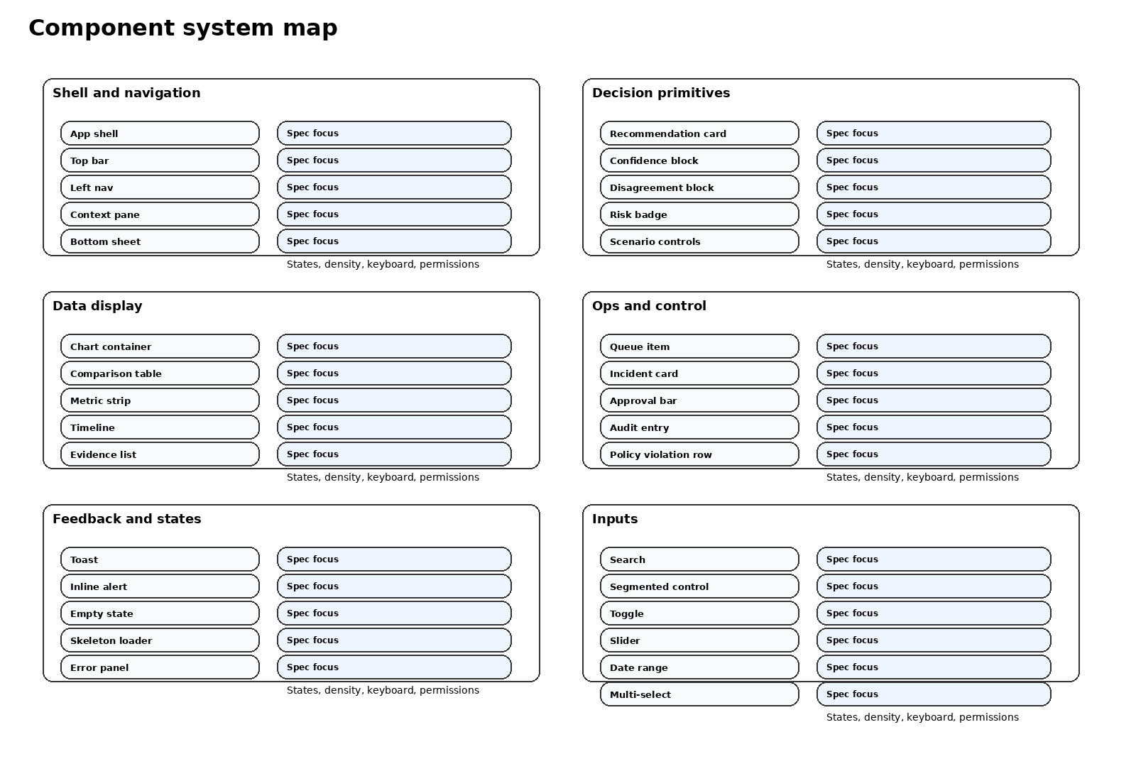
Figure 20-1. First-pass component system map.

10. Component-to-data contract expectations
Component | Minimum data contract | Failure fallback
Recommendation card | id, label, stance, weight, horizon, confidence trio | show unavailable state with explanation
Comparison table | row ids, metric schema, display order, provenance summary | show partial matrix and identify missing rows
Risk badge / strip | current exposure, threshold, status label | render textual status when visuals are unavailable
Queue item | artifact id, state, actor rights, timestamps | disable actions and surface retrieval error

11. Build priority and release staging
Priority tier | Components
Tier 1 for first release | app shell, recommendation card, confidence block, comparison table, alert system, queue item
Tier 2 after baseline | scenario controls, timeline, policy panel, incident card, dense tables
Tier 3 after adoption learning | advanced chart overlays, command palette, richer watchlist management

12. Component sign-off checklist
- The component name, purpose, states, and accessibility rules are documented in one place.
- A frontend implementer can tell which props are required and which are optional.
- QA can derive visual, functional, and role-aware test cases from the spec without product guesswork.

