02_Market_Survey_of_Equity_Analysis_Investment_Research_and_Decision_Support_Tools
Consulting-grade market landscape, workflow analysis, and product implications for the planned QuantPipeline medium-term investment decision-support platform
Prepared for product-definition and Claude-guided implementation planning Date: 22 April 2026

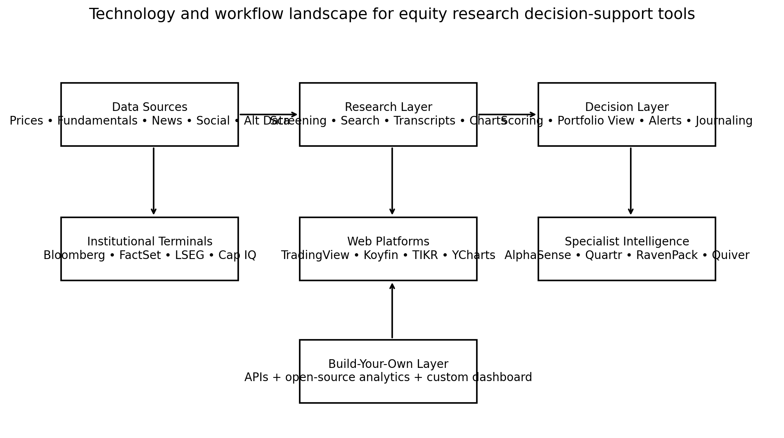
Figure 1. High-level technology and workflow landscape covered by this market survey.

Contents
- 1. Executive summary
- 2. Scope, methodology, and evaluation lens
- 3. Market structure and major product categories
- 4. Buyer needs and workflow decomposition
- 5. Detailed platform profiles
- 6. Cross-platform capability matrix
- 7. What the market is signaling for a private medium-term investor product
- 8. Build-vs-buy implications for QuantPipeline
- 9. Strategic opportunities and risks
- 10. Recommended product stance
- Appendix A. Source notes
The report therefore recommends a hybrid approach: license or integrate commodity inputs where practical, reuse open-source analytics where useful, and keep proprietary effort focused on ranking, evidence binding, review loops, and user experience.
The products surveyed repeatedly signal four durable requirements: first-class text workflows, strong watchlist and alert logic, clear desktop-plus-mobile continuity, and explicit trust signals around ranked outputs. These requirements should drive later UX and technical specification documents.
For QuantPipeline, the strongest design direction is synthesis rather than raw breadth. The product should explain why a name deserves attention, what evidence supports or contradicts the thesis, whether the technical picture confirms the narrative, what changes would invalidate the position, and how the decision fits the portfolio.
The market is fragmented by workflow. Institutional terminals dominate breadth and trust, text-intelligence platforms dominate qualitative compression, charting products dominate technical legibility, and open-source tools dominate flexible analytics for custom builders. No single platform is best across all layers for a single-user medium-term process.
“Truth only” conclusion: the market does not support building a broad, all-purpose retail Bloomberg clone for this project. The evidence points instead to a narrower and stronger opportunity: a private decision-support cockpit for medium-term equity investing that synthesizes text, sentiment, technical state, and portfolio context into one evidence-backed workflow.

1. Executive summary

2. Scope, methodology, and evaluation lens
The scope of this survey is centered on tools that materially shape equity research and medium-term investment decision support. The focus is on workflows measured in weeks to months rather than intraday execution. That shifts the evaluation toward products that help users discover ideas, understand changing narratives, compare evidence, detect signal deterioration, and decide when to enter, size, trim, or exit positions.
The review method combined three lenses. The first lens was platform capability: data breadth, research depth, news and text intelligence, technical-analysis depth, portfolio decision support, mobile usability, export or API potential, and relative accessibility. The second lens was workflow fit: how each product supports idea generation, thesis building, watchlist monitoring, trigger detection, and post-decision review. The third lens was product implication: what the existence of each competitor should change in the planned QuantPipeline architecture and UX.
Because the project is intended for personal use, the survey gives disproportionate weight to synthesis quality, clarity, and practical integration. Enterprise procurement features such as permissions, entitlements, and advisor compliance were considered only when they reveal durable workflow lessons. Exact pricing was not used as a primary comparison axis because vendor contracts change frequently, and pricing often depends on organization type and negotiated bundles. Instead, affordability is used as a relative positioning factor.
The report should therefore be read as a design input rather than a simple vendor ranking. A platform may be excellent in its category yet still be the wrong direct solution for a single-user product. Conversely, a relatively lightweight retail platform may offer highly instructive UX patterns even when its data or analytics depth is not institutional grade.
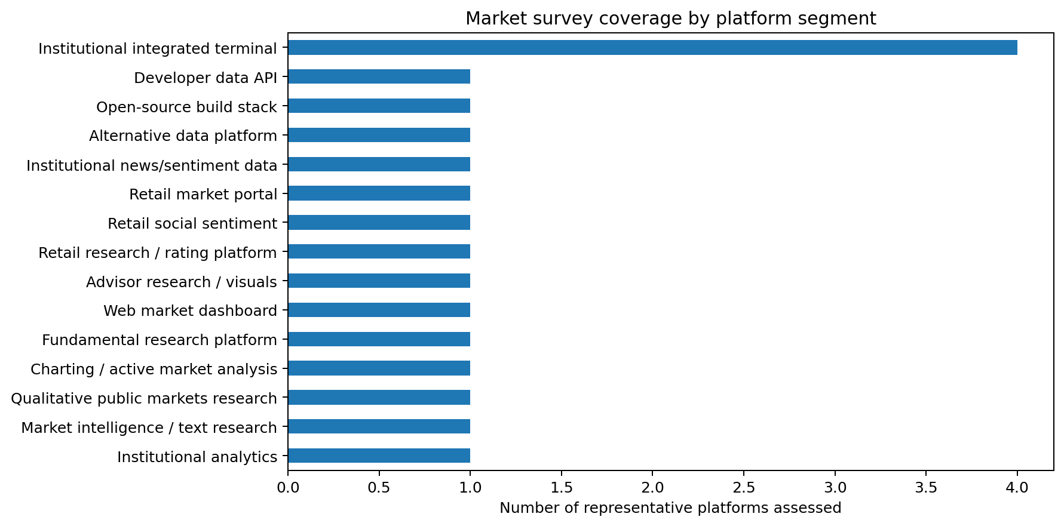
Figure 2. Representative market coverage by product segment.
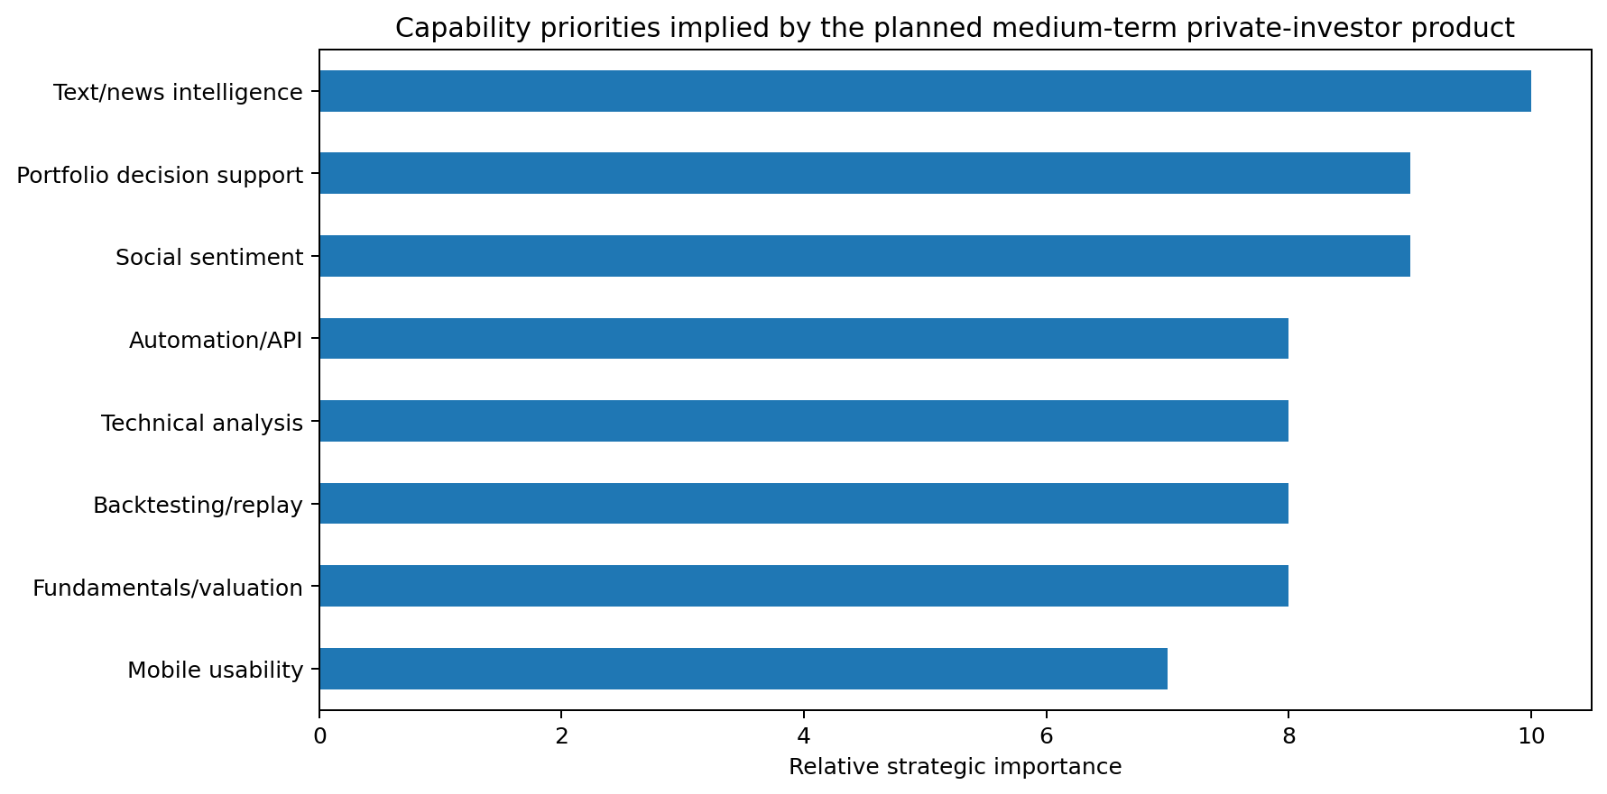
Figure 3. Capability priorities implied by the planned product vision.
Evaluation dimensions used throughout the report:
- Data breadth: quality and breadth of prices, fundamentals, estimates, documents, and alternative data.
- Research depth: screening, valuation, transcript exploration, and support for multi-step investigation.
- News/text intelligence: ability to search, summarize, classify, and compare news, filings, transcripts, and commentary.
- Technical-analysis depth: charting, indicators, alerts, multi-timeframe use, and visual analysis quality.
- Portfolio decision support: watchlists, exposure views, alerts, what-if analysis, and decision journaling potential.
- Mobile usability: quality of mobile or responsive usage for triage and monitoring.
- API/export potential: practical ability to pull data or integrate outputs into a custom stack.
- Affordability/accessibility: relative ease of adoption for a personal project or single-user workflow.

3. Market structure and major product categories
The market can be understood as four stacked layers plus an open-source build layer. The first layer is the institutional integrated terminal. This is where Bloomberg Terminal, FactSet, LSEG Workspace, S&P Capital IQ Pro, and Morningstar Direct sit. These products aggregate data, news, screening, charting, modeling, and portfolio workflows into a unified environment. Their advantage is breadth and trust. Their disadvantage is complexity, cost, and occasional interface density that assumes professional repetition rather than selective use.
The second layer is the specialist research-intelligence layer. AlphaSense and Quartr are the clearest reference points in this survey. They are less concerned with being full market terminals and more concerned with helping users interrogate management commentary, filings, transcripts, broker notes, and thematic evidence. In a world where narrative change often leads price change, this layer has become strategically important even for investors who still rely on other tools for charting or screening.
The third layer is the web-native market analysis and visualization layer. TradingView, Koyfin, TIKR, YCharts, Seeking Alpha Premium, and Yahoo Finance Premium all sit here with different emphases. TradingView is chart-led. Koyfin is dashboard-led. TIKR is fundamental-model-led. YCharts is advisor-visualization-led. Seeking Alpha is community-and-rating-led. Yahoo Finance is portal-and-monitoring-led. These tools matter because they often set the standard for responsiveness, discoverability, and cross-device continuity.
The fourth layer is the specialist data and sentiment layer. RavenPack, Quiver Quant, Stocktwits, and Alpha Vantage represent different ways of packaging data that institutional or custom systems can ingest. RavenPack treats text as structured quantitative input. Quiver packages alternative data that can sharpen attention or context. Stocktwits exposes crowd mood and retail attention. Alpha Vantage reduces friction for developers who need market data, indicators, and some sentiment coverage without building an entire data ingestion estate from scratch.
The fifth layer is the open-source quant stack. vectorbt, QuantStats, and backtrader are not direct substitutes for commercial products, but they are strategically important because they lower the barrier to custom research, replay, and analytics workflows. They are particularly relevant to a FINRL-X-adjacent product because they provide the scaffolding for simulation, backtesting, performance attribution, and report generation even when market data and proprietary signal logic come from elsewhere.

Figure 4. The market works as a layered workflow stack rather than a single vendor hierarchy. The planned product should position itself at the synthesis layer.
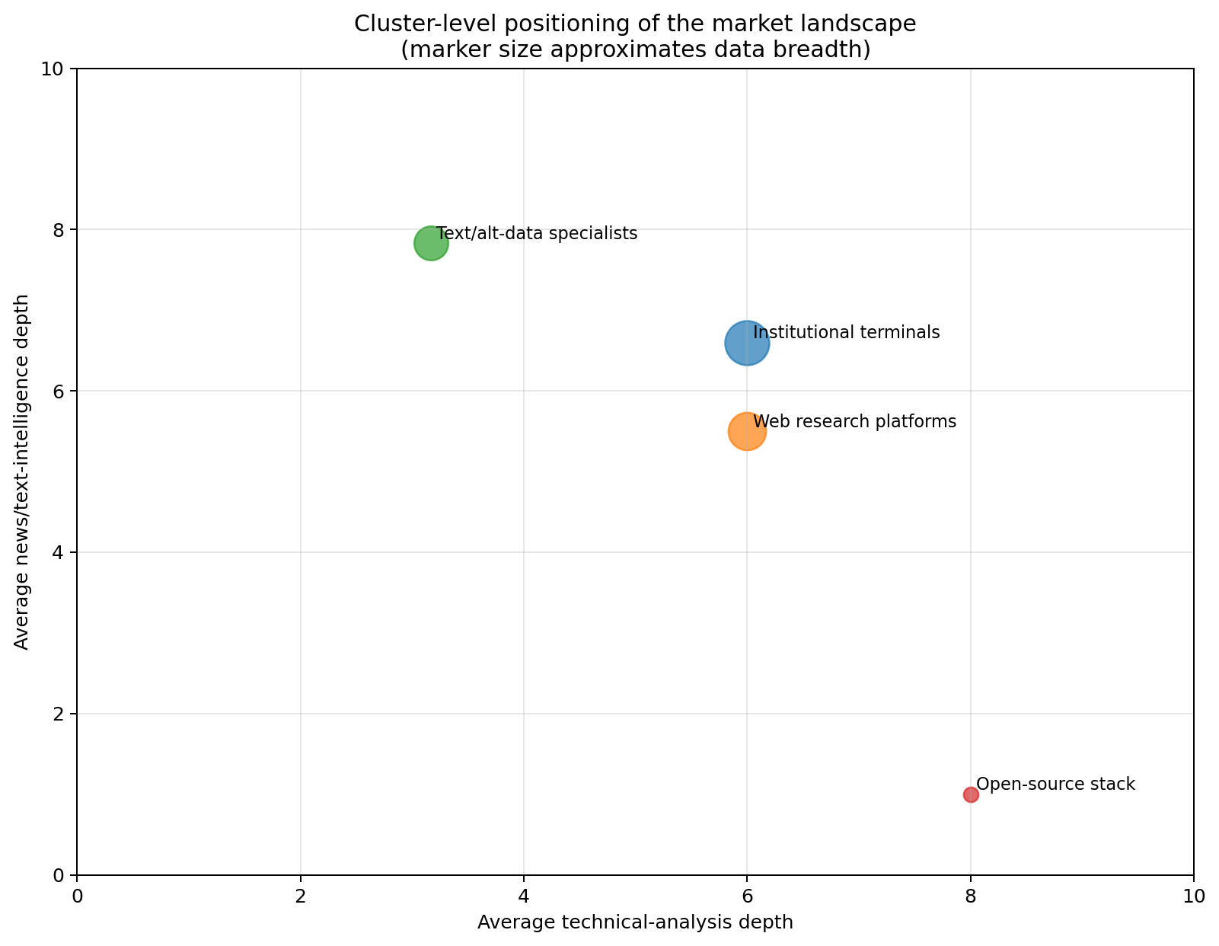
Figure 5. Cluster-level positioning across technical depth and text-intelligence depth.
Implication for product design:
- The planned system should not attempt parity with institutional terminals on data breadth alone.
- The differentiating experience should sit one layer above raw data: synthesis, prioritization, evidence trails, and decision framing.
- Open-source components can replace some analytics plumbing, but not the need for careful data governance and curated UX.

4. Buyer needs and workflow decomposition
Most tools market themselves by feature lists, but investors experience them through workflows. For a medium-term equity process, the workflow usually begins with attention capture. Something changes: news momentum accelerates, management tone shifts, an analyst estimate changes, a chart structure improves, a social discussion cluster emerges, or a watchlist name crosses a threshold. The platform then needs to decide whether the user should ignore, monitor, or investigate the change.
The second workflow stage is thesis building. Here, the investor collects evidence around business quality, valuation context, estimate direction, management language, catalysts, risks, and market structure. The best tools reduce the distance between raw evidence and a reasoned conclusion. AlphaSense and Quartr are especially strong in this stage because they compress document search and transcript navigation. TIKR, FactSet, S&P Capital IQ Pro, and Morningstar Direct contribute through comparable company data, structured financial statements, and estimate histories.
The third workflow stage is trigger design and monitoring. Once a thesis exists, the investor needs structured watchlists, alert logic, chart context, event calendars, and a way to distinguish signal from noise. TradingView is particularly influential here because it makes state changes visually legible. Yahoo Finance and Seeking Alpha matter because they show how mainstream products keep users engaged through alerts and portfolio-centric views. Institutional terminals matter because they demonstrate how mature watchlist and monitor views can become operating systems for daily review.
The fourth workflow stage is decision review. After entry, trim, or exit, high-quality systems help the investor understand whether the signal stack behaved as expected. This includes performance context, attribution, replay, and post-mortem notes. Open-source tools such as vectorbt and QuantStats are strong here because they make custom performance and risk reporting accessible. Few mainstream research products solve this stage elegantly for individual investors, which creates a meaningful design opportunity.
Seen through this workflow lens, the product opportunity becomes clearer. The market has many places to read data and many places to chart. It has fewer places where a medium-term investor can see a unified, evidence-backed explanation of what changed, what matters now, what would confirm the thesis, and what would invalidate it. That is the design center this report recommends.
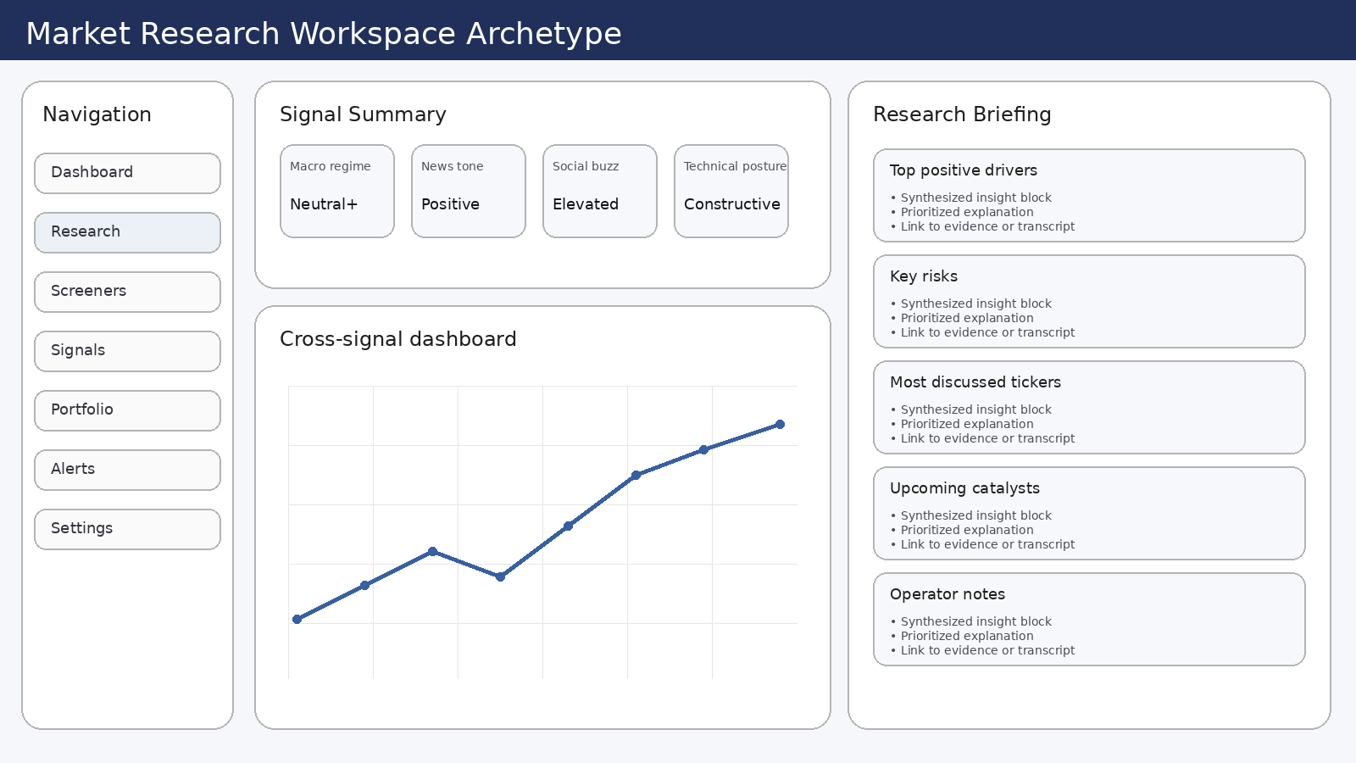
Figure 6. Illustrative desktop research-workspace archetype showing the type of synthesis-first interface the market suggests.
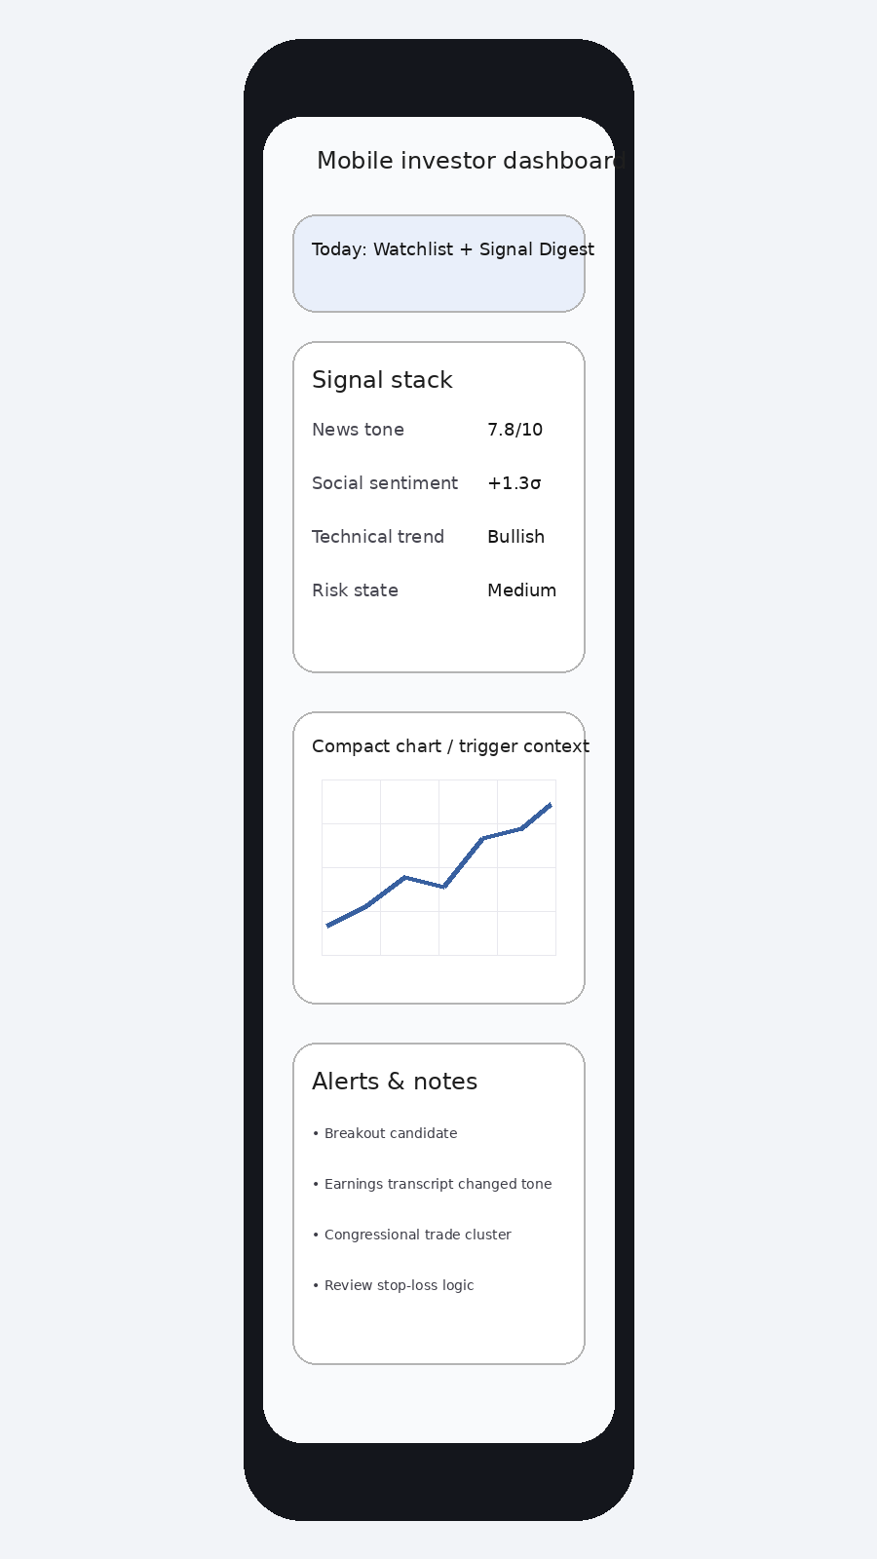
Figure 7. Illustrative mobile dashboard archetype focused on triage, alerts, and continuity from desktop.
Workflow design requirements inferred from the market:
- Attention capture must be ranked and explained; a feed without prioritization is insufficient.
- Thesis building must bind together text evidence, structured metrics, technical state, and watchlist relevance.
- Monitoring must be watchlist-centric, not merely ticker-centric.
- Review must include a memory layer: what the system believed before, what changed, and how the decision turned out.

5. Detailed platform profiles

Bloomberg Terminal
Category: Institutional integrated terminal | Relative fit: Institutional benchmark | Notable strengths: Real-time market data, News and workflows, Excel integration, Broad cross-asset coverage
Bloomberg Terminal remains the archetype of the fully integrated market workstation. Official materials emphasize real-time data, news, analytics, communication, and execution workflows in a single environment [S1]. For this survey, Bloomberg matters less as a direct procurement candidate and more as the benchmark that shapes user expectations around information density, speed, and credibility. When investors say a product feels 'institutional', they are often reacting to interface patterns that Bloomberg normalized years ago.
From a workflow perspective, Bloomberg excels at keeping the user inside one evidence universe. News, price action, watchlists, estimates, company documents, and alerts can be navigated without switching mental models. The trade-off is complexity. A product optimized for a single-user personal workflow should study Bloomberg's density and auditability, but not inherit its command-structure burden.
Product implication for QuantPipeline: use Bloomberg as a reference for information hierarchy, watchlist seriousness, and evidence traceability, not as a blueprint for breadth or keyboard-driven navigation.

FactSet
Category: Institutional integrated terminal | Relative fit: Institutional benchmark | Notable strengths: Deep fundamentals, Screening/modeling, Portfolio analytics, Workflow integration
FactSet positions its workstation around research, analytics, portfolio workflows, and connected productivity integrations [S2]. It is especially relevant as a benchmark for how structured fundamentals and portfolio views can coexist without becoming visually chaotic. Compared with Bloomberg, FactSet often feels more modular and more explicitly oriented toward research teams, analysts, and asset managers.
FactSet is strong where a workflow requires moving from screening to detailed company analysis to portfolio implications. It shows the importance of preserving context: users should not lose their rationale when moving from a stock view to a basket or portfolio view. This is directly relevant to QuantPipeline, which should never force the user to rebuild context when moving between signal, thesis, and position perspectives.
Product implication: emulate FactSet's continuity between security-level analysis and portfolio consequences, while avoiding unnecessary enterprise process overhead.

LSEG Workspace
Category: Institutional integrated terminal | Relative fit: Institutional benchmark | Notable strengths: News and data, Charting, Datastream history, Desktop/web/mobile
LSEG Workspace represents the evolution of the Refinitiv/Eikon lineage into a broader desktop and web workspace with strong data, news, charting, and time-series capabilities [S3][S4]. The product is influential because it demonstrates that institutional-grade research can be distributed across desktop, browser, and mobile surfaces with more coherence than legacy terminals historically provided.
Workspace is particularly informative for products that want to balance market monitoring and deeper research. It suggests that the future state for serious investors is not a single monolithic screen, but a persistent environment where charting, news, and analytic context are mutually aware. That principle fits the planned QuantPipeline approach very well.
Product implication: study Workspace for cross-surface continuity, modular panes, and the coexistence of charting with document-led workflows.

S&P Capital IQ Pro
Category: Institutional integrated terminal | Relative fit: Institutional benchmark | Notable strengths: Fundamentals, Private/public company coverage, GenAI document tools, Excel workflow
S&P Capital IQ Pro is built around extensive public and private company data, screening, Excel-connected workflows, and, increasingly, AI-assisted document analysis [S5][S6]. For this survey it matters because it links deep structured data with newer text-centric workflows rather than treating them as separate categories.
The platform is less chart-led than TradingView and less portal-like than Yahoo Finance. Its strength is disciplined research depth and the ability to move from company context to comparable sets, filings, estimates, and documents. The addition of AI-powered document analysis is strategically important because it confirms that textual synthesis is now a mainstream expectation in professional research environments.
Product implication: use Capital IQ Pro as a benchmark for company dossier depth and for how AI can accelerate document analysis without replacing verifiable evidence.

Morningstar Direct
Category: Institutional analytics | Relative fit: Institutional benchmark | Notable strengths: Portfolio analytics, Manager/fund research, Wealth workflows, Data consistency
Morningstar Direct is highly relevant where portfolio analytics, manager research, and standardized data are central [S7]. It is not the flashiest product in the surveyed set, but it is a useful benchmark for disciplined, repeatable analytical workflows. Its design logic prioritizes decision support over moment-to-moment market excitement.
For QuantPipeline, Morningstar Direct is a reminder that not every high-value screen needs to optimize for immediacy. Some screens should optimize for deliberation: how exposures are evolving, what concentrations exist, and how a thesis fits the broader portfolio. This becomes more important as the planned product matures from signal discovery into capital allocation support.
Product implication: borrow portfolio-discipline patterns and reporting clarity, especially for review and allocation screens.

AlphaSense
Category: Market intelligence / text research | Relative fit: Text intelligence leader | Notable strengths: Search across docs, Broker research, Generative search, Deep qualitative workflows
AlphaSense sits near the front of the market-intelligence category, with official positioning around market intelligence, document search, broker research, generative AI, and thematic discovery [S8]. It matters because it collapses a large portion of the qualitative research process into a fast, searchable environment. Instead of reading every document sequentially, the user can pivot by theme, keyword, management claim, or change in tone.
For a medium-term investor, AlphaSense demonstrates that text research is no longer a specialist workflow; it is a central decision input. Earnings calls, filings, and research notes often contain earlier evidence of thesis change than price charts do. AlphaSense also teaches an important UX lesson: when text volume is high, users need summaries and semantic search, but they still need the original excerpt and source context within easy reach.
Product implication: the QuantPipeline product should treat text intelligence as first-class, with evidence snippets, traceable links to sources, and explicit change detection.

Quartr
Category: Qualitative public markets research | Relative fit: Qualitative research specialist | Notable strengths: Transcripts and filings, Earnings workflows, AI summaries/chat, Mobile-friendly
Quartr has become a significant reference point for public-markets qualitative research, especially around earnings calls, transcripts, filings, summaries, and alerts [S9]. It is noteworthy because it packages high-value investor content in a relatively accessible, modern interface and places strong emphasis on mobile continuity. That matters for a serious investor who monitors developments away from the desk.
Quartr's design logic is focused and opinionated. It does not try to become everything. Instead, it tries to become the fastest route from company event to usable understanding. This is a crucial lesson for QuantPipeline: a narrower but more coherent workflow can outperform a broader feature set that feels scattered.
Product implication: study Quartr closely for event-driven research flows, transcript navigation, summary presentation, and mobile-friendly briefing design.

TradingView
Category: Charting / active market analysis | Relative fit: Charting leader | Notable strengths: Advanced charting, Social ideas, Screeners, Cross-device UX
TradingView is the clearest market leader in chart-led analysis among broadly accessible platforms [S10]. Its importance extends beyond indicators and drawing tools. It has normalized a standard of interaction speed, cross-device responsiveness, social idea sharing, and screen cleanliness that many users now expect from any serious market-facing interface.
While the planned product is not primarily a charting platform, TradingView shows how technical context can be made legible to a wide range of users without dumbing it down. States are visually obvious. Alerts are actionable. Layouts are flexible. This is especially valuable for a medium-term investor who does not want to live in technical indicators all day but still wants decisive confirmation or invalidation signals.
Product implication: adopt TradingView-grade clarity for charts and triggers, but do not let charting dominate the product identity.

Koyfin
Category: Web market dashboard | Relative fit: Affordable market dashboard leader | Notable strengths: Dashboards, Charts, Macro + equities, Institutional-like UX
Koyfin is one of the most instructive comparators for the planned product because it offers a web-native, dashboard-oriented environment that feels more approachable than an institutional terminal while still serving serious analytical workflows [S11]. It demonstrates that users value curated panels, linked views, and the ability to move quickly among macro, equity, and relative-performance contexts.
Koyfin is especially useful as a reference for layout philosophy. It balances overview and depth effectively and avoids some of the friction associated with legacy terminals. For a personal decision-support product, that balance is highly relevant: the user wants to move from watchlist view to stock detail to macro backdrop without feeling lost or overburdened.
Product implication: Koyfin is one of the strongest direct UX references for the dashboard layer of QuantPipeline.

TIKR
Category: Fundamental research platform | Relative fit: Fundamental value research leader | Notable strengths: Financial statements, Analyst estimates, Valuation, Transcripts
TIKR is a strong specialist in fundamental equity research, with emphasis on financial statements, estimates, valuation, and transcript access [S12]. It appeals to users who need structured company analysis without paying institutional-terminal costs. The platform shows that there is durable demand for a focused research tool that does a smaller number of jobs very well.
For QuantPipeline, TIKR matters because it proves users will tolerate less visual flourish if the underlying research workflow is efficient and trustworthy. It is also a useful reminder that medium-term decision support still depends on clean access to valuation and estimate context, even when the product's differentiation is broader than fundamentals alone.
Product implication: build clean bridges from signals into valuation and estimate context; do not force users to open a separate mental workspace for basic fundamental interpretation.

YCharts
Category: Advisor research / visuals | Relative fit: Advisor workflow specialist | Notable strengths: Visuals, Portfolio construction, Reporting, Advisor workflows
YCharts is best known for investment research visuals, portfolio construction, and reporting flows, especially in advisor contexts [S13]. It is relevant because it treats communication and comparison as first-class features. Many products help users arrive at a conclusion; fewer help them explain the conclusion clearly, even to themselves.
This becomes important for the planned product's note-taking and journaling layers. A medium-term investor often benefits from restating the case: what the system believes, what evidence drives the rating, and why it may be wrong. YCharts highlights how visuals can aid disciplined interpretation rather than merely adding aesthetic polish.
Product implication: use YCharts as a reference for report-like visual clarity, comparison cards, and decision-review pages.

Seeking Alpha Premium
Category: Retail research / rating platform | Relative fit: Retail idea generation leader | Notable strengths: Quant ratings, Crowd + editorial research, Portfolio alerts, Screeners
Seeking Alpha Premium combines editorial and community research with quant ratings, screeners, portfolio tools, and alerts [S14]. Its significance lies in the way it packages idea generation. Users are not merely given raw data; they are given ranked attention. That can be noisy, but it is powerful. Many investors want a starting point, not just a database.
For QuantPipeline, Seeking Alpha is a cautionary and instructive example. The positive lesson is that users value synthesized rankings and thesis-ready prompts. The caution is that community-driven or black-box scores can create false confidence if the evidence chain is weak. A stronger private tool should therefore preserve explainability whenever it produces ranked outputs.
Product implication: ranked idea surfacing is valuable, but every score should be paired with supporting evidence and explicit uncertainty.

Yahoo Finance Premium
Category: Retail market portal | Relative fit: Broad retail default | Notable strengths: News, Portfolio tracking, Advanced charts, Research reports
Yahoo Finance remains one of the most familiar mainstream investor portals, with news, portfolios, advanced charts, screeners, and research reports [S15]. Although it is not a deep specialist in any single category, it sets expectations for accessibility, broad market coverage, and casual monitoring. Users return because it is easy to check, not because it is analytically exhaustive.
This makes Yahoo Finance a useful benchmark for engagement and alert loops. A serious private product still needs low-friction entry points. Not every session begins with a deep thesis review. Some sessions begin with a quick glance at what moved and why. The better the product handles this low-intensity usage mode, the more likely users are to remain inside its ecosystem.
Product implication: maintain a lightweight portal mode alongside deeper analytic views.

RavenPack
Category: Institutional news/sentiment data | Relative fit: Structured news sentiment leader | Notable strengths: News analytics, Sentiment datasets, Quant workflows, Institutional usage
RavenPack is a benchmark for structured news analytics and sentiment at institutional scale [S16]. It demonstrates how textual information can be transformed into quantitative features rather than treated as purely narrative context. For a FINRL-X-adjacent architecture, this is strategically important because it shows how news can become a direct model input and not just a reading layer for humans.
RavenPack also highlights the boundary between product experience and data infrastructure. Much of its value exists behind the scenes as machine-readable signals. This is a good reminder that some of the strongest capabilities in QuantPipeline will not be visible as standalone UI elements; they will manifest as better ranking, alerting, and explanation quality.
Product implication: where possible, design the internal system so text features are reusable across ranking, replay, backtesting, and user-facing explanation.

Quiver Quant
Category: Alternative data platform | Relative fit: Alternative data specialist | Notable strengths: Government data, Insider/politician tracking, API access, Alerts
Quiver Quant packages alternative datasets such as politician trading, government signals, and other public-interest data in a way that is more accessible than building those feeds independently [S17]. For a personal product, this is useful not because every data source is essential, but because it shows how differentiated context can sharpen attention. An unusual data point can act as a catalyst lens or tie-breaker.
The deeper lesson is selective enrichment. Many platforms fail by trying to display every alternative metric all the time. Quiver is most useful when it surfaces context selectively. That pattern should carry into QuantPipeline: alternative data should not clutter the primary workflow unless it materially changes interpretation.
Product implication: support optional enrichment cards and catalyst overlays rather than forcing alternative data into every dashboard state.

Stocktwits
Category: Retail social sentiment | Relative fit: Social pulse signal | Notable strengths: Real-time conversation, Retail attention/sentiment, Mobile app, Trend surfacing
Stocktwits is not a replacement for rigorous research, but it is a practical reference for social attention and retail sentiment flows [S18]. It excels at surfacing what large online communities are suddenly discussing. For a medium-term investor this can be relevant as an attention signal, a volatility warning, or a sign that narrative momentum is shifting faster than mainstream news coverage suggests.
The risk with social platforms is obvious: sentiment is noisy, reflexive, and easily gamed. Yet ignoring it entirely can leave the investor blind to retail-driven narrative acceleration. The design challenge is therefore not whether to use social sentiment, but how to scale and qualify it responsibly.
Product implication: incorporate social sentiment as one layer in a multi-factor explanation stack, never as a standalone decision authority.

Alpha Vantage
Category: Developer data API | Relative fit: Developer-friendly data layer | Notable strengths: Market data APIs, Technical indicators, News sentiment API, Low-friction access
Alpha Vantage represents the developer-friendly API layer, with market data, technical indicators, and a News & Sentiment API exposed in a relatively low-friction way [S19]. It is valuable less as a destination product and more as evidence that practical data access matters. If a custom system cannot obtain clean data economically, elegant UX will not save it.
For QuantPipeline, Alpha Vantage is a reminder to distinguish between strategic and tactical dependencies. A developer API may be sufficient for early-stage prototyping, benchmarking, and low-cost iteration even if it is not the ultimate data backbone for a production-grade private system.
Product implication: adopt a staged data strategy in which lower-friction APIs accelerate prototyping while the architecture remains ready for higher-quality sources later.

vectorbt + QuantStats + backtrader
Category: Open-source build stack | Relative fit: DIY quant stack | Notable strengths: Backtesting, Analytics, Flexibility, Python-native
The open-source stack centered on vectorbt, QuantStats, and backtrader is highly relevant even though it is not a polished SaaS competitor [S20][S21][S22]. vectorbt enables vectorized portfolio and signal research. QuantStats produces rich performance analytics and tear sheets. backtrader remains a familiar event-driven backtesting framework. Together, they demonstrate how much analytic depth can be assembled outside commercial terminals.
This matters for QuantPipeline because the product is not merely a dashboard. It needs replay, validation, and post-trade review. Open-source tools provide leverage here, especially if the proprietary part of the system focuses on signal orchestration, evidence binding, and interface quality rather than reinventing every analytics primitive.
Product implication: use open-source quant components to accelerate internal analytics while reserving custom work for the differentiated decision workflow.

6. Cross-platform capability matrix
The following matrix is a relative assessment intended to compare workflow coverage, not a statement of vendor quality in absolute terms. Scores run from 1 to 10 and reflect the needs of the planned product more than generic market reputation.
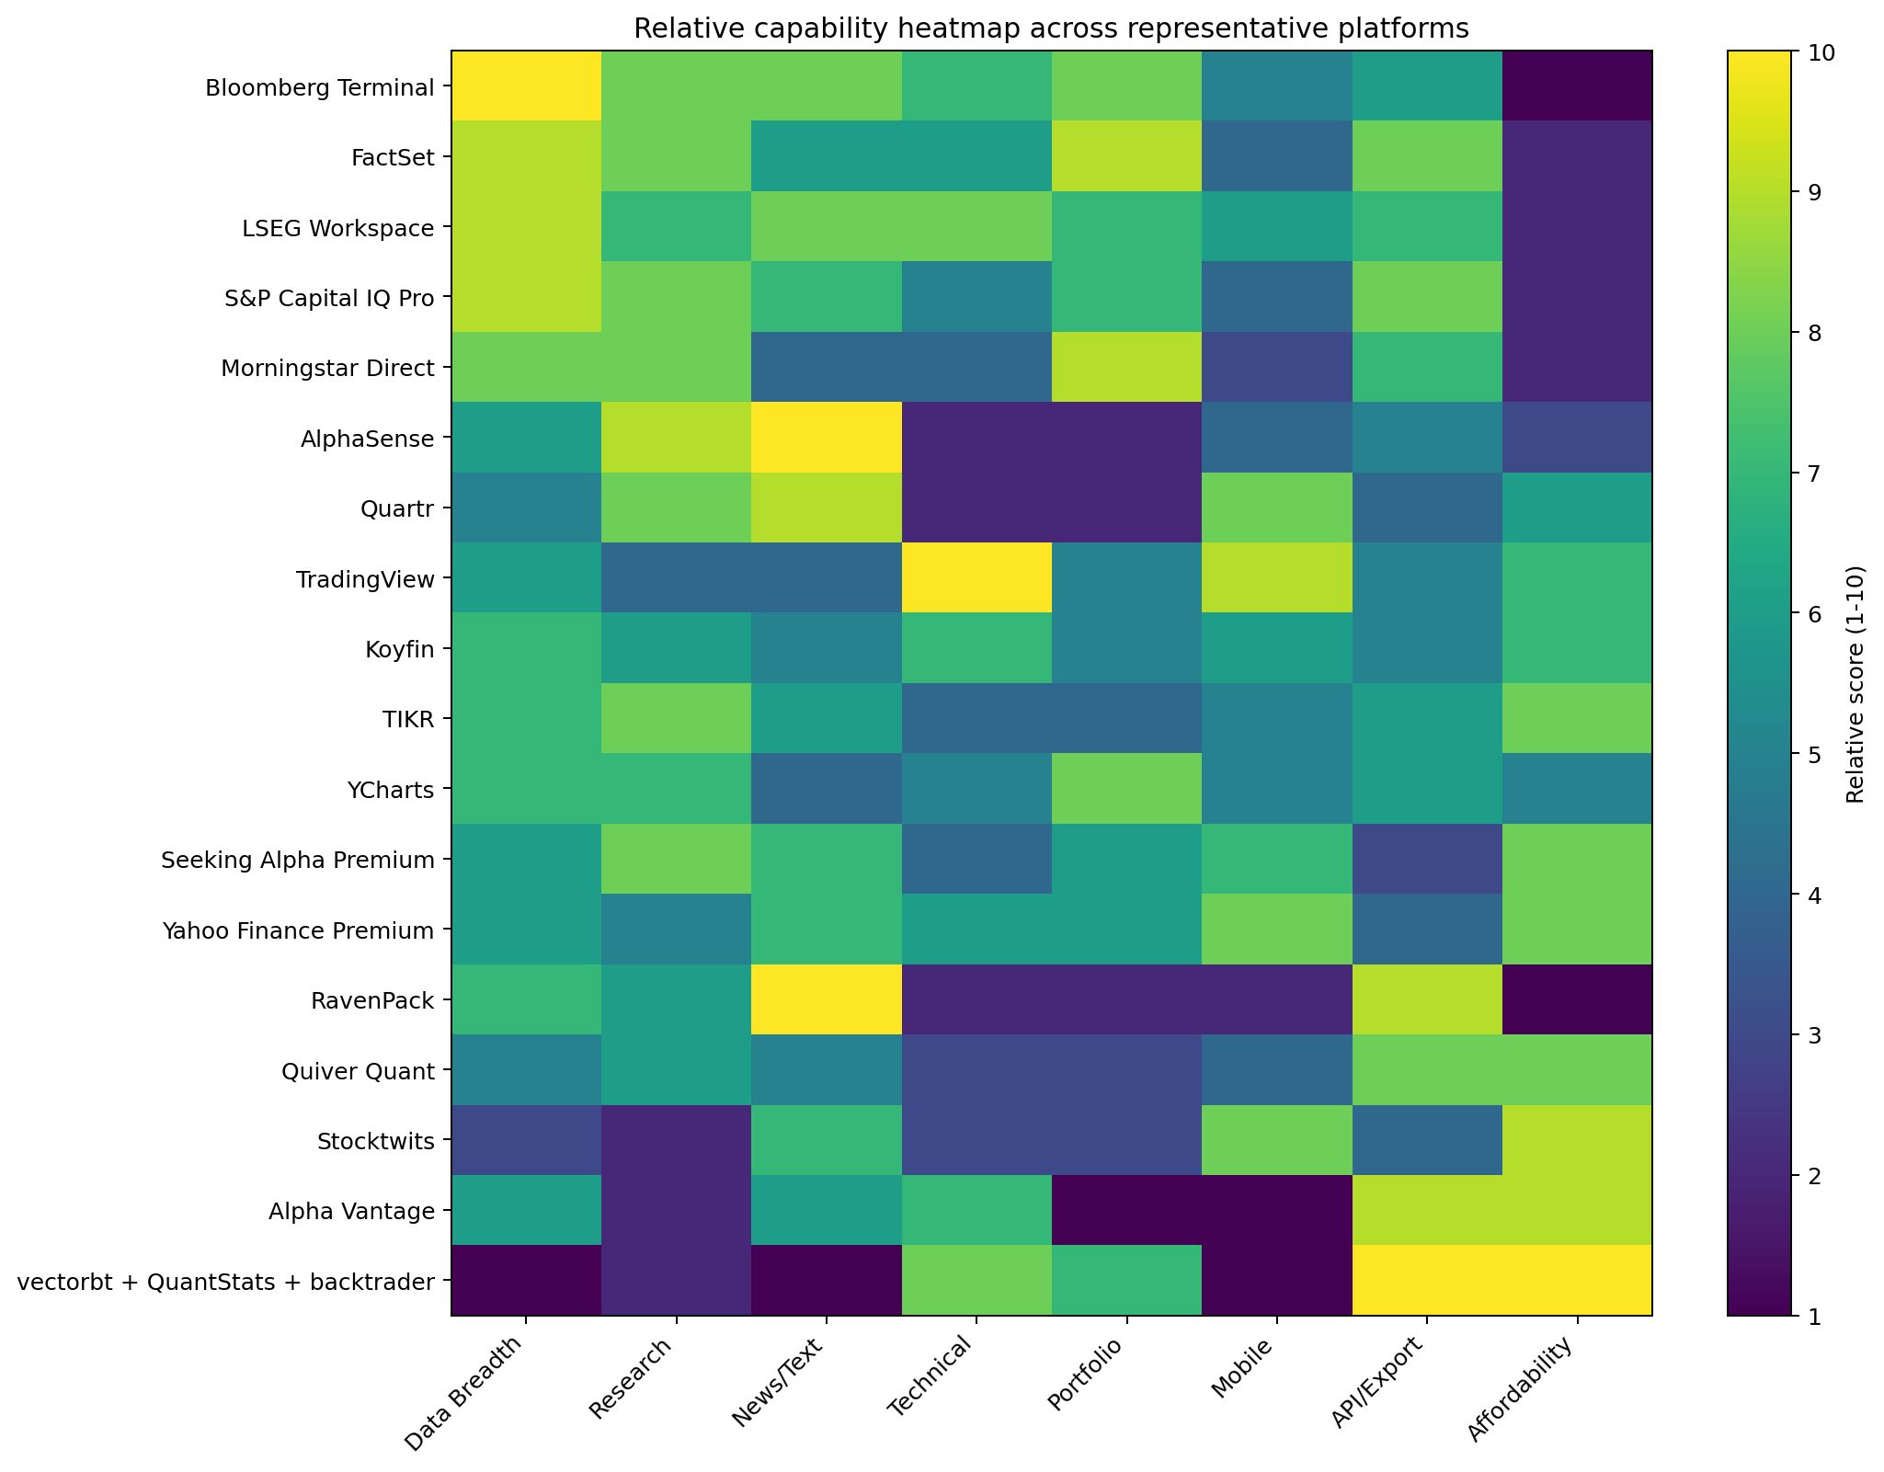
Figure 8. Relative capability heatmap across representative platforms. Scores are interpretive and designed for product-planning, not procurement.
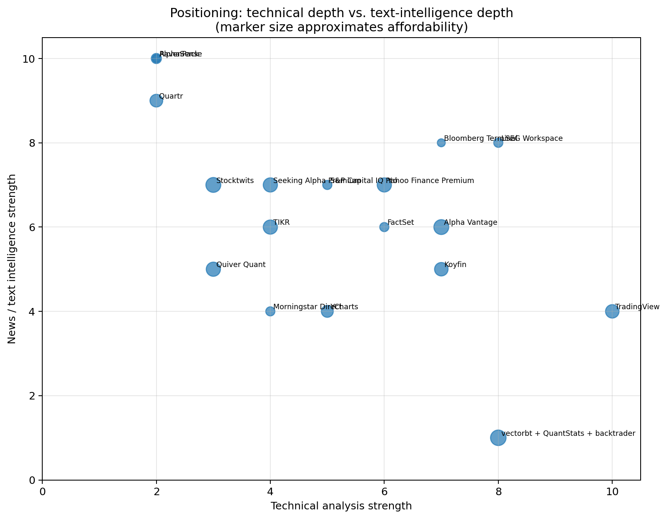
Figure 9. Positioning across technical-analysis depth and text-intelligence depth; marker size approximates affordability.
Platform | Best used for | Main risk / limitation | Strongest lesson for QuantPipeline | Accessibility | Mobile role
Bloomberg Terminal | Integrated institutional workflow | Too broad and expensive for direct replication | Auditability and information density | Low | Secondary
FactSet | Research + portfolio continuity | Enterprise-oriented complexity | Preserve context across security and portfolio levels | Low | Secondary
LSEG Workspace | Modular monitoring + analytics | Still institutionally heavy | Cross-surface continuity | Low | Meaningful
S&P Capital IQ Pro | Company and document dossier depth | Less natural for chart-led work | Blend structured data with AI-assisted documents | Low | Secondary
AlphaSense | Document and transcript intelligence | Not a full decision cockpit | Evidence-backed semantic research | Medium | Secondary
Quartr | Event-driven qualitative research | Narrower scope than full platforms | Fast event-to-understanding flow | Medium | High
TradingView | Technical confirmation and alerts | Weak on deep text/fundamental synthesis | Make state changes obvious | High | High
Koyfin | Web-native market dashboard | Depth varies by workflow | Clean overview-to-detail dashboarding | High | Useful
TIKR | Fundamental and estimate context | Less differentiated UX | Fast bridge from signals into valuation | High | Useful
Seeking Alpha Premium | Idea generation and ranked attention | Explainability and noise risk | Ranked surfacing is valuable if evidence is explicit | High | High
RavenPack | Structured news sentiment data | Infrastructure more than UX product | Reuse text features across models and UX | Low | Low
vectorbt + QuantStats + backtrader | Backtesting and review analytics | Requires engineering and data plumbing | Use OSS for analytics, keep custom UX proprietary | High | Low

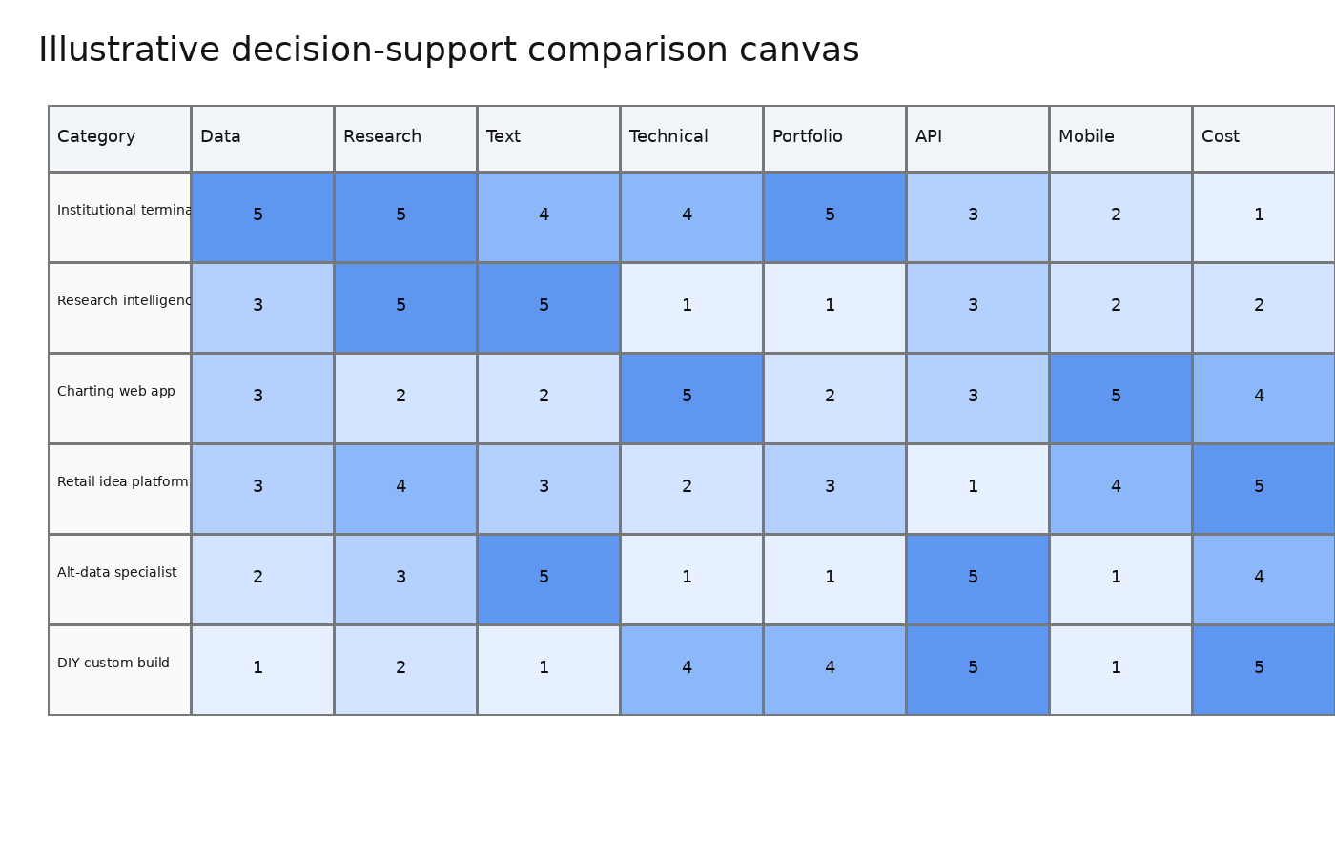
Figure 10. Illustrative comparison canvas showing how market categories differ by strength rather than by linear rank order.

7. What the market is signaling for a private medium-term investor product
The clearest market signal is that synthesis is under-served. There are many places to source data, many places to chart, and an increasing number of tools for document search. There are fewer products that reconcile these layers into a coherent medium-term view tailored to one investor's decision process. The product should therefore optimize for synthesis density: each major screen should answer what changed, why it matters, whether the change is corroborated, what remains uncertain, and what next step should follow.
A second market signal is that text has become unavoidable. Earnings calls, guidance changes, management confidence, regulatory filings, and broker commentary are not side channels anymore. Tools such as AlphaSense, Quartr, and the AI-assisted features arriving in Capital IQ Pro show that even traditional research workflows are becoming text-native. This strongly supports the inclusion of a first-class text and news layer in QuantPipeline.
A third signal is that technical analysis remains important but should be framed as confirmation rather than identity for this product. TradingView proves that charting quality matters enormously. However, the planned service will stand out more if charts help the user confirm or invalidate a story rather than if the product competes to become the most advanced drawing-tool environment on the web.
A fourth signal is that modern products must support two interaction intensities. The first is deep work on desktop: review, compare, interpret, and decide. The second is light but serious monitoring on mobile: alerts, digest review, catalyst checks, and exception handling. Quartr, TradingView, Yahoo Finance, and other mobile-capable products demonstrate that users no longer accept a desktop-only serious workflow.
A fifth signal is that trust and explainability are increasingly differentiating. The more a product summarizes and ranks on the user's behalf, the more important it becomes to reveal source context, confidence, evidence count, and possible contradictions. This is particularly important for a product that blends text, sentiment, and quantitative signals. Hidden or opaque scoring may feel magical briefly, but over time it weakens user discipline.
Design principles implied by these signals:
- Every ranked signal should have an evidence drawer.
- Every alert should answer 'why now' and 'why this matters'.
- Every thesis view should contain both supporting and disconfirming evidence.
- Every major screen should be legible in under 10 seconds, with optional depth available on demand.

8. Build-vs-buy implications for QuantPipeline
A direct build-from-scratch approach is unrealistic if the goal is to match market leaders on raw data breadth, historical depth, and document entitlements. The more sensible path is selective leverage. Data access can come from one or more APIs or licensed sources. Text extraction and summarization can use curated pipelines.
Technical analytics can be built partly on existing libraries. Performance review can leverage open-source analytics. The proprietary layer should live where the market is weakest: signal orchestration, evidence binding, decision memory, portfolio-aware ranking, and user-facing explanation.
This leads to a three-part stack. First, a dependable ingestion layer for prices, fundamentals, news, transcripts, and social or alternative data. Second, an analytics layer that computes technical context, text classifications, sentiment aggregations, watchlist state changes, and replay-ready features. Third, a presentation layer that turns those outputs into an evidence-first decision cockpit with desktop and mobile continuity.
A hybrid build strategy is especially attractive given the user's intended scope. Because the service is for personal use, the product can optimize ruthlessly around the actual operator workflow rather than around generic customer personas. That means fewer general-purpose configuration panels and more carefully designed defaults. The market survey strongly supports this approach: almost every strong competitor benefits from having a clear center of gravity.
The recommended buy or partner areas are commodity data access, transcripts or filings where feasible, and low-level analytics primitives that are not differentiating. The recommended build areas are signal ranking, multi-source explanation, watchlist triage logic, medium-term thesis state, portfolio-aware decision support, and workflow memory. These are the places where a private product can create a decisively better fit than general-purpose platforms.
Layer | Prefer buy / license | Prefer build | Rationale
Market and reference data | Yes | No unless strategically necessary | Commodity inputs are expensive to recreate and rarely differentiate the UX.
Document access (filings/transcripts) | Mostly yes | Build processing around them | The value is in search, extraction, comparison, and state tracking.
Technical indicators and chart primitives | Mixed | Mixed | Indicators are commodity; chart state modeling and explanation are more differentiated.
Backtesting / performance analytics | Mixed | Build orchestration, reuse OSS analytics | Open-source tools accelerate analytics, while custom replay logic binds them to the product workflow.
Signal ranking and explanation | No | Yes | This is where the planned product can be unique.
Decision memory / journaling / review | No | Yes | Few competitors handle this well for a single serious investor.

9. Strategic opportunities and risks
Opportunity 1: cross-signal interpretation. The product can outperform generic dashboards if it becomes the best place to understand how text, sentiment, technicals, and portfolio relevance interact. Users do not need one more metric wall; they need a judgment aid.
Opportunity 2: medium-term process discipline. Most visible market products lean either toward intraday action or long-horizon analytics. A system designed explicitly for weeks-to-months holding periods can organize timeframes, catalyst windows, and thesis review loops more coherently than generalist tools.
Opportunity 3: private-operator ergonomics. Because the service is for one user, the product can be unapologetically opinionated. It can preserve personal workflow memory, preferred signal thresholds, review rituals, and watchlist taxonomies. General-purpose products struggle to feel that tailored.
Risk 1: data-source fragility. The most elegant synthesis layer fails if upstream data is inconsistent, delayed, or non-comparable. The architecture should therefore isolate providers and preserve clear provenance metadata.
Risk 2: false precision. Combining multiple signals into a single score can create an illusion of certainty. The product must expose uncertainty, conflicts, sparse-data warnings, and missing-coverage states clearly.
Risk 3: feature sprawl. The market is full of products that accreted features because adjacent capabilities looked attractive. The planned service should resist this. If a feature does not improve attention capture, thesis formation, monitoring, or review, it should remain secondary.
Risk 4: overfitting to interesting data. Alternative datasets and social sentiment can add value, but they can also distract from decision quality. The system should reward evidence that changes the decision, not evidence that merely feels novel.

10. Recommended product stance
The recommended stance is to position QuantPipeline as a premium personal decision cockpit for medium-term equity investing. It should not describe itself as a terminal, a social network, or a charting platform. Its identity should be synthesis, explanation, and disciplined review.
The dashboard should function as the command center. It should prioritize watchlist changes, thesis-risk shifts, catalysts, and ranked opportunities. From there, the user should be able to open a security view that combines five synchronized panels: narrative and news, social or attention context, technical posture, valuation and estimate context, and decision state.
The product should also include a review and replay layer. This is one of the least crowded opportunities in the market. The user should be able to ask: what did the system believe before the trade, what changed after the trade, and which signals were genuinely useful? Over time this creates a self-improving decision process rather than a static dashboard.
On mobile, the goal should not be full parity with desktop. The goal should be high-value continuity: digest review, alert triage, catalyst checks, and quick portfolio-risk awareness. Deep comparative analysis can remain a desktop strength.
In summary, the best move is not to copy the largest products feature-for-feature. The best move is to combine the strongest market lessons into a tighter, more opinionated workflow: Quartr-grade event research, AlphaSense-style evidence search, TradingView-grade chart clarity, Koyfin-style dashboard layout, and open-source powered replay and review behind the scenes.
Priority recommendations for subsequent specification documents:
- Translate the workflow model in this report into detailed UX flows and wireframes for desktop and mobile dashboard states.
- Define data contracts that preserve provenance, evidence links, and confidence metadata for every surfaced insight.
- Specify the replay/review subsystem early rather than treating it as an optional late-stage feature.
- Keep the first release narrow: watchlists, evidence-backed signals, security workspaces, alerts, and review.

Appendix A. Source notes
The report relies primarily on official product pages, documentation, and selected product-specific press or repository materials. Reddit threads were used only as a limited secondary signal for practitioner perception and discussion themes, not as primary evidence.
- S1: Bloomberg Terminal solutions page on data, news, analytics, and trading workflows. https://www.bloomberg.com/professional/solution/bloomberg-terminal/
- S2: FactSet workstation page covering research, analytics, portfolio, and integrations. https://www.factset.com/products/workstation
- S3: LSEG Data & Analytics overview describing global data, analytics, and Workspace ecosystem. https://www.lseg.com/en/data-analytics
- S4: LSEG Workspace service description covering charting/technical analysis and historical time series. https://www.lseg.com/content/dam/data-analytics/en_us/documents/support/workspace/service-description.pdf
- S5: S&P Capital IQ Pro product page highlighting data breadth and GenAI tools. https://www.spglobal.com/market-intelligence/en/solutions/products/sp-capital-iq-pro
- S6: S&P Global press release on ChatIQ and multi-document research in Capital IQ Pro. https://press.spglobal.com/2025-10-22-S-P-Global-Redefines-Financial-Insights-with-New-AI-Powered-Multi-Document-Research-and-Analysis-Tool-in-Capital-IQ-Pro-ChatIQ
- S7: Morningstar data and analytics / Direct platform pages. https://www.morningstar.com/business/brands/data-analytics
- S8: AlphaSense market intelligence platform and help-center pages on generative workflows. https://www.alpha-sense.com/solutions/market-intelligence-platform/
- S9: Quartr product pages and newsroom updates for summaries, alerts, and AI workflows. https://quartr.com/features/summaries
- S10: TradingView product pages on charts, screeners, alerts, and paper trading. https://www.tradingview.com/features/
- S11: Koyfin product pages covering dashboards, charting, watchlists, and screening. https://www.koyfin.com/features/
- S12: TIKR product pages on financial data, analyst estimates, valuations, and transcripts. https://www.tikr.com/fundamental-analysis
- S13: YCharts platform pages on portfolio construction, visualizations, and reporting. https://www.ycharts.com/
- S14: Seeking Alpha platform and Premium pages on quant ratings, screeners, and portfolio tools. https://seekingalpha.com/subscriptions/premium-stock-analysis-tools
- S15: Yahoo Finance plans, charts, portfolios, and research reports pages. https://finance.yahoo.com/about/plans/compare/
- S16: RavenPack home and News Analytics pages on sentiment and institutional use cases. https://www.ravenpack.com/products/edge/data/news-analytics
- S17: Quiver Quant home, data source, and API pages. https://www.quiverquant.com/
- S18: Stocktwits platform pages on sentiment, trends, and subscriptions. https://stocktwits.com/sentiment
- S19: Alpha Vantage home and documentation pages on financial APIs and News & Sentiment API. https://www.alphavantage.co/documentation/
- S20: vectorbt GitHub repository and tutorials showing interactive exploration and backtesting. https://github.com/polakowo/vectorbt
- S21: QuantStats GitHub repository on portfolio analytics and HTML reports. https://github.com/ranaroussi/quantstats
- S22: Backtrader GitHub repository on Python backtesting library. https://github.com/mementum/backtrader
- S23: Reddit discussion on best stock research apps indicating user-perceived leaders and trade-offs. https://www.reddit.com/r/ValueInvesting/comments/1pjjqj1/what_are_the_best_stock_research_apps_overall/
- S24: Reddit discussion on Bloomberg/FactSet alternatives citing Koyfin, TradingView, and AlphaSense. https://www.reddit.com/r/ValueInvesting/comments/1lmnb5a/factset_bloomberg_alternatives/

