03_FINRLX Solution Landscape, Implementation Needs, and Maximum Capability Utilization Report
Consulting-style technical and implementation study for the planned private medium-term decision platform

Field | Value
Document purpose | Explain what a serious FINRL-X-informed solution landscape looks like for the planned private service
Primary audience | Founder, future development partner, and Claude implementation workflow
Explicit lens | Medium-term investing horizon of weeks to months, private usage, heavy emphasis on dashboard quality and operational trust
Method | Official repository and paper review, ecosystem review, selected Reddit/GitHub signal reading, and implementation synthesis

Executive Summary
This report answers a narrower and more practical question than Document 1. Document 1 asked what FINRL-X is and why it matters. Document 3 asks what kinds of solutions can realistically be built on top of FINRL-X ideas, what implementation prerequisites those solutions require, and how far the current project should go in order to maximize value without overbuilding.
The key conclusion is that the highest-value adoption path is neither superficial nor maximalist. A superficial path borrows only rhetoric and leaves the system fragmented. A maximalist path attempts to reproduce a full production trading stack too early and adds complexity faster than value. The recommended path is a balanced one: adopt the common recommendation contract, preserve the staged policy pipeline, and build the validation and trust surfaces early.
In practical terms, this means the planned service should use FINRL-X primarily as an architectural template: one recommendation object, one sequence of selection, allocation, timing, and risk overlay, and one validation framework spanning backtests, replay, paper monitoring, and operations. The founder's service should then differentiate through stronger text intelligence, dashboard quality, private workflow optimization, and clearer trust semantics.
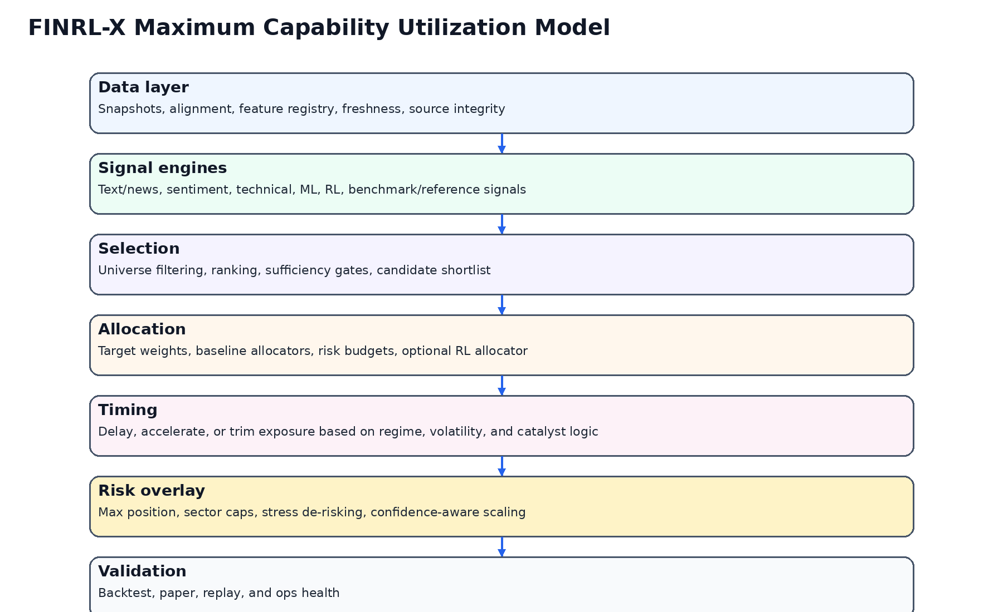
Figure 1. Capability stack for maximum-value FINRL-X-informed adoption.

1. Research Basis and Source Framing
The official FinRL-Trading repository describes FinRL-X as a next-generation, AI-native quantitative trading infrastructure and says it accompanies the paper 'FinRL-X: An AI-Native Modular Infrastructure for Quantitative Trading.' The repository and release notes both frame the system around a consistent weight-centric interface and a deployment-aware architecture rather than around one specific learning algorithm.
The original FinRL repository now explicitly frames itself as the preserved educational and research framework and points production-oriented users to FinRL-X / FinRL-Trading. This matters because it signals that the ecosystem's own maintainers are separating legacy educational value from the newer architectural direction.
The paper abstract reinforces the same point. It emphasizes that FinRL-X unifies data processing, strategy construction, backtesting, and broker execution under a weight-centric interface, and it explicitly calls out a composable strategy pipeline that includes stock selection, portfolio allocation, timing, and portfolio-level risk overlays.
Community discussion remains less mature for FINRL-X itself than for FinRL or RL-for-trading more broadly. That means practical lessons must be taken not only from the official FINRL-X materials but also from broader discussions around RL trading complexity, slippage realism, partial fills, paper-versus-live gaps, and dashboard trust. Those broader lessons matter because they describe the exact failure modes that a FINRL-X-informed product still has to survive.
Source class | What it contributed | How it was used in this report
Official FINRL-X repository and release notes | Product positioning, architecture language, deployment consistency claims | Primary architectural source
FINRL-X paper abstract / HTML / PDF | Formal articulation of the weight-centric pipeline | Primary conceptual source
Original FinRL repository note | Authoritative ecosystem positioning against classic FinRL | Baseline comparison source
Reddit / algotrading discussions | Reality checks on paper-vs-live gap, slippage, and RL complexity | Practical constraint source
Related GitHub projects | Examples of adjacent stacks mixing RL, dashboards, and portfolio analytics | Solution-pattern source

2. What 'Solution Landscape' Means in This Context
In this report, the term solution landscape does not mean a random catalog of code repositories. It means a structured map of the credible build paths available to a founder who wants to use FINRL-X ideas in a private, medium-term investment system. The goal is to identify what kinds of systems are possible, what those systems demand technically, and which level of ambition is justified for this project.
There are at least five distinct build paths. The first is educational exploration: classic notebooks, experiments, toy pipelines, and isolated agent training. The second is modular research infrastructure: a repeatable pipeline that still remains mostly research-facing. The third is a private decision platform: a product with a recommendation object, a dashboard, replay, validation, and operations. The fourth is paper-trading infrastructure: a system that adds execution assumptions and simulated portfolio monitoring. The fifth is live deployment: broker connectivity, execution reliability, and real operational accountability.
The present project clearly belongs to the third category now, with a deliberate bridge to the fourth. It does not need to jump directly to the fifth in order to become useful. In fact, skipping straight to live deployment would likely distract from the product's most important challenge: turning heterogeneous signals into one coherent and trustworthy recommendation experience.
Build path | Typical traits | Where it fits this project
Educational experimentation | Notebooks, manual runs, weak contracts, high flexibility | Useful only as background
Modular research stack | Cleaner modules, repeatable evaluations, some policy separation | Necessary as backend foundation
Private decision platform | Recommendation object, dashboard, replay, comparison, trust layer | Primary target now
Paper-trading platform | Adds simulated holdings, drift, execution assumptions, monitoring | Recommended after the core decision platform
Live execution platform | Broker integrations, hardened ops, runbooks, severe failure handling | Deferred until later if ever

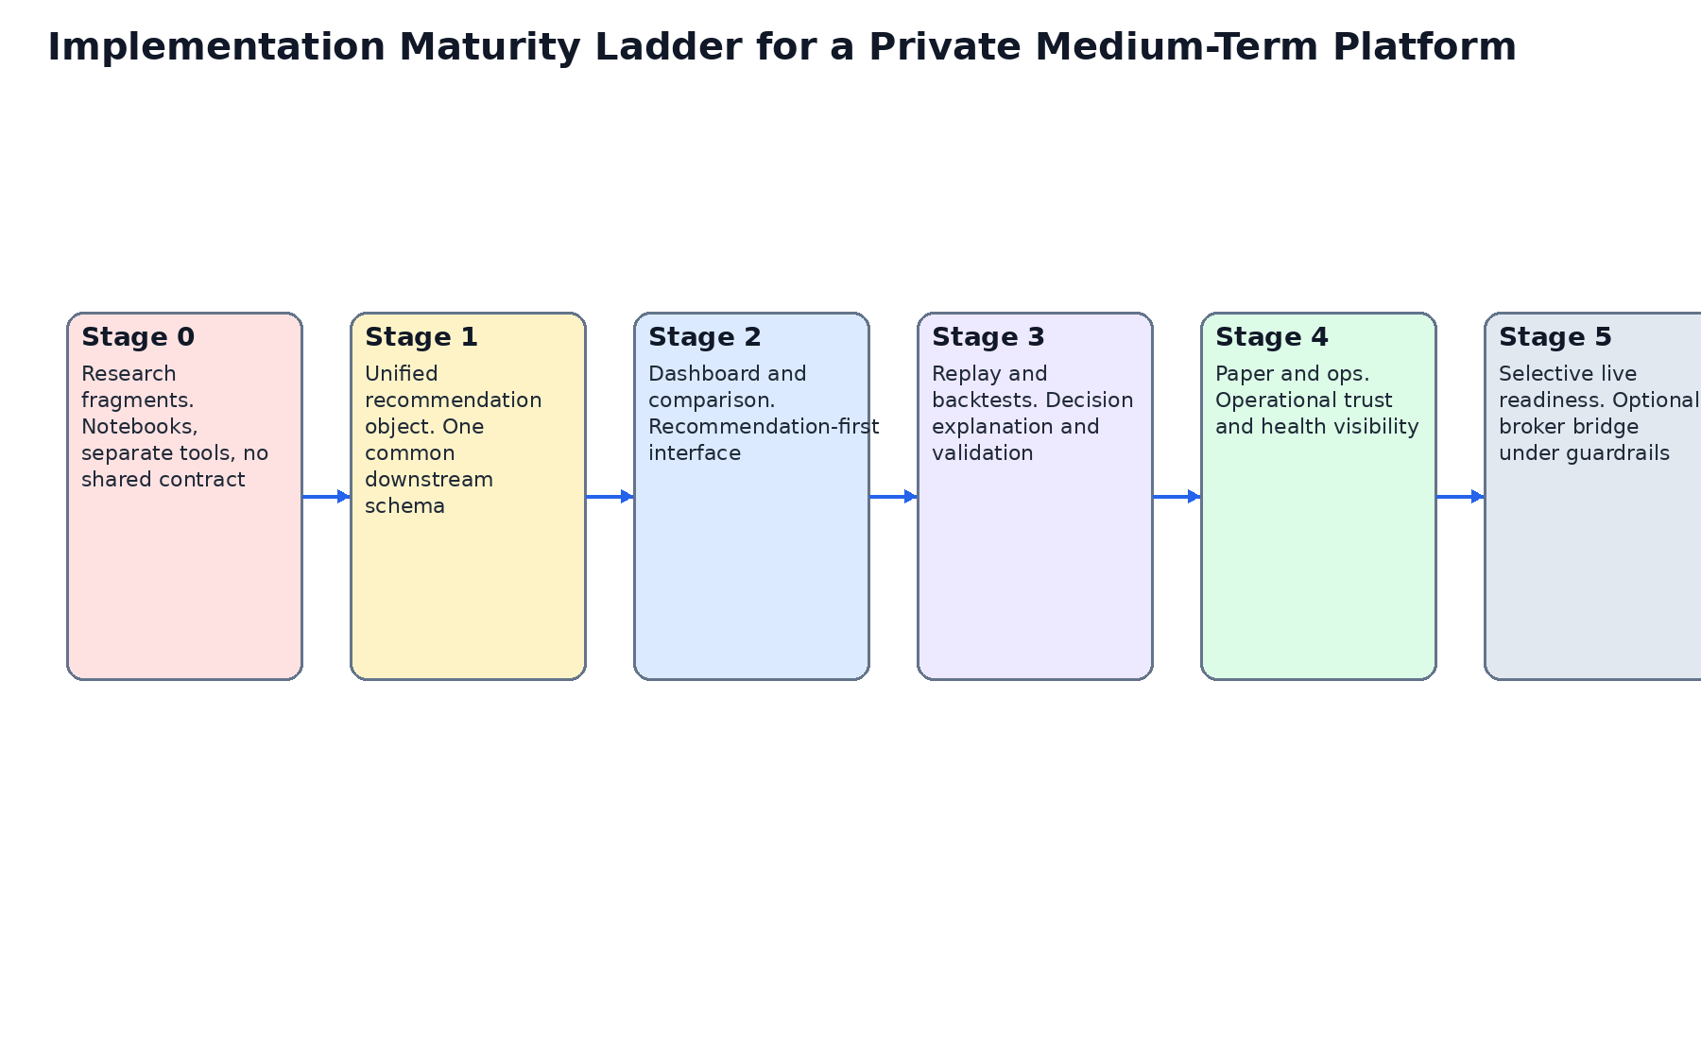
Figure 2. Implementation maturity ladder for the planned service.

3. Maximum-Value Adoption Thesis
Maximum capability utilization does not mean enabling every theoretical feature that the official architecture could support. It means identifying which capabilities create the largest step-change in decision quality for the founder's real workflow.
For this project, the strongest payoffs come from a unified recommendation object, explicit policy layers, confidence decomposition, replayability, and validation continuity. These payoffs compound because they make every future engine more interpretable and every future UI screen more coherent.
A less useful interpretation would be to equate maximum utilization with early broker execution, high-frequency assumptions, or aggressive agent-centric product messaging. Those features are not intrinsically wrong, but they are mismatched to the planned service's time horizon and private usage pattern.
Implementation implication 1 for 3. maximum-value adoption thesis: the system should treat this capability as part of a controlled product workflow rather than as a detached research artifact. In practice that means stable schemas, visible UI semantics, explicit degraded states, and evidence that the capability changes the recommendation in a way the founder can review and challenge.
Implementation implication 2 for 3. maximum-value adoption thesis: the system should treat this capability as part of a controlled product workflow rather than as a detached research artifact. In practice that means stable schemas, visible UI semantics, explicit degraded states, and evidence that the capability changes the recommendation in a way the founder can review and challenge.
Implementation implication 3 for 3. maximum-value adoption thesis: the system should treat this capability as part of a controlled product workflow rather than as a detached research artifact. In practice that means stable schemas, visible UI semantics, explicit degraded states, and evidence that the capability changes the recommendation in a way the founder can review and challenge.
Implementation implication 4 for 3. maximum-value adoption thesis: the system should treat this capability as part of a controlled product workflow rather than as a detached research artifact. In practice that means stable schemas, visible UI semantics, explicit degraded states, and evidence that the capability changes the recommendation in a way the founder can review and challenge.
Implementation implication 5 for 3. maximum-value adoption thesis: the system should treat this capability as part of a controlled product workflow rather than as a detached research artifact. In practice that means stable schemas, visible UI semantics, explicit degraded states, and evidence that the capability changes the recommendation in a way the founder can review and challenge.

4. Capability Family A — Data Layer and Snapshot Discipline
The official FINRL-X framing is only as useful as the data discipline beneath it. A solution informed by FINRL-X requires snapshots, time alignment, freshness logic, and a feature registry strong enough to support replay.
For the current project, this means storing raw source captures or canonicalized references for market data, news items, sentiment inputs, and portfolio state. Without that layer, later explanations become rhetorical rather than evidentiary.
The practical output of this capability family is not a screen. It is the ability to say what the system knew, when it knew it, and which transformed features were actually in force at recommendation time.
Implementation implication 1 for 4. capability family a — data layer and snapshot discipline: the system should treat this capability as part of a controlled product workflow rather than as a detached research artifact. In practice that means stable schemas, visible UI semantics, explicit degraded states, and evidence that the capability changes the recommendation in a way the founder can review and challenge.
Implementation implication 2 for 4. capability family a — data layer and snapshot discipline: the system should treat this capability as part of a controlled product workflow rather than as a detached research artifact. In practice that means stable schemas, visible UI semantics, explicit degraded states, and evidence that the capability changes the recommendation in a way the founder can review and challenge.
Implementation implication 3 for 4. capability family a — data layer and snapshot discipline: the system should treat this capability as part of a controlled product workflow rather than as a detached research artifact. In practice that means stable schemas, visible UI semantics, explicit degraded states, and evidence that the capability changes the recommendation in a way the founder can review and challenge.
Implementation implication 4 for 4. capability family a — data layer and snapshot discipline: the system should treat this capability as part of a controlled product workflow rather than as a detached research artifact. In practice that means stable schemas, visible UI semantics, explicit degraded states, and evidence that the capability changes the recommendation in a way the founder can review and challenge.
Implementation implication 5 for 4. capability family a — data layer and snapshot discipline: the system should treat this capability as part of a controlled product workflow rather than as a detached research artifact. In practice that means stable schemas, visible UI semantics, explicit degraded states, and evidence that the capability changes the recommendation in a way the founder can review and challenge.

5. Capability Family B — Signal Engines and Heterogeneous Evidence
The planned service explicitly wants to combine market news and text analysis, social sentiment, technical analysis, and any relevant FINRL-X-supported or FINRL-X-compatible intelligence component. That means the solution landscape must accommodate heterogeneous engines from day one.
The right pattern is not to force all engines into one model family. It is to normalize their outputs into compatible downstream meaning. Some engines will naturally emit scores. Some will produce rankings. Some will produce risk warnings. Some can propose exposure changes. The system needs an engine-output schema that can preserve these differences while still supporting policy composition.
This design choice is especially important for text and sentiment layers. Text systems are noisy, regime-sensitive, and sometimes difficult to calibrate. Their value is highest when they can influence selection, timing, or confidence rather than when they are treated as a solitary oracle.
Implementation implication 1 for 5. capability family b — signal engines and heterogeneous evidence: the system should treat this capability as part of a controlled product workflow rather than as a detached research artifact. In practice that means stable schemas, visible UI semantics, explicit degraded states, and evidence that the capability changes the recommendation in a way the founder can review and challenge.
Implementation implication 2 for 5. capability family b — signal engines and heterogeneous evidence: the system should treat this capability as part of a controlled product workflow rather than as a detached research artifact. In practice that means stable schemas, visible UI semantics, explicit degraded states, and evidence that the capability changes the recommendation in a way the founder can review and challenge.
Implementation implication 3 for 5. capability family b — signal engines and heterogeneous evidence: the system should treat this capability as part of a controlled product workflow rather than as a detached research artifact. In practice that means stable schemas, visible UI semantics, explicit degraded states, and evidence that the capability changes the recommendation in a way the founder can review and challenge.
Implementation implication 4 for 5. capability family b — signal engines and heterogeneous evidence: the system should treat this capability as part of a controlled product workflow rather than as a detached research artifact. In practice that means stable schemas, visible UI semantics, explicit degraded states, and evidence that the capability changes the recommendation in a way the founder can review and challenge.
Implementation implication 5 for 5. capability family b — signal engines and heterogeneous evidence: the system should treat this capability as part of a controlled product workflow rather than as a detached research artifact. In practice that means stable schemas, visible UI semantics, explicit degraded states, and evidence that the capability changes the recommendation in a way the founder can review and challenge.

6. Capability Family C — Selection Layer
The paper explicitly includes stock selection as part of the composable pipeline. For this project, selection is one of the most natural and valuable early layers because the founder is targeting medium-term investing rather than broad all-asset execution.
Selection should answer a bounded question: which symbols or sectors deserve attention now, under the current evidence and policy configuration? That question can incorporate text catalysts, momentum context, universe constraints, and basic sufficiency checks.
A properly designed selection layer dramatically simplifies downstream explanation because it creates a visible shortlist. The UI can show what entered the shortlist, what was excluded, and why. That alone increases transparency compared with opaque ranking-only systems.
Implementation implication 1 for 6. capability family c — selection layer: the system should treat this capability as part of a controlled product workflow rather than as a detached research artifact. In practice that means stable schemas, visible UI semantics, explicit degraded states, and evidence that the capability changes the recommendation in a way the founder can review and challenge.
Implementation implication 2 for 6. capability family c — selection layer: the system should treat this capability as part of a controlled product workflow rather than as a detached research artifact. In practice that means stable schemas, visible UI semantics, explicit degraded states, and evidence that the capability changes the recommendation in a way the founder can review and challenge.
Implementation implication 3 for 6. capability family c — selection layer: the system should treat this capability as part of a controlled product workflow rather than as a detached research artifact. In practice that means stable schemas, visible UI semantics, explicit degraded states, and evidence that the capability changes the recommendation in a way the founder can review and challenge.
Implementation implication 4 for 6. capability family c — selection layer: the system should treat this capability as part of a controlled product workflow rather than as a detached research artifact. In practice that means stable schemas, visible UI semantics, explicit degraded states, and evidence that the capability changes the recommendation in a way the founder can review and challenge.
Implementation implication 5 for 6. capability family c — selection layer: the system should treat this capability as part of a controlled product workflow rather than as a detached research artifact. In practice that means stable schemas, visible UI semantics, explicit degraded states, and evidence that the capability changes the recommendation in a way the founder can review and challenge.

7. Capability Family D — Allocation Layer
Allocation is where FINRL-X-style discipline becomes materially useful. Many research stacks produce scores but leave portfolio construction implicit or ad hoc. A serious solution path must turn research outputs into target weights or explicit exposure changes.
This is the natural home for both baseline allocators and more advanced RL-informed allocation logic. The important requirement is not whether the allocator is classical or learned. The requirement is that it produces a transparent allocation proposal that can be compared, stress tested, and overlaid with later policy controls.
For the planned service, a credible path begins with simple baselines such as equal weight or confidence-weighted allocation, then moves toward richer allocators only after replay, backtests, and confidence interpretation are stable.
Implementation implication 1 for 7. capability family d — allocation layer: the system should treat this capability as part of a controlled product workflow rather than as a detached research artifact. In practice that means stable schemas, visible UI semantics, explicit degraded states, and evidence that the capability changes the recommendation in a way the founder can review and challenge.
Implementation implication 2 for 7. capability family d — allocation layer: the system should treat this capability as part of a controlled product workflow rather than as a detached research artifact. In practice that means stable schemas, visible UI semantics, explicit degraded states, and evidence that the capability changes the recommendation in a way the founder can review and challenge.
Implementation implication 3 for 7. capability family d — allocation layer: the system should treat this capability as part of a controlled product workflow rather than as a detached research artifact. In practice that means stable schemas, visible UI semantics, explicit degraded states, and evidence that the capability changes the recommendation in a way the founder can review and challenge.
Implementation implication 4 for 7. capability family d — allocation layer: the system should treat this capability as part of a controlled product workflow rather than as a detached research artifact. In practice that means stable schemas, visible UI semantics, explicit degraded states, and evidence that the capability changes the recommendation in a way the founder can review and challenge.
Implementation implication 5 for 7. capability family d — allocation layer: the system should treat this capability as part of a controlled product workflow rather than as a detached research artifact. In practice that means stable schemas, visible UI semantics, explicit degraded states, and evidence that the capability changes the recommendation in a way the founder can review and challenge.

8. Capability Family E — Timing Layer
Timing is explicitly named in the paper's composable pipeline, and it is particularly important for this product because the time horizon is weeks to months. That horizon still benefits from timing, but it benefits from timing as a gatekeeper and exposure modulator rather than as a day-trading trigger machine.
The solution landscape should therefore treat timing as a dedicated layer capable of delaying entry, trimming exposure, or switching the recommendation posture from aggressive to cautious. Technical signals, volatility regimes, and large text-driven catalysts are all natural inputs.
Separating timing from allocation is analytically powerful because it preserves clarity. The system can say that a symbol is attractive on selection and allocation grounds while still reducing or deferring exposure because timing conditions are poor.
Implementation implication 1 for 8. capability family e — timing layer: the system should treat this capability as part of a controlled product workflow rather than as a detached research artifact. In practice that means stable schemas, visible UI semantics, explicit degraded states, and evidence that the capability changes the recommendation in a way the founder can review and challenge.
Implementation implication 2 for 8. capability family e — timing layer: the system should treat this capability as part of a controlled product workflow rather than as a detached research artifact. In practice that means stable schemas, visible UI semantics, explicit degraded states, and evidence that the capability changes the recommendation in a way the founder can review and challenge.
Implementation implication 3 for 8. capability family e — timing layer: the system should treat this capability as part of a controlled product workflow rather than as a detached research artifact. In practice that means stable schemas, visible UI semantics, explicit degraded states, and evidence that the capability changes the recommendation in a way the founder can review and challenge.
Implementation implication 4 for 8. capability family e — timing layer: the system should treat this capability as part of a controlled product workflow rather than as a detached research artifact. In practice that means stable schemas, visible UI semantics, explicit degraded states, and evidence that the capability changes the recommendation in a way the founder can review and challenge.
Implementation implication 5 for 8. capability family e — timing layer: the system should treat this capability as part of a controlled product workflow rather than as a detached research artifact. In practice that means stable schemas, visible UI semantics, explicit degraded states, and evidence that the capability changes the recommendation in a way the founder can review and challenge.

9. Capability Family F — Portfolio-Level Risk Overlay
The paper's explicit inclusion of portfolio-level risk overlays is one of the strongest reasons FINRL-X is useful for this project. It recognizes that risk is not an afterthought and not merely a position-level stop-loss problem.
For the planned service, this layer should own constraints such as max position size, sector concentration, confidence-aware scaling, de-risking under stress, and defensive posture transitions. This is also where data confidence and operational confidence can reasonably influence the final output.
Exposing this layer in the UI is strategically valuable. It makes the product look and behave like a mature decision environment rather than a pile of analytics with hidden overrides.
Implementation implication 1 for 9. capability family f — portfolio-level risk overlay: the system should treat this capability as part of a controlled product workflow rather than as a detached research artifact. In practice that means stable schemas, visible UI semantics, explicit degraded states, and evidence that the capability changes the recommendation in a way the founder can review and challenge.
Implementation implication 2 for 9. capability family f — portfolio-level risk overlay: the system should treat this capability as part of a controlled product workflow rather than as a detached research artifact. In practice that means stable schemas, visible UI semantics, explicit degraded states, and evidence that the capability changes the recommendation in a way the founder can review and challenge.
Implementation implication 3 for 9. capability family f — portfolio-level risk overlay: the system should treat this capability as part of a controlled product workflow rather than as a detached research artifact. In practice that means stable schemas, visible UI semantics, explicit degraded states, and evidence that the capability changes the recommendation in a way the founder can review and challenge.
Implementation implication 4 for 9. capability family f — portfolio-level risk overlay: the system should treat this capability as part of a controlled product workflow rather than as a detached research artifact. In practice that means stable schemas, visible UI semantics, explicit degraded states, and evidence that the capability changes the recommendation in a way the founder can review and challenge.
Implementation implication 5 for 9. capability family f — portfolio-level risk overlay: the system should treat this capability as part of a controlled product workflow rather than as a detached research artifact. In practice that means stable schemas, visible UI semantics, explicit degraded states, and evidence that the capability changes the recommendation in a way the founder can review and challenge.

10. Validation Surfaces — Backtests, Replay, and Paper
The official FINRL-X vision is deployment-consistent rather than purely backtest-centric. In the present project, that idea translates into three visible validation surfaces: backtests, replay, and paper monitoring.
Backtests are needed to compare policies under shared assumptions. Replay is needed to show how one recommendation was formed from the exact evidence available at the time. Paper monitoring is needed because public trading discussions repeatedly show that backtest assumptions often understate slippage, latency, and partial-fill reality.
A private platform gains trust when these three surfaces agree structurally. The same recommendation object should flow into the dashboard, the replay view, the historical evaluator, and the simulated portfolio monitor.
Implementation implication 1 for 10. validation surfaces — backtests, replay, and paper: the system should treat this capability as part of a controlled product workflow rather than as a detached research artifact. In practice that means stable schemas, visible UI semantics, explicit degraded states, and evidence that the capability changes the recommendation in a way the founder can review and challenge.
Implementation implication 2 for 10. validation surfaces — backtests, replay, and paper: the system should treat this capability as part of a controlled product workflow rather than as a detached research artifact. In practice that means stable schemas, visible UI semantics, explicit degraded states, and evidence that the capability changes the recommendation in a way the founder can review and challenge.
Implementation implication 3 for 10. validation surfaces — backtests, replay, and paper: the system should treat this capability as part of a controlled product workflow rather than as a detached research artifact. In practice that means stable schemas, visible UI semantics, explicit degraded states, and evidence that the capability changes the recommendation in a way the founder can review and challenge.
Implementation implication 4 for 10. validation surfaces — backtests, replay, and paper: the system should treat this capability as part of a controlled product workflow rather than as a detached research artifact. In practice that means stable schemas, visible UI semantics, explicit degraded states, and evidence that the capability changes the recommendation in a way the founder can review and challenge.
Implementation implication 5 for 10. validation surfaces — backtests, replay, and paper: the system should treat this capability as part of a controlled product workflow rather than as a detached research artifact. In practice that means stable schemas, visible UI semantics, explicit degraded states, and evidence that the capability changes the recommendation in a way the founder can review and challenge.

11. Practical Reddit and GitHub Lessons That Change the Design
Broader trading-community discussions repeatedly warn that paper and backtest results can diverge sharply from live behavior because of slippage, spread, partial fills, liquidity conditions, and psychological effects. Even when the present project does not go live immediately, those warnings still matter because they shape how honest the validation layer needs to be.
Related open-source projects often present one of two extremes: impressive academic modeling with weak product surfaces, or visually rich dashboards with weak contract discipline. The current project should deliberately avoid both extremes by coupling contract discipline with recommendation-first UX.
This is where the private nature of the service is an advantage. The product does not need to flatter a broad consumer audience. It can be explicit about confidence, uncertainty, and degraded conditions.
Implementation implication 1 for 11. practical reddit and github lessons that change the design: the system should treat this capability as part of a controlled product workflow rather than as a detached research artifact. In practice that means stable schemas, visible UI semantics, explicit degraded states, and evidence that the capability changes the recommendation in a way the founder can review and challenge.
Implementation implication 2 for 11. practical reddit and github lessons that change the design: the system should treat this capability as part of a controlled product workflow rather than as a detached research artifact. In practice that means stable schemas, visible UI semantics, explicit degraded states, and evidence that the capability changes the recommendation in a way the founder can review and challenge.
Implementation implication 3 for 11. practical reddit and github lessons that change the design: the system should treat this capability as part of a controlled product workflow rather than as a detached research artifact. In practice that means stable schemas, visible UI semantics, explicit degraded states, and evidence that the capability changes the recommendation in a way the founder can review and challenge.
Implementation implication 4 for 11. practical reddit and github lessons that change the design: the system should treat this capability as part of a controlled product workflow rather than as a detached research artifact. In practice that means stable schemas, visible UI semantics, explicit degraded states, and evidence that the capability changes the recommendation in a way the founder can review and challenge.
Implementation implication 5 for 11. practical reddit and github lessons that change the design: the system should treat this capability as part of a controlled product workflow rather than as a detached research artifact. In practice that means stable schemas, visible UI semantics, explicit degraded states, and evidence that the capability changes the recommendation in a way the founder can review and challenge.

12. Three Realistic Solution Archetypes
There are three realistic archetypes worth considering. The first is the research-heavy archetype: excellent for experimentation, weak for day-to-day personal use. The second is the balanced decision-platform archetype: strong recommendation workflow, strong trust layer, selective validation, moderate complexity. The third is the operations-heavy archetype: strong paper/live progression, stronger ops, higher burden.
For this project, the balanced decision-platform archetype is the best fit. It captures the highest-value FINRL-X benefits without forcing premature operational scope.
That archetype is also the most compatible with iterative development using Claude, because its contracts and UX surfaces can be built and verified in phases.
Implementation implication 1 for 12. three realistic solution archetypes: the system should treat this capability as part of a controlled product workflow rather than as a detached research artifact. In practice that means stable schemas, visible UI semantics, explicit degraded states, and evidence that the capability changes the recommendation in a way the founder can review and challenge.
Implementation implication 2 for 12. three realistic solution archetypes: the system should treat this capability as part of a controlled product workflow rather than as a detached research artifact. In practice that means stable schemas, visible UI semantics, explicit degraded states, and evidence that the capability changes the recommendation in a way the founder can review and challenge.
Implementation implication 3 for 12. three realistic solution archetypes: the system should treat this capability as part of a controlled product workflow rather than as a detached research artifact. In practice that means stable schemas, visible UI semantics, explicit degraded states, and evidence that the capability changes the recommendation in a way the founder can review and challenge.
Implementation implication 4 for 12. three realistic solution archetypes: the system should treat this capability as part of a controlled product workflow rather than as a detached research artifact. In practice that means stable schemas, visible UI semantics, explicit degraded states, and evidence that the capability changes the recommendation in a way the founder can review and challenge.
Implementation implication 5 for 12. three realistic solution archetypes: the system should treat this capability as part of a controlled product workflow rather than as a detached research artifact. In practice that means stable schemas, visible UI semantics, explicit degraded states, and evidence that the capability changes the recommendation in a way the founder can review and challenge.

13. Implementation Needs — Non-Negotiables
Certain implementation needs are non-negotiable if the solution is to deliver on its promise. First, there must be one canonical recommendation schema. Second, there must be stage persistence for replay. Third, there must be an explicit confidence model separating model confidence, data confidence, and operational confidence.
Fourth, the system needs fixture data and staged APIs so that frontend work can proceed in parallel with data-engine and model hardening. Fifth, the project needs an admin or ops surface, because without it the founder will never be sure whether a weak recommendation came from the market or from the system.
None of these requirements are glamorous. But they distinguish a real product from a stacked demo.
Implementation implication 1 for 13. implementation needs — non-negotiables: the system should treat this capability as part of a controlled product workflow rather than as a detached research artifact. In practice that means stable schemas, visible UI semantics, explicit degraded states, and evidence that the capability changes the recommendation in a way the founder can review and challenge.
Implementation implication 2 for 13. implementation needs — non-negotiables: the system should treat this capability as part of a controlled product workflow rather than as a detached research artifact. In practice that means stable schemas, visible UI semantics, explicit degraded states, and evidence that the capability changes the recommendation in a way the founder can review and challenge.
Implementation implication 3 for 13. implementation needs — non-negotiables: the system should treat this capability as part of a controlled product workflow rather than as a detached research artifact. In practice that means stable schemas, visible UI semantics, explicit degraded states, and evidence that the capability changes the recommendation in a way the founder can review and challenge.
Implementation implication 4 for 13. implementation needs — non-negotiables: the system should treat this capability as part of a controlled product workflow rather than as a detached research artifact. In practice that means stable schemas, visible UI semantics, explicit degraded states, and evidence that the capability changes the recommendation in a way the founder can review and challenge.
Implementation implication 5 for 13. implementation needs — non-negotiables: the system should treat this capability as part of a controlled product workflow rather than as a detached research artifact. In practice that means stable schemas, visible UI semantics, explicit degraded states, and evidence that the capability changes the recommendation in a way the founder can review and challenge.

14. What to Borrow and What Not to Borrow
The project should borrow FINRL-X's policy layering, recommendation contract discipline, and deployment-consistent philosophy. It should not borrow assumptions that push it prematurely toward broker-centric identity or unnecessary live execution complexity.
It should also borrow the idea that both rule-based and AI-driven components can coexist. That matters because text analysis, social sentiment, and technical timing are not all best represented by the same modeling family.
It should not pretend that FINRL-X alone solves the hard parts of data quality, confidence calibration, or UX clarity. Those still require explicit design work.
Implementation implication 1 for 14. what to borrow and what not to borrow: the system should treat this capability as part of a controlled product workflow rather than as a detached research artifact. In practice that means stable schemas, visible UI semantics, explicit degraded states, and evidence that the capability changes the recommendation in a way the founder can review and challenge.
Implementation implication 2 for 14. what to borrow and what not to borrow: the system should treat this capability as part of a controlled product workflow rather than as a detached research artifact. In practice that means stable schemas, visible UI semantics, explicit degraded states, and evidence that the capability changes the recommendation in a way the founder can review and challenge.
Implementation implication 3 for 14. what to borrow and what not to borrow: the system should treat this capability as part of a controlled product workflow rather than as a detached research artifact. In practice that means stable schemas, visible UI semantics, explicit degraded states, and evidence that the capability changes the recommendation in a way the founder can review and challenge.
Implementation implication 4 for 14. what to borrow and what not to borrow: the system should treat this capability as part of a controlled product workflow rather than as a detached research artifact. In practice that means stable schemas, visible UI semantics, explicit degraded states, and evidence that the capability changes the recommendation in a way the founder can review and challenge.
Implementation implication 5 for 14. what to borrow and what not to borrow: the system should treat this capability as part of a controlled product workflow rather than as a detached research artifact. In practice that means stable schemas, visible UI semantics, explicit degraded states, and evidence that the capability changes the recommendation in a way the founder can review and challenge.

15. Maximum Capability Utilization Map for the Planned Service
Maximum-value utilization for this specific project looks like this: text and news analysis feed selection, timing, and rationale; social sentiment feeds timing, anomaly detection, and confidence modifiers; technical analysis feeds timing and context; classical or learned ranking feeds selection; baseline allocators and later RL allocators feed target weights; risk overlay constrains and scales the result; replay, backtests, paper, and ops expose trust.
This map is rich enough to justify the product and narrow enough to be buildable. It uses the FINRL-X worldview without turning the service into a generic research framework.
Just as importantly, this capability map is legible to a single user. It can be understood, challenged, and improved over time.
Implementation implication 1 for 15. maximum capability utilization map for the planned service: the system should treat this capability as part of a controlled product workflow rather than as a detached research artifact. In practice that means stable schemas, visible UI semantics, explicit degraded states, and evidence that the capability changes the recommendation in a way the founder can review and challenge.
Implementation implication 2 for 15. maximum capability utilization map for the planned service: the system should treat this capability as part of a controlled product workflow rather than as a detached research artifact. In practice that means stable schemas, visible UI semantics, explicit degraded states, and evidence that the capability changes the recommendation in a way the founder can review and challenge.
Implementation implication 3 for 15. maximum capability utilization map for the planned service: the system should treat this capability as part of a controlled product workflow rather than as a detached research artifact. In practice that means stable schemas, visible UI semantics, explicit degraded states, and evidence that the capability changes the recommendation in a way the founder can review and challenge.
Implementation implication 4 for 15. maximum capability utilization map for the planned service: the system should treat this capability as part of a controlled product workflow rather than as a detached research artifact. In practice that means stable schemas, visible UI semantics, explicit degraded states, and evidence that the capability changes the recommendation in a way the founder can review and challenge.
Implementation implication 5 for 15. maximum capability utilization map for the planned service: the system should treat this capability as part of a controlled product workflow rather than as a detached research artifact. In practice that means stable schemas, visible UI semantics, explicit degraded states, and evidence that the capability changes the recommendation in a way the founder can review and challenge.
Implementation implication 6 for 15. maximum capability utilization map for the planned service: the system should treat this capability as part of a controlled product workflow rather than as a detached research artifact. In practice that means stable schemas, visible UI semantics, explicit degraded states, and evidence that the capability changes the recommendation in a way the founder can review and challenge.

16. Recommended Roadmap
The implementation roadmap should begin with schemas, fixture data, and recommendation-object persistence. The second phase should build the recommendation-first dashboard and core controls. The third should add engine comparison, replay, and backtests. The fourth should add paper monitoring and ops. Only after those surfaces stabilize should more advanced allocators or selective live bridges be considered.
This sequence is not merely an engineering convenience. It is how the product accumulates trust. Each phase adds a new layer of explanation or validation before adding more automation.
For a private system, trust accumulation matters more than breadth accumulation.
Implementation implication 1 for 16. recommended roadmap: the system should treat this capability as part of a controlled product workflow rather than as a detached research artifact. In practice that means stable schemas, visible UI semantics, explicit degraded states, and evidence that the capability changes the recommendation in a way the founder can review and challenge.
Implementation implication 2 for 16. recommended roadmap: the system should treat this capability as part of a controlled product workflow rather than as a detached research artifact. In practice that means stable schemas, visible UI semantics, explicit degraded states, and evidence that the capability changes the recommendation in a way the founder can review and challenge.
Implementation implication 3 for 16. recommended roadmap: the system should treat this capability as part of a controlled product workflow rather than as a detached research artifact. In practice that means stable schemas, visible UI semantics, explicit degraded states, and evidence that the capability changes the recommendation in a way the founder can review and challenge.
Implementation implication 4 for 16. recommended roadmap: the system should treat this capability as part of a controlled product workflow rather than as a detached research artifact. In practice that means stable schemas, visible UI semantics, explicit degraded states, and evidence that the capability changes the recommendation in a way the founder can review and challenge.
Implementation implication 5 for 16. recommended roadmap: the system should treat this capability as part of a controlled product workflow rather than as a detached research artifact. In practice that means stable schemas, visible UI semantics, explicit degraded states, and evidence that the capability changes the recommendation in a way the founder can review and challenge.
Implementation implication 6 for 16. recommended roadmap: the system should treat this capability as part of a controlled product workflow rather than as a detached research artifact. In practice that means stable schemas, visible UI semantics, explicit degraded states, and evidence that the capability changes the recommendation in a way the founder can review and challenge.

17. Final Recommendation
The recommended build path is a FINRL-X-informed private decision platform, not a full broker-first trading system and not a shallow dashboard layered over disconnected models.
The founder should maximize FINRL-X value by adopting the recommendation contract, the policy pipeline, and the validation surfaces. The product should then differentiate through text intelligence, dashboard quality, replayability, and explicit trust semantics.
This is the path that best fits the stated time horizon, the private-user context, and the desire to turn multiple signal families into one advanced yet accessible interface.
Implementation implication 1 for 17. final recommendation: the system should treat this capability as part of a controlled product workflow rather than as a detached research artifact. In practice that means stable schemas, visible UI semantics, explicit degraded states, and evidence that the capability changes the recommendation in a way the founder can review and challenge.
Implementation implication 2 for 17. final recommendation: the system should treat this capability as part of a controlled product workflow rather than as a detached research artifact. In practice that means stable schemas, visible UI semantics, explicit degraded states, and evidence that the capability changes the recommendation in a way the founder can review and challenge.
Implementation implication 3 for 17. final recommendation: the system should treat this capability as part of a controlled product workflow rather than as a detached research artifact. In practice that means stable schemas, visible UI semantics, explicit degraded states, and evidence that the capability changes the recommendation in a way the founder can review and challenge.
Implementation implication 4 for 17. final recommendation: the system should treat this capability as part of a controlled product workflow rather than as a detached research artifact. In practice that means stable schemas, visible UI semantics, explicit degraded states, and evidence that the capability changes the recommendation in a way the founder can review and challenge.
Implementation implication 5 for 17. final recommendation: the system should treat this capability as part of a controlled product workflow rather than as a detached research artifact. In practice that means stable schemas, visible UI semantics, explicit degraded states, and evidence that the capability changes the recommendation in a way the founder can review and challenge.
Implementation implication 6 for 17. final recommendation: the system should treat this capability as part of a controlled product workflow rather than as a detached research artifact. In practice that means stable schemas, visible UI semantics, explicit degraded states, and evidence that the capability changes the recommendation in a way the founder can review and challenge.
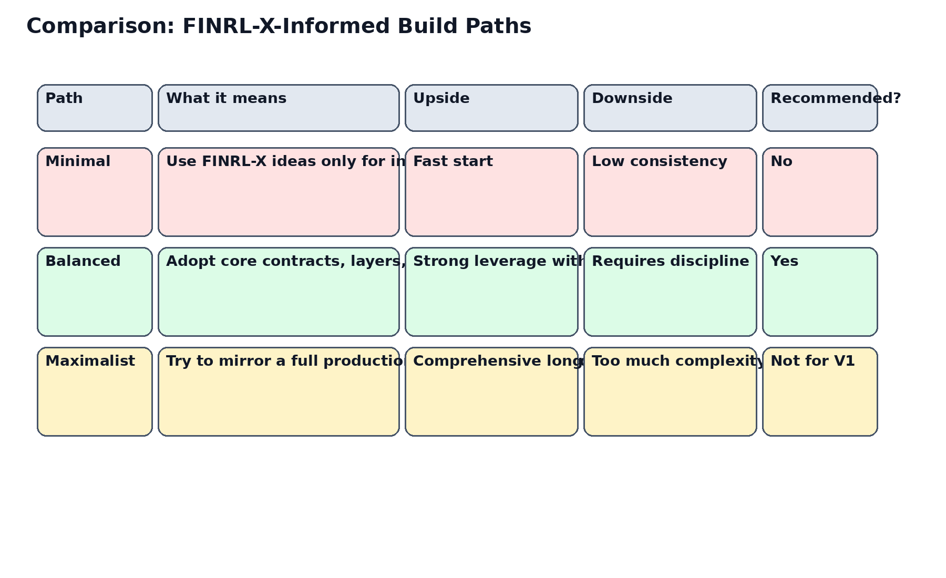
Figure 3. Three practical build paths and the recommended balanced path.

18. Comparative Solution Table
Solution archetype | Core promise | Main weakness | Fit for this project
Research-heavy | Flexible experimentation with models and environments | Weak user workflow and weak operational trust surfaces | Partial fit only
Balanced decision platform | Coherent recommendation workflow with replay and validation | Requires disciplined schema and UX design | Best fit
Operations-heavy platform | Closer to full paper/live readiness | More complexity and maintenance than current scope justifies | Later-stage option

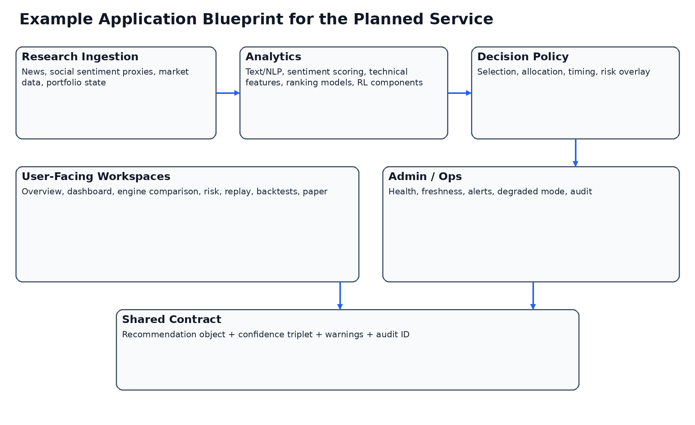
Figure 4. Example application blueprint for the planned service.

19. Risks, Caveats, and Honest Boundaries
The public FINRL-X footprint is still significantly smaller than the footprint of the original FinRL ecosystem and of more general trading-tool communities. That means the implementation guidance here must combine official FINRL-X claims with broader market and engineering realism.
This report does not claim that public GitHub or Reddit evidence proves production performance. It uses those sources to identify likely design gaps, common pitfalls, and feature patterns that matter when moving from research concepts to a stable private tool.
The report also does not claim that RL will necessarily outperform simpler policies for the founder's use case. The recommendation is to architect the system so that simpler baselines and more advanced policies can coexist and be compared fairly.

20. References and Source Notes
AI4Finance FinRL-Trading repository: https://github.com/AI4Finance-Foundation/FinRL-Trading
AI4Finance FinRL-Trading releases: https://github.com/AI4Finance-Foundation/FinRL-Trading/releases
FinRL-X paper (abstract): https://arxiv.org/abs/2603.21330
FinRL-X paper HTML: https://arxiv.org/html/2603.21330v1
Original FinRL repository note: https://github.com/AI4Finance-Foundation/FinRL
AI4Finance organization repository listing: https://github.com/orgs/AI4Finance-Foundation/repositories
Reddit: Does anyone have experience with RL?: https://www.reddit.com/r/algotrading/comments/uo42g4/does_anyone_have_experience_with_reinforcement/
Reddit: Anybody else doing reinforcement learning for trading?: https://www.reddit.com/r/algotrading/comments/zi6cli/anybody_else_doing_reinforcement_learning_for/
Reddit: live vs paper realism discussions: https://www.reddit.com/r/algotrading/comments/1r0h13s/am_i_ready_to_go_full_live_1_month_of_constant/
Reddit: slippage and fill realism: https://www.reddit.com/r/algotrading/comments/1sh6fug/help_to_calculate_accurate_slippage_in_a_backtest/
GitHub topic view: finrl: https://github.com/topics/finrl
Open-Finance-Lab trading agent demo: https://github.com/Open-Finance-Lab/FinLLM-Leaderboard/blob/main/docs/source/demos_of_finagents/trading_agent.rst

21. Example Product Modes for the Planned Service
The platform can usefully support multiple product modes without changing its core schema. A baseline mode can focus on recommendation and explanation only. An analyst mode can surface per-engine details, comparison, and manual scenario control. A validation mode can emphasize replay, backtests, and paper monitoring. An admin mode can emphasize health, freshness, and suppression logic.
These modes do not require separate products. They require carefully designed visibility policies. The same recommendation object and the same underlying run can appear differently based on the user's current intent.
For a private single-user system, this approach is still valuable because it reduces cognitive overload. It allows the founder to approach the same recommendation as an investor, as an analyst, or as an operator depending on the task of the moment.
Additional design implication 1 for 21. example product modes for the planned service: implementation should preserve explicit boundaries, visible warnings, and auditable downstream effects. The project should always prefer a narrower but inspectable capability over a broader but opaque capability, because this service is intended to improve one user's real decisions rather than to maximize demo breadth.
Additional design implication 2 for 21. example product modes for the planned service: implementation should preserve explicit boundaries, visible warnings, and auditable downstream effects. The project should always prefer a narrower but inspectable capability over a broader but opaque capability, because this service is intended to improve one user's real decisions rather than to maximize demo breadth.
Additional design implication 3 for 21. example product modes for the planned service: implementation should preserve explicit boundaries, visible warnings, and auditable downstream effects. The project should always prefer a narrower but inspectable capability over a broader but opaque capability, because this service is intended to improve one user's real decisions rather than to maximize demo breadth.
Additional design implication 4 for 21. example product modes for the planned service: implementation should preserve explicit boundaries, visible warnings, and auditable downstream effects. The project should always prefer a narrower but inspectable capability over a broader but opaque capability, because this service is intended to improve one user's real decisions rather than to maximize demo breadth.
Additional design implication 5 for 21. example product modes for the planned service: implementation should preserve explicit boundaries, visible warnings, and auditable downstream effects. The project should always prefer a narrower but inspectable capability over a broader but opaque capability, because this service is intended to improve one user's real decisions rather than to maximize demo breadth.
Additional design implication 6 for 21. example product modes for the planned service: implementation should preserve explicit boundaries, visible warnings, and auditable downstream effects. The project should always prefer a narrower but inspectable capability over a broader but opaque capability, because this service is intended to improve one user's real decisions rather than to maximize demo breadth.

22. Example Use Cases and Their Technical Consequences
A news-driven swing opportunity should primarily stress the text pipeline, timing logic, and confidence decomposition. The recommendation may move aggressively only if the catalyst is sufficiently strong and the risk overlay allows it.
A sentiment divergence use case should likely modify confidence and timing more than base allocation. Social sentiment can be informative but often needs stricter confidence handling than structured market data.
A technical-regime deterioration use case should illustrate why timing and risk overlays are separate. Selection can remain attractive while timing becomes cautious and risk scaling becomes defensive.
A cross-check use case should show the value of replay: the founder should be able to ask why a recommendation moved, which evidence changed, and whether the change was driven by one engine, a policy layer, or system degradation.
Additional design implication 1 for 22. example use cases and their technical consequences: implementation should preserve explicit boundaries, visible warnings, and auditable downstream effects. The project should always prefer a narrower but inspectable capability over a broader but opaque capability, because this service is intended to improve one user's real decisions rather than to maximize demo breadth.
Additional design implication 2 for 22. example use cases and their technical consequences: implementation should preserve explicit boundaries, visible warnings, and auditable downstream effects. The project should always prefer a narrower but inspectable capability over a broader but opaque capability, because this service is intended to improve one user's real decisions rather than to maximize demo breadth.
Additional design implication 3 for 22. example use cases and their technical consequences: implementation should preserve explicit boundaries, visible warnings, and auditable downstream effects. The project should always prefer a narrower but inspectable capability over a broader but opaque capability, because this service is intended to improve one user's real decisions rather than to maximize demo breadth.
Additional design implication 4 for 22. example use cases and their technical consequences: implementation should preserve explicit boundaries, visible warnings, and auditable downstream effects. The project should always prefer a narrower but inspectable capability over a broader but opaque capability, because this service is intended to improve one user's real decisions rather than to maximize demo breadth.
Additional design implication 5 for 22. example use cases and their technical consequences: implementation should preserve explicit boundaries, visible warnings, and auditable downstream effects. The project should always prefer a narrower but inspectable capability over a broader but opaque capability, because this service is intended to improve one user's real decisions rather than to maximize demo breadth.
Additional design implication 6 for 22. example use cases and their technical consequences: implementation should preserve explicit boundaries, visible warnings, and auditable downstream effects. The project should always prefer a narrower but inspectable capability over a broader but opaque capability, because this service is intended to improve one user's real decisions rather than to maximize demo breadth.

23. Data and Feature Checklist for Real Implementation
A real implementation should enumerate source ownership, freshness expectations, missing-data policy, and replay retention for each source class. Market data, news, sentiment proxies, and portfolio state should not be treated as equivalent in trust or cadence.
Feature engineering should distinguish durable features from transient context features. Some features belong in historical backtests. Some belong only in current-run overlays or confidence modifiers.
Feature lineage matters. The founder should be able to answer whether a final recommendation depended on one stale source, one failed transform, or one outlier engine.
Additional design implication 1 for 23. data and feature checklist for real implementation: implementation should preserve explicit boundaries, visible warnings, and auditable downstream effects. The project should always prefer a narrower but inspectable capability over a broader but opaque capability, because this service is intended to improve one user's real decisions rather than to maximize demo breadth.
Additional design implication 2 for 23. data and feature checklist for real implementation: implementation should preserve explicit boundaries, visible warnings, and auditable downstream effects. The project should always prefer a narrower but inspectable capability over a broader but opaque capability, because this service is intended to improve one user's real decisions rather than to maximize demo breadth.
Additional design implication 3 for 23. data and feature checklist for real implementation: implementation should preserve explicit boundaries, visible warnings, and auditable downstream effects. The project should always prefer a narrower but inspectable capability over a broader but opaque capability, because this service is intended to improve one user's real decisions rather than to maximize demo breadth.
Additional design implication 4 for 23. data and feature checklist for real implementation: implementation should preserve explicit boundaries, visible warnings, and auditable downstream effects. The project should always prefer a narrower but inspectable capability over a broader but opaque capability, because this service is intended to improve one user's real decisions rather than to maximize demo breadth.
Additional design implication 5 for 23. data and feature checklist for real implementation: implementation should preserve explicit boundaries, visible warnings, and auditable downstream effects. The project should always prefer a narrower but inspectable capability over a broader but opaque capability, because this service is intended to improve one user's real decisions rather than to maximize demo breadth.
Additional design implication 6 for 23. data and feature checklist for real implementation: implementation should preserve explicit boundaries, visible warnings, and auditable downstream effects. The project should always prefer a narrower but inspectable capability over a broader but opaque capability, because this service is intended to improve one user's real decisions rather than to maximize demo breadth.

24. Recommended Metrics for Comparing Capability Maturity
The system should evaluate itself not only by return metrics but by platform maturity metrics. Recommendation continuity, explanation completeness, replay coverage, source freshness, paper drift, and warning quality are all part of capability utilization.
A weak but honest system is more useful than a superficially strong system that hides uncertainty. Therefore, internal maturity metrics should include degraded-mode coverage and evidence coverage, not just backtest outcomes.
These metrics are especially important in a private platform because there is no separate support organization to absorb ambiguity. The product itself must communicate its own reliability.
Additional design implication 1 for 24. recommended metrics for comparing capability maturity: implementation should preserve explicit boundaries, visible warnings, and auditable downstream effects. The project should always prefer a narrower but inspectable capability over a broader but opaque capability, because this service is intended to improve one user's real decisions rather than to maximize demo breadth.
Additional design implication 2 for 24. recommended metrics for comparing capability maturity: implementation should preserve explicit boundaries, visible warnings, and auditable downstream effects. The project should always prefer a narrower but inspectable capability over a broader but opaque capability, because this service is intended to improve one user's real decisions rather than to maximize demo breadth.
Additional design implication 3 for 24. recommended metrics for comparing capability maturity: implementation should preserve explicit boundaries, visible warnings, and auditable downstream effects. The project should always prefer a narrower but inspectable capability over a broader but opaque capability, because this service is intended to improve one user's real decisions rather than to maximize demo breadth.
Additional design implication 4 for 24. recommended metrics for comparing capability maturity: implementation should preserve explicit boundaries, visible warnings, and auditable downstream effects. The project should always prefer a narrower but inspectable capability over a broader but opaque capability, because this service is intended to improve one user's real decisions rather than to maximize demo breadth.
Additional design implication 5 for 24. recommended metrics for comparing capability maturity: implementation should preserve explicit boundaries, visible warnings, and auditable downstream effects. The project should always prefer a narrower but inspectable capability over a broader but opaque capability, because this service is intended to improve one user's real decisions rather than to maximize demo breadth.
Additional design implication 6 for 24. recommended metrics for comparing capability maturity: implementation should preserve explicit boundaries, visible warnings, and auditable downstream effects. The project should always prefer a narrower but inspectable capability over a broader but opaque capability, because this service is intended to improve one user's real decisions rather than to maximize demo breadth.

25. Example Comparison Between a Loose Stack and a FINRL-X-Informed Stack
A loose stack often consists of several notebooks, a few charts, and disconnected model outputs. In such a stack, the founder can often tell that something interesting happened but cannot reliably tell why the final decision should change.
A FINRL-X-informed stack, by contrast, does not merely add more models. It imposes structure. The system knows which candidates were selected, how weights were proposed, how timing intervened, how risk scaled the final output, and what evidence was available at each step.
This difference is what makes the architecture valuable for the current project. The benefit is not theoretical elegance alone. The benefit is a cleaner and more governable user experience.
Additional design implication 1 for 25. example comparison between a loose stack and a finrl-x-informed stack: implementation should preserve explicit boundaries, visible warnings, and auditable downstream effects. The project should always prefer a narrower but inspectable capability over a broader but opaque capability, because this service is intended to improve one user's real decisions rather than to maximize demo breadth.
Additional design implication 2 for 25. example comparison between a loose stack and a finrl-x-informed stack: implementation should preserve explicit boundaries, visible warnings, and auditable downstream effects. The project should always prefer a narrower but inspectable capability over a broader but opaque capability, because this service is intended to improve one user's real decisions rather than to maximize demo breadth.
Additional design implication 3 for 25. example comparison between a loose stack and a finrl-x-informed stack: implementation should preserve explicit boundaries, visible warnings, and auditable downstream effects. The project should always prefer a narrower but inspectable capability over a broader but opaque capability, because this service is intended to improve one user's real decisions rather than to maximize demo breadth.
Additional design implication 4 for 25. example comparison between a loose stack and a finrl-x-informed stack: implementation should preserve explicit boundaries, visible warnings, and auditable downstream effects. The project should always prefer a narrower but inspectable capability over a broader but opaque capability, because this service is intended to improve one user's real decisions rather than to maximize demo breadth.
Additional design implication 5 for 25. example comparison between a loose stack and a finrl-x-informed stack: implementation should preserve explicit boundaries, visible warnings, and auditable downstream effects. The project should always prefer a narrower but inspectable capability over a broader but opaque capability, because this service is intended to improve one user's real decisions rather than to maximize demo breadth.
Additional design implication 6 for 25. example comparison between a loose stack and a finrl-x-informed stack: implementation should preserve explicit boundaries, visible warnings, and auditable downstream effects. The project should always prefer a narrower but inspectable capability over a broader but opaque capability, because this service is intended to improve one user's real decisions rather than to maximize demo breadth.

26. Closing Implementation Guidance
The product should be built so that every future enhancement has an obvious home. New text intelligence should attach at engine or timing level. New allocator ideas should attach at the allocation layer. New trust rules should attach in confidence or risk-overlay logic. New screens should consume the same shared recommendation object.
This is the best way to keep the system extensible without allowing it to sprawl. It is also the best way to keep Claude's implementation work reviewable. When every enhancement has a defined place in the architecture, evidence and acceptance are easier to judge.
If the founder follows this path, FINRL-X becomes less a dependency and more a durable blueprint. That is the most realistic meaning of maximum capability utilization for the project.
Additional design implication 1 for 26. closing implementation guidance: implementation should preserve explicit boundaries, visible warnings, and auditable downstream effects. The project should always prefer a narrower but inspectable capability over a broader but opaque capability, because this service is intended to improve one user's real decisions rather than to maximize demo breadth.
Additional design implication 2 for 26. closing implementation guidance: implementation should preserve explicit boundaries, visible warnings, and auditable downstream effects. The project should always prefer a narrower but inspectable capability over a broader but opaque capability, because this service is intended to improve one user's real decisions rather than to maximize demo breadth.
Additional design implication 3 for 26. closing implementation guidance: implementation should preserve explicit boundaries, visible warnings, and auditable downstream effects. The project should always prefer a narrower but inspectable capability over a broader but opaque capability, because this service is intended to improve one user's real decisions rather than to maximize demo breadth.
Additional design implication 4 for 26. closing implementation guidance: implementation should preserve explicit boundaries, visible warnings, and auditable downstream effects. The project should always prefer a narrower but inspectable capability over a broader but opaque capability, because this service is intended to improve one user's real decisions rather than to maximize demo breadth.
Additional design implication 5 for 26. closing implementation guidance: implementation should preserve explicit boundaries, visible warnings, and auditable downstream effects. The project should always prefer a narrower but inspectable capability over a broader but opaque capability, because this service is intended to improve one user's real decisions rather than to maximize demo breadth.
Additional design implication 6 for 26. closing implementation guidance: implementation should preserve explicit boundaries, visible warnings, and auditable downstream effects. The project should always prefer a narrower but inspectable capability over a broader but opaque capability, because this service is intended to improve one user's real decisions rather than to maximize demo breadth.
Implementation layer | Loose stack failure mode | FINRL-X-informed mitigation
Data | Inputs are updated inconsistently and are hard to replay | Snapshot discipline and feature lineage
Engines | Outputs are incomparable across models | Shared engine output contract
Selection | Interesting ideas do not become a clear shortlist | Explicit candidate layer
Allocation | Scores do not map cleanly to positions | Target-weight proposal stage
Timing | Entry logic is mixed into everything else | Dedicated timing stage
Risk | Hidden overrides confuse the user | Visible portfolio-level risk overlay
Validation | Backtests, paper, and dashboard disagree semantically | Shared recommendation object across surfaces

27. Build-versus-Buy Implications
27. Build-versus-Buy Implications paragraph 1. For this project, the practical question is not whether every capability can theoretically be built, but whether each capability improves decision quality enough to justify complexity. The correct threshold is higher than in a public demo product because the platform is intended for real private use. As a result, the implementation should prioritize durable contracts, validation coverage, and explanation surfaces over novelty. A narrower but fully inspectable feature set is strategically stronger than a broader but weakly governed system.
27. Build-versus-Buy Implications paragraph 2. For this project, the practical question is not whether every capability can theoretically be built, but whether each capability improves decision quality enough to justify complexity. The correct threshold is higher than in a public demo product because the platform is intended for real private use. As a result, the implementation should prioritize durable contracts, validation coverage, and explanation surfaces over novelty. A narrower but fully inspectable feature set is strategically stronger than a broader but weakly governed system.
27. Build-versus-Buy Implications paragraph 3. For this project, the practical question is not whether every capability can theoretically be built, but whether each capability improves decision quality enough to justify complexity. The correct threshold is higher than in a public demo product because the platform is intended for real private use. As a result, the implementation should prioritize durable contracts, validation coverage, and explanation surfaces over novelty. A narrower but fully inspectable feature set is strategically stronger than a broader but weakly governed system.
27. Build-versus-Buy Implications paragraph 4. For this project, the practical question is not whether every capability can theoretically be built, but whether each capability improves decision quality enough to justify complexity. The correct threshold is higher than in a public demo product because the platform is intended for real private use. As a result, the implementation should prioritize durable contracts, validation coverage, and explanation surfaces over novelty. A narrower but fully inspectable feature set is strategically stronger than a broader but weakly governed system.
27. Build-versus-Buy Implications paragraph 5. For this project, the practical question is not whether every capability can theoretically be built, but whether each capability improves decision quality enough to justify complexity. The correct threshold is higher than in a public demo product because the platform is intended for real private use. As a result, the implementation should prioritize durable contracts, validation coverage, and explanation surfaces over novelty. A narrower but fully inspectable feature set is strategically stronger than a broader but weakly governed system.
27. Build-versus-Buy Implications paragraph 6. For this project, the practical question is not whether every capability can theoretically be built, but whether each capability improves decision quality enough to justify complexity. The correct threshold is higher than in a public demo product because the platform is intended for real private use. As a result, the implementation should prioritize durable contracts, validation coverage, and explanation surfaces over novelty. A narrower but fully inspectable feature set is strategically stronger than a broader but weakly governed system.
27. Build-versus-Buy Implications paragraph 7. For this project, the practical question is not whether every capability can theoretically be built, but whether each capability improves decision quality enough to justify complexity. The correct threshold is higher than in a public demo product because the platform is intended for real private use. As a result, the implementation should prioritize durable contracts, validation coverage, and explanation surfaces over novelty. A narrower but fully inspectable feature set is strategically stronger than a broader but weakly governed system.
27. Build-versus-Buy Implications paragraph 8. For this project, the practical question is not whether every capability can theoretically be built, but whether each capability improves decision quality enough to justify complexity. The correct threshold is higher than in a public demo product because the platform is intended for real private use. As a result, the implementation should prioritize durable contracts, validation coverage, and explanation surfaces over novelty. A narrower but fully inspectable feature set is strategically stronger than a broader but weakly governed system.

28. Delivery Governance and Review Requirements
28. Delivery Governance and Review Requirements paragraph 1. For this project, the practical question is not whether every capability can theoretically be built, but whether each capability improves decision quality enough to justify complexity. The correct threshold is higher than in a public demo product because the platform is intended for real private use. As a result, the implementation should prioritize durable contracts, validation coverage, and explanation surfaces over novelty. A narrower but fully inspectable feature set is strategically stronger than a broader but weakly governed system.
28. Delivery Governance and Review Requirements paragraph 2. For this project, the practical question is not whether every capability can theoretically be built, but whether each capability improves decision quality enough to justify complexity. The correct threshold is higher than in a public demo product because the platform is intended for real private use. As a result, the implementation should prioritize durable contracts, validation coverage, and explanation surfaces over novelty. A narrower but fully inspectable feature set is strategically stronger than a broader but weakly governed system.
28. Delivery Governance and Review Requirements paragraph 3. For this project, the practical question is not whether every capability can theoretically be built, but whether each capability improves decision quality enough to justify complexity. The correct threshold is higher than in a public demo product because the platform is intended for real private use. As a result, the implementation should prioritize durable contracts, validation coverage, and explanation surfaces over novelty. A narrower but fully inspectable feature set is strategically stronger than a broader but weakly governed system.
28. Delivery Governance and Review Requirements paragraph 4. For this project, the practical question is not whether every capability can theoretically be built, but whether each capability improves decision quality enough to justify complexity. The correct threshold is higher than in a public demo product because the platform is intended for real private use. As a result, the implementation should prioritize durable contracts, validation coverage, and explanation surfaces over novelty. A narrower but fully inspectable feature set is strategically stronger than a broader but weakly governed system.
28. Delivery Governance and Review Requirements paragraph 5. For this project, the practical question is not whether every capability can theoretically be built, but whether each capability improves decision quality enough to justify complexity. The correct threshold is higher than in a public demo product because the platform is intended for real private use. As a result, the implementation should prioritize durable contracts, validation coverage, and explanation surfaces over novelty. A narrower but fully inspectable feature set is strategically stronger than a broader but weakly governed system.
28. Delivery Governance and Review Requirements paragraph 6. For this project, the practical question is not whether every capability can theoretically be built, but whether each capability improves decision quality enough to justify complexity. The correct threshold is higher than in a public demo product because the platform is intended for real private use. As a result, the implementation should prioritize durable contracts, validation coverage, and explanation surfaces over novelty. A narrower but fully inspectable feature set is strategically stronger than a broader but weakly governed system.
28. Delivery Governance and Review Requirements paragraph 7. For this project, the practical question is not whether every capability can theoretically be built, but whether each capability improves decision quality enough to justify complexity. The correct threshold is higher than in a public demo product because the platform is intended for real private use. As a result, the implementation should prioritize durable contracts, validation coverage, and explanation surfaces over novelty. A narrower but fully inspectable feature set is strategically stronger than a broader but weakly governed system.
28. Delivery Governance and Review Requirements paragraph 8. For this project, the practical question is not whether every capability can theoretically be built, but whether each capability improves decision quality enough to justify complexity. The correct threshold is higher than in a public demo product because the platform is intended for real private use. As a result, the implementation should prioritize durable contracts, validation coverage, and explanation surfaces over novelty. A narrower but fully inspectable feature set is strategically stronger than a broader but weakly governed system.

29. Final Shortlist of Must-Have Capabilities
29. Final Shortlist of Must-Have Capabilities paragraph 1. For this project, the practical question is not whether every capability can theoretically be built, but whether each capability improves decision quality enough to justify complexity. The correct threshold is higher than in a public demo product because the platform is intended for real private use. As a result, the implementation should prioritize durable contracts, validation coverage, and explanation surfaces over novelty. A narrower but fully inspectable feature set is strategically stronger than a broader but weakly governed system.
29. Final Shortlist of Must-Have Capabilities paragraph 2. For this project, the practical question is not whether every capability can theoretically be built, but whether each capability improves decision quality enough to justify complexity. The correct threshold is higher than in a public demo product because the platform is intended for real private use. As a result, the implementation should prioritize durable contracts, validation coverage, and explanation surfaces over novelty. A narrower but fully inspectable feature set is strategically stronger than a broader but weakly governed system.
29. Final Shortlist of Must-Have Capabilities paragraph 3. For this project, the practical question is not whether every capability can theoretically be built, but whether each capability improves decision quality enough to justify complexity. The correct threshold is higher than in a public demo product because the platform is intended for real private use. As a result, the implementation should prioritize durable contracts, validation coverage, and explanation surfaces over novelty. A narrower but fully inspectable feature set is strategically stronger than a broader but weakly governed system.
29. Final Shortlist of Must-Have Capabilities paragraph 4. For this project, the practical question is not whether every capability can theoretically be built, but whether each capability improves decision quality enough to justify complexity. The correct threshold is higher than in a public demo product because the platform is intended for real private use. As a result, the implementation should prioritize durable contracts, validation coverage, and explanation surfaces over novelty. A narrower but fully inspectable feature set is strategically stronger than a broader but weakly governed system.
29. Final Shortlist of Must-Have Capabilities paragraph 5. For this project, the practical question is not whether every capability can theoretically be built, but whether each capability improves decision quality enough to justify complexity. The correct threshold is higher than in a public demo product because the platform is intended for real private use. As a result, the implementation should prioritize durable contracts, validation coverage, and explanation surfaces over novelty. A narrower but fully inspectable feature set is strategically stronger than a broader but weakly governed system.
29. Final Shortlist of Must-Have Capabilities paragraph 6. For this project, the practical question is not whether every capability can theoretically be built, but whether each capability improves decision quality enough to justify complexity. The correct threshold is higher than in a public demo product because the platform is intended for real private use. As a result, the implementation should prioritize durable contracts, validation coverage, and explanation surfaces over novelty. A narrower but fully inspectable feature set is strategically stronger than a broader but weakly governed system.
29. Final Shortlist of Must-Have Capabilities paragraph 7. For this project, the practical question is not whether every capability can theoretically be built, but whether each capability improves decision quality enough to justify complexity. The correct threshold is higher than in a public demo product because the platform is intended for real private use. As a result, the implementation should prioritize durable contracts, validation coverage, and explanation surfaces over novelty. A narrower but fully inspectable feature set is strategically stronger than a broader but weakly governed system.
29. Final Shortlist of Must-Have Capabilities paragraph 8. For this project, the practical question is not whether every capability can theoretically be built, but whether each capability improves decision quality enough to justify complexity. The correct threshold is higher than in a public demo product because the platform is intended for real private use. As a result, the implementation should prioritize durable contracts, validation coverage, and explanation surfaces over novelty. A narrower but fully inspectable feature set is strategically stronger than a broader but weakly governed system.
Capability | Why it is non-negotiable now | Why it should not wait
Canonical recommendation object | It keeps all downstream surfaces consistent | Without it, the product remains fragmented
Replay and history | It turns outputs into inspectable decisions | Without it, trust is rhetorical
Confidence decomposition | It separates weak markets from weak system conditions | Without it, the founder cannot interpret uncertainty correctly
Dashboard-first delivery | It creates daily utility quickly | Without it, the system stays research-only
Ops / health visibility | It distinguishes system failure from market caution | Without it, every weak recommendation is ambiguous

