06. UX Appendix — Detailed Site, Dashboard, and Admin Experience
Detailed UX and UI appendix for the planned private investment decision platform

This appendix translates the product concept into screen-level UX/UI guidance for the full site, with special emphasis on the dashboard, validation surfaces, and admin/ops experience.
The design target is a premium, highly legible, decision-first analytical product that helps one informed owner-operator understand the current recommendation, the reasons behind it, the active risk posture, the level of trust, and any operational caveats.
The appendix is intentionally more specific than a generic UX brief. It should function as a downstream specification that can guide information architecture, component design, responsive behavior, interaction logic, state handling, and phased implementation.
Attribute | UX direction
Primary interaction model | Decision-first, chart-first, panel-based exploration
Primary screen goal | Show current recommendation and the reasons for it
Secondary screen goals | Risk interpretation, validation, replay, and operational truth
Desktop posture | Dense but structured multi-panel workspace
Mobile posture | Triage-first and review-first, not parity-first

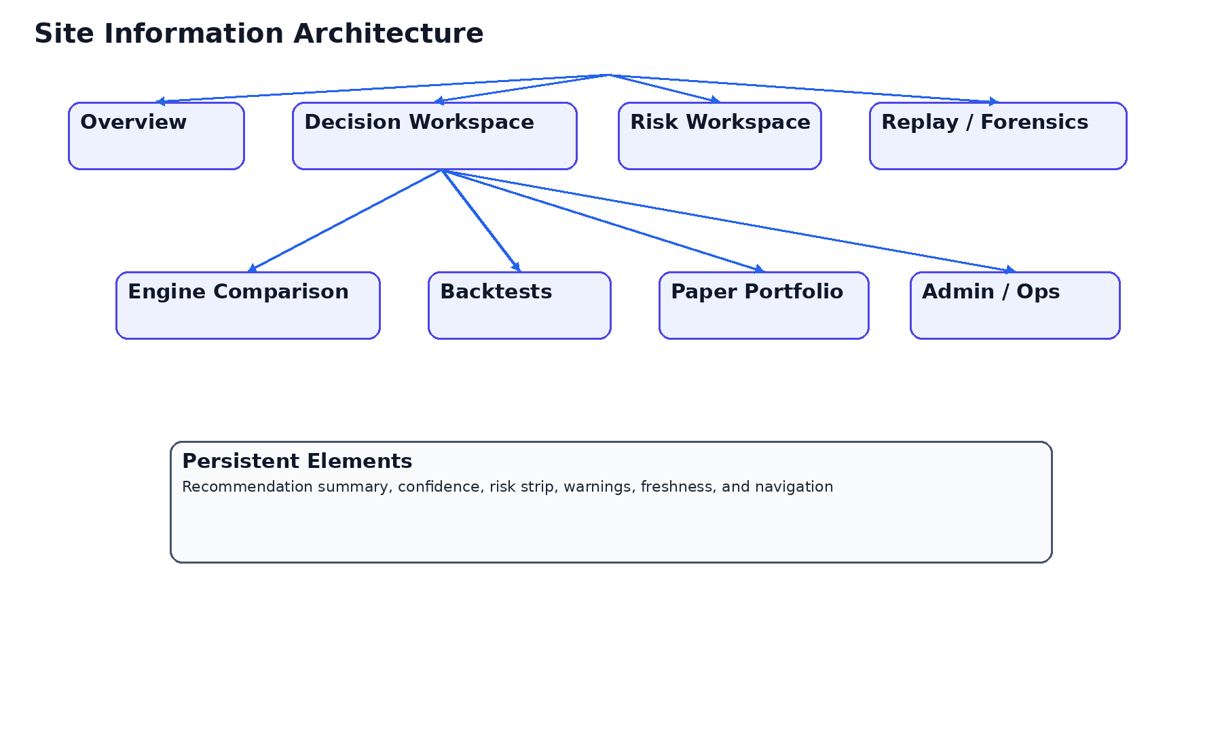
Figure 1. Proposed site map and screen hierarchy.

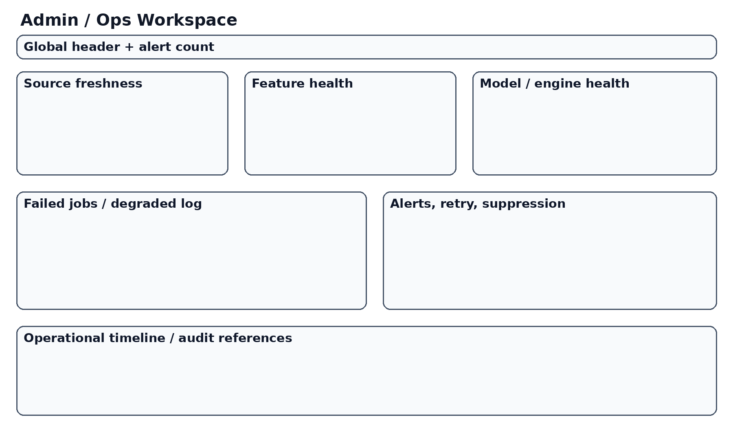
Figure 5. Admin / Ops concept.

UX principles and design posture
The product should prioritize interpretability over spectacle, and actionability over metric abundance.
The recommendation object is the center of the experience. The rest of the interface exists to explain, challenge, validate, or operationalize that object.
The most important visual hierarchy should be reserved for recommendation state, risk state, trust state, warnings, and change narrative.
In implementation terms, ux principles and design posture should be treated as a controlling UX specification rather than a descriptive note. This appendix is intended to reduce ambiguity for future design and engineering work by defining what must be visible, what should be collapsed, how states should degrade, and how the user should move between overview, decision, risk, validation, and operations. For a private medium-term investment product, clarity does not come from removing advanced capability; it comes from structuring capability around user questions and around the recommendation object. Therefore, every rule in this section should be interpreted as part of a decision-first information architecture rather than as a generic dashboard guideline.

Information architecture for the full site
The full site should be organized around Overview, Dashboard, Engine Comparison, Risk, Replay, Backtests, Paper Portfolio, and Admin / Ops.
The IA should answer concrete questions rather than mirror backend services. This reduces cognitive switching and keeps navigation semantically stable.
In implementation terms, information architecture for the full site should be treated as a controlling UX specification rather than a descriptive note. This appendix is intended to reduce ambiguity for future design and engineering work by defining what must be visible, what should be collapsed, how states should degrade, and how the user should move between overview, decision, risk, validation, and operations. For a private medium-term investment product, clarity does not come from removing advanced capability; it comes from structuring capability around user questions and around the recommendation object. Therefore, every rule in this section should be interpreted as part of a decision-first information architecture rather than as a generic dashboard guideline.

Home / overview screen
The overview should act as a mission-control entry point. It should summarize what changed, what is currently recommended, what risk posture is active, whether the system is healthy, and where deeper review is needed.
The overview should allow rapid triage in under one minute.
In implementation terms, home / overview screen should be treated as a controlling UX specification rather than a descriptive note. This appendix is intended to reduce ambiguity for future design and engineering work by defining what must be visible, what should be collapsed, how states should degrade, and how the user should move between overview, decision, risk, validation, and operations. For a private medium-term investment product, clarity does not come from removing advanced capability; it comes from structuring capability around user questions and around the recommendation object. Therefore, every rule in this section should be interpreted as part of a decision-first information architecture rather than as a generic dashboard guideline.

Main dashboard workspace
The dashboard should be the main working surface for the product and should support a stable three-region layout on desktop: controls/context on the left, chart and central reasoning in the middle, recommendation and trust on the right.
It must avoid the equal-weight card wall pattern. Not all information is equally important.
In implementation terms, main dashboard workspace should be treated as a controlling UX specification rather than a descriptive note. This appendix is intended to reduce ambiguity for future design and engineering work by defining what must be visible, what should be collapsed, how states should degrade, and how the user should move between overview, decision, risk, validation, and operations. For a private medium-term investment product, clarity does not come from removing advanced capability; it comes from structuring capability around user questions and around the recommendation object. Therefore, every rule in this section should be interpreted as part of a decision-first information architecture rather than as a generic dashboard guideline.

Recommendation card design
The recommendation card should show target weights, current weights, deltas, timing status, confidence decomposition, and the top drivers behind the recommendation.
The recommendation card should remain visible or easily retrievable while the user navigates deeper into supporting detail.
In implementation terms, recommendation card design should be treated as a controlling UX specification rather than a descriptive note. This appendix is intended to reduce ambiguity for future design and engineering work by defining what must be visible, what should be collapsed, how states should degrade, and how the user should move between overview, decision, risk, validation, and operations. For a private medium-term investment product, clarity does not come from removing advanced capability; it comes from structuring capability around user questions and around the recommendation object. Therefore, every rule in this section should be interpreted as part of a decision-first information architecture rather than as a generic dashboard guideline.

Chart UX and visual explanation
The main chart is not just a market chart. It is the primary explanatory canvas for price, benchmark, technical context, timing blocks, entry/exit zones, and recommendation changes.
Charts should emphasize readable scales, restrained annotation, and purposeful overlays.
In implementation terms, chart ux and visual explanation should be treated as a controlling UX specification rather than a descriptive note. This appendix is intended to reduce ambiguity for future design and engineering work by defining what must be visible, what should be collapsed, how states should degrade, and how the user should move between overview, decision, risk, validation, and operations. For a private medium-term investment product, clarity does not come from removing advanced capability; it comes from structuring capability around user questions and around the recommendation object. Therefore, every rule in this section should be interpreted as part of a decision-first information architecture rather than as a generic dashboard guideline.

Engine comparison workspace
The engine comparison view should help the user understand agreement, disagreement, and contribution across text/news, sentiment, technical, ML, and RL-informed components.
This workspace is about interpretation, not about giving every engine equal product status.
In implementation terms, engine comparison workspace should be treated as a controlling UX specification rather than a descriptive note. This appendix is intended to reduce ambiguity for future design and engineering work by defining what must be visible, what should be collapsed, how states should degrade, and how the user should move between overview, decision, risk, validation, and operations. For a private medium-term investment product, clarity does not come from removing advanced capability; it comes from structuring capability around user questions and around the recommendation object. Therefore, every rule in this section should be interpreted as part of a decision-first information architecture rather than as a generic dashboard guideline.

Risk workspace
Risk deserves its own workspace because risk is both a policy layer and a user question.
The risk screen should show exposures, concentration, benchmark divergence, scenario impacts, volatility expectations, and active overlay rules.
In implementation terms, risk workspace should be treated as a controlling UX specification rather than a descriptive note. This appendix is intended to reduce ambiguity for future design and engineering work by defining what must be visible, what should be collapsed, how states should degrade, and how the user should move between overview, decision, risk, validation, and operations. For a private medium-term investment product, clarity does not come from removing advanced capability; it comes from structuring capability around user questions and around the recommendation object. Therefore, every rule in this section should be interpreted as part of a decision-first information architecture rather than as a generic dashboard guideline.

Replay and forensics
Replay should expose the lifecycle of a recommendation: source state, features, engine outputs, policy-stage changes, risk adjustments, and final publication.
The user should be able to understand not only what the system recommends, but how the system got there.
In implementation terms, replay and forensics should be treated as a controlling UX specification rather than a descriptive note. This appendix is intended to reduce ambiguity for future design and engineering work by defining what must be visible, what should be collapsed, how states should degrade, and how the user should move between overview, decision, risk, validation, and operations. For a private medium-term investment product, clarity does not come from removing advanced capability; it comes from structuring capability around user questions and around the recommendation object. Therefore, every rule in this section should be interpreted as part of a decision-first information architecture rather than as a generic dashboard guideline.

Backtests UX
Backtests should be framed carefully to avoid false certainty. The screen should emphasize assumptions, date ranges, transaction logic, benchmark context, and where backtest relevance is weaker.
The visual structure should clearly separate headline outcomes from methodological caveats.
In implementation terms, backtests ux should be treated as a controlling UX specification rather than a descriptive note. This appendix is intended to reduce ambiguity for future design and engineering work by defining what must be visible, what should be collapsed, how states should degrade, and how the user should move between overview, decision, risk, validation, and operations. For a private medium-term investment product, clarity does not come from removing advanced capability; it comes from structuring capability around user questions and around the recommendation object. Therefore, every rule in this section should be interpreted as part of a decision-first information architecture rather than as a generic dashboard guideline.

Paper portfolio workspace
Paper portfolio is the forward-looking validation surface. It should show holdings, drift, realized vs hypothetical outcomes, benchmark context, and how current recommendations would alter the paper portfolio.
This workspace should bridge abstract recommendation logic and practical portfolio implications.
In implementation terms, paper portfolio workspace should be treated as a controlling UX specification rather than a descriptive note. This appendix is intended to reduce ambiguity for future design and engineering work by defining what must be visible, what should be collapsed, how states should degrade, and how the user should move between overview, decision, risk, validation, and operations. For a private medium-term investment product, clarity does not come from removing advanced capability; it comes from structuring capability around user questions and around the recommendation object. Therefore, every rule in this section should be interpreted as part of a decision-first information architecture rather than as a generic dashboard guideline.

Watchlists and universe management
Watchlists should support quick triage, grouping, filtering, and entry into the main workspace.
Universe management should remain powerful but should not overwhelm the core decision screens.
In implementation terms, watchlists and universe management should be treated as a controlling UX specification rather than a descriptive note. This appendix is intended to reduce ambiguity for future design and engineering work by defining what must be visible, what should be collapsed, how states should degrade, and how the user should move between overview, decision, risk, validation, and operations. For a private medium-term investment product, clarity does not come from removing advanced capability; it comes from structuring capability around user questions and around the recommendation object. Therefore, every rule in this section should be interpreted as part of a decision-first information architecture rather than as a generic dashboard guideline.

News and text-analysis experience
Text-analysis outputs should be concise, ranked, and explicitly linked to recommendation relevance.
The UX should distinguish raw content from synthesized product interpretation.
In implementation terms, news and text-analysis experience should be treated as a controlling UX specification rather than a descriptive note. This appendix is intended to reduce ambiguity for future design and engineering work by defining what must be visible, what should be collapsed, how states should degrade, and how the user should move between overview, decision, risk, validation, and operations. For a private medium-term investment product, clarity does not come from removing advanced capability; it comes from structuring capability around user questions and around the recommendation object. Therefore, every rule in this section should be interpreted as part of a decision-first information architecture rather than as a generic dashboard guideline.

Social sentiment experience
Social sentiment should be visible as a supporting context layer, with freshness, source-type, and confidence clearly exposed.
Because sentiment is noisy, the interface should visually signal uncertainty and avoid overstatement.
In implementation terms, social sentiment experience should be treated as a controlling UX specification rather than a descriptive note. This appendix is intended to reduce ambiguity for future design and engineering work by defining what must be visible, what should be collapsed, how states should degrade, and how the user should move between overview, decision, risk, validation, and operations. For a private medium-term investment product, clarity does not come from removing advanced capability; it comes from structuring capability around user questions and around the recommendation object. Therefore, every rule in this section should be interpreted as part of a decision-first information architecture rather than as a generic dashboard guideline.

Alerting and notification strategy
Alerts should be meaningful, sparse, and linked to user questions such as recommendation change, risk breach, stale source, or operational degradation.
Alerting should not replicate consumer-trading urgency patterns that distort medium-term decision quality.
In implementation terms, alerting and notification strategy should be treated as a controlling UX specification rather than a descriptive note. This appendix is intended to reduce ambiguity for future design and engineering work by defining what must be visible, what should be collapsed, how states should degrade, and how the user should move between overview, decision, risk, validation, and operations. For a private medium-term investment product, clarity does not come from removing advanced capability; it comes from structuring capability around user questions and around the recommendation object. Therefore, every rule in this section should be interpreted as part of a decision-first information architecture rather than as a generic dashboard guideline.

Admin / ops information architecture
Admin / Ops should be structured into at least four domains: source freshness, feature integrity, model/engine health, and publication state.
This helps the operator understand whether a problem comes from data, transformation, logic, or publishing.
In implementation terms, admin / ops information architecture should be treated as a controlling UX specification rather than a descriptive note. This appendix is intended to reduce ambiguity for future design and engineering work by defining what must be visible, what should be collapsed, how states should degrade, and how the user should move between overview, decision, risk, validation, and operations. For a private medium-term investment product, clarity does not come from removing advanced capability; it comes from structuring capability around user questions and around the recommendation object. Therefore, every rule in this section should be interpreted as part of a decision-first information architecture rather than as a generic dashboard guideline.

Admin / ops screens and behaviors
Admin views should support both summary and diagnosis. They should make it easy to see what is degraded, what is blocked, what recovered, and what requires manual intervention.
Historical incident context is useful, but the primary screen should focus on present trust and next actions.
In implementation terms, admin / ops screens and behaviors should be treated as a controlling UX specification rather than a descriptive note. This appendix is intended to reduce ambiguity for future design and engineering work by defining what must be visible, what should be collapsed, how states should degrade, and how the user should move between overview, decision, risk, validation, and operations. For a private medium-term investment product, clarity does not come from removing advanced capability; it comes from structuring capability around user questions and around the recommendation object. Therefore, every rule in this section should be interpreted as part of a decision-first information architecture rather than as a generic dashboard guideline.

Global states: empty, loading, stale, warning, and degraded
A mature product needs explicit rules for empty, loading, stale, partial, and degraded states.
The interface should never silently hide missing data or failed model outputs.
In implementation terms, global states: empty, loading, stale, warning, and degraded should be treated as a controlling UX specification rather than a descriptive note. This appendix is intended to reduce ambiguity for future design and engineering work by defining what must be visible, what should be collapsed, how states should degrade, and how the user should move between overview, decision, risk, validation, and operations. For a private medium-term investment product, clarity does not come from removing advanced capability; it comes from structuring capability around user questions and around the recommendation object. Therefore, every rule in this section should be interpreted as part of a decision-first information architecture rather than as a generic dashboard guideline.

Responsive strategy and mobile-first triage
Mobile should optimize for review and triage rather than for full analytical parity.
The default mobile order should be recommendation, risk, trust, warning, and chart summary before deeper detail.
In implementation terms, responsive strategy and mobile-first triage should be treated as a controlling UX specification rather than a descriptive note. This appendix is intended to reduce ambiguity for future design and engineering work by defining what must be visible, what should be collapsed, how states should degrade, and how the user should move between overview, decision, risk, validation, and operations. For a private medium-term investment product, clarity does not come from removing advanced capability; it comes from structuring capability around user questions and around the recommendation object. Therefore, every rule in this section should be interpreted as part of a decision-first information architecture rather than as a generic dashboard guideline.

Design system, accessibility, and interaction details
The design system should define typography, spacing, table density, control behavior, hover/focus rules, chart chrome, status colors, and keyboard behavior.
Accessibility should be built into color use, semantic structure, focus management, and dense-data readability.
In implementation terms, design system, accessibility, and interaction details should be treated as a controlling UX specification rather than a descriptive note. This appendix is intended to reduce ambiguity for future design and engineering work by defining what must be visible, what should be collapsed, how states should degrade, and how the user should move between overview, decision, risk, validation, and operations. For a private medium-term investment product, clarity does not come from removing advanced capability; it comes from structuring capability around user questions and around the recommendation object. Therefore, every rule in this section should be interpreted as part of a decision-first information architecture rather than as a generic dashboard guideline.

Detailed screen inventory
Screen | Primary question answered | Must be visible on initial load
Overview | What changed and what needs attention now? | Current recommendation, trust, risk, warnings, shortcuts
Dashboard | What is the recommendation and why? | Recommendation block, chart, trust, primary controls
Engine Comparison | Where do engines agree or diverge? | Agreement matrix, contribution view, warnings
Risk | What are the current exposures and constraints? | Exposure summary, active overlay rules, concentration state
Replay | How was this recommendation formed? | Stage timeline, before/after states, audit references
Backtests | How did the policy behave historically? | Headline outcomes, assumptions, benchmark, caveats
Paper Portfolio | How does this affect the simulated portfolio? | Current holdings, drift, target deltas, benchmark view
Admin / Ops | Can the platform be trusted operationally right now? | Freshness, health domains, alerts, status summary

Wireframe-level behavior notes
- Recommendation, trust, and warning semantics must remain consistent across all major screens.
- The user should never lose context when moving from dashboard to risk or replay.
- If a model or source is degraded, the product should explicitly downgrade trust instead of pretending nothing changed.
- The UI should preserve stateful deep-linking where possible so the same recommendation context can be reopened.
- The first mobile viewport should never be occupied by secondary filters alone.

External research basis
This appendix reflects current public product positioning and dashboard principles from several sources. Koyfin explicitly positions itself as a platform where investors can research markets, analyze portfolios, and create reports in one place, which supports the integrated-context direction used here.
TradingView reinforces the importance of chart-first exploration and broad market screening, while NN/g materials reinforce that dashboards should support rapid human interpretation and that complex applications need disciplined structure rather than visual overload.
Koyfin’s public mobile commentary also supports the idea that a mobile app can be a streamlined extension rather than a one-to-one clone of the web experience, which aligns with the triage-first mobile recommendation in this appendix.

