07. Competitor Benchmark, Detailed Comparison Matrix, and Differentiation Strategy
Expanded competitor benchmark for the planned private investment decision platform

Purpose | Benchmark adjacent products and extract the best patterns without losing the platform's uniqueness
Use case | Private medium-term investment decision support
Benchmark focus | Research platforms, portfolio analytics tools, chart-first tools, and AI-oriented stock research products
Strategic lens | Absorb strengths, reject misaligned incentives, and define the product's unique position

This report benchmarks adjacent products and translates their strongest patterns into a differentiation strategy for the planned private platform. The purpose is not to prove that the product category is crowded. The purpose is to identify which product behaviors should be absorbed, which should be rejected, and how the planned service can become more coherent and more decision-useful than the tools it overlaps with.
The benchmark is deliberately selective. It focuses on tools and product families that matter to the founder's actual workflow: research platforms such as Koyfin and TIKR, portfolio analytics products such as PortfoliosLab, chart-first environments such as TradingView and MarketSurge, and visual research/portfolio tools such as Simply Wall St. These tools are relevant because they each solve part of the problem the planned service aims to solve.
The most important conclusion is that the future product should not attempt to copy any single competitor. Its strength should come from disciplined integration. Competitors tend to be strongest in one or two categories — research depth, charting power, portfolio analytics, or visual explanation — while remaining weak in unified recommendation logic, trust decomposition, replay, and operational honesty. The planned product can win by orchestrating those layers around one recommendation object.
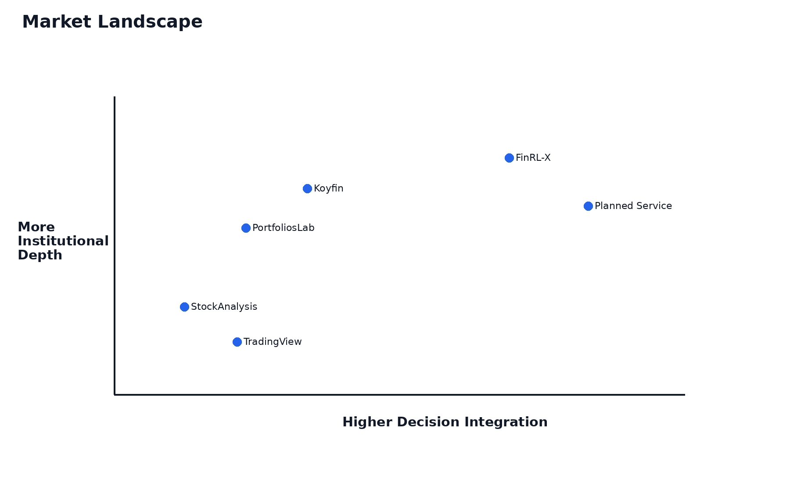
Figure 1. Market landscape and strategic positioning.

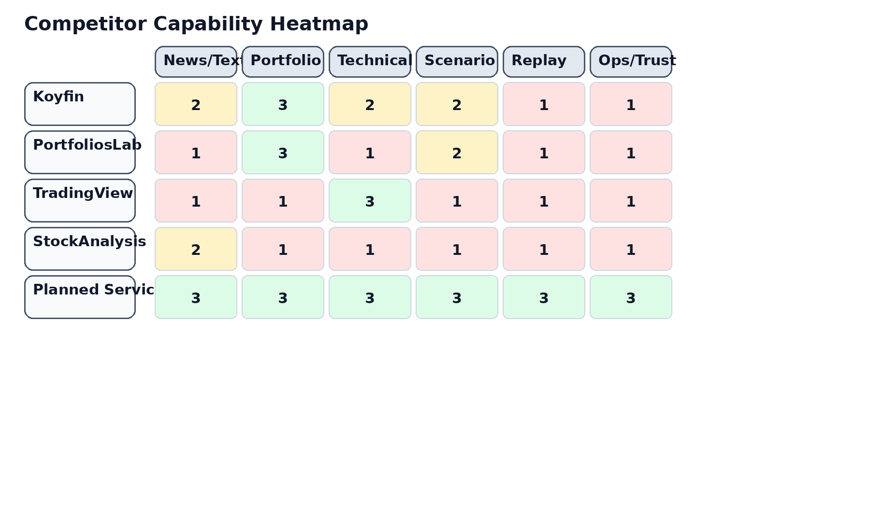
Figure 2. Illustrative competitor capability heatmap.

Product / category | What it is strong at | Where it tends to stop short | Implication for QuantPipeline
Koyfin | Integrated research, charts, portfolio analysis, reports | Less centered on one explicit decision object | Borrow integrated context and report discipline
PortfoliosLab | Portfolio metrics, benchmarking, risk, correlations | Less oriented to multi-engine decision orchestration | Borrow portfolio-aware interpretation
TradingView | Charting, screeners, alerts, visual exploration | Not fundamentally organized around portfolio policy | Borrow chart power without chart dominance
Stock Analysis | Accessible stock data, news, financials, simple portfolio tools | Less analytical orchestration, lighter risk depth | Borrow clarity and legibility
Simply Wall St | Visual explanation, portfolio command views, discovery flows | Visual simplification can mask methodological limits | Borrow visual communication selectively
TIKR | Deep company data, valuation, estimates, portfolio tracking | More research-heavy than recommendation-heavy | Borrow data-depth expectations
MarketSurge | Growth-investor workflow, charts, pattern and EPS overlays | Methodology narrower and strategy-style specific | Borrow selective workflow cues

1. Benchmarking Method
The benchmark groups products according to the user job they serve rather than according to their marketing labels. This matters because the founder's workflow crosses categories. One product may be a research platform, another a portfolio analytics tool, another a charting environment, and another a visual-explanation product, but the real question is what each contributes to the final investment decision.
The benchmark also distinguishes between strengths that derive from product focus and weaknesses that derive from product misalignment. For example, a broker app may have polished mobile execution flows, but that does not mean those flows are strategically important to a private decision-intelligence platform. Conversely, a portfolio analytics tool may have weak social appeal, but its risk decomposition may be extremely relevant.
Finally, the benchmark prioritizes official product positioning and feature descriptions over hype. Where possible, comparisons are anchored in what the products publicly claim to provide, such as research plus portfolio analysis at Koyfin, in-depth financial data and portfolio tracking at TIKR, portfolio analysis and risk metrics at PortfoliosLab, charting and screeners at TradingView, and visual portfolio tools at Simply Wall St.

2. Koyfin Benchmark
Koyfin publicly positions itself as a modern investment platform where advisors and investors can research markets, analyze portfolios, and create reports in one place. That matters because it validates a strong demand for integrated context rather than tool fragmentation.
The strongest lesson from Koyfin is not that the planned product needs institutional breadth at all costs. The real lesson is that users value continuity between research, portfolio analysis, and presentation. The planned product should preserve that continuity while remaining more opinionated and recommendation-focused.
The planned service should therefore absorb three things from Koyfin: integrated market and portfolio context, a premium analytical tone, and the idea that analysis should flow into a structured output. It should not attempt to replicate every dataset or advisor workflow.
A deeper benchmarking implication is that the planned platform should treat this competitor not as a feature checklist but as a proof point about user value. If a competitor is strong in one dimension, that dimension should be evaluated against the private medium-term use case: does it improve understanding, conviction, portfolio context, or execution of a disciplined decision? The answer should then drive whether the pattern is absorbed, adapted, or rejected.

3. PortfoliosLab Benchmark
PortfoliosLab demonstrates how much value investors derive from rigorous portfolio analytics. Risk-adjusted performance, correlations, drawdowns, diversification, benchmark comparisons, and historical portfolio behavior remain foundational.
The implication is that portfolio consequences should sit next to the recommendation engine, not behind it. A compelling investment idea that cannot be translated into allocation, concentration, benchmark-relative impact, and diversification consequences is incomplete.
The planned product should therefore absorb the portfolio-first seriousness of PortfoliosLab but place it inside a larger system that also understands text/news, timing, and trust states.

4. TradingView Benchmark
TradingView is the clearest benchmark for chart-first interaction. Its enduring appeal demonstrates that serious users want charting to be fast, rich, and interactive. The product also validates the value of screeners, alerts, and a broadly capable visual environment.
At the same time, a charting-first product is not equivalent to a decision platform. TradingView is strongest when the user already knows the conceptual frame they want to investigate. The planned service needs to go one step further by connecting that investigation to a portfolio-level recommendation.
The practical takeaway is to build strong chart surfaces, but keep them subordinated to the recommendation pipeline rather than making the whole product a chart shell.

5. Stock Analysis Benchmark
Stock Analysis is a useful benchmark for clarity, approachability, and breadth of fundamental information without terminal heaviness. It demonstrates that a product can still feel useful and fast without forcing the user through excessive complexity.
The planned service should borrow this legibility. Even though the overall system is more advanced, the default layer should still be understandable in seconds. This reinforces the principle that the main dashboard must show recommendation, trust, risk, and recent change clearly before exposing deep diagnostics.

6. Simply Wall St Benchmark
Simply Wall St is a strong benchmark for visual explanation and narrative simplification. Its portfolio-related product direction — including visual portfolio tracking and command-center style messaging — validates the demand for turning complex investment information into more legible mental models.
However, visual simplification can sometimes trade off against methodological explicitness. The planned service should therefore borrow the idea of clear visual storytelling while preserving stronger transparency about methodology, confidence, and constraints.

7. TIKR Benchmark
TIKR is a strong benchmark for deep company-level research, estimates, valuation data, and broad coverage. It demonstrates how valuable robust underlying data can be when investors need to move beyond lightweight summaries.
The planned product does not need to become a data warehouse or a terminal clone. But it should respect the expectation that a serious tool can expose enough company-level and portfolio-level context to support conviction.

8. MarketSurge Benchmark
MarketSurge is especially relevant as a workflow benchmark for growth-oriented investors who mix chart structure, pattern recognition, earnings context, and screening. It shows the continued power of a disciplined workflow design targeted at a clear strategy style.
The planned product can learn from that workflow discipline while remaining broader and more portfolio-aware. It should not inherit MarketSurge's narrower strategy assumptions, but it should adopt the idea that product power often comes from structured workflow, not from raw feature count.

9. Detailed Comparison Matrix
Dimension | Koyfin | PortfoliosLab | TradingView | Stock Analysis | Simply Wall St | TIKR | MarketSurge | Planned Platform
Integrated research context | High | Low-Medium | Medium | Medium | Medium | Medium | Medium | High
Portfolio analytics depth | High | High | Low-Medium | Low | Medium | Medium | Medium | High
Charting power | Medium-High | Low | High | Low-Medium | Low | Medium | High | High
Visual explanation | Medium | Low | Medium | Medium | High | Low-Medium | Medium | High
Recommendation object | Low | Low | Low | Low | Low | Low | Low | High
Risk as first-class product object | Medium | High | Low | Low | Medium | Low-Medium | Low | High
Replay / forensic explanation | Low | Low | Low | Low | Low | Low | Low | High
Operational transparency | Low | Low | Low | Low | Low | Low | Low | High
Multi-engine fusion | Low | Low | Low | Low | Low | Low | Low | High
Private workflow fit | Medium | Medium | Medium | Medium | Medium | Medium | Medium | High

10. Absorb / Adapt / Reject Framework
Competitor pattern | Decision | Why
Integrated research plus portfolio context | Absorb | Critical for reducing fragmentation
Terminal-like breadth without hierarchy | Reject | Would degrade clarity and focus
Chart-first interactivity | Adapt | Important, but must remain subordinate to recommendation logic
Portfolio risk decomposition | Absorb | Core to trust and actionability
Visually simplified explanations | Adapt | Useful if paired with stronger methodology transparency
Broker-centric execution UX | Reject for V1 | Not the primary value driver for the private use case
Pattern-recognition overlays | Adapt selectively | Useful as timing/context aids, not as product identity
Client-reporting workflows | Adapt lightly | Helpful for exporting thinking, but not a primary V1 need

11. What our product should copy in principle, not in appearance
A serious differentiation strategy should not be based on novelty slogans. It should be based on durable product advantages that remain meaningful after the first demo. For the planned platform, that means coherent integration, a visible recommendation pipeline, explicit trust decomposition, portfolio-aware context, replayability, and operational honesty. Competitors tend to be strongest in isolated pieces of this puzzle. The product's opportunity is to combine those strengths while exposing a more disciplined end-to-end decision flow.

12. What our product must not inherit from competitors

13. How the uploaded FinRL-X notes change the competitor reading

14. Why the product's uniqueness is integration, not just another feature

15. Differentiation by trust model

16. Differentiation by recommendation object

17. Differentiation by replay and historical accountability

18. Differentiation by admin / ops honesty

19. Differentiation by medium-term workflow fit

20. Strategic Positioning Statement
The planned platform should be positioned as a private decision-intelligence platform for medium-term portfolio management. It should not present itself as a mass-market broker substitute, a social investing app, or a general-purpose charting portal.
Its core claim should be that it integrates multiple forms of evidence into one structured recommendation while telling the truth about confidence, risk, freshness, disagreement, and system health.
That positioning allows it to absorb strengths from adjacent categories without becoming trapped by their business-model assumptions or UX compromises.

21. Recommendations
- Adopt integrated research plus portfolio context as a foundational design principle.
- Keep charting strong but subordinate to recommendation logic.
- Make portfolio analytics and risk first-class rather than secondary.
- Define differentiation around recommendation object, trust, replay, and ops visibility.
- Borrow visual explanation patterns selectively, but preserve stronger methodological transparency.
- Do not build the product around broker-style execution UX in the first release.
- Use competitor strengths as inputs to a coherent private workflow rather than as a copying list.

References and Source Basis
This benchmark draws on official public product positioning and feature pages, including Koyfin's description of research, portfolio analysis, and reports in one place; PortfoliosLab's portfolio-analysis and performance materials; TradingView's features and portfolio pages; Simply Wall St's portfolio features; TIKR's stock analysis and portfolio tracking materials; and public materials for MarketSurge features.
The benchmark also incorporates the uploaded FinRL-X notes indirectly by treating the product's target architecture as a modular recommendation system rather than as a collection of uncoordinated analytical engines.

22. Competitive Positioning by Workflow Stage
The relevant competitive question is not merely who has more features. The deeper question is which product most closely supports the actual workflow that matters to this platform: interpreting medium-term opportunities, translating them into a portfolio recommendation, stress-testing that recommendation, and maintaining trust in the underlying system. From that viewpoint, many adjacent tools are excellent local optimizers. They are optimized for charts, for financial data, for portfolio metrics, or for visual explanation. Very few are optimized for disciplined synthesis across all of those layers. This is the opening for the planned product. Its differentiation should come from putting those layers into one coherent flow that is explicit about confidence, risk, disagreement, validation, and operational conditions. That is a stronger competitive position than simply attempting to surpass incumbents on raw breadth or on isolated visual features.

23. Feature Adoption Prioritization Matrix

24. Where Competitors Are Strong but Strategically Misaligned

25. What a Best-in-Class Private Product Should Learn from Public Tools

26. Final Competitive Thesis

