09. Functional Requirements Specification
Detailed functional requirements for the private medium-term investment decision platform

Purpose | Define system behavior in functional terms for product, design, engineering, QA, and Claude-driven implementation
Primary use case | Private decision-intelligence platform for medium-term equity portfolio decisions
Relationship to other documents | Builds on the CDR, dashboard research, competitor benchmark, and technology recommendation
Architectural assumption | Weight-centric recommendation object driven by Selection, Allocation, Timing, and Portfolio-Level Risk Overlay

This Functional Requirements Specification converts the concept work into an implementation-facing behavioral document. Its purpose is to remove ambiguity about what the system must do, what each major surface must expose, how major states should behave, and how the user should move between explanation, validation, and action.
The FRS is written for a private, owner-operated platform rather than for a public brokerage or consumer investing app. This means the specification can assume a higher level of analytical sophistication, can prioritize structured depth over onboarding simplicity, and can define a stronger relationship between evidence and portfolio action than most public tools attempt.
The specification assumes the system receives heterogeneous evidence from text/news analysis, social sentiment signals, technical analysis, machine-learning engines, reinforcement-learning inspired policy logic, and portfolio analytics. The system must translate those upstream signals into one recommendation object rather than present them as disconnected outputs.
A guiding principle of this FRS is that functional requirements should mirror the policy architecture. Therefore the system is specified around a recommendation pipeline that makes Selection, Allocation, Timing, and Risk Overlay visible both in backend behavior and in user-facing explanation.
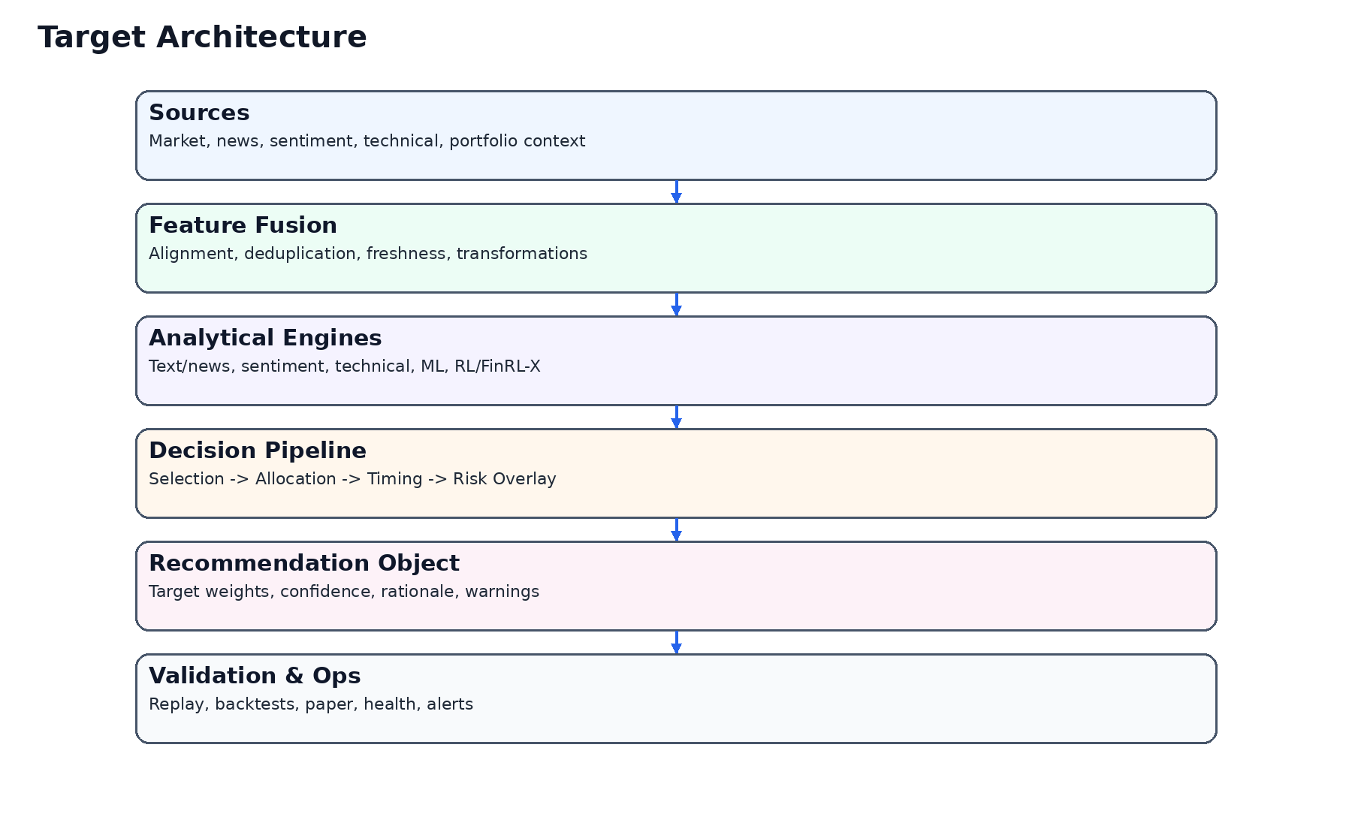
Figure 1. Functional architecture anchor.

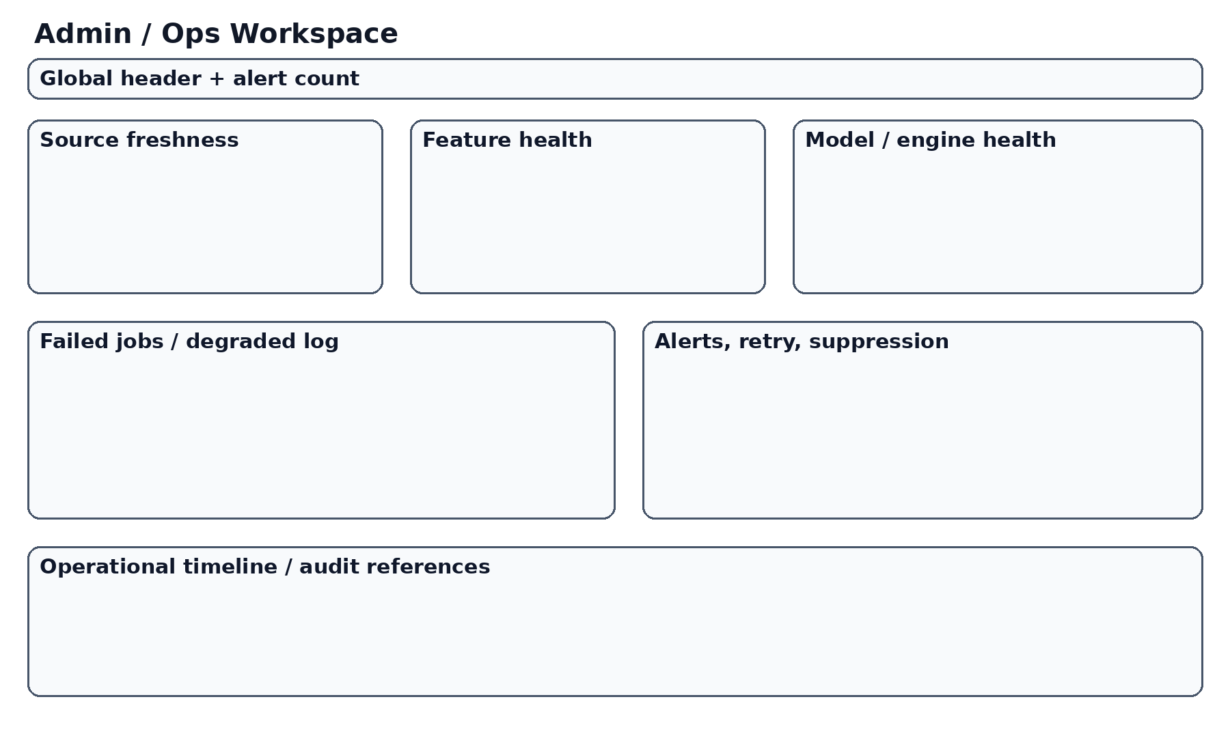
Figure 3. Admin / ops reference concept.

1. Scope of Functional Specification
- Recommendation generation and publication behavior
- User-facing workspaces and navigation logic
- State handling for normal, warning, degraded, and suppressed conditions
- Validation surfaces including replay, backtests, and paper portfolio
- Operational and admin surfaces
- Functional interactions with settings, controls, filters, and scenario changes
- User-facing trust, confidence, and warning semantics
- Functional requirements for content, states, and transitions across major modules

2. Actors and Their Primary Goals
Actor | Primary goal | Critical functional expectations
Strategic Investor | Understand the current recommendation and decide whether to act | Immediate access to recommendation, trust, risk, change rationale, and portfolio implications
Analytical Power User | Inspect the recommendation path and compare engines or scenarios | Deep comparison, replay, validation, and scenario control
Operator / Admin | Maintain source, feature, model, and publication integrity | Operational visibility, degraded-state clarity, and incident context
System | Acquire data, transform features, run engines, publish or suppress outputs | Traceable, deterministic, and governable pipeline behavior

3. Functional Principles
Principle | Functional implication
Decision-first behavior | The system shall present one current recommendation as the primary object of the site.
Policy transparency | The system shall expose Selection, Allocation, Timing, and Risk Overlay as distinct concepts.
Trust decomposition | The system shall distinguish model confidence, data confidence, and operational confidence.
Operational honesty | The system shall expose degraded or suppressed states explicitly rather than silently fallback.
Replayability | The system shall make every published recommendation reconstructable.
Portfolio relevance | The system shall express outputs in portfolio-impact terms, not just in signal scores.

4. Core Domain Objects — Functional View
Object | Functional role | Minimum visible behavior
Recommendation Object | Primary answer delivered to the user | Must be retrievable, interpretable, and linkable to history and replay
Selection Result | Investable shortlist and ranking state | Must be explainable and not hidden inside later layers
Allocation Proposal | Pre-risk target allocation state | Must be available for comparison against final output
Timing Adjustment | Decision to delay, reduce, or confirm exposure changes | Must be visible in recommendation explanation
Risk Overlay Result | Portfolio-level de-risking and constraint output | Must show what was changed by risk policy
Replay Record | Evidence trail of the run | Must support stage-by-stage inspection
Health Snapshot | Operational state of the recommendation pipeline | Must support warning, downgrade, or suppression logic

5. Recommendation Engine and Publication Module
- The system shall generate a Recommendation Object for each eligible run context.
- The Recommendation Object shall include target weights or equivalent exposure instructions, delta versus previous state, trust decomposition, warnings, and an audit / replay reference.
- The system shall not silently publish incomplete or degraded recommendations as if they were normal recommendations.
- When publication rules fail, the system shall either suppress publication or downgrade the recommendation and attach explicit warnings.
The functional objective in this module is not simply to expose data. It is to expose the right interpretation at the right level. This means the module must be judged on whether it reduces ambiguity around the recommendation path, the user’s trust in that path, and the portfolio meaning of any change. Each module should therefore be built to reveal intent, state, and consequence rather than simply render raw upstream outputs.

6. Overview Screen Functional Requirements
- The Overview screen shall answer the question: what is the recommendation right now?
- The Overview shall display recommendation summary, confidence triplet, risk summary, freshness, and recent change summary above all secondary analytics.
- The Overview shall provide direct navigation to the Main Decision Workspace, Replay, Risk, Backtests, Paper Portfolio, and Admin / Ops where relevant.
- If no current recommendation is available, the Overview shall show an explicit unavailable state with cause and next-best action.

7. Main Decision Workspace Functional Requirements
- The Main Decision Workspace shall be the primary analytical environment for understanding why the current recommendation exists.
- The screen shall contain a stable control surface, a main chart area, a recommendation card, a trust/warnings region, and a decision breakdown region.
- The workspace shall expose Selection, Allocation, Timing, and Risk Overlay contributions to the final recommendation.
- Changing scenario controls shall not silently replace state; the system shall visibly indicate that the scenario is updating or has changed.

8. Engine Comparison Functional Requirements
- The system shall provide an Engine Comparison view that shows where engines agree, diverge, and contribute to the final recommendation.
- The comparison view shall support structured matrix presentation, contribution summary, and drill-down per engine.
- If one or more engines are unavailable, stale, or suppressed, that condition shall be represented explicitly.

9. Risk Workspace Functional Requirements
- The Risk Workspace shall make portfolio-level risk first-class and independently inspectable.
- The screen shall display exposure, concentration, active constraints, stress interpretation, and risk history or state transitions where available.
- The user shall be able to understand how the final recommendation differs from the pre-risk proposal.

10. Replay / Forensics Functional Requirements
- Every published recommendation shall be replayable through a user-facing Replay screen.
- The Replay screen shall support inspection of major stages including inputs, selection, allocation, timing, risk overlay, and final publication.
- The system shall preserve enough information to compare before and after states within the replay narrative.

11. Backtests Functional Requirements
- The system shall provide a Backtests area that compares strategy behavior under standardized assumptions.
- The system shall expose common metrics, benchmark-relative results, and allocation or exposure history.
- The Backtests surface shall make assumptions visible so that the user does not mistake incomparable runs for fair comparisons.

12. Paper Portfolio Functional Requirements
- The system shall provide a Paper Portfolio surface that tracks simulated holdings, performance, and recommendation-following behavior under explicit realism assumptions.
- The system shall expose drift, benchmark comparison, and rebalance history.
- If the paper model uses simplified assumptions, the system shall state that visibly.

13. Admin / Ops Functional Requirements
- The system shall provide an Admin / Ops surface that distinguishes source freshness, feature health, model health, and publication health.
- The system shall expose alert states, degraded states, and suppressed publication reasons.
- The system shall not require the user to inspect raw logs in order to understand operational trust.

14. Settings and Scenario Control Functional Requirements
- The system shall expose configurable scenario controls such as universe, benchmark, horizon, allocator profile, timing profile, and risk profile.
- Scenario changes shall be functionally separated from immediate execution unless the system explicitly indicates a live update.
- The system shall preserve user orientation when settings change.

15. Global State Handling Requirements
State | Required behavior
Loading | The system shall use structured loading states that preserve screen layout and maintain user orientation.
Empty | The system shall explain what is missing and what the user can do next.
Warning | The system shall expose warnings without hiding the primary recommendation context.
Degraded | The system shall visibly reduce trust or downgrade presentation when key pipeline issues exist.
Suppressed | The system shall state that publication was suppressed and explain why.
Unavailable | The system shall distinguish total unavailability from a deliberate suppressed decision.

16. Confidence and Trust Requirements
Trust dimension | Functional requirement
Model confidence | The system shall expose model confidence independently from data and operational confidence.
Data confidence | The system shall expose whether input freshness or completeness weakens trust.
Operational confidence | The system shall expose runtime, job, and publication integrity.
Combined interpretation | The system may summarize trust but shall not collapse all dimensions into one opaque number without explanation.

17. Cross-Screen Navigation Requirements
- The system shall allow the user to move from recommendation summary to full dashboard explanation in one interaction.
- The system shall allow direct navigation from current recommendation to replay, risk, backtests, paper portfolio, and admin/ops where appropriate.
- Every deep analytical screen shall provide a clear return path to the main recommendation context.
- Navigation labels shall reflect user tasks rather than internal implementation modules where possible.

18. Screen-by-Screen Content Priorities
Screen | Primary content | Secondary content | Tertiary content
Overview | Recommendation, trust, risk, freshness | Recent change narrative | Deep links
Dashboard | Chart, recommendation, controls, policy breakdown | Warnings, comparison snapshot | Advanced diagnostics
Comparison | Matrix, disagreement, contribution | Engine notes | Raw feature details
Risk | Exposure, constraints, stress | Risk history | Advanced diagnostics
Replay | Timeline, before/after states | Narrative detail | Stage metadata
Backtests | Metrics, curves, regime view | Assumption controls | Run metadata
Paper | Holdings, drift, benchmark, rebalances | Assumption details | Extended logs
Admin/Ops | Source, feature, model, publication health | Alerts and retries | Incident history

19. Functional User Journeys
- Review the current recommendation and decide whether it differs materially from the previous recommendation.
- Enter the dashboard, inspect why the recommendation changed, and identify the dominant drivers.
- Open the comparison screen and determine whether major engines disagree.
- Open the risk screen and see whether portfolio-level de-risking materially changed the pre-risk allocation.
- Use replay to confirm the chronology of one recommendation.
- Use backtests and paper portfolio to contextualize confidence in the policy.
- Use admin/ops to determine whether system health should change the user’s trust in the current recommendation.
A strong user journey in this platform should begin with recommendation intake, continue through targeted explanation, and end either in validated action or deliberate non-action. The system should never force the user to assemble that story manually across disconnected tools or screens. Therefore, each journey is also a test of functional coherence.

20. Functional Requirements by Data Freshness and Degradation Scenario
Scenario | Required system behavior
Text/news pipeline stale but market data fresh | Downgrade text-derived confidence, retain market-aware recommendation if governance permits, and display explicit warning
One engine unavailable | Continue if policy allows, but disclose missing contribution and adjust trust
Risk overlay cannot run | Do not publish normal recommendation; suppress or publish as degraded according to governance rules
Benchmark data missing for backtests | Disable comparable benchmark view and explain limitation
Paper portfolio assumptions changed | Record assumption version and disclose that comparisons may no longer be directly comparable

21. Functional Requirements for Auditability
- The system shall associate every published recommendation with a stable audit or replay identifier.
- The system shall preserve enough context to reconstruct stage outputs in a user-facing replay flow.
- The system shall make it possible to understand not only the final recommendation but what each policy layer changed.
Auditability in this context is not only a compliance feature. It is a user-facing trust function. Because the planned system integrates multiple evidence classes, replay is one of the main ways the user can distinguish disciplined synthesis from arbitrary output.

22. Product-Level Acceptance Logic
Area | Acceptance question
Recommendation | Does the system publish a coherent recommendation object with trust, warnings, and delta?
Dashboard | Does the main workspace explain the recommendation without clutter or hidden states?
Risk | Can the user understand portfolio-level risk and post-risk changes?
Replay | Can the user reconstruct a recommendation?
Backtests | Are historical validation assumptions visible and consistent?
Paper | Is simulated validation explicit and not misleading?
Ops | Can the user see whether the pipeline is healthy enough to trust outputs?

23. Out-of-Scope Behaviors for the Initial Functional Baseline
- Full broker-connected live execution
- Public social or community investing features
- Beginner education and onboarding as a primary product surface
- Options-specific execution tooling
- Multi-tenant collaboration as a first-release requirement

24. Functional Risks and Clarifications
The main functional risk in this product class is false coherence: a dashboard that looks integrated while the underlying behaviors remain fragmented. This specification therefore insists that functions be defined in relation to the recommendation object and policy pipeline. Another major risk is false confidence created by hidden degradation. Functional requirements must make degraded, stale, partial, and suppressed states explicit. A further risk is screen overload. The specification responds by enforcing information hierarchy rather than leaving screen behavior to later improvisation.

25. Summary of Functional Direction
This Functional Requirements Specification defines the platform as a recommendation-first, trust-aware, policy-transparent, and portfolio-relevant decision system. Its core requirement is not merely that the system display sophisticated data. Its core requirement is that the system convert heterogeneous evidence into one coherent recommendation, then explain, validate, and operationally qualify that recommendation in a way the user can actually rely on.

Appendix A — Functional Requirement Matrix by Module
This appendix expands the main body into a matrix suitable for implementation planning and QA traceability. Each module is described in terms of actor, trigger, expected response, fallback behavior, and user-visible states.
A consulting-grade functional specification should not stop at headline features. It must make implementation behavior testable under both normal and imperfect conditions. For this platform, that means specifying not only what the user sees when the system works cleanly, but also what happens when one engine is stale, one feed is partial, one comparison is impossible, one policy layer is bypassed, or one recommendation is suppressed. The value of this appendix is therefore precision: it converts architecture and UX intent into repeatable behavioral expectations.
Module | Actor | Trigger | Expected behavior | Failure or fallback behavior
Overview | Investor | Open site | Show current recommendation, risk, confidence, freshness | If unavailable, show explicit no-current-recommendation state
Dashboard | Investor | Open main workspace | Show chart, recommendation, controls, breakdown | If partial degradation exists, preserve workspace but display warning state
Comparison | Analytical user | Open comparison | Show matrix and disagreement | If one engine missing, show explicit unavailable entry
Risk | Investor | Open risk workspace | Show exposures, constraints, post-risk state | If risk overlay absent, do not present normal recommendation semantics
Replay | Analytical user | Open replay from audit ID | Show full chronology | If one stage missing, identify missing segment explicitly
Paper | Investor | Open paper portfolio | Show simulated holdings and drift | If assumptions changed, disclose comparability caveat
Ops | Admin | Open ops workspace | Show health by domain | If health is unknown, show unknown explicitly rather than normalizing

Appendix B — Exception Handling and Edge Conditions
Complex decision systems fail in partial ways. This appendix describes how the product must behave when freshness, completeness, health, or comparison conditions are not ideal.
Condition | Required user-visible response
Stale market data | Downgrade data confidence and warn prominently
Partial news coverage | Retain recommendation only if governance allows; explain reduced data confidence
One engine unavailable | Continue comparison with explicit missing row and adjusted trust
Backtest assumptions changed | Warn that result comparison across runs may not be direct
Replay data incomplete | Show available stages and clearly identify missing audit detail
Paper portfolio drift large | Expose drift and explain recommendation-following gap

Appendix C — User Stories and Acceptance-Oriented Scenarios
This appendix turns the functional requirements into scenario-driven stories that are easier to test and review.
- As the owner, I want to know within seconds whether the current recommendation changed materially since the last run.
- As the owner, I want to understand whether the change came from text/news, technical context, ML, RL, or risk policy adjustments.
- As the owner, I want to know whether any pipeline degradation should reduce my trust before I act.
- As the owner, I want to compare engines without losing the recommendation context.
- As the owner, I want replay and validation surfaces to use the same terminology as the dashboard so the product feels coherent.

Appendix D — Functional Decomposition of the Decision Pipeline
This appendix spells out what each stage must do, what it must expose, and what downstream surfaces rely on that behavior.
Stage | Must produce | Must expose to UI
Selection | Shortlist / ranking | Selection summary and why certain assets rose or fell
Allocation | Pre-risk target allocation | Allocation proposal and rationale
Timing | Delay/reduce/confirm state | Timing summary with affected assets or exposures
Risk Overlay | Final constrained recommendation | Post-risk weights, active constraints, de-risking explanation
Publication | Recommendation object | Trust, warnings, freshness, and audit reference

Appendix E — UI State Inventory
This appendix captures required states for major screens and shared components so that the build does not skip difficult conditions.
Screen / component | Required states
Overview | loading, normal, warning, degraded, unavailable
Dashboard | loading, normal, dirty-controls, updating, warning, degraded
Recommendation card | normal, warning, degraded, unavailable
Comparison matrix | loading, filtered, partial, warning, empty
Replay timeline | loading, selected-stage, partial-audit, unavailable
Ops panels | normal, warning, critical, unknown

Appendix F — Detailed Functional Narratives

Overview screen narrative
Functionally, this surface should preserve user orientation, expose the recommendation context, and make state transitions understandable. The user should never need to infer whether the content reflects a fresh, stale, partial, degraded, or suppressed state. The system must therefore make status, trust, and change semantics explicit. In addition, every surface should support drill-down without severing the link back to the current recommendation and its portfolio meaning. This requirement is especially important because the platform combines several analytical domains that would otherwise feel fragmented.

Dashboard narrative

Comparison narrative

Risk narrative

Replay narrative

Backtests narrative

Paper narrative

Ops narrative

