10. Technical Architecture Specification
Target architecture for the private medium-term portfolio decision platform

Project: QuantPipeline
Document status: Working baseline for product and engineering delivery
Version: v1.0
Date: 2026-04-23
Audience: Product owner, architecture, development, QA, and future implementation agents

Purpose: This document is intended to be implementable. It defines contracts, boundaries, and decisions that should survive future feature growth without breaking the core recommendation pipeline.

Document Control
Field | Value
Document code | 10
Title | Technical Architecture Specification
Primary input set | Documents 01-09, A1 technology recommendation, and baseline truth table
Primary architecture anchor | Data & Feature Layer -> Signals -> Selection -> Allocation -> Timing -> Risk Overlay -> Recommendation Object -> Backtest / Paper / Replay / Ops
Assumed release posture | Private single-user first release with future-safe modular boundaries
Key dependencies | A1 Technology Recommendation, 08 PRD, 09 Functional Requirements
Quality rule | No silent degradation, explicit trust semantics, and replayable output

1. Purpose and Architectural Scope
This specification translates the product direction into a buildable architecture. It defines the major runtime layers, service boundaries, data and control flows, deployment shape, and cross-cutting non-functional rules required to implement QuantPipeline as a private portfolio decision platform for medium-term investing.
The architecture is intentionally recommendation-centric. The platform is not organized around disconnected research widgets. It is organized around one canonical pipeline that converts heterogeneous evidence into a unified recommendation object, preserves the stages that produced it, and exposes that evidence consistently across user experience, replay, backtests, paper shadowing, and admin operations.
The scope of this document covers logical architecture, runtime flows, deployment topology, service responsibilities, resilience, observability, security, and change control. Detailed schemas and endpoint definitions are delegated to Documents 11 and 12, but the architecture here governs their boundaries and interactions.

2. Architecture Principles
- One canonical recommendation contract across production, replay, backtests, and paper.
- Clear separation between evidence generation and portfolio policy decisions.
- Explicit handling of degraded, stale, and suppressed conditions rather than silent fallback.
- Service modularity with low-coupling contracts and stable domain identifiers.
- Replayability and auditability by design, not as a later add-on.
- Desktop-primary experience with credible mobile access and consistent API behavior.
- Batch-oriented analytical pipelines combined with low-latency read APIs for the user interface.
- Operational honesty: system health must be reflected in what the user sees.

3. Assumed First-Release Context
The first release is private and single-user in product posture, but the architecture should not hard-code single-user shortcuts that would make future administrative separation or role-based access impossible. This means explicit authentication, explicit audit trails, and explicit ownership of scenarios, recommendations, approvals, and overrides.
The architecture assumes moderate scale in user count but meaningful scale in data processing breadth: daily and intraday bars, news and text events, sentiment updates, feature recalculation, multiple policy variants, backtest jobs, and continuous paper monitoring. The limiting factor is not concurrent public traffic; it is analytical correctness, operational clarity, and reproducibility of decisions.

4. Target Logical Architecture
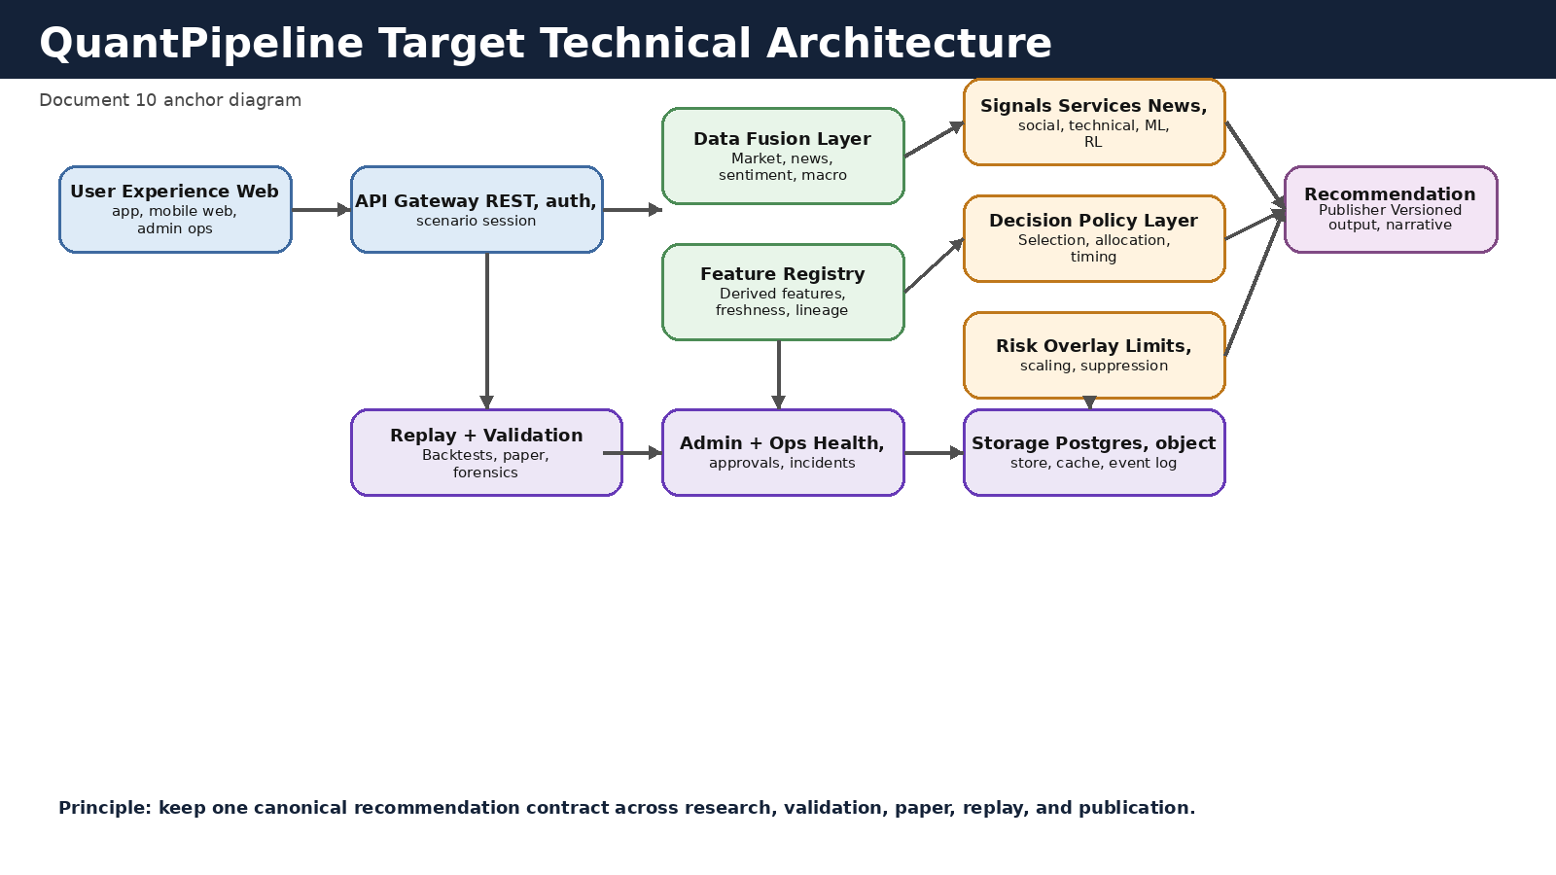
Figure 10-1. Recommended target architecture.

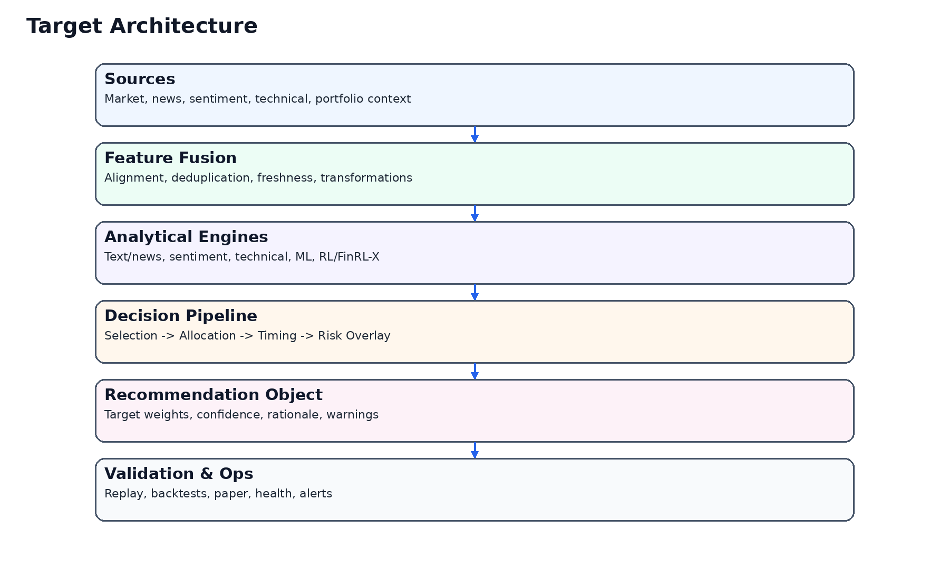
Figure 10-2. Prior architecture concept retained as continuity reference.

The platform should be read from left to right. The user experience layer consumes read-optimized APIs; the APIs orchestrate access to recommendation state, decision-stage evidence, and validation outputs; the analytical core constructs policy outputs in a deterministic order; and the storage layer preserves enough detail to recreate both current state and historical runs.

5. Major Architectural Layers
Each architectural layer owns a distinct responsibility and should have a clear contract. Implementation may consolidate layers into fewer deployable services at the beginning, but the conceptual boundaries must remain intact so the platform can grow without redesigning the decision lifecycle.
Layer | Primary responsibility | Input examples | Output examples
Experience layer | Present current recommendation, breakdown, validation, and ops state | Scenario filters, selected recommendation id | Rendered overview, dashboard data, admin actions
API gateway | Authenticate, authorize, compose read models, and issue write commands | HTTP requests, session tokens | Versioned JSON responses, accepted jobs
Data fusion | Normalize raw market, text, and macro feeds | Vendor payloads, scraped text, batch imports | Curated time-aligned inputs
Feature registry | Persist derived features with freshness and lineage | Curated inputs, feature jobs | Feature sets, completeness markers, provenance
Signal services | Generate engine-level outputs from news, social, technical, ML, RL | Feature sets, model artifacts | Signal runs, confidence, rationale fragments
Decision policy layer | Convert signals into selection, allocation, timing, and pre-risk proposals | Signal runs, universes, policy settings | Decision-stage objects
Risk overlay | Apply portfolio constraints, stress rules, and suppressions | Pre-risk proposal, portfolio state, risk rules | Post-risk proposal, modifications, warnings
Recommendation publisher | Materialize current recommendation and publication state | Post-risk proposal, ops state | Published recommendation object, narrative, status
Validation and replay | Run historical evaluation and reconstruct past decisions | Frozen snapshots, policy variants | Backtests, paper records, replay narratives
Admin and ops | Track health, incidents, approvals, and change state | Alerts, jobs, approval actions | Ops dashboards, audit events, incident records

6. Service Decomposition Recommendation
For the first release, deployable simplicity matters. The recommended implementation is not one microservice per conceptual layer. Instead, use a small number of deployables with strong internal domain modules. This preserves architectural clarity without incurring orchestration overhead too early.
A pragmatic initial decomposition is: (1) Web experience service, (2) API and orchestration service, (3) Data and analytics worker service, (4) Validation worker service, and (5) Shared storage and cache infrastructure. These deployables may share a single repository while still respecting the domain modules described below.
Deployable | Contains | Why this grouping works
Web experience | React/Next.js app, authenticated pages, client-side state, charts | Keeps the user experience release cycle independent from heavy analytical jobs
API/orchestration | REST API, session management, recommendation read models, command handlers | Owns user-facing contracts and policy publication workflow
Analytics worker | Ingestion, feature jobs, signal generation, selection/allocation/timing/risk jobs | Allows batch scheduling and compute isolation
Validation worker | Backtests, ablations, replay precomputation, paper portfolio maintenance | Separates longer-running evaluation work from operational recommendation jobs
Shared platform | PostgreSQL, object storage, Redis/cache, scheduler, logs, metrics | Centralizes persistence, coordination, and operational evidence

7. Runtime Modes
The architecture must support four distinct runtime modes that share contracts but differ in latency expectations, data windows, and publication behavior.
Mode | Trigger | Latency expectation | Publishes user-visible output?
Production recommendation run | Scheduled or operator-triggered | Minutes, deterministic | Yes, if policy and ops gates pass
Scenario simulation | User-initiated | Seconds to low minutes | No, returns temporary scenario output
Replay reconstruction | User-initiated from history | Seconds | No, read-only reconstruction
Backtest / validation | Operator or release workflow | Minutes to hours | No direct publication; results feed validation surfaces
Paper shadow update | Scheduled with market and policy cadence | Minutes | Yes, to paper portfolio surfaces only

8. Canonical Production Flow
- Acquire or refresh raw inputs from market, text, sentiment, macro, and portfolio sources.
- Normalize timestamps, enrich metadata, and store curated input batches with source lineage.
- Compute or refresh feature sets. Mark completeness and freshness explicitly.
- Run engine-level signal services. Persist confidence, rationale snippets, and warnings.
- Execute selection policy on a defined universe.
- Execute allocation policy on the shortlisted set.
- Execute timing policy to adjust aggressiveness, delay, or exposure posture.
- Execute risk overlay to enforce portfolio-level controls and suppression rules.
- Publish a versioned recommendation object only if operational and policy gates pass.
- Emit audit, metrics, and user-facing freshness or degraded state metadata.
Architectural rule: Selection, allocation, timing, and risk overlay must be stored as separate stage outputs. The final recommendation must never be the only preserved artifact.

9. Storage and Compute Architecture
QuantPipeline requires a hybrid persistence model. Relational storage should own canonical operational state, domain entities, decision-stage records, and read models. Object storage should own large immutable artifacts such as raw source payloads, model bundles, exported reports, and frozen backtest packages. Cache should be used only for performance and coordination, not as the system of record.
The compute model should prefer scheduled jobs with explicit run identifiers and bounded retries. Long-running backtests and paper analysis must never block recommendation publication or UI read performance.
Technology role | Recommended store | Notes
Canonical metadata and domain entities | PostgreSQL | Relational integrity, migrations, index control, and reporting flexibility
Raw payload archives and large artifacts | Object storage | Immutable storage keyed by source and snapshot ids
Short-lived cache and job coordination | Redis or equivalent | Used for deduplication, locks, and view caching
Observability events and metrics | Metrics store + log pipeline | Separate operational telemetry from product domain data
Search-oriented retrieval for text drill-down | Optional document index | Only after core contracts are stable

10. Deployment Topology
A multi-environment topology is required even for a private product. At minimum, maintain local development, integration/staging, and production. Validation environments can share infrastructure with staging but should preserve isolated datasets and separate experiment namespaces.
Environment | Purpose | Allowed data | Key controls
Local development | Feature development and manual debugging | Synthetic or scrubbed data | Developer-owned configs, seeded fixtures
Integration / staging | End-to-end verification and release rehearsal | Staged or delayed production-like data | Shared auth, smoke tests, migration rehearsal
Production | Live private usage and paper monitoring | Current operational data | Strict secrets management, audit, backups, alerting
Validation sandbox | Heavy backtest and policy experimentation | Frozen historical snapshots | No direct publication rights to production

11. Security Architecture
- All provider credentials, ingestion secrets, and model keys remain server-side only.
- Use authenticated sessions even for a private single-user product so that audit, admin separation, and remote access can remain disciplined.
- Store recommendation history, settings, and portfolio state as sensitive data with strict access logging.
- Separate read permissions from write permissions for publication, suppression, and policy changes.
- Require immutable audit events for recommendation publication, approval, suppression, and manual overrides.
- Apply signed or verified artifact references for model bundles and policy packages promoted to production.
- Protect replay and validation data from accidental mutation by using frozen snapshots and read-only references.

12. Observability and Operational Architecture
Observability must cover both machine health and decision health. Infrastructure metrics alone are insufficient because the product can appear technically alive while the recommendation pipeline is stale, suppressed, or semantically degraded.
The architecture should therefore produce structured metrics and logs for source freshness, feature completeness, signal coverage, policy execution, publication gates, API latency, cache hit rate, background job backlog, incident state, and user-visible suppression conditions.
Telemetry family | Examples | Consumer
Infrastructure | CPU, memory, disk, queue lag, API latency | Engineering and ops
Data health | Missing bars, missing news, stale macro data, vendor failures | Ops and admin
Decision health | Selection universe size, allocation feasibility, timing suppressions, risk overrides | Product owner and replay users
Publication health | Published / suppressed count, approval latency, freshness age | User-facing overview and admin
Validation health | Backtest queue, failed experiments, paper drift alerts | Operator and release governance

13. Resilience and Failure Strategy
The platform must fail in ways that preserve honesty. If one evidence family is unavailable, the system may continue only if policy rules explicitly allow degraded operation and the published output reflects that condition. If a stage is mandatory for publication, the pipeline must stop and mark the recommendation as suppressed or stale rather than silently substituting normal output.
Retries should be bounded and stage-specific. Repeated failures in ingestion or feature builds should not cascade into corrupted decision outputs. The recommended pattern is: isolate failing jobs, preserve prior healthy recommendation state, raise an admin-visible alert, and expose clear freshness and suppression signals to the user interface.

14. Performance and Scalability Expectations
Performance requirements are asymmetric. Read APIs for current recommendation, dashboard drill-down, and admin state should feel interactive. Production recommendation jobs may take minutes if they preserve determinism and evidence. Backtests may take longer as long as they are observable, cancellable, and isolated from operational flows.
Scalability should first optimize analytical concurrency and storage hygiene, not public web throughput. The main future risks are growing history, more engines, larger universes, richer replay artifacts, and validation load.
Capability | Initial expectation | Architecture implication
Overview load | Sub-2 second perceived response | Use read models and cache stable aggregates
Recommendation run | Low minutes, deterministic | Favor scheduled jobs with explicit orchestration
Scenario simulation | Interactive to low-minute | Reuse cached features and last healthy signal runs when valid
Backtest batch | Minutes to hours | Worker isolation, artifact storage, resumable jobs
Historical archive | Multi-year retention | Partition tables and externalize bulky artifacts

15. Architecture Decision Records and Change Control
Architecture changes that affect contracts, persistence boundaries, publication logic, or validation comparability should be captured in ADRs. This includes changing the recommendation object, adding a new evidence family, replacing an allocator, introducing a new suppression rule, or changing retention and snapshot semantics.
Every ADR should state the decision, motivation, alternatives considered, compatibility impact, migration plan, test impact, and rollback posture. This is especially important because the system is intended to evolve from a private product into a richer decision platform without losing continuity of historical evidence.
ADR category | Examples | Mandatory review?
Contract | Recommendation object, API envelope, id strategy | Yes
Policy | Selection rule set, timing controller, risk overlay semantics | Yes
Platform | Storage engine, queue model, deployment topology | Yes
Observability | New SLO, alert semantics, evidence retention | Usually
UX/ops coupling | Expose new degraded states or operator actions | Yes if user-visible

16. Non-Functional Traceability Matrix
The following matrix turns general architecture quality claims into implementation obligations.
Need | Architecture response | Primary owner
Replayability | Store stage outputs, snapshot ids, and immutable publication records | API + data domains
Operational honesty | Expose freshness, suppressions, and degraded states end-to-end | API + admin ops
Scalability | Partition storage and isolate heavy jobs | Platform
Security | Server-side secrets, RBAC, immutable audits | Platform + admin
Validation integrity | Frozen datasets and isolated experiment namespaces | Validation domain
Future mobile path | Stable APIs and scenario-safe payloads | Experience + API

Appendix A - Reference Sequence Flows
Reference flow 1: Scheduled recommendation run. Trigger scheduler -> ingest refresh -> feature build -> signal generation -> policy stages -> risk overlay -> publication gate -> publish read model -> audit event -> user-visible freshness update.
Reference flow 2: User scenario simulation. User changes horizon or allocator -> API validates scenario -> snapshot current curated inputs -> run selection/allocation/timing/risk in temporary mode -> return scenario result with clear non-published flag.
Reference flow 3: Replay request. User opens historical recommendation -> API loads publication record -> resolves linked stage outputs and evidence -> reconstructs narrative and diffs -> returns read-only response.
Reference flow 4: Backtest promotion. Operator starts experiment -> validation worker freezes inputs and config -> runs walk-forward tests -> stores metrics and artifacts -> governance rules evaluate pass/fail -> admin surface proposes or blocks policy promotion.

Appendix B - Open Architecture Decisions for Next Iteration
- Whether to introduce a dedicated feature store service or keep feature registry inside the analytics worker module.
- Whether text retrieval should use a dedicated search index in v1 or remain relational plus object-store based.
- Whether paper shadow rebalances should be computed by the validation worker or by a dedicated portfolio monitor service.
- Whether mobile push-style notifications are needed before a native app exists.
- Whether to split the API gateway from orchestration once scenario traffic and admin actions become materially different workloads.

