11. Data Model and Schema Specification
Canonical entities, storage design, lineage, and schema rules for QuantPipeline

Project: QuantPipeline
Document status: Working baseline for product and engineering delivery
Version: v1.0
Date: 2026-04-23
Audience: Product owner, architecture, development, QA, and future implementation agents

Purpose: This document is intended to be implementable. It defines contracts, boundaries, and decisions that should survive future feature growth without breaking the core recommendation pipeline.

Document Control
Field | Value
Document code | 11
Title | Data Model and Schema Specification
Primary input set | Documents 01-09, A1 technology recommendation, and baseline truth table
Primary architecture anchor | Data & Feature Layer -> Signals -> Selection -> Allocation -> Timing -> Risk Overlay -> Recommendation Object -> Backtest / Paper / Replay / Ops
Assumed release posture | Private single-user first release with future-safe modular boundaries
Key dependencies | Documents 10 and 12, 08 PRD, 09 Functional Requirements
Quality rule | No silent degradation, explicit trust semantics, and replayable output

1. Purpose and Modeling Scope
This document defines the canonical data model for QuantPipeline. It specifies the main entities, tables, relationships, identifiers, temporal rules, lineage requirements, and storage conventions required to support one coherent recommendation pipeline across operational usage, replay, backtesting, paper shadowing, and admin oversight.
The central design rule is that decisions must be reconstructable. It is not enough to store the final recommendation. The schema must preserve what was known, which features existed, which policy versions were active, what each stage decided, which guardrails modified the output, and what was finally published or suppressed.

2. Data Modeling Principles
- Stable identifiers over mutable labels.
- Append-only history for decision outputs and publication records.
- Explicit timestamps for event time, processing time, and publication time.
- Freshness and confidence as stored fields, not implied behavior.
- Separation of raw source preservation from curated analytical state.
- Separation of canonical domain entities from denormalized read models.
- Schema support for both production recommendations and historical validation artifacts.
- Version every policy, model, feature recipe, and manual override that can affect output.

3. Canonical Data Domains
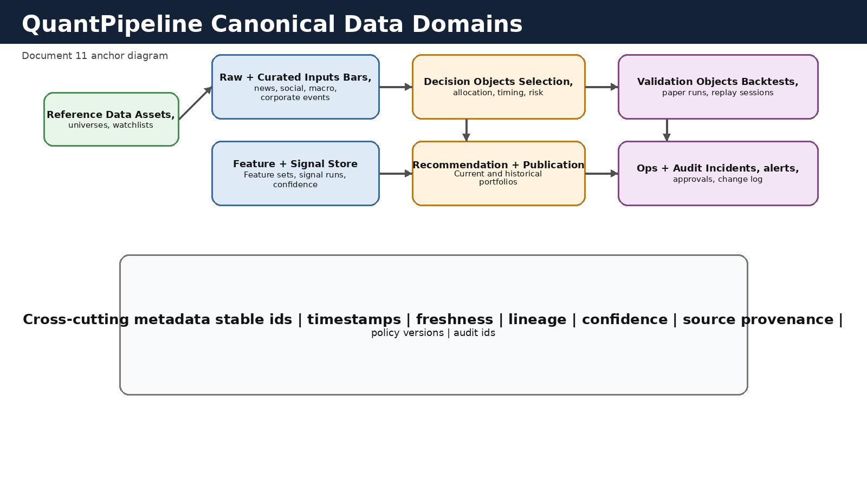
Figure 11-1. Canonical data domains and their metadata spine.

The schema is organized into seven domains: reference data, raw and curated inputs, feature and signal store, decision-stage objects, recommendation and publication history, validation artifacts, and ops/audit records. A shared metadata spine provides stable ids, time semantics, lineage, confidence, and policy versioning across all domains.

4. Identifier and Time Semantics
Every persisted object that can appear in a user-facing flow should have a stable identifier. Internal row ids may exist for convenience, but they must not be the sole reference mechanism for recommendation runs, replay ids, experiment ids, or incident ids.
QuantPipeline requires three families of time fields. Event time captures when the market or text event actually occurred. Processing time captures when QuantPipeline ingested or derived the object. Effective time captures the time window for which a feature set, policy output, or recommendation is considered valid.
Where historical correction is possible, preserve both original source timestamps and normalized timestamps. Do not overwrite raw timestamps during normalization.
Field family | Example | Why it exists
Stable ids | asset_id, recommendation_id, experiment_id | Cross-table joins, API references, replay
Event time | bar_close_ts, article_published_ts | Temporal alignment and causality
Processing time | ingested_at, feature_computed_at | Operational freshness and debugging
Effective window | valid_from, valid_to | Publication and scenario comparisons
Version refs | policy_version_id, model_version_id | Reproducibility and governance

5. Reference Data Domain
Reference data defines what can be analyzed and how instruments are grouped. It includes instruments, universes, watchlists, classification mappings, benchmark definitions, and user-managed scenario sets.
Table | Purpose | Key columns
assets | Canonical tradable instruments | asset_id, ticker, asset_type, currency, exchange, is_active
asset_aliases | Ticker and vendor symbol resolution | alias_id, asset_id, provider, alias_value
asset_classifications | Sector, industry, theme, region | classification_id, asset_id, taxonomy, value
universes | Named investment universes | universe_id, name, scope_type, status
universe_membership | Membership history | universe_id, asset_id, effective_from, effective_to
watchlists | User-defined collections | watchlist_id, owner_id, name, notes
watchlist_membership | Watchlist history | watchlist_id, asset_id, added_at, removed_at
benchmarks | Benchmark definitions | benchmark_id, name, methodology, currency

6. Raw and Curated Input Domain
Raw inputs should be preserved in immutable form where practical. Curated inputs should normalize schema, resolve timestamps, assign source quality fields, and attach lineage links back to the raw payload archive. This allows later reprocessing without pretending that the original feed was cleaner than it was.
Table or store | Purpose | Key fields
source_feeds | Catalog of upstream providers and collectors | source_id, source_type, owner, reliability_tier
raw_payload_manifest | Object-store pointer per raw batch | payload_id, source_id, collected_at, uri, checksum
market_bars | Curated price/volume bars | asset_id, interval, event_ts, open, high, low, close, volume, source_id
news_events | Normalized articles and metadata | news_id, source_id, published_ts, title, language, uri
news_asset_links | Links between articles and assets | news_id, asset_id, link_strength, method
social_events | Posts and aggregates | social_id, source_id, published_ts, channel, author_hash, content_ref
macro_events | Macro releases and indicators | macro_id, series_key, event_ts, value, surprise, revision_flag
portfolio_snapshots | Observed actual portfolio state or user reference portfolio | portfolio_snapshot_id, observed_at, holdings_json_ref

7. Feature Registry Domain
Feature generation should be treated as a governed data product. A feature set is not merely a temporary array in memory. It is a named, versioned, time-bounded object with completeness, lineage, and schema definition so that downstream signals and validation can refer to it reliably.
Table | Purpose | Key columns
feature_recipes | Named feature definitions | feature_recipe_id, name, version, owner, description
feature_sets | Materialized feature collection for a run window | feature_set_id, universe_id, effective_ts, status, completeness_score
feature_values | Atomic feature values by asset | feature_set_id, asset_id, feature_key, value_num, value_text, freshness_age_sec
feature_lineage | Links from feature sets to source batches | feature_set_id, payload_id, transformation_step
feature_anomalies | Missing, outlier, or alignment issues | anomaly_id, feature_set_id, severity, rule_key, message

8. Signal and Engine Output Domain
Signal outputs should preserve engine individuality without breaking downstream comparability. Each engine may have specialized fields, but every signal run must also conform to a common minimum contract.
Table | Purpose | Common contract fields
signal_runs | Run header per engine and context | signal_run_id, engine_id, feature_set_id, run_ts, confidence, status
signal_asset_outputs | Per-asset score or classification | signal_run_id, asset_id, score, direction, confidence, warning_flags
signal_rationales | Short explanation fragments | signal_run_id, asset_id, rationale_summary, evidence_refs
signal_artifacts | Pointers to model or explainability artifacts | signal_run_id, artifact_type, uri, checksum
engine_versions | Versioned engine registry | engine_id, version, engine_family, promoted_at, status

Minimum contract: Every signal run should be linkable to the feature_set_id, engine_version, effective time, confidence, warnings, and rationale fragments that explain the result.

9. Decision Pipeline Domain
The decision pipeline is the schema heart of QuantPipeline. Selection, allocation, timing, and risk overlay each get their own records and their own change explanations. This allows the system to answer what changed, where it changed, and why the final portfolio differs from the pre-risk proposal.
Table | Purpose | Key columns
selection_runs | Universe filtering and ranking result | selection_run_id, universe_id, policy_version_id, candidate_count, shortlist_count
selection_members | Ranked shortlist members | selection_run_id, asset_id, rank, inclusion_reason, exclusion_reason
allocation_runs | Pre-risk target allocation | allocation_run_id, selection_run_id, allocator_version_id, gross_exposure
allocation_weights | Per-asset proposed weights | allocation_run_id, asset_id, target_weight, capital_bucket
timing_runs | Timing controller output | timing_run_id, allocation_run_id, timing_policy_version_id, posture, aggressiveness_factor
timing_adjustments | Per-asset or portfolio timing changes | timing_run_id, asset_id, delta_weight, rule_trigger
risk_overlay_runs | Portfolio-level risk pass | risk_run_id, timing_run_id, risk_policy_version_id, status
risk_adjustments | Exposure trims, caps, suppressions | risk_run_id, asset_id, before_weight, after_weight, reason

10. Recommendation and Publication Domain
Recommendation records are not only stage outputs. They are a user-facing contract. A recommendation record should capture the published portfolio, its explanation summary, status, freshness, confidence decomposition, and links to every contributing stage object.
Table | Purpose | Key columns
recommendation_runs | Canonical final proposal per context | recommendation_id, risk_run_id, current_status, overall_confidence, horizon
recommendation_weights | Published or proposed target weights | recommendation_id, asset_id, target_weight, rationale_snippet
recommendation_diffs | Change against previous recommendation | recommendation_id, previous_recommendation_id, material_change_flag, summary
publication_records | Published, suppressed, or staged states | publication_id, recommendation_id, publication_state, published_at, approver_id
publication_reasons | Reason codes for non-normal publication | publication_id, reason_type, reason_code, message
current_recommendation_view | Read model for fast dashboard access | context_key, recommendation_id, freshness_age_sec, health_state

11. Validation, Backtest, Paper, and Replay Domain
Historical evaluation objects must be isolated from live publication while still using the same canonical contract shapes. The schema should allow experiments to reference frozen inputs, policy packages, and result artifacts without polluting production recommendation history.
Table | Purpose | Key columns
experiment_runs | Validation run header | experiment_id, methodology_version, policy_bundle_id, frozen_snapshot_id, status
backtest_results | High-level metrics per experiment | experiment_id, benchmark_id, cagr, drawdown, turnover, sharpe
backtest_period_results | Window-level metrics | experiment_id, period_key, return, benchmark_return, regime_tag
paper_portfolios | Named paper portfolios | paper_portfolio_id, policy_bundle_id, inception_ts, status
paper_rebalances | Historical paper rebalance actions | paper_rebalance_id, paper_portfolio_id, recommendation_id, executed_ts
replay_sessions | Replay request or cached reconstruction | replay_id, recommendation_id, generated_at, narrative_uri
replay_stage_views | Stage-specific replay data | replay_id, stage_name, object_ref, delta_summary

12. Admin, Ops, and Governance Domain
Admin and ops data must explain system health in business terms rather than raw log fragments. This domain stores incidents, alerts, approvals, suppressions, manual notes, policy promotions, and operator actions.
Table | Purpose | Key columns
alerts | Current and historical alert instances | alert_id, alert_type, severity, state, raised_at, linked_object_ref
incidents | Operator-managed incident records | incident_id, severity, status, owner_id, opened_at, resolved_at
audit_events | Immutable audit trail | audit_event_id, actor_id, action_type, object_ref, occurred_at, payload_ref
approvals | Approval and rejection records | approval_id, object_ref, workflow_type, decision, actor_id, decided_at
policy_versions | Selection/allocation/timing/risk bundle registry | policy_version_id, bundle_type, semantic_version, promoted_at
manual_overrides | Explicit operator overrides | override_id, object_ref, override_type, reason, expires_at

13. Read Models and API-Optimized Views
Not every user-facing response should be assembled from normalized tables at request time. The schema should include read models or materialized views optimized for the overview, decision breakdown, admin command center, and replay summary screens.
Read models should be rebuildable from canonical state. They are convenience layers, not the source of truth.
Read model | Purpose | Built from
overview_snapshot_view | Fast current recommendation summary | recommendation_runs, publication_records, current freshness metrics
decision_breakdown_view | Selection/allocation/timing/risk explainer | decision-stage tables and rationale fragments
engine_comparison_view | Cross-engine matrix | signal_runs and signal_asset_outputs
ops_command_center_view | Admin home screen | alerts, incidents, queue and freshness aggregates
paper_monitor_view | Paper status and drift summary | paper_rebalances, portfolio snapshots, recommendation diffs

14. Retention, Partitioning, and Index Strategy
Retention should reflect product value, legal sensitivity, and operational cost. Recommendation history, stage outputs, approvals, and audit events should be kept long enough to support meaningful replay and trust analysis. High-volume raw payloads and feature values may be tiered between hot and cold storage.
Partition the heaviest time-series and event tables by date and, where useful, by interval or source. Index for the most common joins: asset plus time, recommendation plus stage reference, experiment plus benchmark, and alert plus state.
Data family | Suggested retention posture | Notes
Recommendation and stage history | Long-term | Required for replay and trust
Raw payload manifests | Long-term manifest, cold-store payloads | Keep checksums and URIs even if blobs are tiered
Feature values | Tiered by age | Hot recent windows, cold archive for reproducibility
Logs and metrics | Policy-driven operational retention | Separate from domain retention
Paper and validation artifacts | Long-term for promoted methods; tiered otherwise | Preserve evidence for policy changes

15. Migration and Schema Evolution Rules
- Use forward-only, version-controlled migrations.
- Never change a historical meaning of a status or risk reason without explicit migration and mapping.
- Prefer additive schema changes over destructive ones when historical replay would be impacted.
- Treat changes to ids, timestamps, or publication-state semantics as high-risk migrations requiring rehearsal.
- Preserve compatibility windows between Document 11 schemas and Document 12 API contracts.
- When introducing a new stage or engine family, add canonical metadata fields before adding specialized payloads.

Appendix A - Canonical Recommendation JSON Skeleton
{ "recommendation_id": "...", "as_of": "...", "context": {"universe_id": "...", "horizon": "medium_term"}, "stage_refs": {"selection_run_id": "...", "allocation_run_id": "...", "timing_run_id": "...", "risk_run_id": "..."}, "portfolio": [{"asset_id": "...", "target_weight": 0.08}], "confidence": {"overall": 0.72, "data": 0.81, "model": 0.69, "operational": 0.93}, "status": {"publication_state": "published", "health_state": "healthy"}, "warnings": [], "audit_ref": "..." }

Appendix B - Table Creation Priority
- Reference data, raw manifests, market_bars, and news_events.
- Feature registry and signal runs.
- Selection, allocation, timing, and risk overlay tables.
- Recommendation and publication records plus current read models.
- Validation, paper, replay, alerts, incidents, approvals, and audit events.

