12. API Contract Specification
Service contracts for experience, decision, validation, and admin workflows

Project: QuantPipeline
Document status: Working baseline for product and engineering delivery
Version: v1.0
Date: 2026-04-23
Audience: Product owner, architecture, development, QA, and future implementation agents

Purpose: This document is intended to be implementable. It defines contracts, boundaries, and decisions that should survive future feature growth without breaking the core recommendation pipeline.

Document Control
Field | Value
Document code | 12
Title | API Contract Specification
Primary input set | Documents 01-09, A1 technology recommendation, and baseline truth table
Primary architecture anchor | Data & Feature Layer -> Signals -> Selection -> Allocation -> Timing -> Risk Overlay -> Recommendation Object -> Backtest / Paper / Replay / Ops
Assumed release posture | Private single-user first release with future-safe modular boundaries
Key dependencies | Documents 10 and 11, 08 PRD, 09 Functional Requirements
Quality rule | No silent degradation, explicit trust semantics, and replayable output

1. API Contract Purpose
This document defines the service contract surface of QuantPipeline. It covers the request and response expectations for the experience layer, scenario workflows, replay, validation, paper monitoring, and admin operations. The goal is to make the platform buildable across web, mobile web, and future native clients without changing the meaning of core domain objects.
The API surface is intentionally recommendation-centric and audit-aware. Endpoints should not expose backend implementation fragments without user meaning. They should deliver objects that map to real screens, decision questions, and operator workflows while still carrying trace identifiers and stage references for debugging and replay.

2. API Surface Map
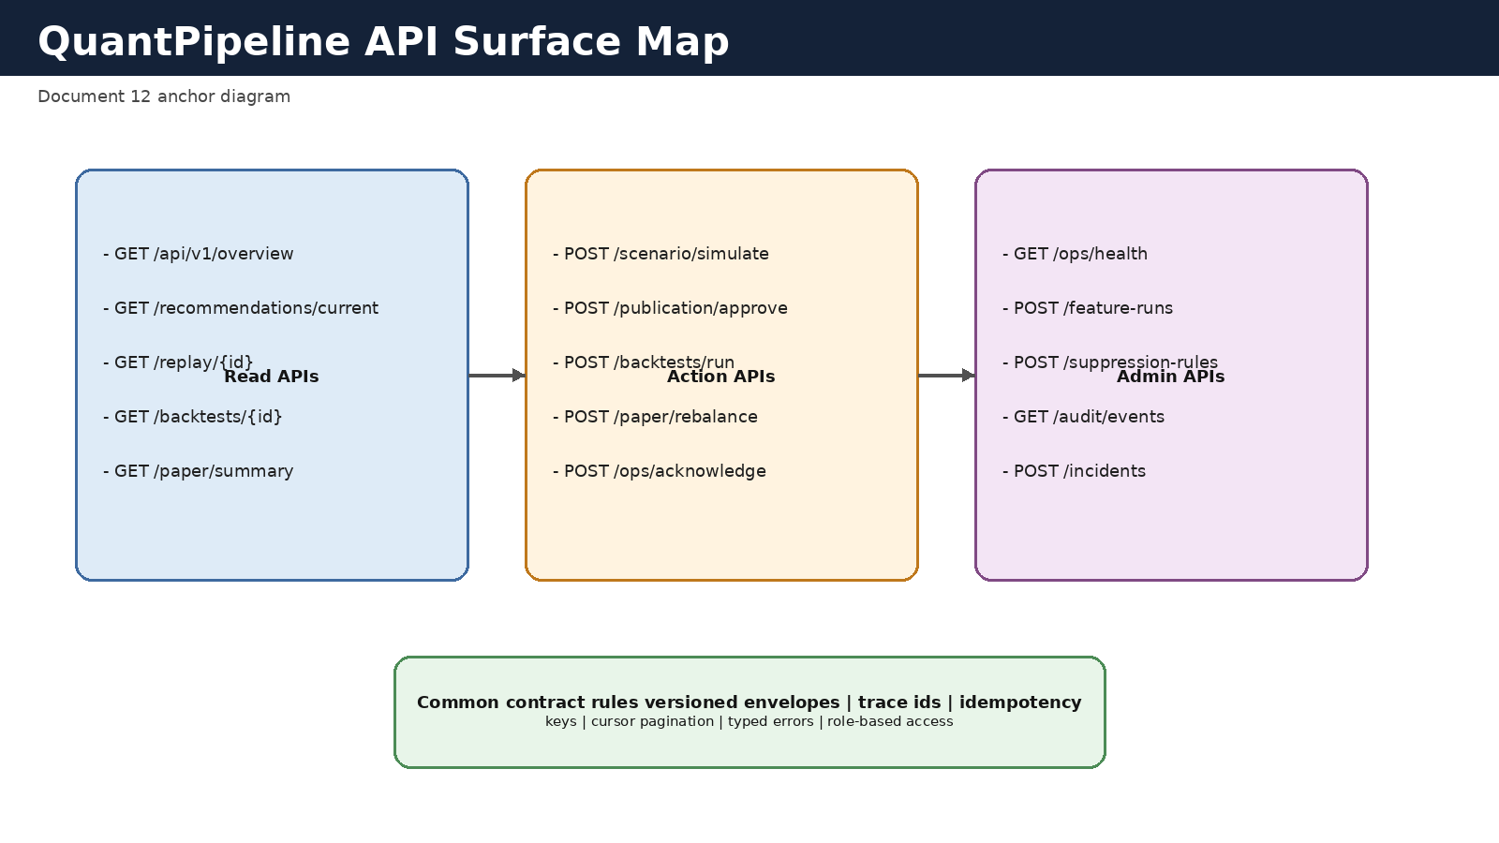
Figure 12-1. High-level API surface map.

3. Contract Principles
- Version every public route namespace.
- Return typed envelopes with metadata, data payload, and warnings.
- Expose trace_id and recommendation or run references where relevant.
- Use typed error objects instead of free-form error strings.
- Keep user-facing semantics stable even if internal services change.
- Mark temporary scenario outputs explicitly so they cannot be confused with published recommendations.
- Support partial and degraded states through explicit status fields rather than transport-level ambiguity.
- Design for desktop-first payload richness while staying safe for mobile clients.

4. Authentication and Authorization
The initial product is private, but the API still requires explicit authentication and role-aware authorization. At minimum, distinguish between read, simulate, approve/publish, and admin/ops actions. This avoids hard-wiring a security exception that would later weaken auditability.
Recommended mechanism: secure session or token-based auth at the gateway, server-side session validation, and policy checks in command handlers. Every mutation endpoint should emit an audit event containing actor, action, object reference, and outcome.
Role | Read recommendation | Run scenario | Publish/approve | Admin mutate
Viewer | Yes | Optional | No | No
Operator | Yes | Yes | Conditional | Limited
Admin | Yes | Yes | Yes | Yes
Service account | Scoped | Scoped | No human publication | Scoped

5. Common Envelope and Metadata
All successful responses should follow a common envelope so that clients can handle freshness, warnings, and traceability consistently.
{ "meta": { "trace_id": "...", "api_version": "v1", "generated_at": "...", "warnings": [], "freshness": {"state": "healthy", "age_sec": 120} }, "data": { ... } }
For collections, add pagination metadata. For asynchronous operations, return a job resource reference. For degraded states, use warnings and status fields inside data rather than silently omitting relevant context.

6. Standard Types
The following object families recur across the API surface and should retain stable names: RecommendationSummary, RecommendationDetail, DecisionStageDetail, EngineComparisonRow, ReplayNarrative, BacktestSummary, PaperPortfolioSummary, AlertSummary, IncidentDetail, ApprovalDecision, and TypedError.
Where payloads differ by screen, preserve a shared core subset so clients can reuse rendering and avoid hidden semantic drift.
Type | Core fields
RecommendationSummary | recommendation_id, as_of, status, overall_confidence, top_changes, target_weights[]
DecisionStageDetail | stage_name, run_id, version_ref, summary, adjustments[], warnings[]
EngineComparisonRow | engine_id, stance, confidence, freshness_state, contribution_summary
ReplayNarrative | replay_id, recommendation_id, chronology[], stage_diffs[], evidence_refs[]
TypedError | code, category, message, retryable, object_ref, trace_id

7. Reference and Setup Endpoints
These endpoints support the initial shell, filters, universes, watchlists, and settings selectors used across the product.
Method | Path | Purpose | Notes
GET | /api/v1/reference/universes | List available universes | Supports status and scope filters
GET | /api/v1/reference/watchlists | List user watchlists | May include counts and freshness
GET | /api/v1/reference/benchmarks | List benchmarks | For backtests and paper
GET | /api/v1/reference/assets/search | Search instruments | Supports ticker and name query
GET | /api/v1/settings/current | Load saved user settings | Includes preferred horizon and display rules
POST | /api/v1/settings/current | Update user settings | Audit required for changed defaults

8. Overview and Current Recommendation Endpoints
The overview surface answers the question: what is the recommendation right now, how healthy is it, and what changed? These routes must be fast and read-model oriented.
Method | Path | Response | Behavior
GET | /api/v1/overview | OverviewSnapshot | Primary home screen payload
GET | /api/v1/recommendations/current | RecommendationDetail | Returns the latest published or staged recommendation for the selected context
GET | /api/v1/recommendations/{id} | RecommendationDetail | Historical detail by stable id
GET | /api/v1/recommendations/{id}/diff | RecommendationDiff | Changes vs previous recommendation
GET | /api/v1/recommendations/{id}/weights | RecommendationWeights | Portfolio table plus change metrics

RecommendationDetail should include the confidence decomposition, freshness state, top drivers, top warnings, links to decision-stage refs, and publication metadata so the client does not need to make multiple calls for a normal detail view.

9. Decision Breakdown Endpoints
These endpoints power the main dashboard and drill-down experiences for selection, allocation, timing, and risk overlay.
Method | Path | Purpose | Key query params
GET | /api/v1/recommendations/{id}/decision-breakdown | Compact breakdown across all stages | stage_filter, include_rationales
GET | /api/v1/selection-runs/{id} | Selection detail and shortlist | include_exclusions
GET | /api/v1/allocation-runs/{id} | Pre-risk allocation detail | include_contributors
GET | /api/v1/timing-runs/{id} | Timing adjustments and posture | include_rule_triggers
GET | /api/v1/risk-runs/{id} | Risk overlay actions and caps | include_before_after

10. Engine Comparison Endpoints
The comparison surface should help the user understand agreement, conflict, and evidence asymmetry without exposing raw internal artifacts by default.
Method | Path | Response | Notes
GET | /api/v1/recommendations/{id}/engines | EngineComparisonList | Matrix-oriented summary for the current recommendation
GET | /api/v1/engine-runs/{id} | EngineRunDetail | Deep detail for one engine run
GET | /api/v1/engines/status | EngineStatusList | Freshness, last success, and promoted version
GET | /api/v1/engines/{engine_id}/history | EngineRunHistory | Recent history for diagnostics

11. Scenario Simulation Endpoints
Scenario endpoints allow the user or operator to explore what-if changes without publishing them as the current recommendation. Every response must state clearly that the output is simulated and temporary.
Method | Path | Purpose | Required request fields
POST | /api/v1/scenarios/simulate | Run temporary scenario | context, scenario_overrides, requested_stages
GET | /api/v1/scenarios/{id} | Fetch stored scenario result | none
POST | /api/v1/scenarios/{id}/pin | Persist scenario preset | name, notes

A scenario result should include scenario_id, base_recommendation_id if any, simulated stage outputs, simulated target weights, deltas vs current recommendation, warnings, and an explicit `is_published = false` marker.

12. Replay and Forensics Endpoints
Replay endpoints should reconstruct one historical recommendation end-to-end. They are read-only but high value for trust and learning.
Method | Path | Purpose
GET | /api/v1/replays/{recommendation_id} | Open or create replay narrative for a historical recommendation
GET | /api/v1/replays/{replay_id}/stages/{stage_name} | Stage-specific replay drill-down
GET | /api/v1/replays/{replay_id}/evidence | Evidence summary with source references and confidence
GET | /api/v1/replays/{replay_id}/changes | What changed vs prior recommendation

13. Backtest and Validation Endpoints
Validation endpoints are primarily admin or operator scoped. They must support job initiation, result retrieval, artifact listing, and promotion decisions.
Method | Path | Purpose | Notes
POST | /api/v1/backtests/run | Start backtest job | Requires methodology and policy bundle references
GET | /api/v1/backtests/{id} | Read backtest summary | High-level metrics and run status
GET | /api/v1/backtests/{id}/periods | Read period-level results | Supports pagination
GET | /api/v1/backtests/{id}/artifacts | List generated artifacts | Charts, reports, raw metrics exports
POST | /api/v1/backtests/{id}/promote-check | Evaluate promotion gate | Returns pass/fail and failed rules

14. Paper Portfolio Endpoints
Paper endpoints track shadow performance and operational drift between the policy and simulated holding evolution.
Method | Path | Purpose
GET | /api/v1/paper/summary | Paper portfolio home payload
GET | /api/v1/paper/rebalances | Historical rebalances and reasons
GET | /api/v1/paper/holdings | Current paper holdings
GET | /api/v1/paper/drift | Drift and benchmark-relative state
POST | /api/v1/paper/rebalance-now | Operator-triggered paper refresh

15. Admin and Ops Endpoints
Admin endpoints provide the health and control plane needed to keep recommendation publication honest.
Method | Path | Purpose | Privilege
GET | /api/v1/ops/health | System health summary | Operator
GET | /api/v1/ops/alerts | List active and historical alerts | Operator
POST | /api/v1/ops/alerts/{id}/acknowledge | Acknowledge alert | Operator
GET | /api/v1/ops/incidents/{id} | Incident detail | Operator
POST | /api/v1/ops/incidents | Create incident | Operator
POST | /api/v1/publication/{id}/approve | Approve publication | Admin
POST | /api/v1/publication/{id}/suppress | Suppress publication | Admin
GET | /api/v1/audit/events | Query audit events | Admin
POST | /api/v1/policies/promote | Promote policy bundle | Admin

16. Error Model
Errors should be typed and actionable. Clients must know whether an error is retryable, whether it indicates a degraded but still usable state, and whether it blocks publication.
Recommended categories: validation_error, authorization_error, not_found, conflict, dependency_failure, degraded_state, and internal_error.
{ "error": { "code": "DEPENDENCY_STALE", "category": "degraded_state", "message": "News feed freshness exceeded publication threshold", "retryable": false, "object_ref": "source:news", "trace_id": "..." } }

17. Idempotency, Concurrency, and Pagination
- Use idempotency keys for scenario creation, approval decisions, and backtest run starts when duplicate submission is possible.
- Protect publication and suppression actions with optimistic concurrency tokens tied to the publication record state.
- Use cursor pagination for growing collections such as alerts, audit events, article lists, and historical run history.
- Return explicit sort keys in paginated collections so replayable views stay stable.

18. Versioning and Deprecation
The route namespace should begin with `/api/v1`. Breaking response changes require a new version. Additive fields are allowed within a version as long as required fields remain stable and semantic meaning does not change.
For high-value types such as RecommendationDetail and DecisionStageDetail, publish compatibility notes before removing or renaming fields. The platform should prefer deprecation windows over abrupt contract changes because replay and historical comparisons depend on contract continuity.

19. Contract Acceptance Checklist
- Every route has a typed success envelope and typed error format.
- Every user-visible recommendation response carries freshness, status, and trace metadata.
- Every mutation route emits an audit event.
- Scenario outputs cannot be mistaken for published recommendations.
- Replay, backtests, paper, and admin routes resolve stable identifiers from Document 11.
- Authorization behavior is explicit and testable for every mutation route.

Appendix A - Example Recommendation Detail Skeleton
{ "meta": {"trace_id": "...", "api_version": "v1", "generated_at": "..."}, "data": { "recommendation_id": "...", "status": {"publication_state": "published", "health_state": "healthy"}, "confidence": {"overall": 0.72, "data": 0.81, "model": 0.69, "operational": 0.93}, "target_weights": [{"asset_id": "AAPL", "target_weight": 0.08}], "decision_breakdown_ref": {"selection_run_id": "...", "allocation_run_id": "...", "timing_run_id": "...", "risk_run_id": "..."}, "top_drivers": ["macro improved", "trend support"], "warnings": [] } }

Appendix B - Example Approval Command
POST /api/v1/publication/{id}/approve
{ "expected_state": "staged_for_approval", "decision_note": "Approved after verifying source freshness and no active incident", "idempotency_key": "..." }

