13. Validation / Backtesting / Paper Methodology
Evidence rules, experiment protocol, and promotion gates for policy changes

Project: QuantPipeline
Document status: Working baseline for product and engineering delivery
Version: v1.0
Date: 2026-04-23
Audience: Product owner, architecture, development, QA, and future implementation agents

Purpose: This document is intended to be implementable. It defines contracts, boundaries, and decisions that should survive future feature growth without breaking the core recommendation pipeline.

Document Control
Field | Value
Document code | 13
Title | Validation / Backtesting / Paper Methodology
Primary input set | Documents 01-09, A1 technology recommendation, and baseline truth table
Primary architecture anchor | Data & Feature Layer -> Signals -> Selection -> Allocation -> Timing -> Risk Overlay -> Recommendation Object -> Backtest / Paper / Replay / Ops
Assumed release posture | Private single-user first release with future-safe modular boundaries
Key dependencies | Documents 10-12, 08 PRD, 09 Functional Requirements
Quality rule | No silent degradation, explicit trust semantics, and replayable output

1. Purpose of the Methodology
This document defines how QuantPipeline earns trust before and after a policy or model change is allowed to influence live recommendations. It covers historical backtesting, walk-forward validation, paper shadowing, replay linkage, promotion gates, and evidence packaging.
The methodology is designed for a medium-term investment decision product. It is not a high-frequency execution research framework. The goal is to verify that decision logic remains coherent, interpretable, and operationally honest across changing regimes, imperfect data, and alternative baselines.

2. Validation Philosophy
- Use one canonical recommendation contract across backtests, paper, replay, and current production.
- Evaluate complete policy bundles, not isolated headline metrics only.
- Freeze inputs, configuration, and code references for every serious experiment.
- Prefer walk-forward realism over single-window optimization theater.
- Treat turnover, costs, and drawdown behavior as first-class results.
- Use ablations to understand what each evidence family actually contributes.
- Require operational evidence in addition to performance evidence.
- Do not promote a policy bundle that cannot be explained or replayed.

3. Methodology Overview
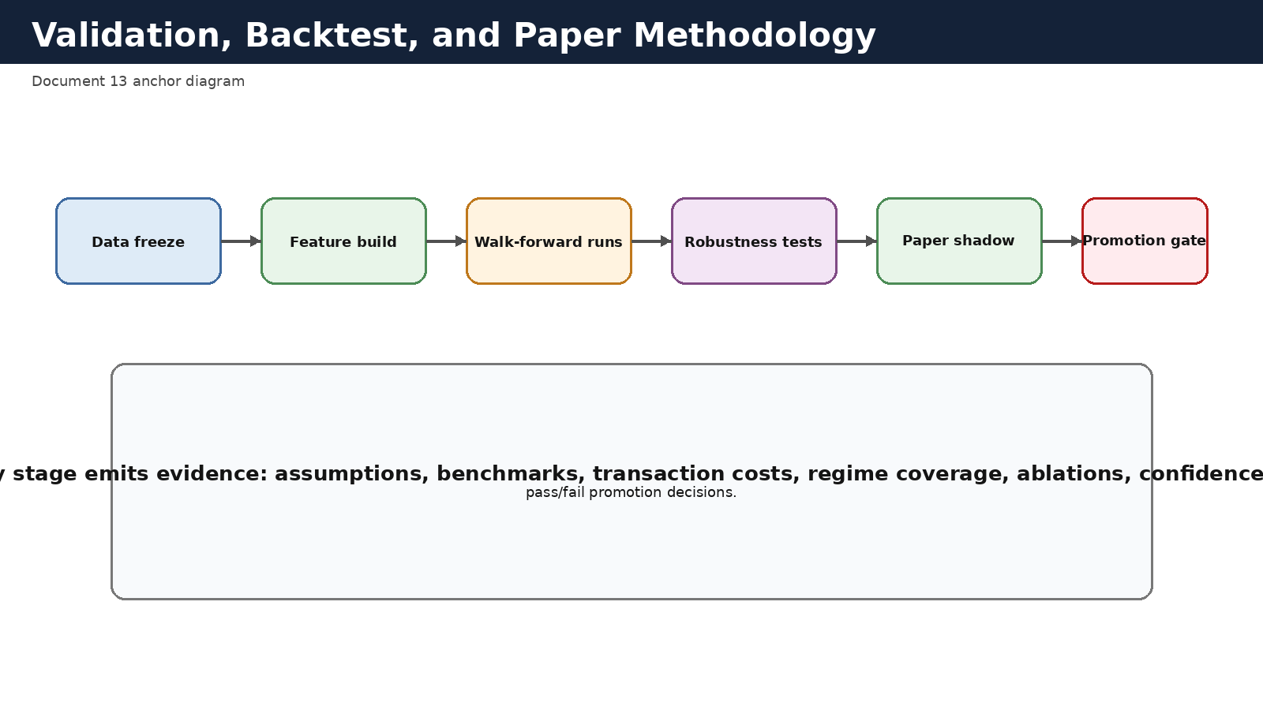
Figure 13-1. Validation and promotion pipeline.

Validation should be treated as a pipeline, not a single report. Each stage reduces a different type of risk: data freeze guards against hidden lookahead and drift, walk-forward runs test behavior over time, robustness tests challenge fragile assumptions, paper shadowing exposes operational reality, and promotion gates convert evidence into a clear yes/no decision.

4. Experiment Unit and Evidence Package
The atomic unit of evaluation is an Experiment Run. An experiment run should reference a frozen input snapshot, a policy bundle, a methodology version, cost assumptions, benchmark set, and output artifact bundle.
An Evidence Package should be generated for every promotion-grade experiment. It should include methodology parameters, period coverage, summary metrics, benchmark comparisons, drawdown analysis, turnover analysis, ablation results, regime results, paper-shadow linkage if available, and pass/fail results against promotion thresholds.
Evidence package element | Why it matters
Frozen snapshot reference | Proves what data was available and prevents quiet restatement
Policy bundle reference | Ties results to exact selection/allocation/timing/risk versions
Methodology version | Explains split rules, windows, cost assumptions, and metrics
Benchmark set | Prevents performance claims without context
Robustness outputs | Shows whether the result survives reasonable perturbations
Promotion checklist | Converts analysis into a binary governance outcome

5. Data Freeze and History Segmentation
Each validation run should begin with a frozen historical dataset definition. The freeze must specify the covered universes, asset mapping rules, benchmark series, raw source versions or manifests, feature recipe versions, and event alignment logic.
History should be segmented into training, validation, and test windows using walk-forward or rolling windows rather than one static in-sample / out-of-sample split. Regime tagging should be preserved so results can be examined in expansion, contraction, stress, and recovery environments.
Window type | Role | Recommended rule
Training | Fit model components or tune thresholds | No publication claims from this window alone
Validation | Select among candidate bundles | Used for controlled comparison, not final bragging
Test | Estimate unseen performance | Strictly held out until promotion review
Walk-forward slices | Repeated realistic evaluation | Advance windows through time using frozen data at each step

6. Baselines and Benchmarks
QuantPipeline should never present a policy bundle only against its own optimized variant. Every serious evaluation needs practical baselines and recognizable benchmarks so the user can judge whether complexity is buying anything useful.
At minimum, compare against: benchmark buy-and-hold, equal-weight shortlist, simple risk-budgeted allocation, and a conservative timing or de-risking baseline. Additional baselines should be added whenever a new policy stage claims to add value.
Baseline family | Example | Purpose
Market benchmark | SPY or relevant benchmark basket | Context for directional performance
Simple portfolio policy | Equal-weight shortlist | Tests whether complex allocation truly helps
Risk-aware baseline | Vol-targeted equal-weight | Separates value from simple de-risking
No-timing baseline | Allocation without timing controller | Tests timing contribution
No-news or no-social ablation | Feature-family removal | Tests evidence-family value

7. Cost, Slippage, and Capacity Assumptions
Because the system is designed for medium-term decisions, transaction costs and turnover must be modeled consistently. Costs should include commissions or spread assumptions where relevant, and slippage should reflect the expected rebalancing cadence rather than intraday trading fantasies.
Every experiment result should store the cost model identifier used. Results that omit costs may be useful diagnostically but should never be eligible for promotion decisions.
Assumption group | Required fields
Trading friction | commission_bps, spread_bps, slippage_model_id
Rebalance policy | rebalance_frequency, threshold_rebalance_rule
Capacity | max_position_notional, liquidity_screen, participation_limit if used
Cash handling | cash_yield_assumption, idle_cash_rule

8. Robustness Test Suite
Promotion-grade experiments should run a standard robustness suite. The point is not to exhaust every imaginable variant. The point is to reject fragile bundles that only look good under one narrow framing.
Robustness test | Question answered | Promotion relevance
Regime slice analysis | Does performance vanish in specific environments? | High
Ablation analysis | Which stage or evidence family actually adds value? | High
Cost sensitivity | Does the edge survive realistic friction changes? | High
Universe sensitivity | Does the bundle overfit one narrow universe? | Medium to high
Rebalance sensitivity | Is performance dependent on one arbitrary cadence? | Medium
Data degradation simulation | Does the bundle fail honestly under missing or stale evidence? | High

9. Paper Portfolio Methodology
Paper shadowing is the bridge between historical evidence and operational trust. The paper portfolio should consume the same recommendation contract used by the overview and replay surfaces, but it should apply explicit execution assumptions and keep its own history of rebalances, holdings, drift, and deviations.
Paper results should be comparable to backtests but not conflated with them. Backtests answer what the policy would have done on frozen history. Paper answers what happened when the live production pipeline generated recommendations under real operational conditions.
Paper object | Purpose | Must link to
paper_portfolio | Named shadow portfolio | policy bundle and benchmark
paper_rebalance | Execution of one paper action | recommendation_id and execution assumptions
paper_holding_snapshot | Observed current paper holdings | paper_portfolio_id and timestamp
paper_drift_event | Unexpected drift or discrepancy | linked paper_rebalance or external cause

10. Replay Linkage
Every promoted experiment and every paper rebalance should be linkable to replay artifacts wherever feasible. The same policy bundle that looks good statistically must also be explainable stage by stage. This reduces the risk of endorsing a method that cannot be reasoned about when it later behaves strangely.
Recommended rule: replay support is not optional for promoted policy bundles. If a bundle cannot be reconstructed in the replay model, its promotion should be blocked or explicitly exception-approved.

11. Promotion Thresholds
Thresholds should be explicit and multidimensional. A policy bundle should not pass because one return metric looks good while drawdown, turnover, or operational behavior are unacceptable.
Threshold family | Example pass rule | Fail examples
Return context | Outperform chosen baseline net of costs over test window | Only beats baseline gross of costs
Risk | Drawdown and volatility within approved envelope | Excessive drawdown concentration
Turnover | Turnover consistent with medium-term product posture | Hyperactive rebalancing
Robustness | No critical failure in standard robustness suite | Performance collapses under mild cost increase
Operational | Paper shadow and replay support available | Missing replay or repeated publication incidents

12. Reporting Pack
Every serious run should produce a consistent reporting pack so that comparisons across time remain intelligible. The report should include summary metrics, benchmark comparisons, period charts, turnover charts, drawdown analysis, contribution by decision stage if available, and a final promotion checklist.
Reports may be rendered as PDFs or dashboard pages, but the underlying raw metrics should also be stored in machine-readable form for future re-analysis.

13. Exceptions and Methodology Change Control
Methodology exceptions should be rare and documented. If a promotion is granted despite failing one threshold, the approval record must state the exception reason, compensating controls, owner, and review expiry.
Any change to windowing, benchmarks, cost model, or metric definitions should create a new methodology version. Historical results should not be silently reinterpreted under a changed methodology label.

14. Acceptance Checklist
- Experiment references a frozen input snapshot and exact policy bundle.
- Net-of-cost results and baseline comparisons are available.
- Robustness suite completed and no critical failures remain unexplained.
- Paper linkage is present where required by governance stage.
- Replay support exists for the promoted bundle.
- Promotion decision and rationale are recorded in admin/audit systems.

Appendix A - Core Metrics Dictionary
Suggested standard metrics include annualized return, benchmark-relative return, drawdown, volatility, turnover, hit ratio, concentration, downside capture, exposure utilization, and confidence stability. The exact formula definitions should live in a machine-readable metrics registry referenced by the methodology version.

Appendix B - Suggested Scorecard Layout
Scorecard sections: run metadata, data window summary, benchmark set, top-line metrics, risk metrics, robustness outcomes, stage contribution notes, paper observations, replay availability, pass/fail checklist, approval notes.

