14. Governance / Guardrails / Ops Reliability Specification
Risk controls, publication safety, incident handling, and operational trust model

Project: QuantPipeline
Document status: Working baseline for product and engineering delivery
Version: v1.0
Date: 2026-04-23
Audience: Product owner, architecture, development, QA, and future implementation agents

Purpose: This document is intended to be implementable. It defines contracts, boundaries, and decisions that should survive future feature growth without breaking the core recommendation pipeline.

Document Control
Field | Value
Document code | 14
Title | Governance / Guardrails / Ops Reliability Specification
Primary input set | Documents 01-09, A1 technology recommendation, and baseline truth table
Primary architecture anchor | Data & Feature Layer -> Signals -> Selection -> Allocation -> Timing -> Risk Overlay -> Recommendation Object -> Backtest / Paper / Replay / Ops
Assumed release posture | Private single-user first release with future-safe modular boundaries
Key dependencies | Documents 10-13, 08 PRD, 09 Functional Requirements
Quality rule | No silent degradation, explicit trust semantics, and replayable output

1. Purpose and Governance Intent
This document defines the controls that keep QuantPipeline honest and reliable. It covers governance roles, decision guardrails, publication and suppression logic, operational reliability targets, incident handling, security, privacy, and audit evidence requirements.
The intent is not bureaucratic overhead. The intent is to prevent a private decision platform from presenting false confidence. Governance here means that recommendations are published, suppressed, changed, and reviewed under explicit rules rather than hidden ad hoc behavior.

2. Control Model Overview
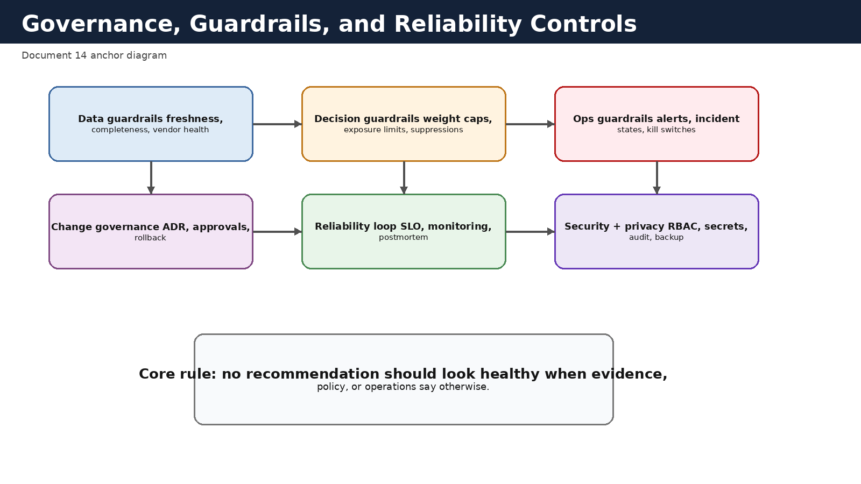
Figure 14-1. Governance, guardrails, and reliability control model.

3. Governance Principles
- No recommendation should look healthy when evidence, policy, or operations say otherwise.
- Publication status is a governed state, not a UI formatting choice.
- Guardrails should be codified and testable.
- Overrides are allowed only when explicit, auditable, and time-bounded.
- Methodology changes require named ownership and review.
- Security and privacy controls apply even in a private single-user product.
- Reliability is measured both technically and semantically.
- Incidents and postmortems should change the system, not just produce notes.

4. Roles and Responsibilities
The first release may be operated by one primary owner, but the governance model should still distinguish responsibilities. This prevents loss of clarity when the same person is acting as viewer, operator, approver, and system maintainer.
Role | Primary responsibilities | Typical actions
Viewer | Consume recommendations and validation outputs | Read only
Operator | Monitor health, manage incidents, inspect failures | Acknowledge alerts, open incidents, run diagnostics
Approver | Approve or suppress publication under defined rules | Approve staged recommendation, suppress publication
Administrator | Manage policies, permissions, and control settings | Promote policy bundle, change guardrail thresholds
Maintainer | Maintain infrastructure, secrets, and deployment pipelines | Rotate secrets, deploy fixes, restore backups

5. Guardrail Taxonomy
Guardrails should be grouped by what they protect. This helps both implementation and user explanation.
Guardrail family | Protects against | Examples
Data guardrails | Stale, incomplete, or contradictory evidence | Freshness max age, missing-source threshold
Decision guardrails | Unsafe or incoherent portfolio proposals | Max position weight, sector cap, cash floor
Publication guardrails | User-facing false normalcy | Suppress if critical incident is active
Operational guardrails | Silent system failure | Queue lag threshold, failed job threshold
Security guardrails | Unauthorized access or secret exposure | RBAC, audit, secret rotation
Change guardrails | Unreviewed drift in methodology or policy | Approval required for bundle promotion

6. Data Guardrails
Data guardrails determine whether a recommendation can be trusted enough to publish. They should be evaluated before and after feature and signal generation, because some issues appear only after fusion.
Guardrail outcomes should be stored as machine-readable objects so admin surfaces and publication logic consume the same result.
Rule type | Example | Typical consequence
Freshness | News feed older than approved threshold | Degraded or suppressed publication
Completeness | Feature coverage below minimum asset threshold | Block selection or mark degraded
Consistency | Major timestamp misalignment across sources | Raise incident and suppress publication
Vendor health | Repeated upstream failures | Fallback if approved; otherwise suppress
Reference integrity | Unresolved asset mapping on critical inputs | Reject affected records and alert operator

7. Decision and Portfolio Guardrails
Decision guardrails should apply after allocation and timing, and again after risk overlay. The risk overlay is itself a control stage, but additional publication checks may still be needed.
Guardrail | Example policy | Stored evidence
Max single position | No final target weight above approved ceiling | Before and after weights, rule trigger
Sector concentration | Sector exposure cap per taxonomy | Sector exposure snapshot
Gross exposure | Maximum gross exposure after timing and risk overlay | Portfolio exposure metrics
Cash floor | Minimum cash in stress regime | Regime tag and final cash level
Suppression rule | Do not publish if critical incident open | Incident reference and publication reason

8. Publication States and Suppression Logic
Publication is a finite-state workflow. Recommended baseline states: draft, staged_for_approval, published, published_with_warning, suppressed, stale, and retired. The overview surface should reflect these states directly rather than inferring them from background signals.
Suppression should be used when a recommendation should not be treated as current guidance. This may be because a critical incident exists, a mandatory data guardrail failed, or a manual governance action intentionally blocked publication.
State | Meaning | Allowed transitions
draft | Run completed but not yet staged | staged_for_approval, suppressed
staged_for_approval | Awaiting explicit decision | published, published_with_warning, suppressed
published | Current approved recommendation | retired, stale, suppressed
published_with_warning | Published but marked degraded | retired, stale, suppressed
suppressed | Not fit to serve as current guidance | draft after rerun, retired
stale | Previously published but beyond freshness policy | published after refresh, suppressed, retired

9. Reliability Model and SLOs
Reliability should be expressed in both service-level and product-level terms. Uptime alone is not enough. The platform also needs freshness, queue, and publication quality indicators.
SLI family | Example SLI | Suggested target
API responsiveness | Overview p95 latency | Within interactive threshold
Job success | Recommendation run success rate | High and stable
Freshness | Age of current recommendation inputs | Within approved envelope
Publication integrity | Percent of current recommendations with unresolved critical warnings | Zero
Admin visibility | Alert to acknowledgement time | Bounded by severity
Recovery | Mean time to restore healthy publication path after incident | Explicit target by severity

10. Monitoring and Alerting
Alerting must map to actionable operators and objects. Generic noise harms trust. Every alert should reference what is affected, what user-visible consequence exists or may occur, and what the expected next action is.
Recommended alert severities: informational, warning, high, and critical. Critical alerts should generally be publication-affecting unless explicitly exempted.
Alert family | Examples | Default owner
Source freshness | Market bars stale, macro release missing | Operator
Feature integrity | Feature job failed or completeness below threshold | Operator
Policy execution | Selection empty unexpectedly, risk overlay failure | Operator / approver
Publication workflow | Approval queue blocked or stale recommendation active | Approver
Security | Auth anomaly, secret rotation overdue | Administrator / maintainer
Platform | Queue lag, storage degradation, backup failure | Maintainer

11. Incident Management
Incidents should be used when alert-level handling is insufficient or when user trust may be affected. Incidents need severity, owner, timeline, linked objects, mitigation steps, and a final postmortem summary.
Publication-impacting incidents should automatically influence overview and admin state so the user is never shown a clean recommendation while a critical unresolved issue exists.
Severity | Typical impact | Expected workflow
SEV-1 | Current recommendation cannot be trusted | Immediate suppression or warning, active incident room, postmortem required
SEV-2 | Material degradation or partial publication risk | Rapid investigation, mitigation, explicit user-visible warning if published
SEV-3 | Operational issue with limited immediate user harm | Owner assigned, bounded remediation plan
SEV-4 | Minor issue or housekeeping | Tracked in backlog or routine ops

12. Security, Privacy, and Access Control
Even as a private product, QuantPipeline handles sensitive portfolio context, recommendation history, provider credentials, and decision metadata. Security must therefore be designed, not implied.
Minimum controls include role-based access, strong authentication, encrypted transport, server-side secrets, backup protection, immutable audit logs for high-risk actions, and explicit separation between read, simulate, approve, and admin mutation scopes.

13. Change Management and Promotion Control
Policy bundles, methodology versions, model artifacts, and major guardrail changes should move through a documented promotion workflow. Promotion records must state what changed, why it changed, which evidence package justified it, and what rollback path exists.
A bundle should not be promoted directly from experimentation into publication without validation evidence, approval, and a recorded effective time.
Change type | Approval expectation | Rollback expectation
Policy bundle promotion | Formal approval | Previous bundle remains restorable
Methodology version change | Formal approval | Historical reports preserve prior methodology labels
Guardrail threshold change | Formal approval if publication-impacting | Old threshold retained for rollback
UI-only explanatory change | Lightweight review | Standard release rollback
Secret or credential rotation | Operational approval | Verified fallback procedure

14. Backup, Recovery, and Continuity
The platform needs recoverability for canonical relational state, object manifests, policy artifacts, audit logs, and critical reports. Recovery plans should distinguish between restoring service availability and restoring trustworthy publication.
After a restoration event, a recommendation should not be auto-published until freshness and guardrails are re-evaluated.
Asset | Protection rule | Recovery note
PostgreSQL domain data | Regular backups and restore drills | Verify recommendation and audit consistency after restore
Object storage manifests and artifacts | Versioning or replicated storage | Preserve checksums and pointers
Policy bundles and model artifacts | Immutable versioned package store | Promotion history must remain intact
Secrets and credentials | Managed secret store and rotation | Restore requires controlled re-issuance
Monitoring configuration | Version controlled | Needed to restore visibility quickly

15. Audit and Evidence Requirements
Audit is not only for security actions. QuantPipeline should preserve evidence for publication decisions, suppressions, policy promotions, overrides, and methodology exceptions. This evidence is essential for replay and for later trust repair if the system behaves unexpectedly.
Action | Minimum audit fields
Publication approval | actor, object_ref, expected_state, decision_note, occurred_at
Suppression | actor, object_ref, reason_code, linked_incident, occurred_at
Policy promotion | actor, policy_version_id, evidence_package_ref, occurred_at
Manual override | actor, target_object, override_type, expiry, reason
Methodology exception | actor, methodology_version, failed_rule, justification, review_expiry

Appendix A - Core Runbooks
- Runbook 1: stale source blocks publication.
- Runbook 2: recommendation run fails after signal generation.
- Runbook 3: critical incident while a recommendation is currently published.
- Runbook 4: rollback to previous policy bundle after post-promotion issue.
- Runbook 5: restore from backup and re-establish trustworthy publication state.

Appendix B - Governance Questions for Every Promotion
- What changed in the policy or methodology bundle?
- What evidence package supports the change?
- What new risks were introduced or reduced?
- How will rollback be performed if the change causes operational or trust issues?
- What user-visible status or explanation changes are required?

