15. Admin and Ops Specification
Detailed operating model, information architecture, screen requirements, and workflows

Project: QuantPipeline
Document status: Working baseline for product and engineering delivery
Version: v1.0
Date: 2026-04-23
Audience: Product owner, architecture, development, QA, and future implementation agents

Purpose: This document is intended to be implementable. It defines contracts, boundaries, and decisions that should survive future feature growth without breaking the core recommendation pipeline.

Document Control
Field | Value
Document code | 15
Title | Admin and Ops Specification
Primary input set | Documents 01-09, A1 technology recommendation, and baseline truth table
Primary architecture anchor | Data & Feature Layer -> Signals -> Selection -> Allocation -> Timing -> Risk Overlay -> Recommendation Object -> Backtest / Paper / Replay / Ops
Assumed release posture | Private single-user first release with future-safe modular boundaries
Key dependencies | Documents 10-14, 06 UX Appendix, 08 PRD, 09 Functional Requirements
Quality rule | No silent degradation, explicit trust semantics, and replayable output

1. Purpose and Scope
This document specifies the operator-facing side of QuantPipeline: the admin and ops workspace, its information architecture, module definitions, screen behavior, workflows, permissions, and acceptance logic.
The admin workspace is not a back-office afterthought. It is a product-quality layer. It should explain why the system is healthy or unhealthy, allow governed actions on publication and policy state, and preserve a clean audit trail for every meaningful decision.

2. Admin Personas
The first release may have one real person acting in multiple capacities, but the workspace should still recognize distinct modes of work.
Persona | Primary questions | Typical actions
Operator | Is the pipeline healthy? What failed? What needs attention? | Review alerts, inspect runs, annotate incidents
Approver | Is this recommendation safe to publish? | Review staged publication, approve or suppress
Administrator | Are policies, permissions, and guardrails correctly configured? | Promote bundles, manage controls
Forensic reviewer | Why did this recommendation happen? | Open replay, compare runs, inspect evidence history

3. Admin Information Architecture
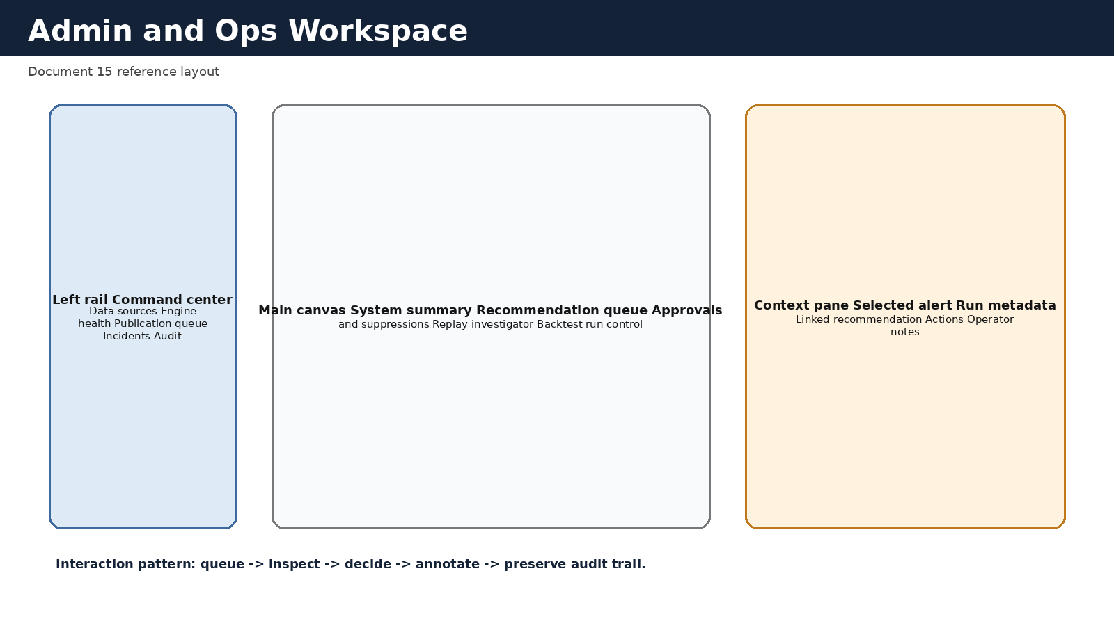
Figure 15-1. Admin and ops workspace layout.

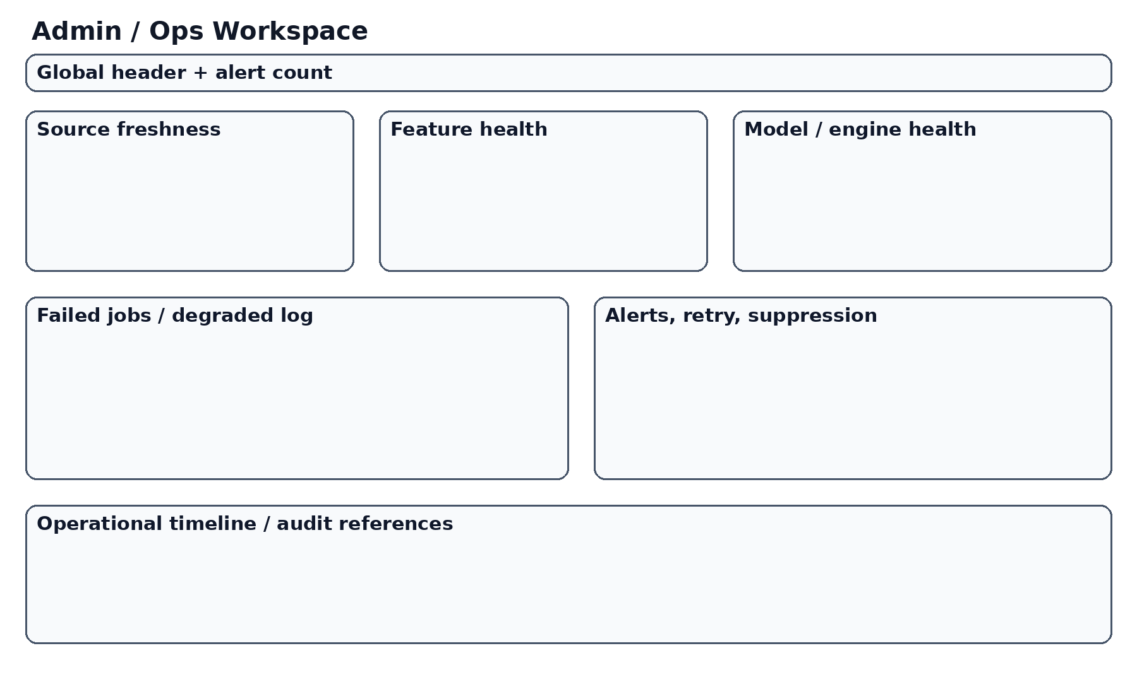
Figure 15-2. Prior admin concept retained as reference.

The recommended layout is a three-part workspace: a left rail for navigation and queue switching, a main canvas for the active module, and a right context pane for selected object details and actions. This keeps operational navigation stable while allowing deep inspection without losing queue context.

4. Core Workspace Rules
- The command center is the default landing screen for admins and operators.
- Every queue item should expose severity, freshness, linked object, and current owner if assigned.
- High-risk actions must require confirmation and capture a decision note.
- Operator notes should be visible in context but clearly distinguished from system facts.
- The right pane should preserve context while navigating between linked objects such as alert -> incident -> recommendation -> replay.
- No module should require raw log access for basic understanding of state.
- All actions that change publication, policy, or incident state must emit audit events.

5. Module Inventory
The admin and ops workspace should be organized into modules that map to distinct operator questions.
Module | Purpose | Primary widgets | Key actions
Command Center | Overall health and pending work | Status cards, queue summary, freshness panel | Open queue item, assign owner
Data Source Control | Source and freshness oversight | Feed status table, source history, exceptions | Acknowledge issue, open incident
Engine Health | Signal and policy execution health | Run timelines, failure matrix, engine versions | Re-run, inspect artifact, suppress if needed
Publication Queue | Approve or suppress staged recommendations | Recommendation list, diff summary, warning badges | Approve, suppress, request rerun
Replay Investigator | Historical forensic review | Replay timeline, stage diffs, evidence links | Pin finding, export note
Backtest Lab Ops | Validation job management | Experiment queue, scorecards, artifact list | Start job, compare runs, mark reviewed
Paper Monitor | Paper drift and shadow performance | Portfolio summary, rebalance log, benchmark chart | Trigger refresh, annotate discrepancy
Policies and Guardrails | Manage bundle versions and controls | Policy catalog, active bundle card, threshold table | Promote, rollback, edit threshold
Incidents and Audit | Investigate and prove actions | Incident board, audit explorer, notes | Create incident, resolve, export evidence
Settings and Access | Permissions and environment controls | Role matrix, environment summary | Update roles, rotate access

6. Command Center Specification
The command center should answer four questions immediately: Is the system healthy, what recommendation is current, what is blocked, and what requires a human decision now.
Recommended components: global health banner, recommendation freshness card, active incidents widget, publication queue widget, top alerts list, and validation backlog summary.
Area | Required content
Global banner | overall health state, active severity, current recommendation status
Freshness card | age of current recommendation inputs, age of latest publication
Pending decisions | count of staged recommendations and approvals waiting
Incidents | active incidents by severity with direct links
Backlog | stuck jobs, failed runs, pending validation reviews

7. Publication Queue Specification
This module is the operational heart of governed recommendation release. Each row should represent one recommendation pending a decision or recently affected by a publication event.
Each queue row should include recommendation id, as-of time, proposed state, overall confidence, freshness state, top warnings, changed weights summary, linked incident if any, and expected decision deadline where relevant.
Queue action | Behavior | Audit requirement
Approve | Publish or mark current recommendation active | Decision note required if warnings exist
Publish with warning | Allow publication in degraded state | Mandatory warning note
Suppress | Block recommendation from being current guidance | Reason code and linked incident required
Request rerun | Send recommendation back for regeneration | Trace job request
Assign reviewer | Transfer decision ownership | Ownership change event

8. Data Source and Engine Health Modules
These modules should make technical failures legible in decision terms. A stale source should show which recommendation contexts are affected. A failed engine should show whether the current recommendation is blocked, degraded, or unaffected.
Widget | Displays | Why it matters
Source status table | source, freshness age, last success, affected contexts | Connects feed health to user impact
Run timeline | last N runs by stage with success/failure | Shows whether problems are isolated or systemic
Failure matrix | stage by environment or by engine | Quick diagnosis of failure clusters
Version panel | promoted engine and policy versions | Helps explain unexpected output changes

9. Replay Investigator Specification
The replay investigator should support a forensic workflow: choose a historical recommendation, inspect chronology, compare stage outputs, identify what changed, and annotate findings.
The screen should preserve a stable left-to-right flow: context summary, chronological narrative, stage diff tabs, evidence references, and operator notes.

10. Backtest Lab Ops and Paper Monitor
Backtest Lab Ops is where validation jobs are started, compared, and reviewed. It should not masquerade as a generic data science notebook. It is an operational lab linked to promotion governance.
Paper Monitor is where the operator sees whether the production pipeline is behaving plausibly under live conditions. It should highlight divergence between expected rebalances and observed paper drift, benchmark-relative movement, and unresolved execution assumptions.
Module | Critical screens
Backtest Lab Ops | Experiment queue, run detail, comparison view, scorecard, promotion readiness view
Paper Monitor | Paper summary, holdings, drift analysis, rebalance history, discrepancy notes

11. Policies and Guardrails Module
This module manages the active policy bundle and guardrail thresholds that shape recommendation publication. It should show not only the active version, but also what changed versus the previous version, which evidence package supported the promotion, and what rollback option exists.
Editing thresholds directly in production should be rare. The module should favor versioned changes that can be reviewed and rolled back.

12. Incidents and Audit Module
The incident board should support severity, status, owner, linked object references, time opened, and current mitigation summary. The audit explorer should support filters by object, actor, action type, time, and severity.
Export of audit bundles should be supported for major review events such as policy promotions, recommendation suppressions, and post-incident analysis.

13. Context Pane Behavior
The right context pane should be reusable across modules. When the user selects an alert, run, recommendation, or incident, the pane should display summary metadata, linked objects, recommended actions, and operator notes.
The pane should not become a dumping ground. It should answer what this object is, why it matters, what it is linked to, and what can be done next.
Selected object type | Pane sections
Alert | Summary, severity, affected object, recommended next step, acknowledge action
Recommendation | Status, confidence, top changes, linked runs, approve/suppress actions
Incident | Severity, owner, timeline, linked objects, resolve controls
Backtest run | Status, top metrics, artifacts, promotion readiness
Paper drift event | Magnitude, benchmark context, linked rebalance, notes

14. Workflow Specifications
The following workflows should be explicitly supported and testable end to end.
Workflow | Happy path | Key exception path
Approve publication | Open staged recommendation -> review warnings -> approve -> audit emitted | Critical incident detected -> suppress instead
Suppress publication | Open queue item -> choose reason -> link incident -> confirm suppression | Reason missing -> block action
Investigate source issue | Open source alert -> inspect affected contexts -> create incident -> decide rerun or suppression | Source recovers but stale recommendation remains -> require refresh review
Review backtest promotion | Open scorecard -> compare thresholds -> approve bundle promotion | Missing replay support -> fail promotion
Handle paper drift | Open paper discrepancy -> inspect linked recommendation -> note operational assumption -> assign action | Repeated unexplained drift -> escalate incident

15. States, Notifications, and Empty Cases
Admin UX should treat state handling explicitly. Required states include healthy, warning, degraded, blocked, empty-but-healthy, loading, stale, and action-completed. Empty states are especially important for queues such as no active incidents or no pending approvals; they should reassure without looking broken.

16. Permissions and Safety
- Read-only users should never see destructive or publication-changing actions.
- Approve, suppress, promote, and rollback actions require elevated permissions.
- High-risk actions should require confirmation and should capture a reason or note.
- Context-preserving deep links should respect permissions and hide unavailable actions gracefully.
- Operator notes should be editable only by permitted roles and preserved historically where relevant.

17. Acceptance Criteria
- Each module answers a distinct operator question without requiring raw log access.
- Publication, suppression, promotion, and incident actions emit audit events.
- Queues, banners, and panes use consistent status semantics with the user-facing product.
- Linked navigation between alert, recommendation, replay, and incident works without losing context.
- Critical workflows are testable by fixtures and smoke checks.
- The workspace remains usable on desktop and credible on tablet-sized displays.

Appendix A - Screen Inventory
Suggested named screens: Admin Home, Publication Queue, Recommendation Review, Source Control, Engine Health, Incident Board, Incident Detail, Replay Investigator, Backtest Queue, Backtest Detail, Paper Monitor, Policy Catalog, Audit Explorer, Access Settings.

Appendix B - Open UX Questions
- Whether approval and suppression should live on one combined queue or two filtered queue modes.
- Whether operator notes should support structured tags for postmortem reuse.
- Whether mobile admin access should be view-only in the first release.
- Whether a dedicated compare mode is needed for policy bundle promotions.

