22. Phase Prompts Pack
Ready-to-paste prompt patterns for Claude to implement, review, repair, and package work on QuantPipeline

1. How to use this prompt pack
Each prompt here is written as a reusable operating prompt for Claude. It assumes Claude has access to the codebase and the 01–20 documents. Replace bracketed placeholders only; keep the control language intact so work remains bounded and evidence-driven.
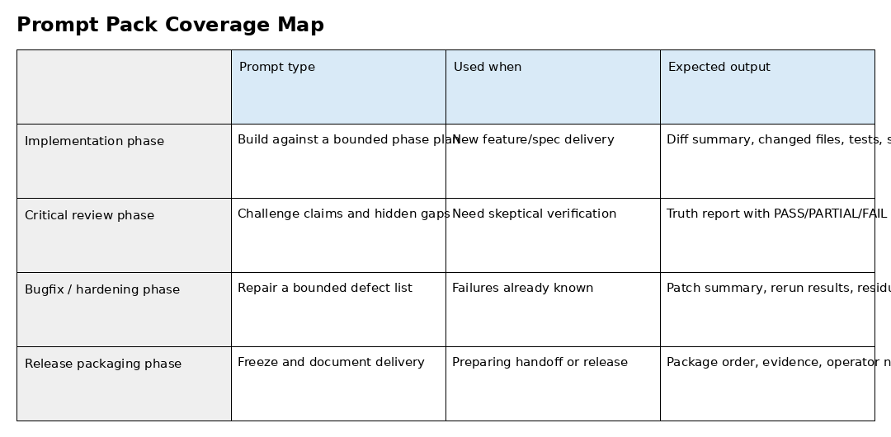

2. Prompt A — bounded implementation phase
You are implementing the next bounded phase of QuantPipeline. Read the provided documents and the current repository before coding. Do not assume file names, tables, services, or routes. Verify them.
Goal:
[INSERT PHASE GOAL]
Required in-scope surfaces:
[INSERT FILES / MODULES / ROUTES / TABLES / SCREENS]
Non-negotiable rules:
1. Work as an evolution, not a revolution.
2. Keep scope bounded and name out-of-scope items.
3. Before coding, restate what already exists and what is missing.
4. After coding, produce:
- exact files changed
- implementation summary
- tests and checks run
- screenshots / renders / endpoint evidence as relevant
- PASS / PARTIAL / FAIL against acceptance criteria
5. Never claim completion without proof.
Acceptance criteria:
[INSERT ACCEPTANCE GATES]

3. Prompt B — skeptical review pass
You are not implementing now. You are acting as a skeptical reviewer. Challenge the claimed outcome against the code, artifacts, screenshots, test outputs, and live behavior if available.
Required output:
- Scope actually reviewed
- Evidence actually inspected
- What is confirmed working
- What is partially working
- What is unverified
- Hidden contradictions or drift
- PASS / PARTIAL / FAIL with reasons
- Exact bounded next actions

4. Prompt C — bugfix and hardening phase
You are repairing a bounded defect list in QuantPipeline.
Defect list:
[INSERT DEFECTS]
Rules:
- Reproduce each defect before fixing when feasible.
- Keep fixes surgical.
- Do not broaden scope into unrelated refactors.
- After each fix cluster, rerun the smallest relevant verification harness.
- Produce a defect-by-defect closure table with status, evidence, and residual risk.

5. Prompt D — document-driven build phase
You are implementing directly from the QuantPipeline specification package. Use documents [INSERT NUMBERS] as the source of truth, but verify the current repository before touching code.
Your job:
- map document requirements to existing code surfaces
- identify exact gaps
- implement only the requirements requested for this phase
- maintain naming consistency across product, architecture, data model, and API contract
- produce an evidence pack that links document requirements to implementation outcomes

6. Prompt E — release packaging and handoff
You are preparing a release-quality handoff.
Required outputs:
- ordered package structure
- updated README / handoff file
- exact deployment steps if relevant
- known limitations and unresolved items
- operator notes for the next model or engineer
- no packaging theater: if proof is missing, say so plainly

7. Prompt F — UI/UX fidelity phase
You are implementing a bounded UX/UI phase against QuantPipeline docs 16–20.
Required behavior:
- respect IA, flows, states, and component rules
- use existing tokens and patterns when present
- show key desktop/mobile/admin states
- verify not only appearance but also information hierarchy, trust cues, and action clarity
- return screenshots or rendered proof for the main scenarios

8. Prompt G — data/API consistency audit
You are auditing consistency across documents 10–12 and the current codebase.
Check:
- entity names
- field names and types
- enum semantics
- endpoint names and payload structure
- error semantics
- ownership of derived metrics and recommendation objects
Return a contradiction log and a repair plan ranked by severity.

9. Prompt H — high-trust continuation after a failed attempt
A previous attempt partially completed the task or crashed. Continue from the current state without pretending prior steps succeeded fully.
Before coding:
- list artifacts that actually exist
- list artifacts that were only claimed
- choose the next smallest safe sub-task
- continue without asking for confirmation between every sub-step
At the end:
- say exactly what was completed in this pass
- say what still requires another pass

10. Operator guidance
When to use | Best prompt
New feature phase from docs | Prompt A or D
Need skeptical truth report | Prompt B
Known defect cleanup | Prompt C
Preparing a package for another model or engineer | Prompt E
UX/UI refinement | Prompt F
Cross-layer contract checking | Prompt G
Recovery after partial crash or broken run | Prompt H

