23. Review Report Template
Standard truth-first review template for Claude and human reviewers

1. Purpose
This template standardizes how a review should be written so that the report does not drift into vague praise, packaging theater, or untestable claims. It can be used after an implementation phase, a QA pass, a documentation update, or a pre-release gate review.
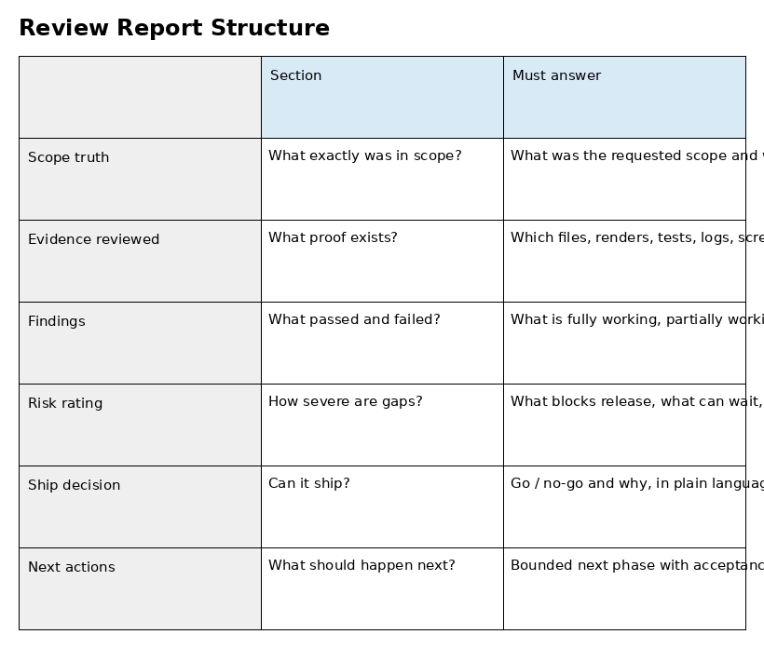

2. Review template

A. Review metadata
Review date, reviewer, branch or package name, requested scope, actual scope reviewed.

B. Sources inspected
Code files, rendered docs, screenshots, logs, endpoint outputs, database evidence, live URLs, and user instructions.

C. Scope truth
What was supposed to change, what actually changed, and what stayed untouched.

D. Findings by area
Frontend, backend, data model, API contract, admin/ops, docs, deployment, or other relevant domains.

E. Evidence table
For each major claim, list the proof source and whether it was directly inspected.

F. Risk classification
Blocker, major, moderate, minor, cosmetic.

G. Ship decision
PASS, PARTIAL, or FAIL and why.

H. Exact next actions
Bounded steps for the next pass, including acceptance criteria.

3. Example evidence table schema
Claim | Evidence inspected | Status | Comment
Primary user flow works end to end | UI screenshot + API response + state change | PASS | Observed directly
Schema and API contract align | Model file + migration + contract doc | PARTIAL | One enum mismatch remained
Admin action is auditable | Admin screen + audit log output | FAIL | No audit trail shown in evidence

4. Recommended wording rules
- Write in direct plain language. Avoid adjectives that imply quality without evidence.
- Separate confirmed facts from inference.
- If something was not checked, say 'unverified' rather than implying it worked.
- Use PASS / PARTIAL / FAIL only against named acceptance gates.
- When a report is favorable, still include the strongest remaining risk.

5. Review depth levels
Level | Use when | Expected effort
Quick truth pass | Need immediate honesty on a bounded phase | Inspect changed files plus primary evidence
Standard review | Need a trustworthy go/no-go recommendation | Inspect artifacts across all touched layers
Release gate review | Need a final ship decision | Inspect package order, evidence completeness, and highest-risk user journeys

6. Review report skeleton to paste into Claude
Use the following output structure:
1. Scope requested
2. Scope actually reviewed
3. Evidence inspected
4. Confirmed working
5. Partially working
6. Unverified
7. Contradictions / drift
8. Risk rating
9. PASS / PARTIAL / FAIL
10. Exact next steps

7. Common anti-patterns to reject
- Summaries that say 'looks good' without naming proof.
- Reports that praise code organization but do not test user-facing behavior.
- Claims of readiness that ignore known partial states.
- Large copied logs with no interpretation.
- Checklist output that hides unresolved blockers.

8. Definition of a useful review
A useful review reduces uncertainty for the next decision-maker. After reading it, the reader should know what was checked, what is solid, where the risks are, and what the smallest safe next move is.

