Nathan Roth

Computer Architecture

Dr. Meier

Lab week 8 write up

Waveform:

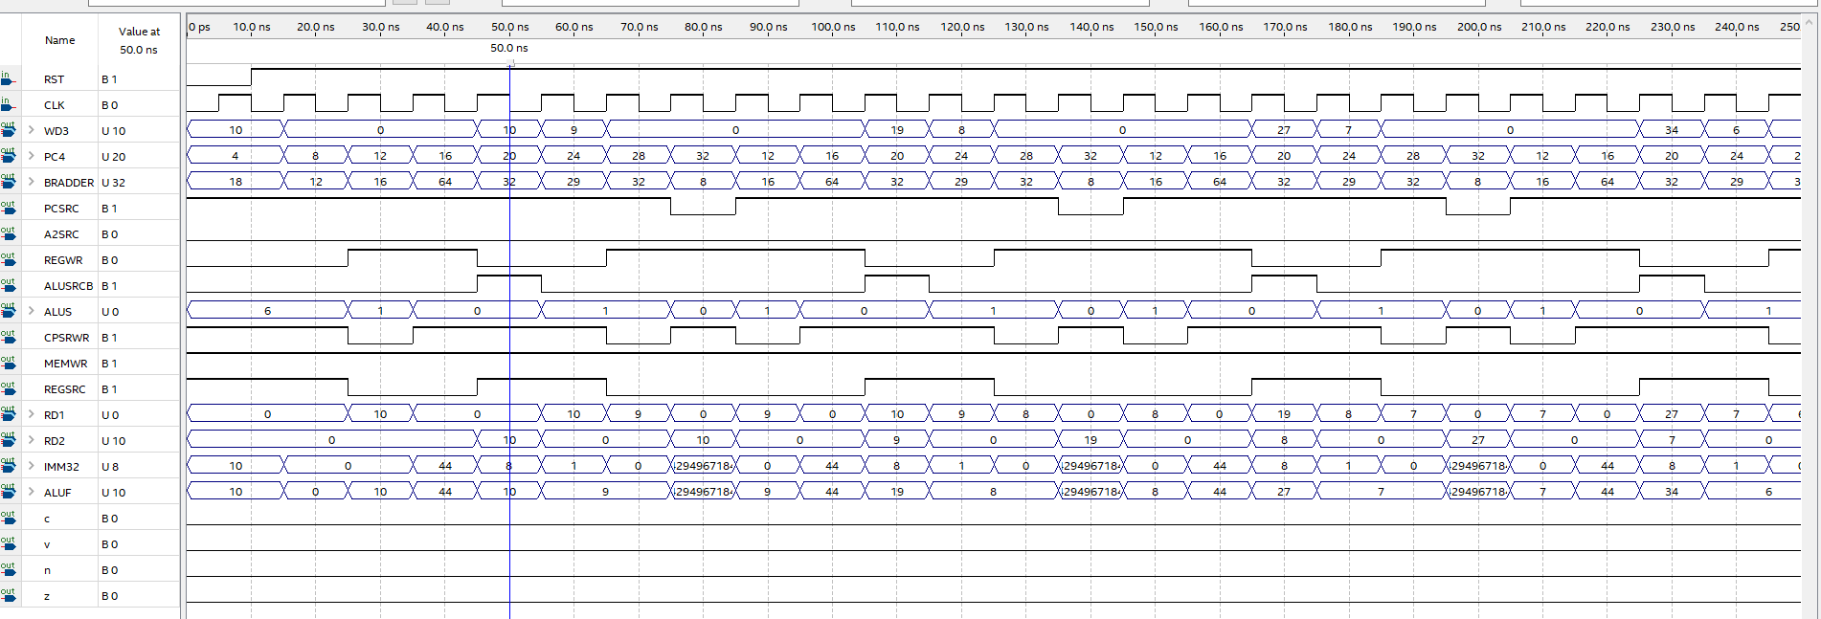This first 250ns of my simulation is correct because, you are able to follow the ALUs and see that it matches the instructions that are fed into it. The first and second instructions are mov instructions, which is 6 on the ALU, the first instruction moved the immediate 10, which you can see in the WD3. Then as you follow WD3 the number will count down signifying the loop counter and you can see the result number count up, right before the PCSRC goes to 0.

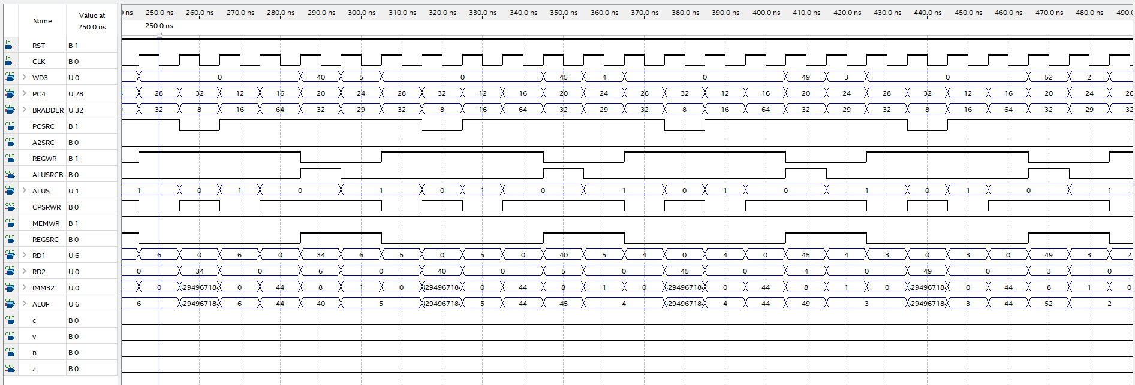

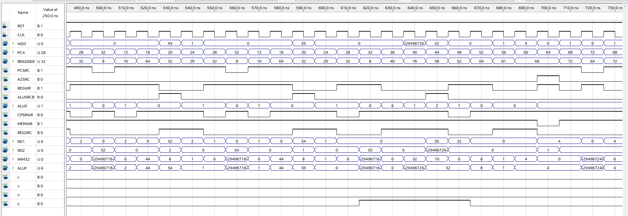This next part of the simulation is also correct because, you see the WD3 continue to count the loop down and add to the result. You can also see the PCSRC go to 0 each time the loop branches. As well as the immediate get passed through the ALU when it is needed for the branch.

This next section of the simulation is also correct because, you see the WD3 count all the way down to 0, and the result reach 55. You then see the number 32, which will later be used to compare against the result of 55 to create the infinite loop at the end.

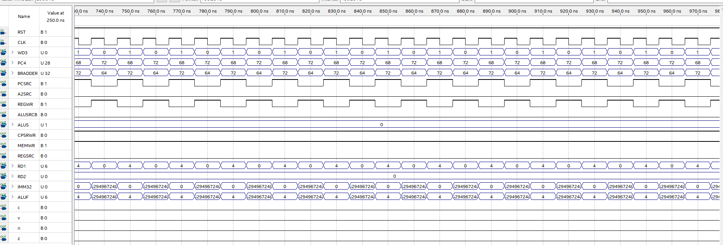

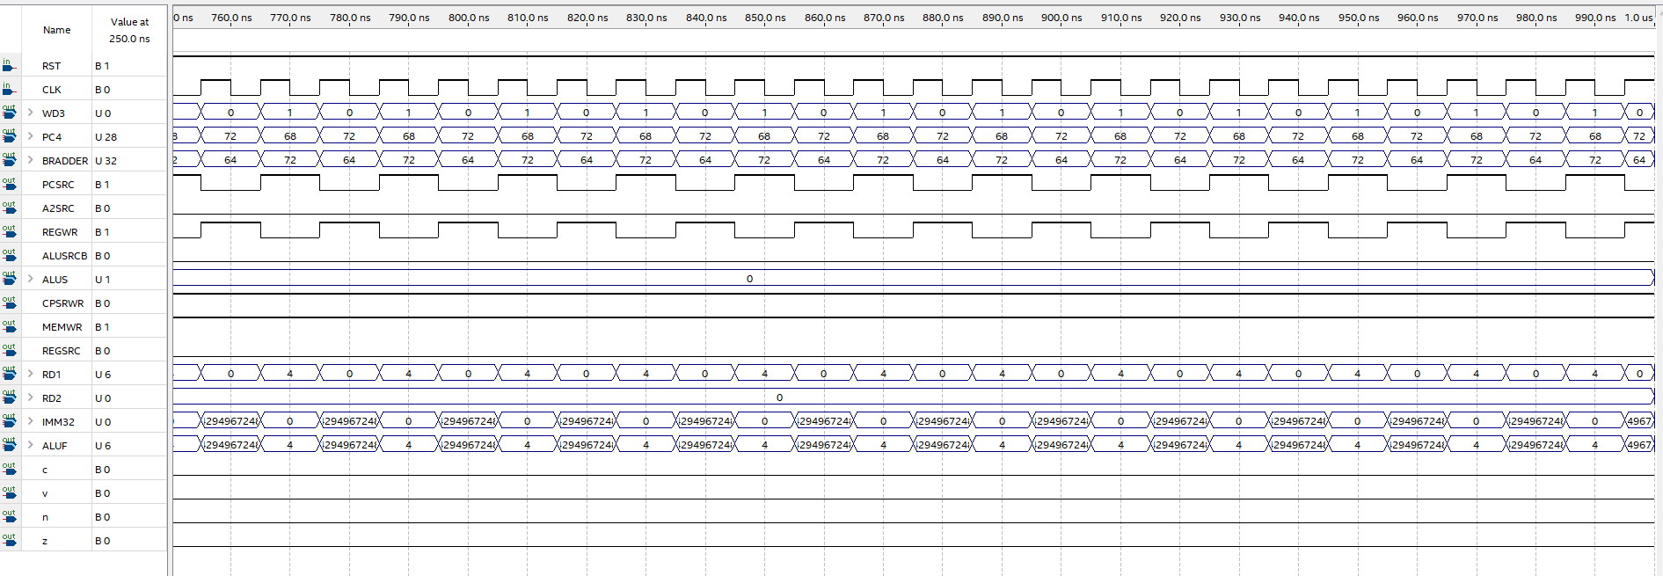

These two are the last part of the simulation where the scp is stuck in its infinite loop, where it continually loops back to itself signifying the end of the program.





