Animation system draft

We want to make a realistic movement on the character without compromising the game play. In order to achieve that goal, we need to merge Animation driven visual, and Physics driven visual seamlessly.
Animation driven visual is often repeatative and predictable but the animator can control every aspect of the movement.
Physics driven visual is often lifeless and mechanical but very responsive to the player's input for the gameplay.

Wether Animation driven or Physics driven movement, the animation system needs to have ability to blend multiple layers of movement as well as blending between the layer of current movement to the next layer.

Layer example: Idle
Traditionally, Idle animation is a single full body animation.
But it can be separated into two basic components. A single base pose, and an additive layer animation of Idle.
The benefit of separating the animation this way is that, the base pose can be independently blended to the next pose where the additive Idle animation will continue to play without a break. A character can be breathing continuously while his underlining poses can be changed.
The breathing layer can have it's own modifiers to alter the look based on the condition. For example, you can change the playback rate based on perceived exhaustion so that the character will breath faster after a big motion. The blend percentage can also be controlled based on the perceived exhaustion so that the movement is at 100 percent after a big move, but toned down after a while.
This breathing animation can be blended out to different styles of breathing independently.

Base pose example: balancing poses
The player character will be actively balancing himself on the skateboard. Depending on the skateboard orientation and physics forces, we need to blend between different leaning base poses. When the character reach a threshold, each poses should be blended into "out of control" poses. There can be multiple "out of control" poses combinations to be triggered randomly at random percentage to diversify the look. This requires careful tuning and filter out certain combinations of poses that does not work.

The core animation can be separated into three parts, anticipation, action, follow through.

Three part example: Jump

Anticipation
In anticipation of the jump, the character should assume certain squashed pose to convey realistic weight movement.
Control responsiveness often dictate the duration of this anticipation phase. Some games just have a few frames, or none of the anticipation phase in order to be responsive.
Some games set it up so that jump is triggered upon button release, not button press. This allows the game to check how long the button is held down. And based on the duration of the hold, game can trigger bigger jump. (Mario Brothers did this but there are no visual changes between the jumps) we can visually tell the player how high the character is going to jump by showing the anticipation pose. For example, if the anticipation pose reaches at its maximum at frame 20, and you hold down the jump button for 20 frames, you would see the maximum jump height that corresponds to the amount of squashed pose in the anticipation. if you tap jump button for the duration of few frames, the character would squash just a little, and the corresponding jump would be a lot lower.

Action
During the jump, we may have in air pose, with layer of body balancing poses.
We should have additive layer of arm swinging movements in various patterns to be layered on the base poses.
We should blend different "in air" poses depending on the distance to the ground. As the character go up higher, he would tuck his legs in, and as he gets closer to the ground, he extend his legs to reach the ground.

Follow through
By the time the character lands on the ground, the character pose will be the accumulation of layers and poses from action. It will be ideal for the physics to takeover the majority of the movement till the character stabilizes or gets new player input.

Semi automatic behavior
Behavior like wiping sweat, or scratching body parts can be triggered every now and then to give character feel more alive.
It has nothing to do with player input or controls, and.
We can also make the character to look at a point of interest every now and then as well. This can be a tagged location or other players, props. Having the look animation trigger when another player is approaching is going to make the player character more alive.
Location specific animation
Ledge climbing, sliding on a rail would require character to blend into location specific animation. In most cases, character can start blending to the specific animation in the mid air.

Approaching the skateboard.
The player can be approaching the skateboard from many angles. we need to prepare the animation system to what comes next. Traditionally, this is where we auto navigate the character to go to specific entry set up. Character may have multiple entry animation blended to support all angles.
Picking up the skateboard
Depending on what kind of approach system we use, we may need a complex pick up system. If the board is flipped, character may need to flip it up right. if the character is auto navigated to a specific set up, it can be a simple system. If the character can pick up the board in any situation, we would need a complex parameterized system to accommodate the different angles.
Getting on the skateboard
Same as the pick up system, if we are letting the character to get to the board from any angle, we need a parameterized system. Also, running approach will require a whole another set.

Standing
Idle layer
Look at POI layer
Look head turn layer
Tossing the board, pickup the board
Walking
Walk forward, turn left turn right
Look at POI layer
Tossing the board
Running
Run forward, turn left, turn right
Look at POI layer
Tossing the board
Jumping
Anticipation, action, follow through
Grabbing ledges, climbing up
In air pose layers

On the board
No speed
Standing
Idle layer
Look at POI layer
Look head turn layer
Low speed
Standing, lean forward, back, left, right
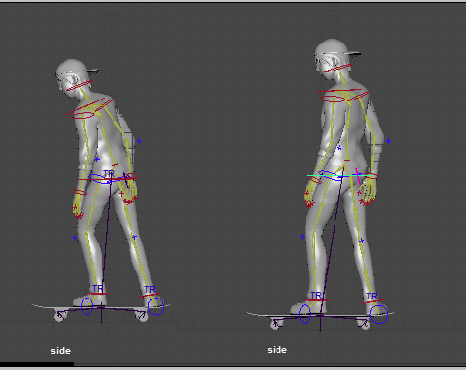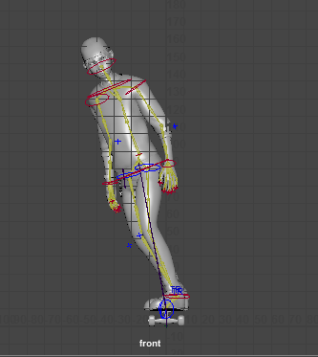
Idle layer
Look at POI layer
Look head turn layer
High speed
Standing, lean forward, back, left, right
Off balance pose forward, back, left, right
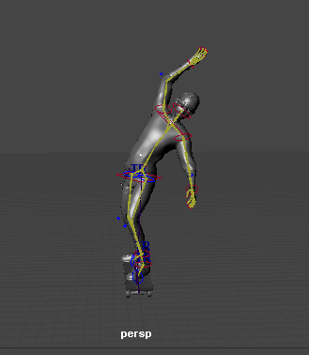
Idle layer
Look at POI layer
Look head turn layer
Jumping
Anticipation
Action
Lean forward, back, left, right
Balancing layer (arm swinging variations)
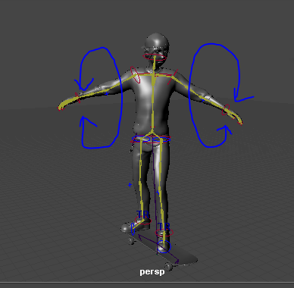
Follow through

getting on /off skateboard
-pending pending animation system discussion

droping / picking up skateboard
-pending animation system discussion

