iCare PROTON

Configuration Management Plan



Infosys Technologies Limited

|  |  |  |  |
| --- | --- | --- | --- |
| Document Name | iCare_Proton_CM_Plan.doc | Version.Rev | 1.0 |
| Authorized by | Gaurav Bhagwat | Date | 8th December 2009 |

**Copyright Notice :**

© 2010 Infosys Technologies Limited, Bangalore, India. All rights reserved. Infosys believes the information in this presentation is accurate as of its publication date; such information is subject to change without notice. Infosys acknowledges the proprietary rights of other companies to the trademarks, product names and such other intellectual property rights mentioned in this document. Except as expressly permitted, neither this presentation nor any part of it may be reproduced, stored in a retrieval system, or transmitted in any form or by any means, electronic, mechanical, printing, photocopying, recording or otherwise, without the prior permission of Infosys Technologies Limited and/or any named intellectual property rights holders under this presentation.

CONFIGURATION MANAGEMENT PLAN REVISION HISTORY

|  |  |  |  |  |  |
| --- | --- | --- | --- | --- | --- |
| Ver. | Date | Author | Reviewed by | Date | Description |
| 0.1 | 23rd November 2009 | Keerthana Surendra | Omkar Joglekar | 1st December | Draft Version |
| 0.2 | 2nd December 2009 | Keerthana Surendra | Omkar Joglekar | 3rdDecember | Draft Version |
| 0.3 | 7th December 2009 | Keerthana Surendra | Omkar Joglekar | 8th December | Draft Version |
| 1.1 | 10th February 2010 | Keerthana Surendra |  |  | Shadow VSS path updated. Infrastructure Folder structure updated. |
| 1.2 | 16th March 2010 | Keerthana Surendra | Malay Saurabh |  | Added Proton Framework version control in Appendix section |
| 1.3 | 26th April 2010 | Keerthana Surendra | Malay Saurabh |  | Confidentiality information added |
| 1.4 | 20th May 2011 | Rajneesh Singh | Rajalakshmi Venkitaraman |  | Information on Copyright notice added. |
| 1.5 | 13th June 2011 | Rajneesh Singh | Rajalakshmi Venkitaraman |  | Modified DART details for MiTime and changed classification details |
|  |  |  |  |  |  |

Table of Contents

1. CM Planning 1

1.1. Life Cycle Configuration Items and Their Storage 1

1.2. Items based on Life Cycle 1

1.3. Directory Structure on VSS 3

1.4. Access / Authority 3

1.4.1. Server Volumes (NT Server) 3

2. Configuration management activities 7

2.1. Configuration Identification 7

2.1.1. Configuration Item Types 7

2.1.2. Naming Schemes 8

2.2. Version/Revision Numbering: 9

2.3. Movement of Configuration Items through their Storage Areas: 9

2.4. Movement of Documents to Baseline Area: 11

2.5. Change Control 13

2.5.1. Change Control for Documents 13

2.5.1.1. Reconciliation 13

2.5.2. Change Control for Sources 13

2.5.3. Defect Tracking through IPM+ 14

2.6. Release 14

2.7. Details of Release Note 15

2.8. CM Tools used 15

2.9. Backup 15

2.10. Archival Procedure 16

3. CONFIGURATION AUDIT 16

4. RESPONSIBILITIES OF CONFIGURATION CONTROLLER 16

5. TERMS AND ABBREVIATIONS 16

6. Document Classification based on Confidentiality 17

7. Appendix 18

# CM Planning

## Life Cycle Configuration Items and Their Storage

VSS will be used as project level repository for all the configurable artefacts. The documents will be prepared for every individual module.

## Items based on Life Cycle

|  |  |  |  |  |  |  |  |  |  |  |  |  |  |  |
| --- | --- | --- | --- | --- | --- | --- | --- | --- | --- | --- | --- | --- | --- | --- |
|  |  |  | **Information Security Classification** | | | | | | |  | **Storage** | | |  |
| **LC Stage** | **Configuration items** | **Managed & controlled items** | **Confidentiality** | | **Integrity** | **Availability** | **Owner** | **Type of Asset** | | **Naming Convention** | **Work** | | **Release** | **Remarks** |
| **RA** | | | | | | | | | | | | | | |
|  | System Specifications Document |  |  | |  | Y | Infosys |  | | iCareProton_ <ModuleName>_<Release#>_Requirements Specifications | $/Work/ Documentation /Requirements Analysis | | $/Release/Documentation/Requirements Analysis | Documents will be prepared for every individual module. |
|  | Tracibility Matrix |  |  | |  | Y | Infosys |  | | iCareProton_ <Release#> Requirement Tracibility Matrix | $/Work/ Documentation /Requirements Analysis | | $/Release/Documentation/Requirements Analysis |  |
| **Design** | | | | | | | | | | | | | | |
|  | Detailed Level Design Document |  |  | |  | Y | Infosys |  | | iCareProton_<ModuleName>_<Release#>_DLD | $/Work/ Documentation /Design | | $/Release/Documentation/Design | Documents will be prepared for every individual module. |
| **Build** | | | | | | | | | | | | | | |
|  | Source Code |  | Y | | Y | Y | Infosys |  |  | | | $/Work/ Source Code/Solution | $/Release/Source Code/Solution |  |
| **Testing** | | | | | | | | | | | | | | |
|  | Unit Test Plan |  | Y | | Y | Y | Infosys |  | | iCareProton _<ModuleName>_<Release#>_UTP | $/Work/ Documentation /Testing/UT/TestCases | | $/Release/Documentation/Testing/UT/TestCases | Documents will be prepared for every individual module. |
|  | Unit Test Results |  | Y | | Y | Y | Infosys |  | | iCareProton _<ModuleName>_<Release#>_Unit Test Results | $/Work/ Documentation /Testing/UT/Results | | $/Release/Documentation/Testing/UT/Results |  |
| **Project Management** | | | | | | | | | | | | | | |
|  |  | Project Plan | | Y | Y | Y | Infosys |  | | iCare_Proton_ Project Plan | S:\Plans_M | | S:\Plans_M |  |
|  |  | Weekly Status Reports | | Y | Y | Y | Infosys |  | | iCare_Proton_ Weekly Status Report _<Week> | S:\Status_M | | S:\Status_M | Done on a Parent Project level |
|  |  | MOM | | Y | Y | Y | Infosys |  | | iCare_Proton_MOM _<Date> | S:\MoM_W | | S:\MoM_W | Done on a Parent Project level |
|  |  | Issue Tracker | | Y | Y | Y | Infosys |  | | iCare_Proton_ISSUE TRACKER | S:\Issues_W | | S:\Issues_W | Done on a Parent Project level |
| **Quality** | | | | | | | | | | | | | | |
|  |  | Audit Reports | | Y | Y | Y | Infosys |  | | iCare_Proton_Audit Reports | S:/Quality/Audit Reports/ | | $/Quality/Audit Reports/ |  |
|  |  | CM Plan | | Y | Y | Y | Infosys |  | | iCare_Proton_CM Plan | $/Quality/Configuration Management / | | $/Quality /Configuration Management |  |
|  |  | CM Audit Reports | | Y | Y | Y | Infosys |  | | iCare_Proton_CM Audit Report | S:/Quality/Configuration Management / | | $/Quality /Configuration Management |  |
|  |  | Standards & Guidelines | | Y | Y | Y | Infosys |  | | MS .NET Coding Standards | S:/Quality /Standards & Guidelines | | $/Quality /Standards & Guidelines |  |
|  |  | Templates | | Y | Y | Y | Infosys |  | |  | S:/Quality/Templates | | $/Quality/Templates |  |

**Note:** The documents in the **Project Management** cycle are not configurable items and will be stored in the shared folder.

## Directory Structure on VSS

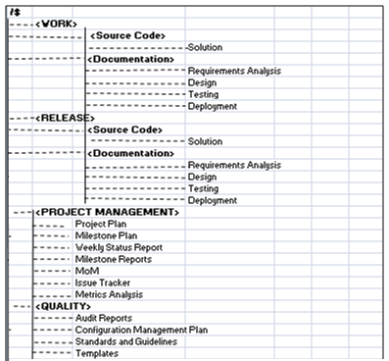

## Access / Authority

* SPM, PM, Project CC, Backup CC for the Project and OSDC CC will have ‘Full Control’ over ‘Project folder’ and its sub directory on the Project server
* iCarePROTON_AccessRight.xls document will be maintained by the project CC and back up CC. This document can be accessed from \\punitpngs02\cmeicare\PROTON\Plans_M\CM Plan
* Access rights for project specific VSS will be given as follows:

|  |  |  |  |  |  |
| --- | --- | --- | --- | --- | --- |
| Role/Rights | Read | Check Out/Check In | Add, Rename, Delete | Destroy | Admin |
| PM/PL | ✓ | ✓ | ✓ | ✓ | ✓ |
| CC | ✓ | ✓ | ✓ | ✓ | ✓ |
| BCC | ✓ | ✓ | ✓ |  |  |
| DV | ✓ | ✓ |  |  |  |

## Server Volumes (NT Server)

One volume will be maintained for PROTON:

* S: is mapped to \\punitpngs02\cmeicare\PROTON

Every member will have this volume mapped as S: and further reference to this volume will be as S:

The Drive (S:\) will be further divided according to the following structure:

* V: is mapped to

\\punitpngs02\CMEICARE\Common\Archive_W\CMEICARE_VSS_Shadow.

* PM, project CC and backup CC will have this volume mapped as V: and further

Reference to this volume will be as V:

|  |  |  |  |  |
| --- | --- | --- | --- | --- |
| **Project Level** | **2nd Level** | **3rd Level** | **4th Level** | **Description** |
| S: |  |  |  | *Project specific directories* |
|  | Archive_W\ |  |  | *Contain sub-directories for upload, download, mails etc are stored.* |
|  |  | Download\ | MonYYYY | *Download directory, contains downloads.* |
|  |  | Mails\ |  | *A store for all important project related mails* |
|  |  | Upload\ | MonYYYY | *Upload directory, contains upload folders.* |
|  |  |  |  |  |
|  | Infrastructure_W\ | Software\ |  | *Project specific infrastructure docs. Contains setup of some software received from the client.* |
|  |  | Licenses\ |  | *Contains the details of 3rd Party Licenses being used in Proton.* |
|  |  | Resources\ |  | *Contains Resources and Installations required as a prerequisite for Proton.* |
|  | Issues_W\ |  |  | *Internal External Issues for current and old releases* |
|  | KM_M\ |  |  | *Knowledge Management repository.* |
|  |  | BoK\ |  | *Documents from KSHOP and material collected from other sources* |
|  |  | CaseStudy\ |  | *Case Studies of other projects* |
|  |  | Presentations\ |  | *Contains Presentations on modules used in the project* |
|  |  | TechDocs\ |  | *Contains User manuals for the project(if any)* |
|  |  | Tools\ |  | *Information about the tools which will be used by the project* |
|  |  | Training\ |  | *Contains Presentations on trainings undergone like .Net, C#* |
|  |  | Tips\ |  | *It has all the KM tips submitted by the Team members* |
|  |  | Quiz\ |  | *Quiz which are conducted within the project* |
|  |  | Recorded KT\ |  | *Contains recorded KT session* |
|  |  | Reference Guide\ |  | *Contains location of the KM documents* |
|  |  | KT Docs\ |  | *Contains documents for KT* |
|  | MoM_W\ |  |  | *Minutes of meetings* |
|  |  | KM |  | *MoMs for KM Session* |
|  | Plans_M\ |  |  | *Project related plans* |
|  |  | CM Plan\ |  | *Updated and latest Configuration Management Plan* |
|  |  | KM Plan\ |  | *Updated and latest Knowledge Management Plan* |
|  |  | PM Plan\ |  | *Updated and latest Project Management Plan* |
|  |  | Misc\ |  | *Miscellaneous documents regarding plans and management activities* |
|  |  | Leave Plans |  | *Contains Leave plan for offshore and onsite team members* |
|  | Projdoc_D\ |  |  | *Other project related documents* |
|  |  | MasterDocuments\ |  | *It contains master documents such as System appreciation doc.* |
|  |  | Requests\ |  | *It contains the Change request xls to track the no of CR's.* |
|  |  | CodeDeployment\ |  | *It contains code deployment documents* |
|  |  | Misc\ |  | *It contains the application related Misc docs given by customer.* |
|  |  | Project Management\ |  | *It contains the project management related documents.* |
|  |  |  | Security\ | *US Denied check documents and other security document* |
|  | Quality_M\ |  |  | *DP and quality related Matrix* |
|  |  | Audits\ |  | *All the audits (CM, PSQA, Internal and Prism) related material* |
|  |  |  | CM\ | *CM audit reports and CM related data* |
|  |  |  | KM\ | *KM audit reports and documents defining goals and objectives for KM activity.* |
|  |  |  | CMMi Assessment\ | *It contains CMMi assessment data* |
|  |  |  | Release\ | *It contains release audit checklists.* |
|  |  | ClosureReport\ |  | *Project Closure reports and docs, Metric Analysis report.* |
|  |  | DP\ |  | *Documents related to Defect Prevention activitie.* |
|  |  | Standards\ |  | *Checklist, guidelines, Coding Standards.* |
|  |  |  | CodingStandards\ | *Coding Standards used for diff technologies.* |
|  |  |  | Testing Standards\ | *Testing Standards* |
|  |  |  | Naming Standards\ | *Naming Standards for deliverable documents* |
|  |  |  | Guidelines\ | *Guidelines such as deployment guidelines.* |
|  |  | Templates\ |  | *Project related Templates* |
|  |  | Guidelines\ |  | *Guidelines for project* |
|  |  | Checklists\ |  | *Contains all the checklists* |
|  |  |  | Release | *It contains release audit checklist* |
|  |  |  | CM\ | *It contains CM audit checklist* |
|  | Release_M\ |  |  | *Contains Release specific folders and documents Also contains RTM, Requirements documents and Estimation documents.* |
|  |  | Release #\ |  |  |
|  | Status_M\ |  |  | *All status reports generated at Project level will be stored over here* |
|  |  | WSR\ |  | *Contains weekly reports for the individual project member of onsite as well as offshore.* |
|  |  | MSR\ |  | *Contains Milestone status report.* |
|  | Users_Q\ |  |  | *User directories space* |
|  |  | <user-name>\ |  | *Users individual directories (Should not be more than 20 MB)* |
|  |  | Shared |  | *Contains common project data which needs to be accessed by the entire team. The team will have full control access rights on this folder.* |
|  | VSS_D\ |  |  | *The VSS database of the Project (Shadow VSS should be kept off diff. Machine)* |

## Configuration management activities

## Configuration Identification

### Configuration Item Types

#### Software Sources

The software sources for PROTON project include the following:

|  |  |
| --- | --- |
| Java Script files | .js |
| HTML files | .html |
| SQL files | .sql |
| Style sheet files | .css |
| Microsoft Visual Studio Solution | .sln |
| Visual C# Project file | .csproj |
| Visual Studio Project User Options file | .csproj.user |
| .NET Managed Resources File | .resx |
| Visual C# Source file | .cs, .designer.cs |
| Class Diagram file | .cd |
| Visual Studio Source Control Project Metadata File | .csproj.vspscc |
| Visual Studio Source Control Solution Metadata File | .vssscc |
| Microsoft SourceSafe Status | .ssc |
| Program Debug Database | .pdb |
| Application Extension | .dll |
| RESOURCES File | .resources |
| CACHE File | .cache |
| XML Configuration File  XML Document | .config  .xml |
| Visual Studio Data Source File | .datasource |
| Visual Studio Dataset Internal Info File | .xsc |
| DB Scripts File | .txt/.sql |
| Icon | .ico |

#### Documents

* Configuration Management Plan
* Project Plans
* Leave Plan
* Estimations
* Detailed Design Documents.
* Business Requirements Document
* Unit Test Plan
* Installation Plans
* Master List of documents
* Issues (To be maintained in an Issue Tracker Document)
* Induction Plan

**Confidentiality Notice and Copyrights**

**All the project related documents must contain following Confidentiality notice :**

© 2010 Infosys Technologies Limited, Bangalore, India. All rights reserved. Infosys believes the information in this presentation is accurate as of its publication date; such information is subject to change without notice. Infosys acknowledges the proprietary rights of other companies to the trademarks, product names and such other intellectual property rights mentioned in this document. Except as expressly permitted, neither this presentation nor any part of it may be reproduced, stored in a retrieval system, or transmitted in any form or by any means, electronic, mechanical, printing, photocopying, recording or otherwise, without the prior permission of Infosys Technologies Limited and/or any named intellectual property rights holders under this presentation.

Each slide should carry “© 2010 Infosys Technologies Limited, India”

**Similarly, all the code files must contain following copyright notice:**

© 2010 Infosys Technologies Limited, Bangalore, India. All rights reserved.

Version:

Except for any open source software components embedded in this Infosys proprietary software program (“Program”), this Program is protected by copyright laws, international treaties and other pending or existing intellectual property rights in India, the United States and other countries. Except as expressly permitted, any unauthorized reproduction, storage, transmission in any form or by any means (including without limitation electronic, mechanical, printing, photocopying, recording or otherwise), or any distribution of this Program, or any portion of it, may result in severe civil and criminal penalties, and will be prosecuted to the maximum extent possible under the law.

.

### Naming Schemes

#### Software sources

All source files will have the following naming conventions -

$FilePurpose.xxx where, $FilePurpose is a brief description of the file.

The extensions of the files can be as follows -

|  |  |
| --- | --- |
| Java Script files | .js |
| HTML files | .html |
| SQL files | .sql |
| Style sheet files | .css |
| Microsoft Visual Studio Solution | .sln |
| Visual C# Project file | .csproj |
| Visual Studio Project User Options file | .csproj.user |
| .NET Managed Resources File | .resx |
| Visual C# Source file | .cs, .designer.cs |
| Class Diagram file | .cd |
| Visual Studio Source Control Project Metadata File | .csproj.vspscc |
| Visual Studio Source Control Solution Metadata File | .vssscc |
| Microsoft SourceSafe Status | .ssc |
| Program Debug Database | .pdb |
| Application Extension | .dll |
| RESOURCES File | .resources |
| CACHE File | .cache |
| XML Configuration File  XML document | .config  .xml |
| Visual Studio Data Source File | .datasource |
| Visual Studio Dataset Internal Info File | .xsc |
| Icon | .ico |

## Version/Revision Numbering:

Each Non-Software Work Product whether it is a CI or MCWP is allocated a version number, as follows:

|  |  |
| --- | --- |
| New document (first draft) | 0.0 |
| After 1st review (second draft) | 0.1 |
| After 2nd review (third draft) | 0.2 |
| ….. | ….. |
| After 9th review (tenth draft) | 0.9 |
| Approved | 1.0 |
| Change is required | |
| First Draft | 1.1 |
| Second Draft | 1.2 |
| Approved | 2.0 |

* For major changes, the version number will be increased by 1.
* For medium changes, the version number will be increased by 0.1.
* For minor changes, the version number will be increased by 0.01.
* The revision made to each configurable item will be captured in the comments while performing check-in of the item in VSS

## Movement of Configuration Items through their Storage Areas:

* Developer checks-out files from the Work Area of VSS, if a file already exists. Developer works on source code and check-in the files into Work Area once the changes have been made
* If a file is not present in Work Area, developer creates a new file. ML, CC or BCC will check it in to Work area of VSS
* Once the Source Code is ready for review, developer informs ML that the Source Code is ready for review
* Reviewer reviews the code and enters comments in IPM+
* Reviewer informs Developer about the completion of Review
* If there are any defects in the code, developer checks-out the Source Code from WORK Area
* Developer fixes defects, checks-in the code into Work Area of VSS and informs ML
* Reviewer reviews the code
* Once all the defects and review comments have been resolved. ML moves the Source Code from WORK area to RELEASE Area and labels it as ITERATIONn_0 where <n> is the next version for Source Code in RELEASE Area
* ML deploys this code to the production environment
* In case any changes are required for the code in Production environment, ML copies the code from RELEASE Area to the Work Area
* Developer checks out the latest version of file from Work area, modifies the file and checks in the file into Work Area

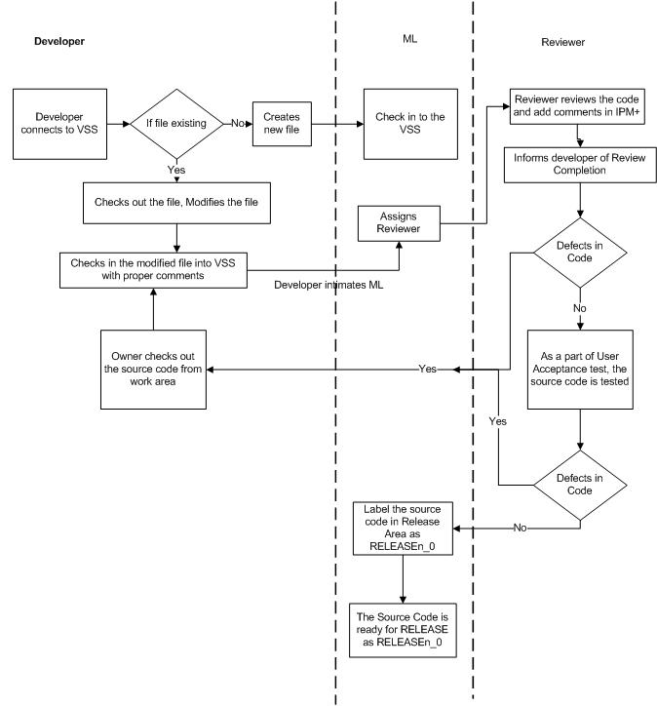

## Movement of Documents to Baseline Area:

* Owner authors the artefact and checks it into WORK Area. If the artefact already exists, owner checks out the artifact from WORK area, modifies it and checks the artifact into WORK AREA
* Owner informs the ML about the completion of the document. ML assigns a reviewer to review the document.
* Reviewer will get the latest version of artifact from WORK area and conduct review of the artifact. Reviewer reviews the document and logs the comments and defects in IPM+
* Reviewer informs Owner about the completion of review of the artifact
* Owner checks out the artifact from WORK area, modifies the document and checks-in the document into VSS
* Owner informs Reviewer to review the artifact
* Reviewer informs Owner about the completion of review
* Owner informs ML to move the artifact in Release area, if there are no open review comments in the artifact
* ML will get the latest version of document from WORK area and check in RELEASE area.

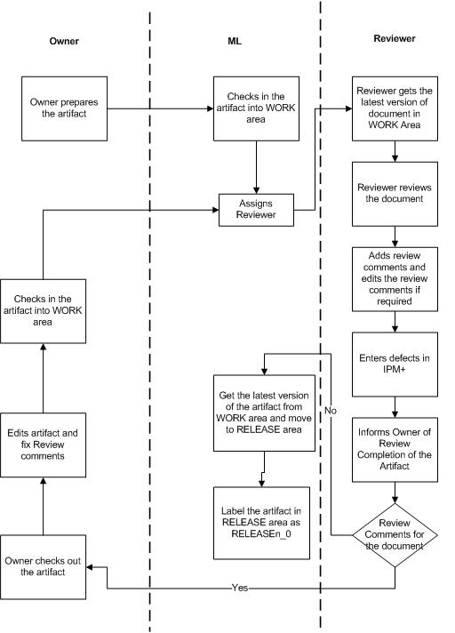

## Change Control

### Change Control for Documents

1. If a document is in the draft stage, the author of the document will have to checkin the file in the respective directory in VSS. The version along with brief description of the modifications of the document has to be entered in the comments section while checkin-in.
2. The reviewer will have to checkout the file into his/her work area. If group review is to be conducted for a document, the author will send the document to the participants for the group review and will arrange the group review meeting.
3. After reviewing, the reviewer will enter all the review comments into IPM+, do an undo-checkout on the file in VSS and send a mail informing the author. Some of the global level comments may be given in the mail itself. The author will maintain the versions between reviews in the modification log of the document. For details, refer to the Defect Tracking IPM+ guidelines.
4. If there are no changes to be made to the document, the reviewer will send a mail to this effect to the author and/or the ML/PM, and will make an entry in the IPM+ for no defects. The document should be baselined after this.

## Reconciliation

The artifact is reconciled with the inputs by the team members, at offshore, other DCs and onsite as well.

1. The artifact is present in the VSS is checked out to its respective folder and is shared to all.
2. Team members are asked to provide their inputs to the artifact present.
3. The artifact is sent to the intended team (Team in other DCs or Onsite) and the artifact is checked back into the VSS.
4. The artifact sent to the other team is updated with the comments/inputs from the team members, and when it is obtained at offshore, the artifact present in the VSS is checked out and is replaced with the obtained version after verifying the data integrity of the received version.
5. After release, the artifact is moved to the baseline area defined for that artifact as per the CM Plan.

### Change Control for Sources

For developing programs, the following procedure will be followed on both UNIX & Non-UNIX platforms;

1. The developer checks out the files to his/her home directory & then makes the changes.
2. After the program is successfully compiled, it is submitted for Code Walk through (CWT). The reviewer logs the defects found during CWT into IPM+. The defects in this program are submitted to the developer and a mail is sent to him/her through the mail facility.
3. The developer removes these defects and then performs self-test in the same directory. The developer rectifies errors found during the self-test.
4. For IUT, similar to the Self-Test, the independent tester will move the files to the runtime environment to test the program. If any defects are found then he/she logs them into IPM+, and submits them to the developer.
5. After the developer closes these defects, the sources are now ready for System Testing.
6. Once, the sources are checked in, they are ready for the release. The PM/ML/developer will make release for the system testing, if required.

### Defect Tracking through IPM+

Any request that causes a change to the existing software (inclusive of sources as well as documentation) kept under configuration control is termed as a ‘defect’. IPM+ will be used to track all such defects (review comments, defects etc.). Defect record will be customized to suit the Project groups.

1. In case of defects the tester/reviewer will submit the defect to the owner of the defect to fix the defect.
2. Defect Managers/leads in the project, SPM and PM will have admin rights in IPM+. ML/DV will have write, update and query rights.

## Release

A dedicated Release team will handle the Release Management. This team consists of Project Manager and Configuration Controller. The following items will be checked for a release item:

* Have all the tests and reviews planned been conducted?
* Is the component labelled as “Ready for Release <Ver. No>” in VSS
* Is the correct version available in VSS and code can be moved to Baseline Area from work area?
* Have all the defects been closed in IPM+? Are the Reviews closed too and percentage completion made 100%?
* Are the headings in all the documents in capitals, bold and underlined?
* Has a release note been prepared and all artifacts for release (Requirements, Usage, Test Plans, Design, PQM Results, Code, RTM, Release note) mentioned in the document?
* Are properties for all word documents and Excel sheets updated?
* Have all the Documents revision history, header/footer updated correctly? Are they aligned properly? Has the table of contents updated in all documents and hyperlinks to the various headings inserted? (The link should be present for the entire table and not just page numbers.)
* Is spell Check for all documents done? Check if the Alignment is proper for the sentences
* Are Open issues /defects added to the release note?

|  |  |  |  |
| --- | --- | --- | --- |
| Configuration item | Release area | Responsibility for building the release & releasing | When released |
| iCareProton_ <ModuleName>_<Release#>_Requirements Specifications | RA folder under RELEASE area in VSS. Refer to Directory structure in section 1.3 | PM | After completion of above steps in section 2.5 |
| iCareProton_ <Release#> Requirement Tracibility Matrix | RA folder under RELEASE area in VSS. Refer to Directory structure in section 1.3 | PM | After completion of above steps in section 2.5 |
| SourceCode | SOLUTION folder within SOURCECODE folder under RELEASE area in VSS. Refer to Directory structure in section 1.3 | PM | After completion of above steps in section 2.5 |
| iCareProton _<ModuleName>_<Release#>_UTP | UT folder under TESTING folder within RELEASE area in VSS. Refer to Directory structure in section 1.3 | PM | After completion of above steps in section 2.5 |

## Details of Release Note

* Release note instructions
* Version number of the release
* Date of release

## CM Tools used

|  |  |  |  |
| --- | --- | --- | --- |
| Sr. No | Tool Name | Item Supported | Installed Location |
| 1 | VSS | Documents, Source Code |  |

## Backup

|  |  |  |  |  |  |  |  |
| --- | --- | --- | --- | --- | --- | --- | --- |
| Storage area to be backed up | Backup media | Numbering scheme | Confidentiality Level | Backup | | Checking backup files | |
|  |  |  |  | Frequency | Responsibility | Frequency | Responsibility |
|  | Tape | Date wise | Confidential | Daily | CCD | Monthly | CC |
|  | Tape | Date wise | Confidential | Daily | CCD | Monthly | CC |
|  |  |  |  |  |  |  |  |

|  |  |
| --- | --- |
| **Directory name ending with** | **Backup frequency** |
|  |  |
| _D | Daily |
| _W | Weekly backup |
| _M | Monthly backup |
| _Q | Quarterly Backup |

## Archival Procedure

|  |  |  |  |  |  |  |
| --- | --- | --- | --- | --- | --- | --- |
| Storage area to be archived | Archival media | No. of copies | Numbering scheme | **Retention Period** (based on Customer Requirements) | Responsibility | Confidentiality Level |
|  | Tape | 2 | Quarter wise |  | CC | Confidential |
|  | Tape | 2 | Quarter wise |  | CC | Confidential |
|  |  |  |  |  |  |  |

# CONFIGURATION AUDIT

|  |  |
| --- | --- |
| **Frequency of audit** | **Responsibility** |
| Monthly CM Audit | Project CC/ Backup CC will do the internal CM audit for a project. CM audit reports are available in ( S:\Quality_M\Audits\CM \CMAudit_mmm-yyyy.xls***.*** |
| Randomly | SQA |
| Release | CC/BackupCC will do Release Audit at the time of Release. (At the end of the test cycle for the iCare Release). The release audit checklists are available in (S:\Quality_M\Audits\Release\iCareProton_Release_Audit_CheckList.xls) |

# RESPONSIBILITIES OF CONFIGURATION CONTROLLER

* CM orientation to project team
* CM tool deployment if applicable
* Configuration item status tracking
* Ensuring backups and archival
* Conducting CM audits as planned
* Generating CM audit reports
* Tracking CM audit discrepancies to closure

# TERMS AND ABBREVIATIONS

|  |  |
| --- | --- |
| Abbreviations | Expansion |
| Dev | Development or technical team |
| VSS | Visual Source Safe |
| CM | Configuration Manager |
| ML | Module Lead |
| PL | Project Lead |

# Document Classification based on Confidentiality

* 1. Classification of Documents
* All the Proton documents would carry the confidentiality information.
* The class of an information asset can change with time. Such changes in class must be authorized by the owner.
* The artifacts will be categorized as
* Internal or Public - Information is classified public or internal when there is a need for everyone or, respectively, all Infoscions to know it and such sharing does not result in violations of any security objectives.
  + Restricted – Documents containing information which may be shared with non-Infoscions like contractors, customers and prospects if the need to do so has been established and after verification with the owners of the information will be categorized under **Restricted.**
  + Confidential – Documents containing information which may be shared with parties outside Infosys, such as contractors, customers and prospects, only if the need to do so has been established and due authorization has been obtained from the owner. Deliberate violation of this policy may lead to termination of employment or legal prosecution will be categorized under **Confidential**
  + Highly Confidential

Documents containing information that can be shared with parties outside Infosys, such as contractors, customers and prospects, only if the need to do so has been established and due authorization has been obtained from the owner. Deliberate violation of this policy may lead to termination of employment or legal prosecution will be categorized as **Highly Confidential**

References:<http://secarch/docs/policies/Information_Classification_Policy.pdf>

* 1. Labelling and categorization of Documents

References: <http://secarch/docs/policies/Document_Labeling_Guidelines.doc>

 Different documents will be categorized as follows:

|  |  |  |
| --- | --- | --- |
| **Restricted** | **Confidential** | **Highly Confidential** |
| Requirement Docs | RTM | DLD |
| User Guide | UTP | Architecture documents |
| System Test Plan | UTP Result | HLD |
| Questionnaire |  |  |
| Installation Guide |  |  |
| Software Release |  |  |

* 1. **Copy Rights of Source code**

All the Source Code would contain the following Copy Righted Text

Copyright © 2010 Infosys Technologies Ltd, All Rights Reserved.

Copyright and other intellectual property laws protect these materials. Reproduction or retransmission of the materials,

in whole or in part, in any manner, without the prior written consent of the copyright holder, is a violation of copyright law.

Individuals must preserve any copyright or other notices contained in or associated with them. Users may not distribute such copies to others,

whether or not in electronic form, whether or not for a charge or other consideration, without prior written consent of the copyright holder of the materials.

* 1. **Protection of IPR & Non Disclosure Agreement**

Protection of IPR & Non Disclosure Agreement to be included before checking in the code to VSS

I <Full Name> have not used any Open Source Software or Copy Righted material in my code which is against the Infosys IPR.

I <Full Name> will not share or reuse any information/idea/design/code from the project “iCare Proton” or that has been shared as part of iCare solution outside the solutions project, which I have gained as a part of being a member of iCare Proton solutions team.

I will be liable for any infringement.

# Appendix

* 1. **The CMEICARE VSS Structure** The VSS directory for CMEIcare will have the following directory sturucture for PROTPSTP-PROTPSEZ Project

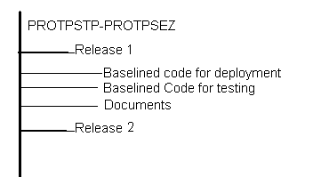

1. The Release 1 folder will contain the Baselined Code for deployment and testing which would include all the files required for the build and will be available in the exe format.
2. The Release 2 folder will contain the Baselined Code for deployment and testing which would include all the installer files for running the iCareProton Project
3. The Documents folder will include all the documents pertaining to the particular relase.
   1. **MiTime Activity code guidelines**

The DART Activity Code guidelines is mentioned in the attached iCARE-DartActivityCodeGuidelines.xls file



* 1. **PROTON Framework version control**
     1. Version maintenance of Proton Framework
* Only the senior members of the team will be having access to the Proton Framework code
* The version format will be major.minor.build.
* For every release, either the major or minor or both have to be changed. In case the build is created more than once during the same release then the build version has to be changed.
* For major changes, the version number will be increased by 1.0.0.
* For minor changes, the version number will be increased by 0.1.0.
* The revision made to each configurable item will be captured in the comments while performing check-in of the item in VSS
* File version need to be changed for every update in the corresponding file.
  + 1. Movement of Framework to Baseline Area:
* After every major release, the Source code of the framework will be moved to the Release area and labelled.
* Both the source code and the dll will be maintained for every major release
* Every build that has been used for testing (either by dev or testing team), demo, release, etc will be archived in the shared folder as well as labelled in the VSS.
* Log of each build will be maintained in \\punitpngs02\cmeicare\PROTON\Release_M\Proton Framework\Release Log.xlsx.

It contains the details of the Framework DLL changes like date, build version and brief description of changes.