**Task 3:**

I am currently maintaining the below Database in Excel as I did not have any RDBMS installed here. Now we have configured MySQL database. Now I need to change the functionality to use MySQL to make it more efficient.

 As you see below, for each claim, I am tracking when the different letters are sent to customers. E.g. for claim “CH014333” we have sent 4 letters on different dates. The last ultimatum letter sent on 30-May. So the status column (Col 1) shows “Ultimatum Sent”.

 I need this data to be maintained in MySQL and Query from it as needed.

 Give me separate sequences that can be used (by sending proper arguments)

* CreateNewRow (ClaimNo, Status, DataRow) – should check if Claim No. already exists in DB before inserting
* UpdateRowStatus (ClaimNo, Status, Date) – should update the row with appropriate status
* GetLetterIssueStatus (ClaimNo) – should return (status, last letter date)

|  |  |  |  |  |  |  |  |  |  |  |
| --- | --- | --- | --- | --- | --- | --- | --- | --- | --- | --- |
| **Letter Issuance Status** | **Acknowledgement Letter Date** | **Reminder 1 Date** | **Reminder 2 Date** | **Ultimatum Date** | **Closure Date** | **CONTTYPE** | **POLICYNO** | **BRANCHCODE** | **BRANCHNAME** | **CLAIMNO** |
| Keep this |  |  |  |  |  |  |  |  |  | 1 |
| Ultimatum Sent | 20170313 | 20170327 | 20170410 | 20170530 |  | HAP | HA000177 | 62 | Corporate | CH014333 |
| 2 Reminder Sent | 20170421 | 20170505 | 20170519 |  |  | HSE | 03778748 | 68 | Agency Team 1 | A1187017 |
| 2 Reminder Sent | 20170508 | 20170514 | 20170530 |  |  | HCR | 04068227 | 81 | Alternative Distribution | A1206981 |
| Acknowledgement Sent | 20170530 |  |  |  |  | HAP | HA000049 | 12 | Penang | CH014537 |

**Solution:**

Pre-requisites:

* Install MySQL 9.4.0.5125
* Install MySQL Connector/ODBC 3.51

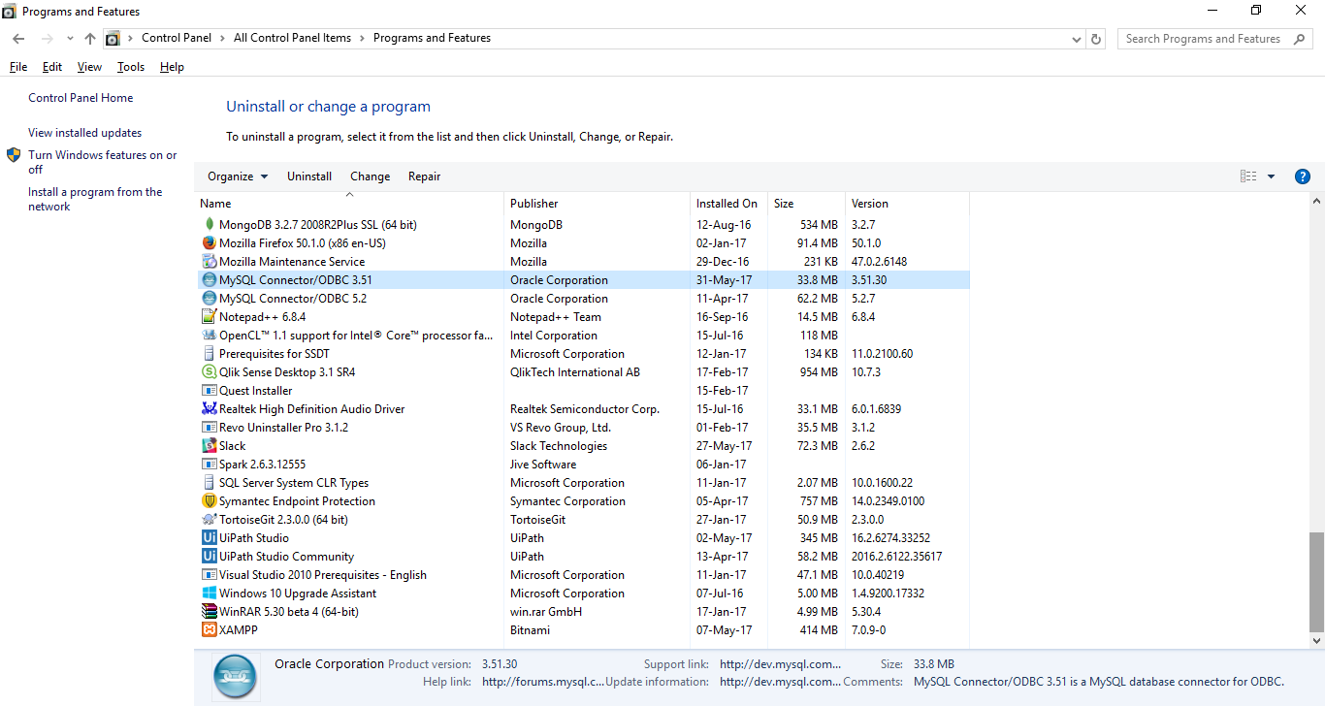

Using **MySQL connector/ODBC 3.51** connect the local database through ODBC Driver (64-bit)

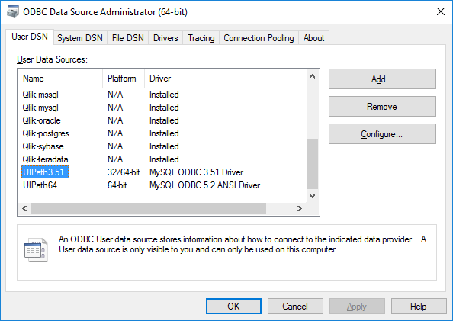

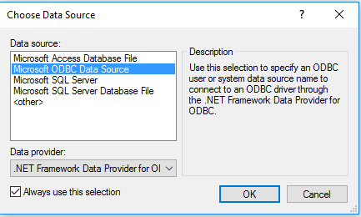

And then we need to select that data source name and give user name and password

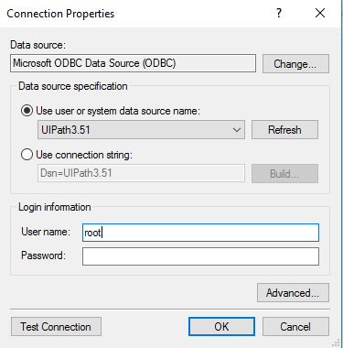

Give Test Connection

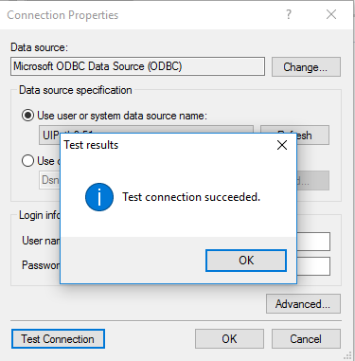

Create Table Query: [We Create the table locally]

**CREATE** **TABLE** `claim_status` (

`id` **BIGINT**(10) **NOT** **NULL** **AUTO_INCREMENT**,

`Claim_No` **VARCHAR**(50) **NULL** **DEFAULT** **NULL**,

`Letter_Issuance_Status` **VARCHAR**(50) **NULL** **DEFAULT** **NULL**,

`Acknowledgement_Letter_Date` **VARCHAR**(8) **NULL** **DEFAULT** **NULL**,

`Reminder1_Date` **VARCHAR**(8) **NULL** **DEFAULT** **NULL**,

`Reminder2_Date` **VARCHAR**(8) **NULL** **DEFAULT** **NULL**,

`Ultimatum_Date` **VARCHAR**(8) **NULL** **DEFAULT** **NULL**,

`Closure_Date` **VARCHAR**(8) **NULL** **DEFAULT** **NULL**,

`Time_Stamp` **DATETIME** **NOT** **NULL** **DEFAULT** **CURRENT_TIMESTAMP** **ON** **UPDATE** **CURRENT_TIMESTAMP**,

**PRIMARY** **KEY** (`id`)

)

**COLLATE**='latin1_swedish_ci'

**ENGINE**=**InnoDB**;

**Table Structure:**



* **ClaimStatus.xaml** File is used for creating / updating the records in the database. In that we need to assign values to below variables

claimNo = "777"

letterStatus = "1 Reminder Sent"

letterSentDate = "20170529"

queryType = "insert/update" OR “select”

* **ClaimStatus.xaml** internally calls **ExecuteQuery.xaml** file.

ExecuteQueries.xaml workflow takes 2 arguments

1. queryType

2. query [value for this argument will be passed by ClaimStatus.xaml internally based on logic]

and returns rowsAffected.

queryType can take only these two values

“insert/update” OR “select”

rowsAffected will return number of rows for **insert/update** and for **select**, rowsAffected will return a datatable

Hence datatype of rowsAffected is GenericValue